**12th CRP PHASE – 4 JEE ADVANCED PCM - 1 CSDJ 31602**

**Validation Done By CSY**

**Single Answer Questions**

1. The final product in following reaction is

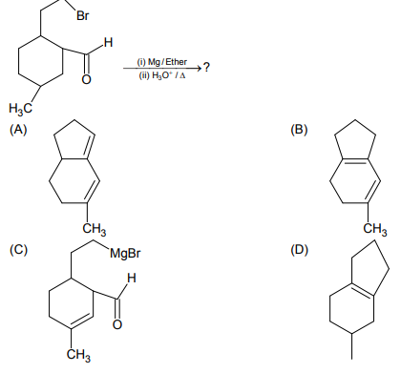

2. Find out major product of following reaction:

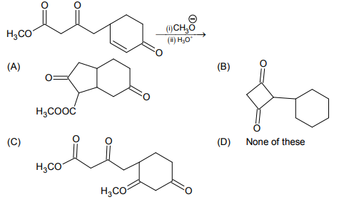

3. Consider the following sequence of reactions:

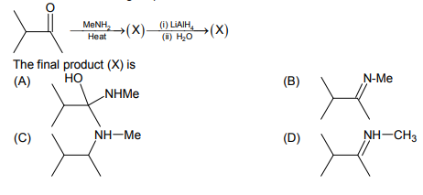

4. Which of the following is the correct option of reagent for the given conversion?

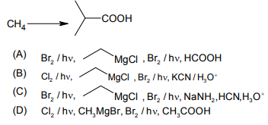

5.

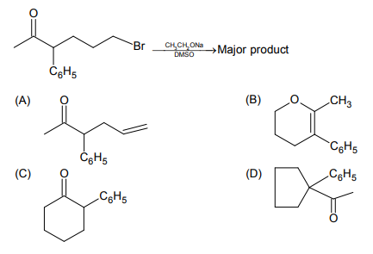

6.

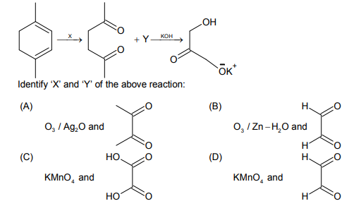

7. Which of the N atoms is least basic in the given compound?

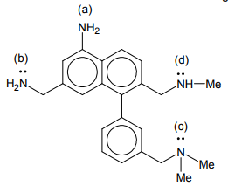

(A) a (B) b (C) c (D) d

8. How many formaldehyde will be formed in the given reaction?

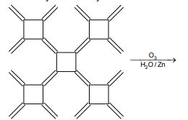

(A) 12 (B) 10 (C) 11 (D) 5

9.

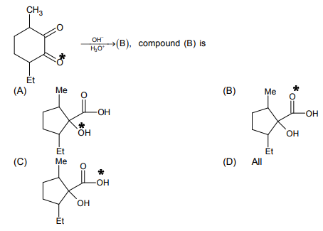

10. Which of the following is reactive intermediate for the following reaction?

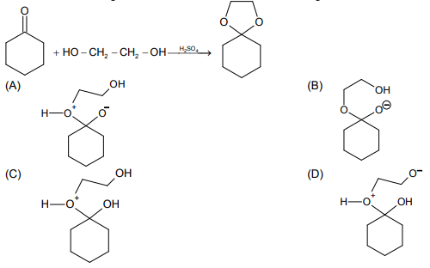

**One or more than one correct option questions**

11. Oberve the following reaction

The correct statement is



1. The product is a mixture of two compounds
2. The product is optically inactive
3. The product is a mixture of two chiral and one achiral steroisomer
4. The product is a mixture of three stereoisomers.

12. In which of the following reaction product formation takes place by Hofmann rule?

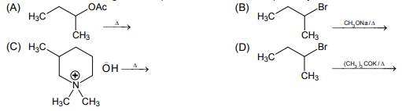

13. In the given reaction which one of the following statement is correct-?



(A) Oxime Amy be E/Z.

(B) Amide on hydrolysis gives a mixture acetic acid, benzoic acid, Aniline, and methylamine.

(C) Preparation of oxime is nucleophilic addition followed by elimination reaction.

(D) Oxmie and amides are isomers.

14. Which of the following will give 3- pentanone?

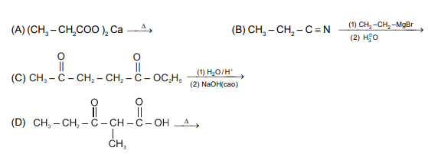

15. What is the expected order of reactivity of the following compounds in electrophillic nitration?

(More reactive, less reactive)?

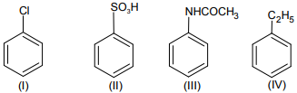

(A) I >II > III > IV (B) IV > I > II > III (C) III > IV > I > II (D) II > I > IV > III

**Numerical**

N1. How many of the following will give 2, 4-DNP test.

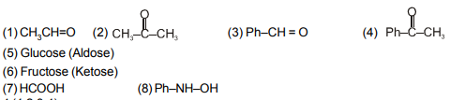

N2.

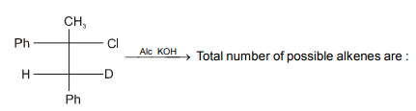

N3.

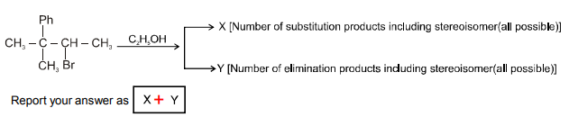

N4. Which carbon atom will give fastest  reaction in given compound?

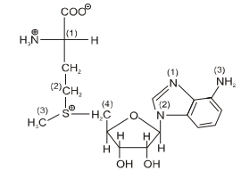

N5. Consider the following reactions

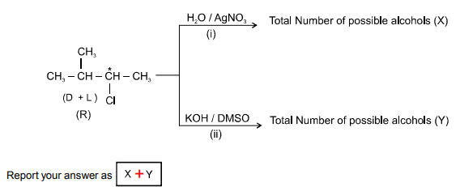

**Answer key**

1. D 2. A 3. C 4. B 5. B

6. B 7. A 8. A 9. A 10. C

11. B, C 12. A, C, D 13. A, B, C 14. A, B, D 15. B

N1. 4 N2. 3 N3. 7 N4. 3 N5. 4

1. C124601 2. C121408 3. C121402 4. C121501 5. C121402

6. C121408 7. C121601 8. C121401 9. C121405 10. C121402

11. C121402 12. C121603 13. C121402 14. C121501 15. C121604

16. C121403 17. C121603 18. C121603 19. C121603 20. C121603