**SQL ACTIVITY**

Consider the following table STUDENT**.**

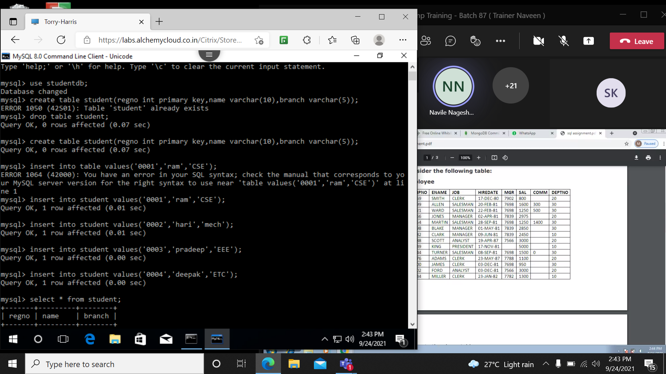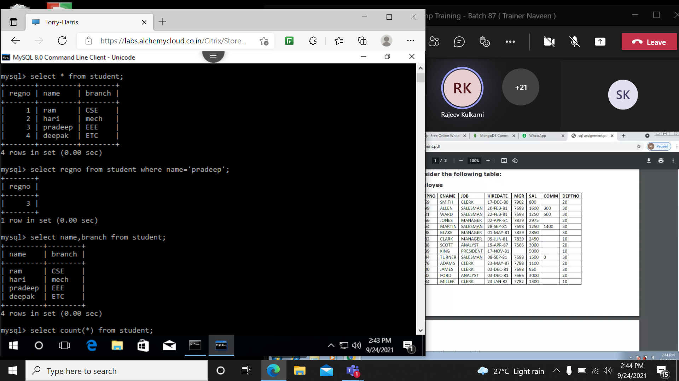

1. Write down the SQL command which will show the regd. No of pradeep.



1. Write down the sql command which will show the name and branch column.



1. Write a sql command which will count the number of rows existing in student table.

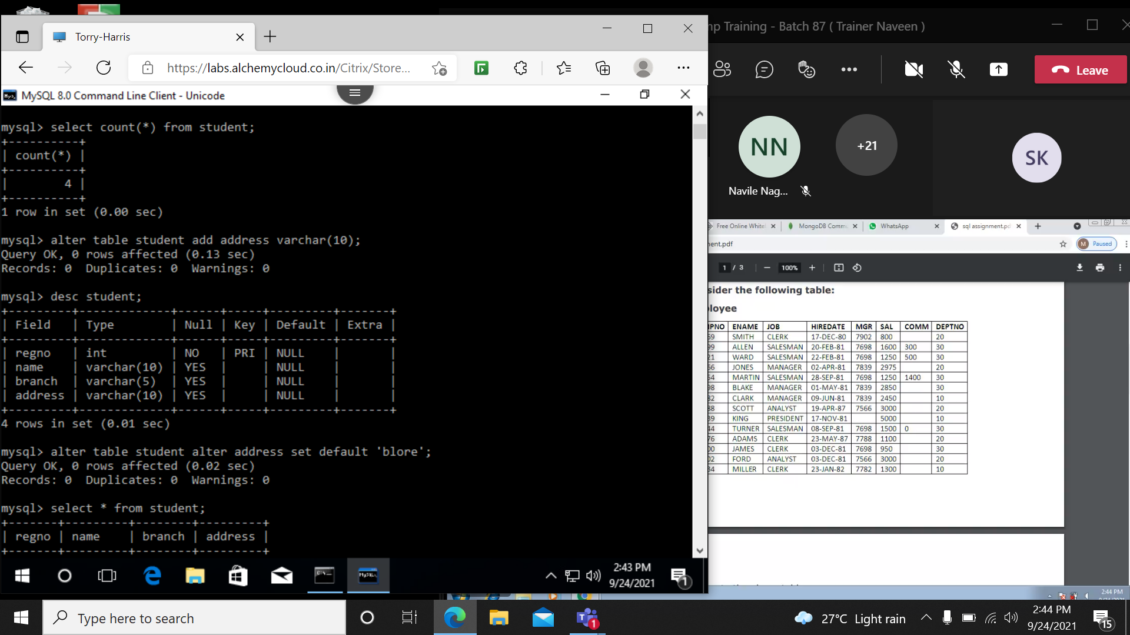

1. I want to add another column in student table as ‘address’. How can I do that?

