**SQL COMMANDS**

**Join-** use to combine rows from two or more table based on related column between them

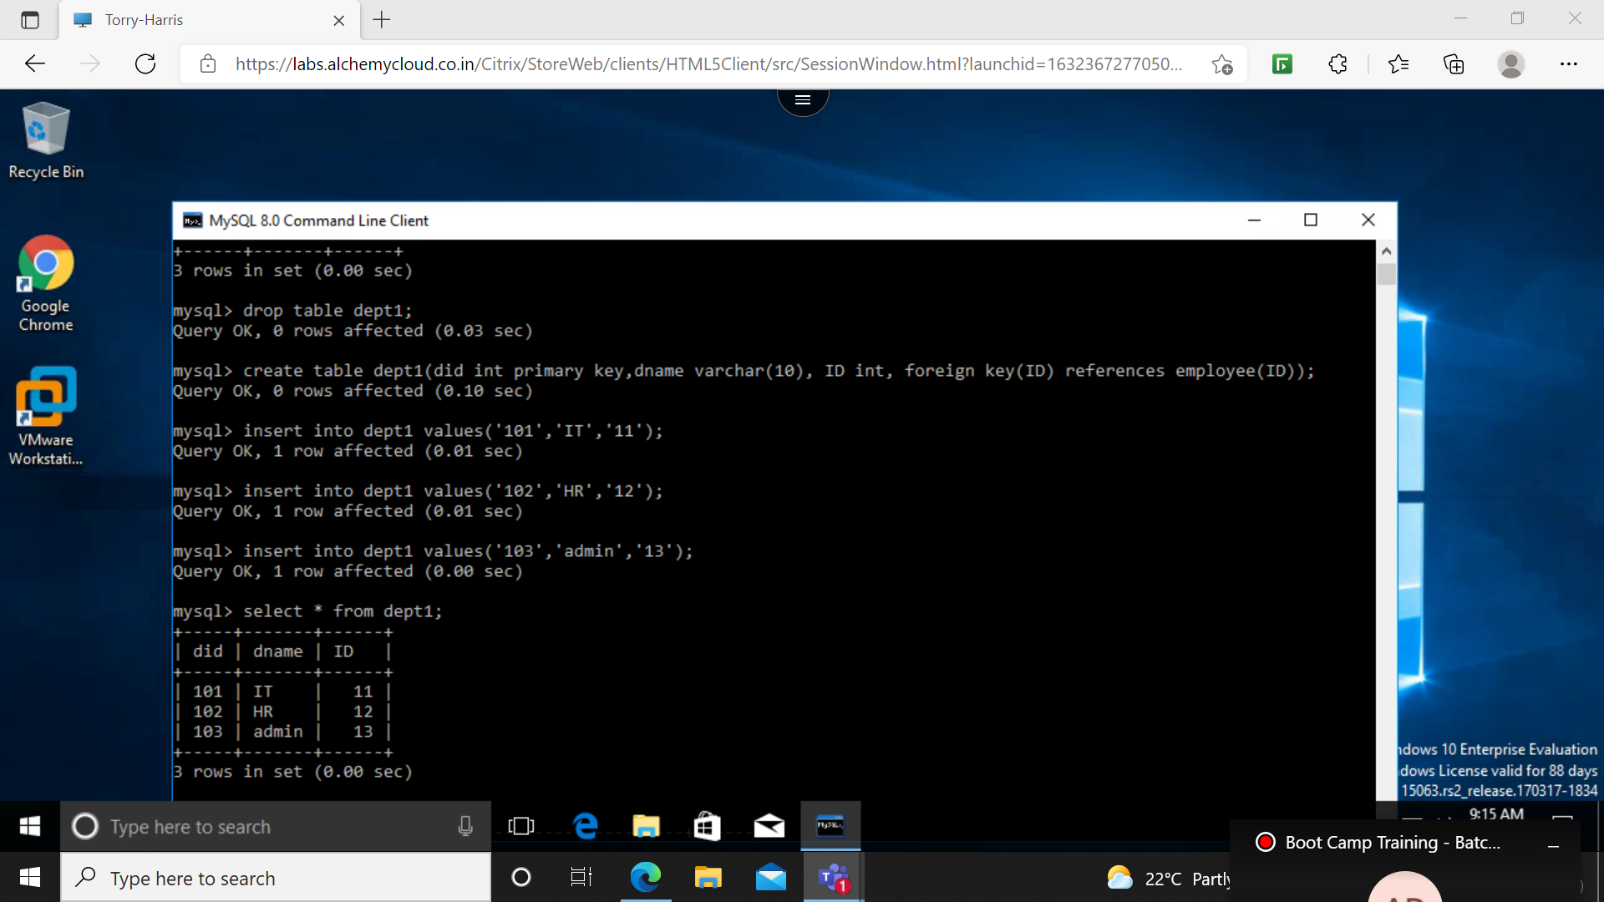

**INNER JOIN:** returns record that have both values matching in both tables;

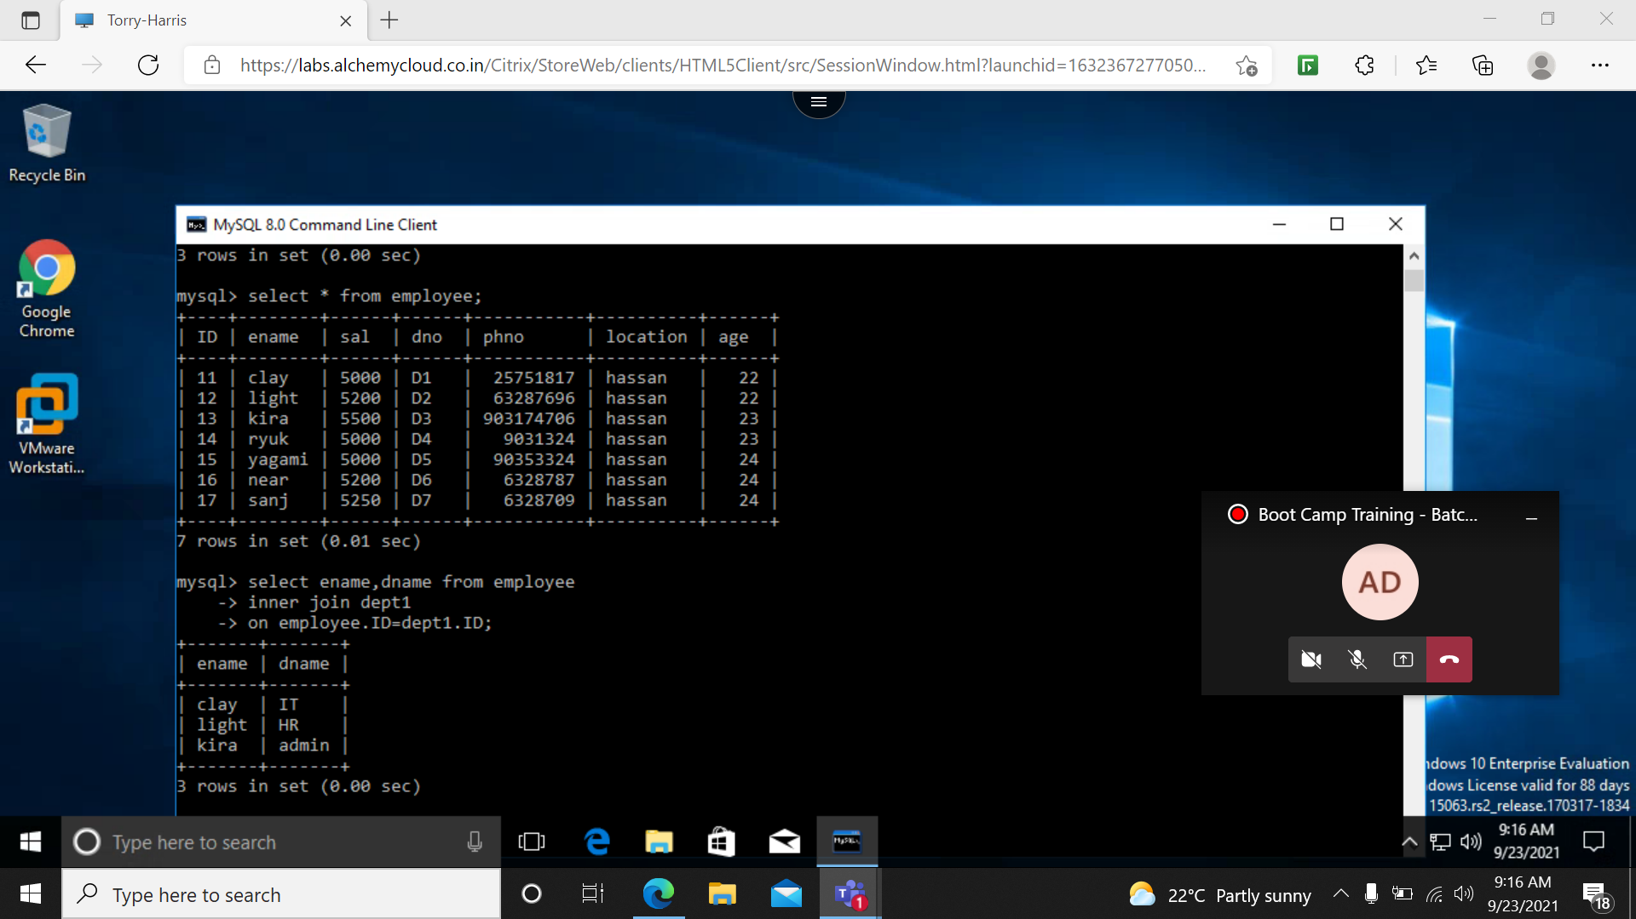

**LEFT OUTER JOIN:** returns all the rows of the table on the left side of the join

**RIGHT OUTER JOIN:** returns all the rows of the table on the right side of the join

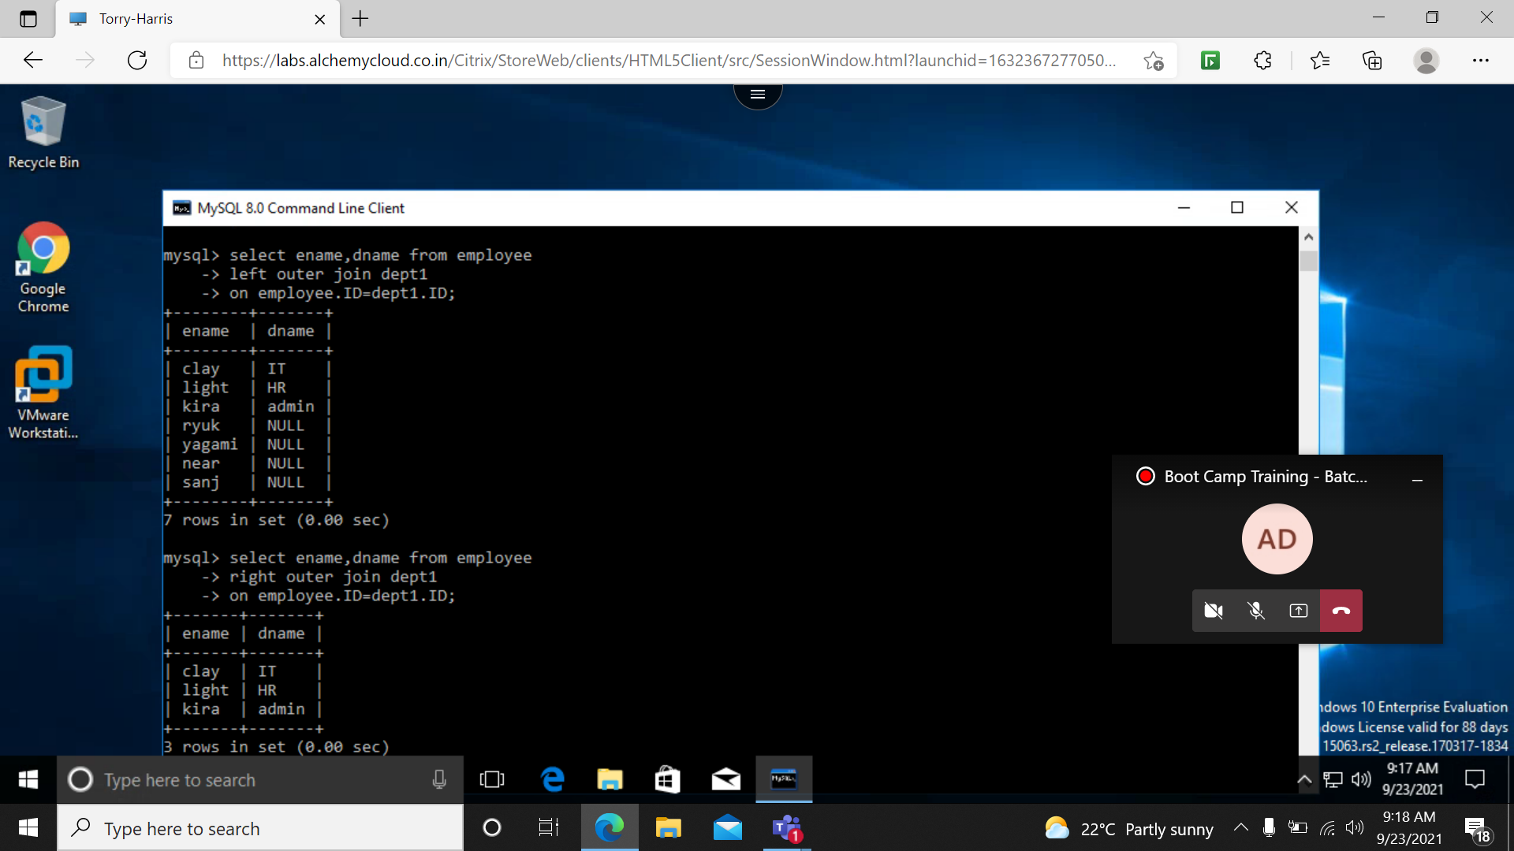

**FULL OUTER JOIN:** returns all the records where there is match in left/right table

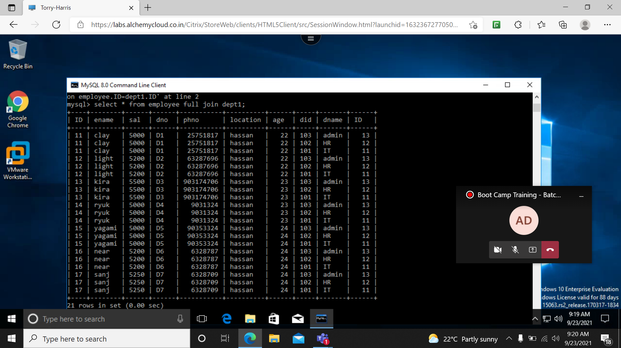

**NORMALIZATION:**

**1NF-** should be atomic and simple

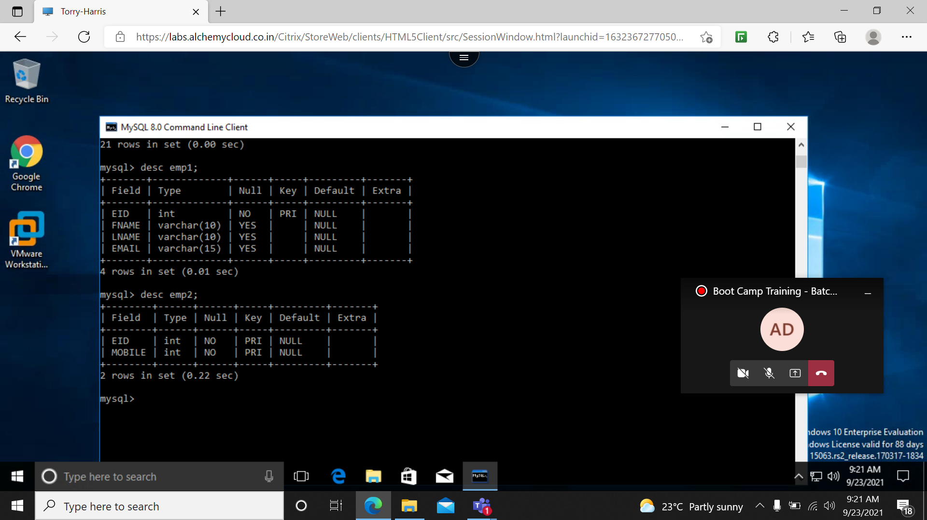

**2NF-** table should be in 1NF.

All non key attributes are fully functional dependent on primary key.

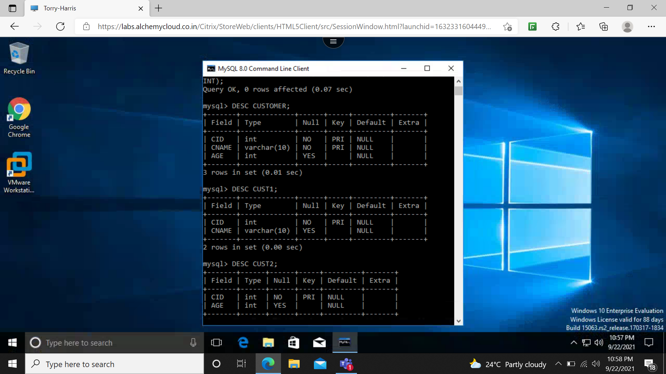

**3NF**: table should be in 2NF

Reduce duplication and achieve integrity

No transitive dependency

