Name: Sanjog Poojary
Roll no : 38

Experiment 9

Aim
Experiment to implement Association mining algorithm(Apriori) using Rapid Miner and Python.

Theory
- Association Rule Mining Association Rule Mining is a data mining technique used to find relationships between different items in a dataset. It helps us understand which items or behaviours frequently occur together. For example, in a grocery store, it can identify products that customers often purchase during the same shopping trip.
- Apriori Algorithm The Apriori algorithm is used to find frequent item combinations and generate association rules from a dataset. It follows the principle that if an itemset is frequent, all its subsets must also be frequent. The main steps are:
- Find frequent itemsets using a minimum support value.
- Generate association rules from the frequent itemsets using a minimum confidence value.
- Important Terms
- Itemset: A group of one or more items.
- Frequent Itemset: A combination of items that appears frequently and satisfies the minimum support threshold.
- Association Rule: A rule written as A ⇒ B, which shows that when A occurs, B may also occur.
- Support: The percentage or proportion of transactions that contain a particular item or itemset.
- Confidence: The probability that B occurs in a transaction when A is already present.
- Lift: A measure used to check how strongly two itemsets are associated compared with what would be expected if they were independent.
- Formulas Support: Support(A) = Number of transactions containing A / Total number of transactions It tells us how frequently an item or itemset appears in the dataset. Confidence: Confidence(A ⇒ B) = Support(A ∪ B) / Support(A) It tells us how often B appears when A is present.
Lift: Lift(A ⇒ B) = Confidence(A ⇒ B) / Support(B)
- Lift greater than 1: A and B have a positive association.
- Lift equal to 1: A and B are independent.
- Lift less than 1: A and B have a negative association.
- Dataset Description The Groceries dataset is obtained from Kaggle and contains grocery purchase records. Each record represents an item purchased by a customer on a particular date. The dataset can be used to study customer purchasing behaviour and discover products that are frequently bought together. The main columns are:
- Member_number: Identifies the customer or member who made the purchase.
- Date: Specifies the date of the purchase.
- itemDescription: Contains the name of the purchased grocery item, such as whole milk or tropical fruit. The dataset does not contain product prices, quantities, or detailed customer information. According to the reference description, it contains 14,963 unique transactions and 167 unique items.
- Use of the Apriori Algorithm To apply Apriori to the grocery dataset, transactions are grouped using the member number and date. A transaction matrix is then created, where rows represent transactions and columns represent grocery items. A value of 1 indicates that an item is present in a transaction, while 0 indicates that it is absent. The Apriori algorithm is applied to identify frequent itemsets and generate association rules. These rules help discover purchasing patterns, such as when customers who buy one product also tend to buy another product. This dataset contains transactional data from a grocery store, capturing customer purchases of various grocery items. The data is likely collected from a retail environment (specific details about the store or location are not provided in the source). Each record represents a single item purchased as part of a customer’s transaction, identified by a member number and date. The dataset is suitable for market basket analysis and association mining, such as applying the Apriori algorithm to discover patterns in customer buying behavior.

Dataset Overview
- Dataset: JioHotstar association transactions (7 regular attributes: High_Watch, Strong_Hook, High_Pacing, High_Visual_Intensity, Skipped_Intro, High_Cognitive_Load, Night_Watch_Safe).
- Licence limit: the Free licence processes 10,000 examples.

Implementation (RapidMiner, FP-Growth)
The JioHotstar association dataset was imported into RapidMiner. This step makes the dataset available for further processing and association rule mining.
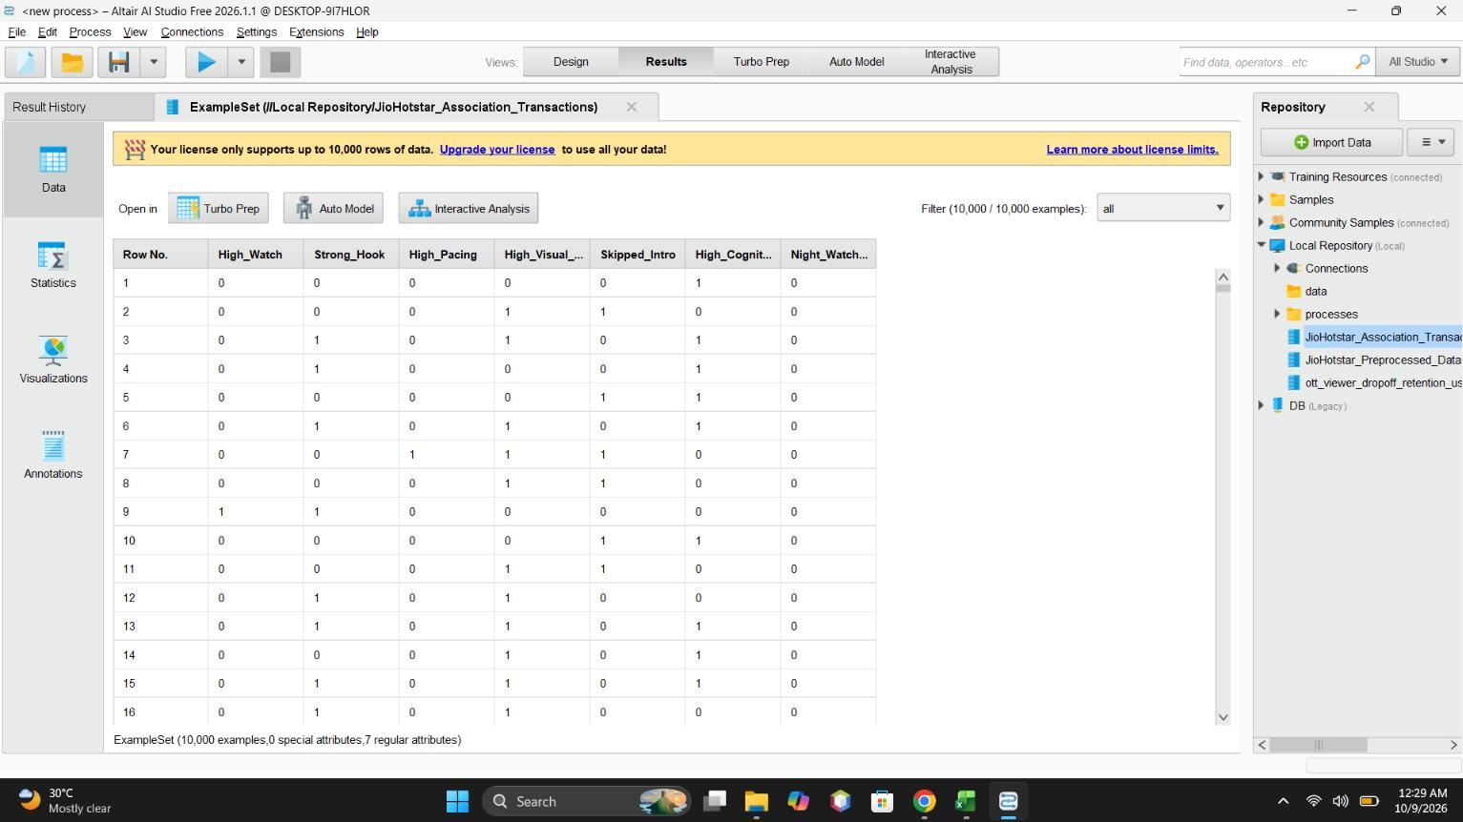
Figure 1: Imported JioHotstar association transactions in the Results view
The imported dataset was checked to confirm that it was loaded correctly and that the required attributes were available.
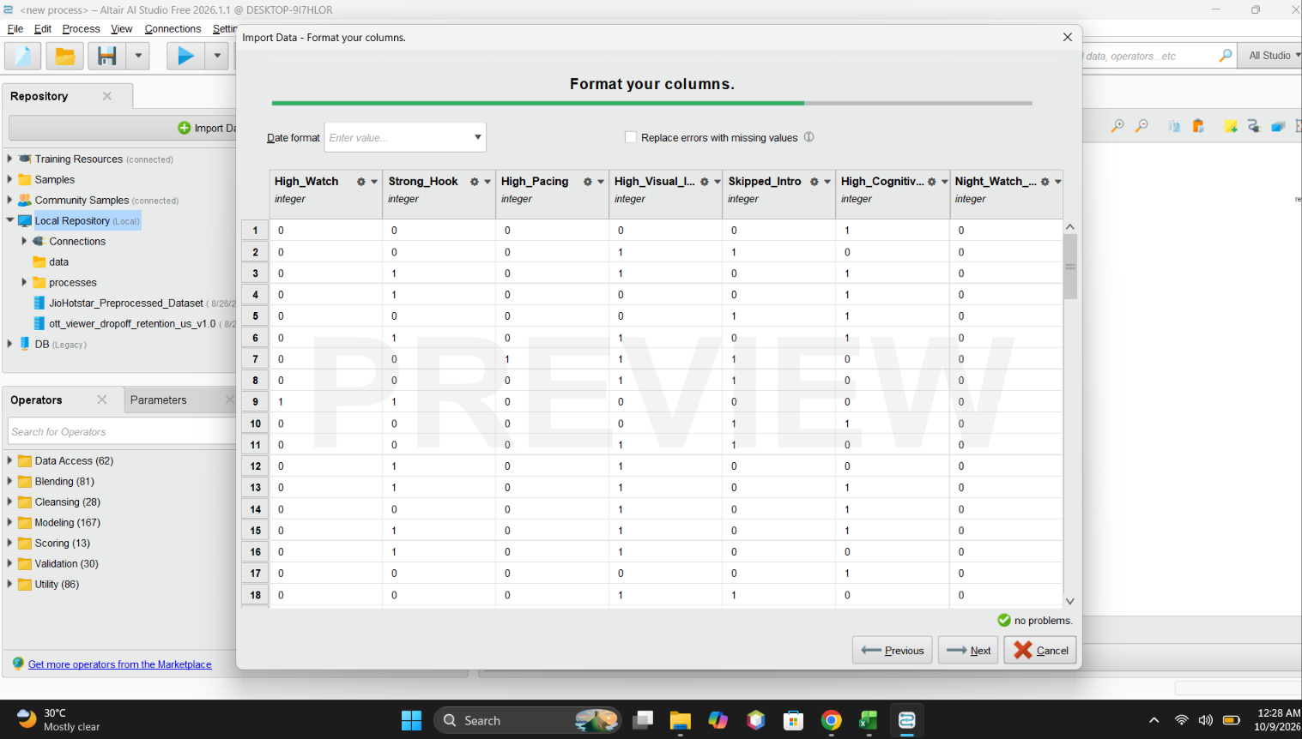
Figure 2: Format your columns: integer attributes checked before import
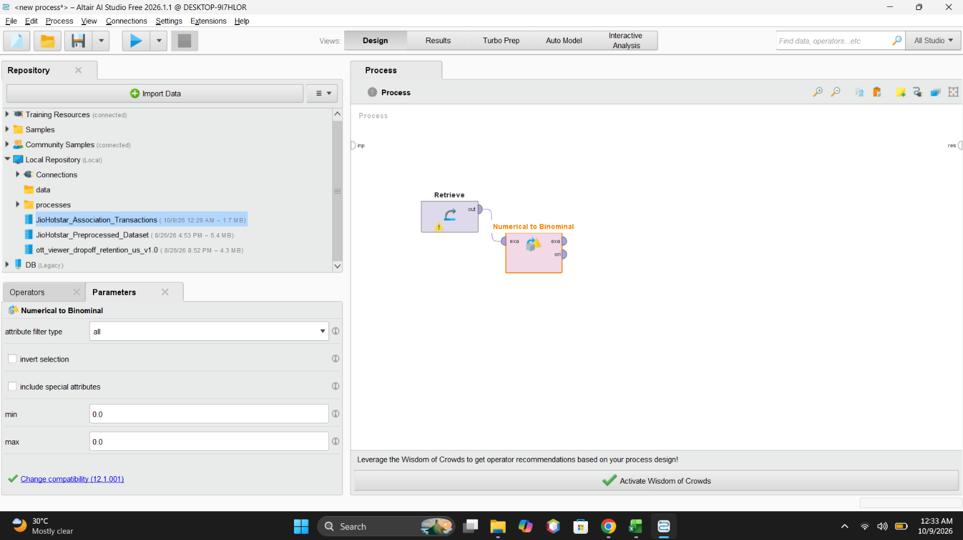
Figure 3: Numerical to Binominal operator connected after Retrieve
The Retrieve operator was connected to the Numerical to Binominal operator. This converts numerical values into binary values so that the data can be processed by the FP-Growth algorithm.
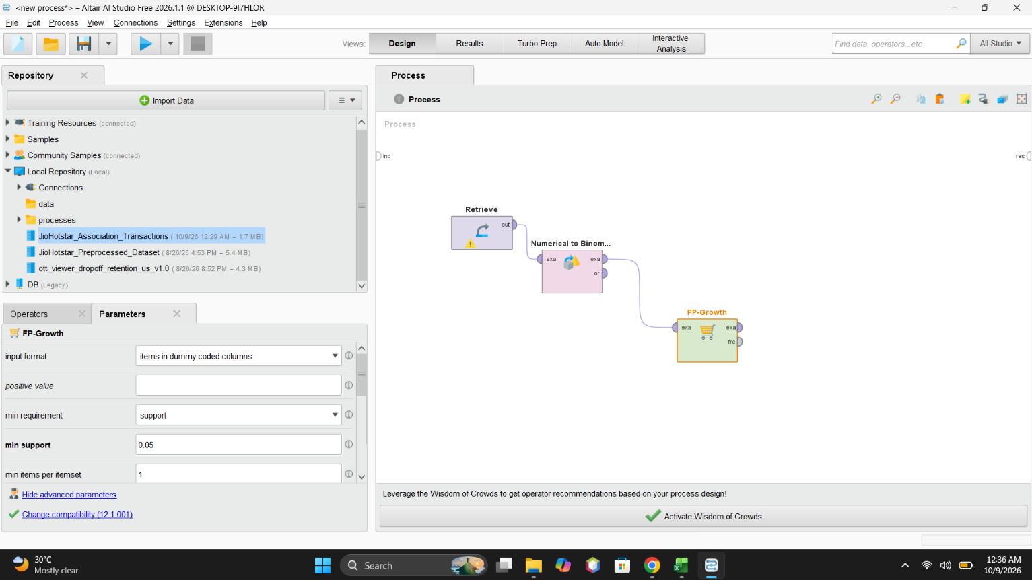
Figure 4: FP-Growth operator with minimum support 0.05
The FP-Growth operator was used to identify frequent itemsets in the dataset. The minimum support was set to 0.05, meaning itemsets occurring in at least 5% of transactions could be considered frequent.
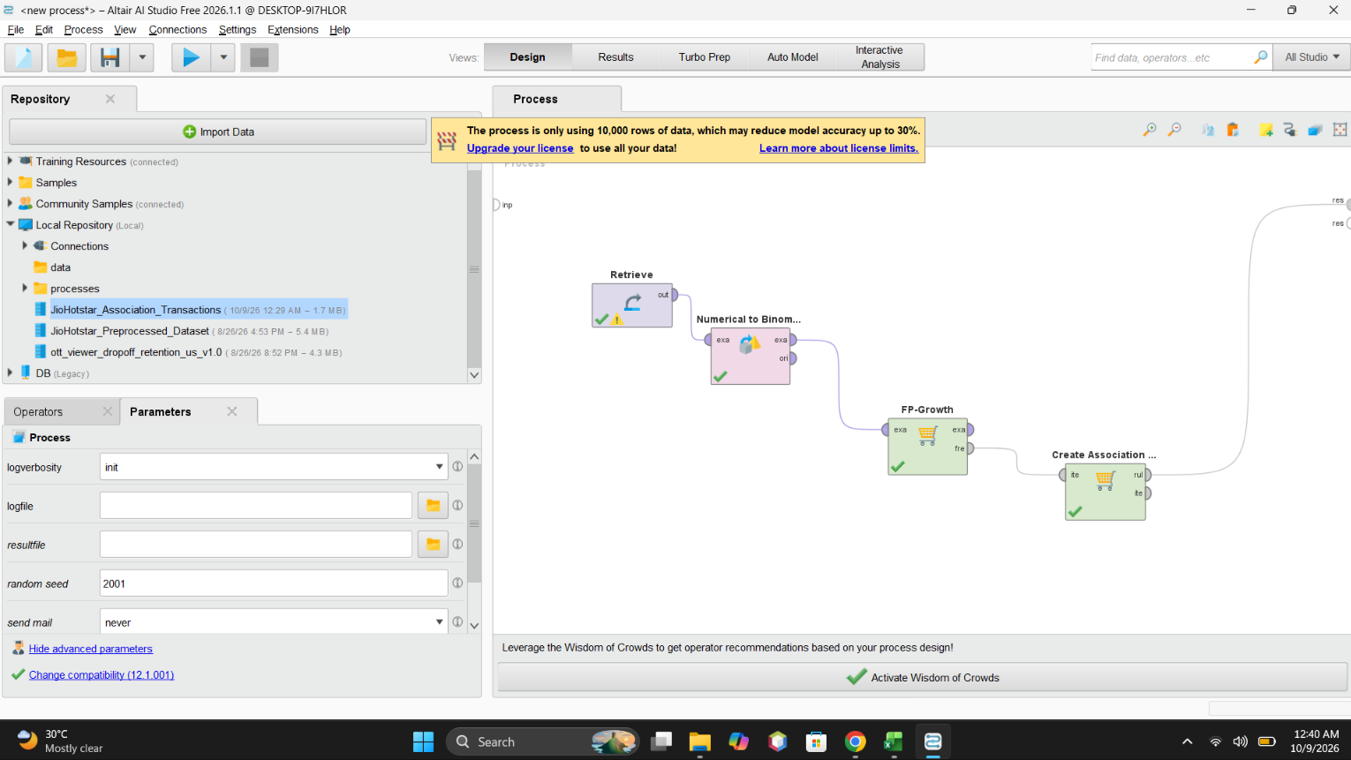
Figure 5: Complete workflow: Retrieve, Numerical to Binominal, FP-Growth and Create Association Rules
The complete workflow was checked to ensure that the operators were connected correctly and that the output was directed to the results section.
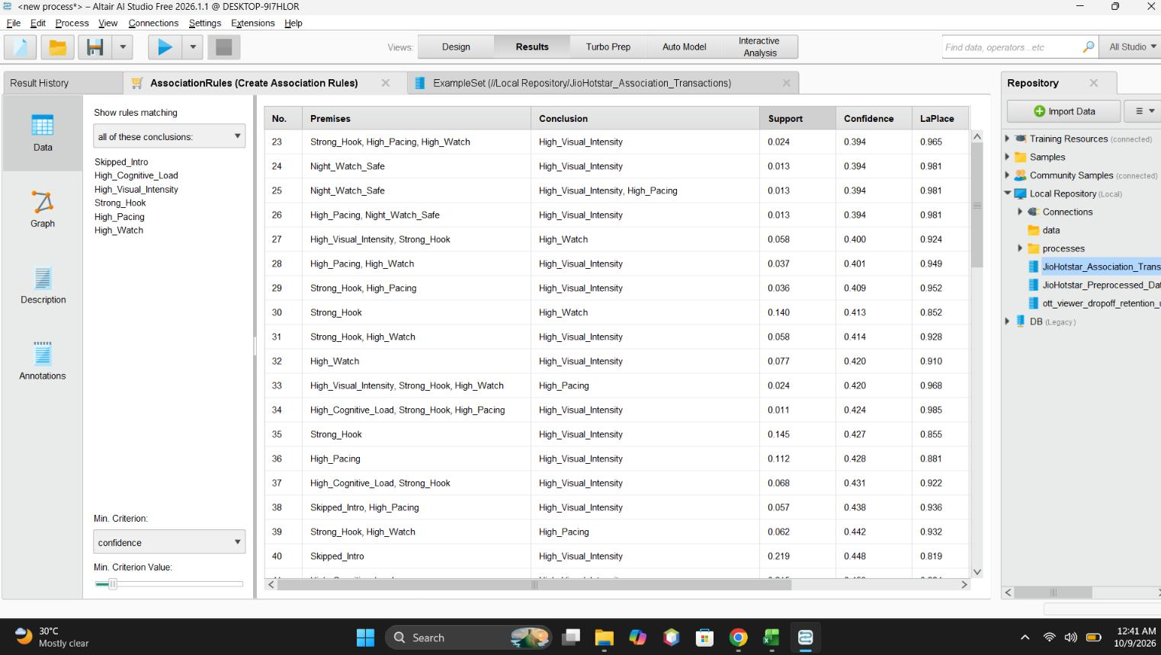
Figure 6: Association rules with premises, conclusion, support, confidence and LaPlace
The generated rules were examined using measures such as support and confidence to understand how frequently the patterns occurred and how reliable the relationships were.
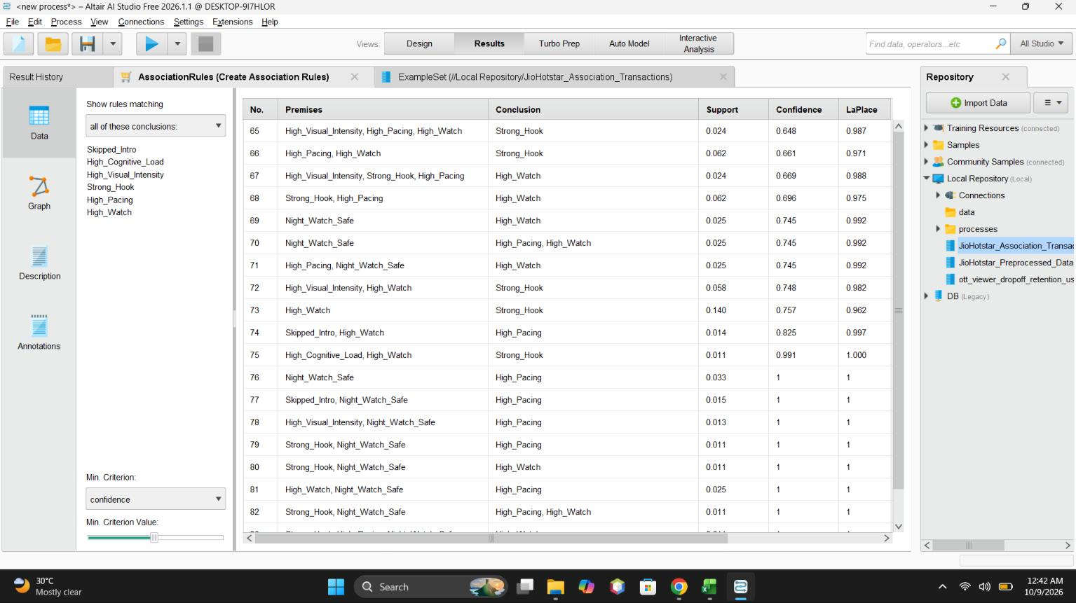
Figure 7: Association rules generated by RapidMiner
The association rules generated by RapidMiner were displayed. These rules show relationships between different viewing behaviours in the JioHotstar dataset.
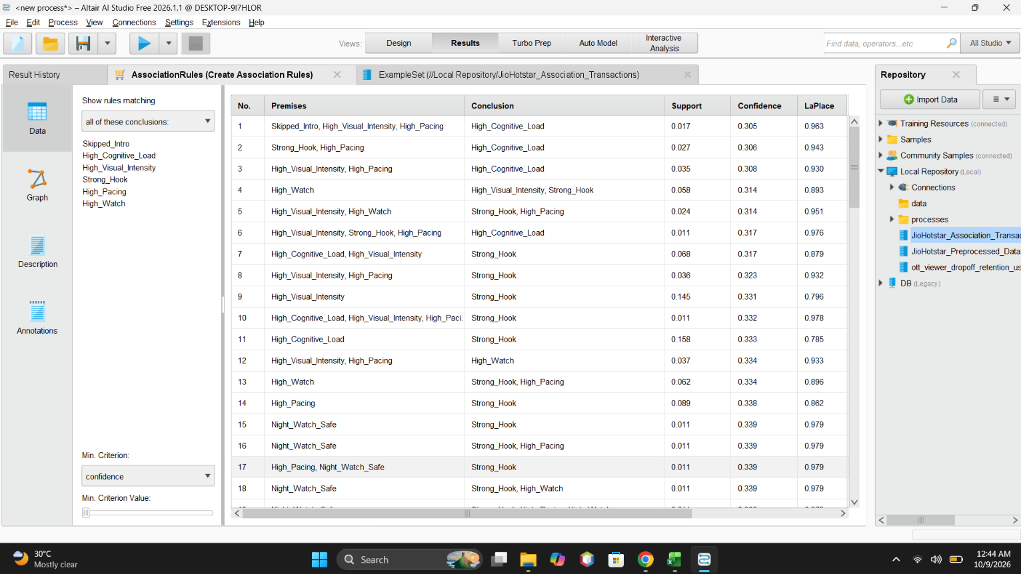
Figure 8: Top association rules ranked by confidence
The top association rules were examined to identify useful relationships between viewing behaviours, such as strong hooks, high watch percentage, high pacing, and visual intensity.

Result
The final result demonstrates that FP-Growth and association rule mining can identify frequent patterns and relationships in the JioHotstar dataset. These patterns can help in understanding viewer behaviour and engagement.

Conclusion
In this experiment, I learned how to perform association rule mining using RapidMiner and the FP-Growth algorithm. I learned how to import the dataset, convert numerical attributes into binominal values, find frequent itemsets, and generate association rules using support and confidence. The experiment helped me understand the relationships between different viewing behaviours in the JioHotstar dataset. These patterns can be useful for analysing viewer engagement and improving content recommendations.
GitHub Folder: https://github.com/Sanjog-Poojary/DMBI-Lab/tree/main/Exp9_FP_Growth_RapidMiner

