Name: Bhavesh Punjabi
Roll no : 40

Experiment 2 – To Perform Data Preprocessing Using Python

Aim
To perform data preprocessing on a synthetic Video Streaming Platform dataset using Python by handling missing values, removing duplicate records, encoding categorical data, and scaling numerical features.

Objectives
- Load the streaming platform dataset using Python.
- Identify and handle missing values.
- Remove duplicate records.
- Convert categorical data into numerical form.
- Normalize/standardize numerical data.
- Prepare clean data for further analysis or machine learning.

Software/Tools Required
- Python 3.x
- Jupyter Notebook / Google Colab
- Pandas
- NumPy
- Scikit-learn

Theory
Data preprocessing is the process of converting raw, incomplete, or inconsistent data into a clean and suitable format for analysis and machine learning.
Common preprocessing steps are:
- Data Cleaning – Handling missing and incorrect values.
- Removing Duplicates – Eliminating repeated records.
- Encoding – Converting categorical values into numerical values.
- Feature Scaling – Bringing numerical features to a similar scale.
- Data Transformation – Converting data into a suitable format.

Dataset
A synthetic dataset of 515 records was generated to represent streaming activity on the Video Streaming Platform, mirroring the Fact_Streams schema designed in Experiment 1. The dataset was intentionally seeded with missing values, duplicate records, and inconsistent categorical text to give every preprocessing step meaningful data to act on.
Columns: user_id, age, subscription_tier, device_type, watch_duration_min, completion_pct, genre, country, monthly_spend

Python Program
import pandas as pd
import numpy as np
from sklearn.preprocessing import LabelEncoder, StandardScaler

# 1. Load Dataset
df = pd.read_csv('streaming_platform_dataset.csv')
print(f"Original Shape: {df.shape}")

# 2. Remove Duplicate Records
duplicates = df.duplicated().sum()
print(f"Duplicates Found: {duplicates}")
df = df.drop_duplicates()
print(f"Shape After Dropping Duplicates: {df.shape}")

# 3. Handle Missing Values
# Numerical imputation using mean
num_cols = ['age', 'watch_duration_min', 'completion_pct']
for col in num_cols:
df[col] = df[col].fillna(df[col].mean())

# Categorical imputation using mode (most frequent value)
df['country'] = df['country'].fillna(df['country'].mode()[0])

# 4. Encode Categorical Data
cat_cols = ['subscription_tier', 'device_type', 'genre', 'country']
label_encoder = LabelEncoder()
for col in cat_cols:
df[col] = label_encoder.fit_transform(df[col])

# 5. Feature Scaling (Standardization: Mean=0, Std=1)
scale_cols = ['age', 'watch_duration_min', 'completion_pct', 'monthly_spend']
scaler = StandardScaler()
df[scale_cols] = scaler.fit_transform(df[scale_cols])

# Display Cleaned Output
print("\nFinal Preprocessed Data Head:")
print(df.head())

Output
1. Loading the Dataset
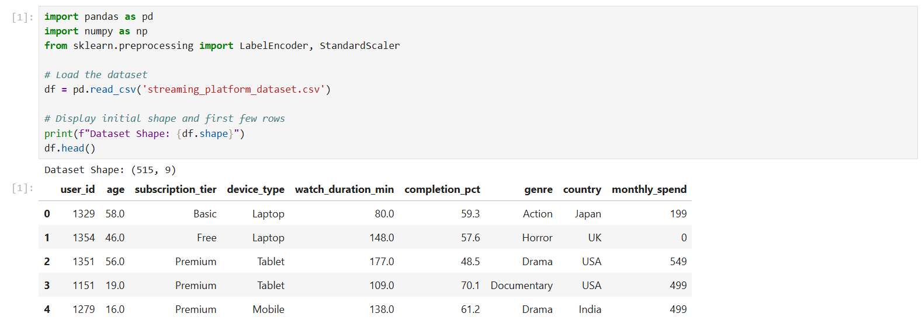
Original dataset loaded – Shape: (515, 9)
2. Checking Duplicates and Missing Values
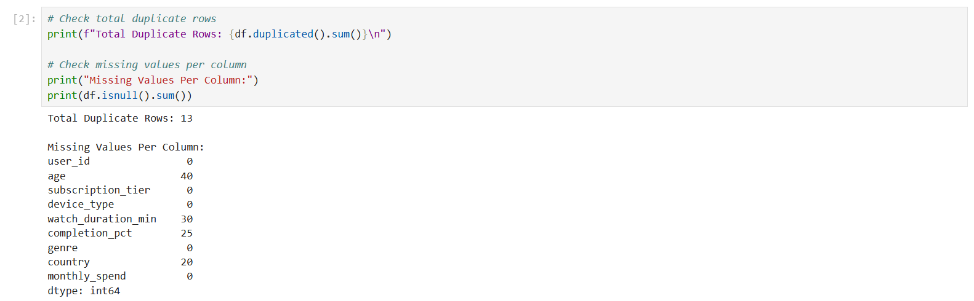
13 duplicate rows found; missing values present in age, watch_duration_min, completion_pct, and country
3. Removing Duplicate Records
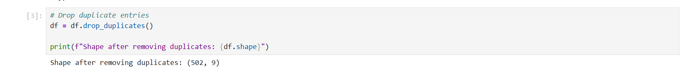
Shape after removing duplicates: (502, 9)
4. Encoding Categorical Data
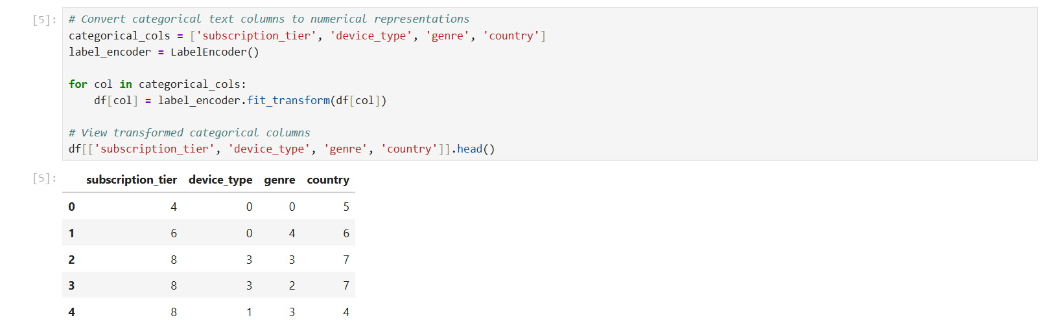
subscription_tier, device_type, genre, and country encoded into numeric labels using LabelEncoder
5. Feature Scaling
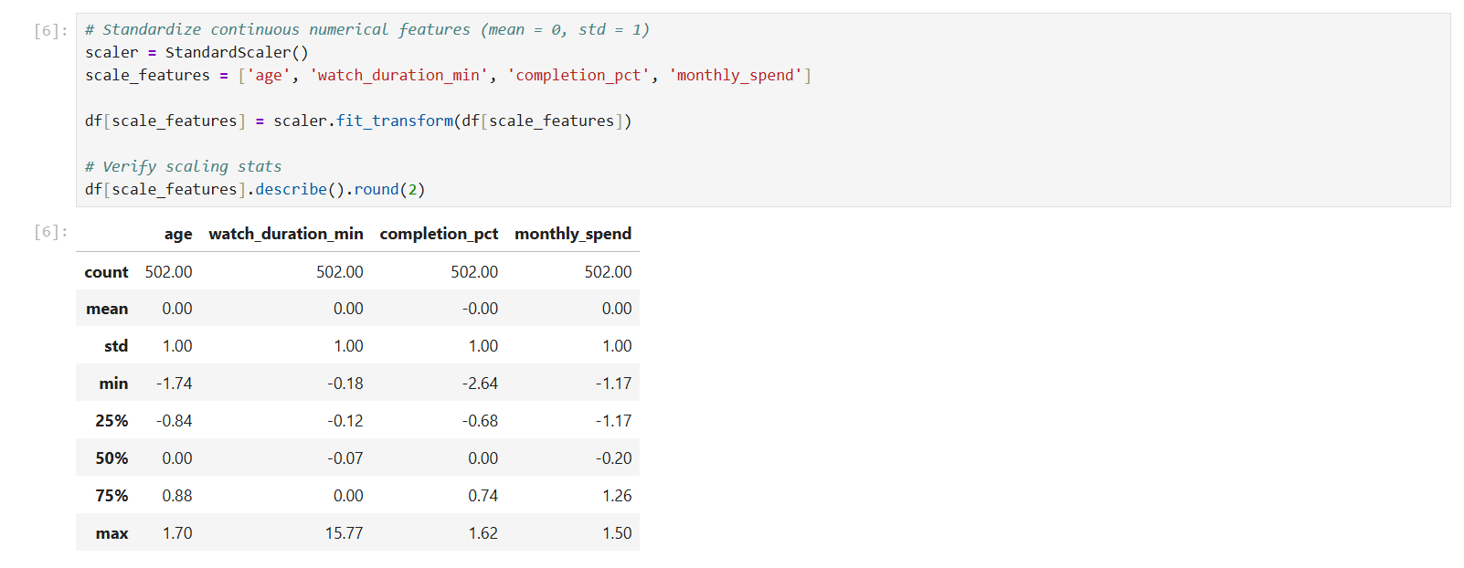
age, watch_duration_min, completion_pct, and monthly_spend standardized to mean = 0, std = 1
6. Final Preprocessed Dataset Info
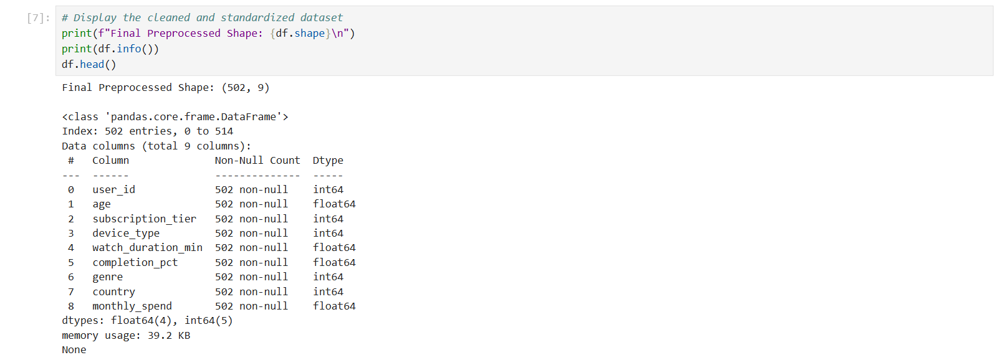
Final shape: (502, 9) with no missing values across all columns
7. Final Preprocessed Dataset (Head)
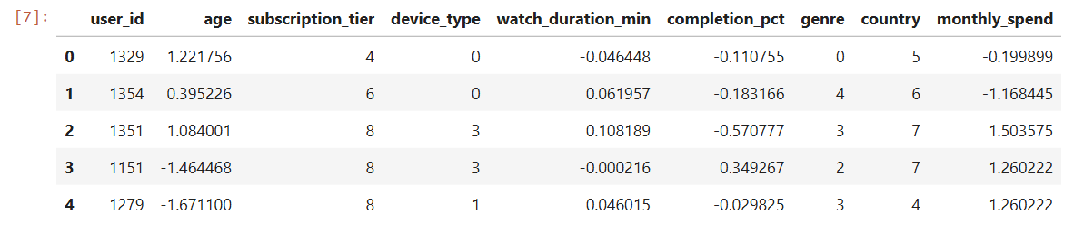
First 5 rows of the cleaned, encoded, and scaled dataset

Result
Thus, the synthetic streaming platform dataset was successfully preprocessed using Python. 13 duplicate records were removed, missing values in age, watch_duration_min, completion_pct, and country were imputed using mean/mode, categorical columns (subscription_tier, device_type, genre, country) were label-encoded, and numerical features (age, watch_duration_min, completion_pct, monthly_spend) were standardized. The final dataset (502 rows × 9 columns) is clean and ready for further analysis or machine learning.

