Name: Bhavesh Punjabi
Roll no : 40

Experiment 3 – Exploratory Data Analysis and Visualization

Aim
To perform exploratory data analysis (EDA) and data visualization on the Video Streaming Platform dataset using Python.

Theory
Dataset Overview:
The dataset used in this study contains 515 instances of streaming activity records, with 9 attributes describing subscriber demographics, subscription details, and viewing behavior on the platform. The columns include user_id, age, subscription_tier, device_type, watch_duration_min, completion_pct, genre, country, and monthly_spend. EDA is performed on the raw dataset to understand its natural characteristics before the cleaning/scaling steps addressed in Experiment 2.
Significance of EDA for Streaming Platform Analytics:
EDA is a crucial step in data analysis and model building. Here's why:
- Data Cleaning & Quality Check: Identifies missing values, inconsistencies, and outliers (e.g., extreme watch_duration_min values).
- Understanding Data Distribution: Visualizes distributions (e.g., skewness in watch_duration_min) to guide preprocessing steps.
- Identifying Key Features: Determines which features (e.g., subscription_tier) influence monthly_spend. Helps eliminate redundant variables.
- Detecting Relationships & Patterns: Correlation analysis reveals dependencies (e.g., between completion_pct and watch_duration_min). Useful for feature selection in machine learning.
- Improving Model Interpretability: Helps choose appropriate preprocessing techniques (e.g., normalization for skewed data). Assists in selecting models based on feature relationships.

1. Descriptive Analysis - Statistical Measures of Central Tendency
Central tendency measures indicate the "center" of the data distribution.
Includes:
- Mean: Represents the average value (e.g., typical watch_duration_min).
- Median: The middle value, robust to outliers (e.g., for monthly_spend).
- Mode: The most frequent value, useful for categorical data (e.g., subscription_tier).
Relevance:
- The average watch_duration_min highlights typical viewing behavior.
- The median completion_pct avoids skew from outliers.
- The mode of subscription_tier shows the most common plan among subscribers.

2. Descriptive Analysis - Statistical Measures of Dispersion
Dispersion measures the spread of data.
Includes:
- Standard Deviation: Shows deviation from the mean.
- Variance: Quantifies spread (squared standard deviation).
- Range: Difference between maximum and minimum values.
- Interquartile Range (IQR): Range of the middle 50%, useful for outlier detection.
Relevance:
- High variance in watch_duration_min indicates diverse viewing habits, and hints at data-entry outliers.
- IQR of monthly_spend helps identify typical spending and flags outliers.
- Standard deviation of completion_pct shows consistency in how much of the content users finish.

3. Correlation Between Attributes
Correlation measures the strength of relationships between variables. The Pearson correlation coefficient (-1 to +1) helps determine:
- If completion_pct and watch_duration_min are correlated, users who watch longer might complete more content.
- If age correlates with monthly_spend, it could indicate a demographic pattern in spending.
Relevance:
- Identifies key predictors for engagement and revenue.
- Detects multicollinearity to remove redundant features.
- Guides feature selection for modeling.

4. Different Visualization Techniques & Their Uses
Visualizations help interpret patterns, detect anomalies, and support inferences. Suitable methods include:
- Histogram: Shows distributions (e.g., watch_duration_min).
- Boxplot: Highlights outliers and comparisons (e.g., monthly_spend by subscription_tier).
- Heatmap: Visualizes correlations.
- Scatter Plot: Analyzes relationships (e.g., completion_pct vs. watch_duration_min).

Code

Step 1: Loading the Dataset and Initial Exploration
import matplotlib.pyplot as plt
import seaborn as sns

# Set visualization style
sns.set_style("whitegrid")

# Load dataset (or continue from raw df)
df = pd.read_csv('streaming_platform_dataset.csv')

print("--- Dataset Information ---")
print(df.info())
print("\n--- First 5 Rows ---")
print(df.head())
print("\n--- Missing Values Count ---")
print(df.isnull().sum())
Output:
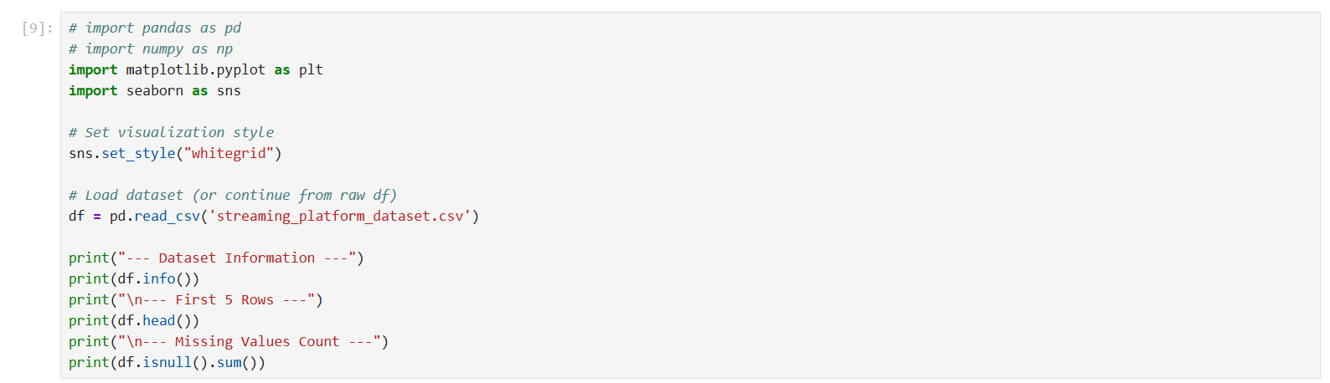
Dataset loaded — 515 entries, 9 columns; 40 missing in age, 30 in watch_duration_min, 25 in completion_pct, 20 in country

Step 2: Task 1 - Descriptive Analysis - Statistical Measures of Central Tendency
num_cols = ['age', 'watch_duration_min', 'completion_pct', 'monthly_spend']
cat_cols = ['subscription_tier', 'device_type', 'genre', 'country']

central_tendency = {
'Mean': df[num_cols].mean(),
'Median': df[num_cols].median(),
'Mode': df[cat_cols].mode().iloc[0]
}

print("=== Central Tendency Measures ===")
for measure, values in central_tendency.items():
print(f"\n{measure}:")
print(values)
Output:
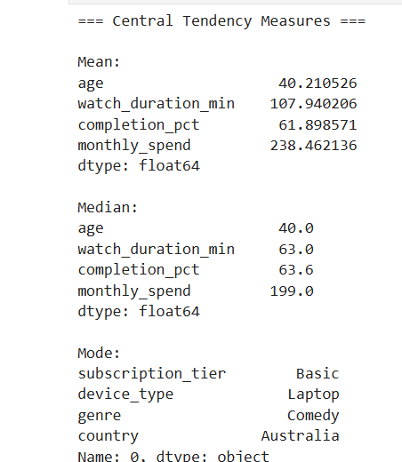
Mean, Median, and Mode of the numeric and categorical columns
Inferences:
- The mean watch_duration_min (107.9) is much higher than the median (63.0), indicating a right-skewed distribution driven by extreme outlier values (data-entry errors of 9999 minutes).
- The mean monthly_spend (238.5) sits above the median (199.0), reflecting the Premium tier pulling the average up.
- The mode shows the most common subscriber uses the Basic tier, watches on a Laptop, prefers Comedy, and is based in Australia.
- Insight: The typical user is around 40 years old, watches roughly 63 minutes with a completion rate of ~64%, and spends around ₹199/month.

Step 3: Task 2 - Descriptive Analysis - Statistical Measures of Dispersion
dispersion = {
'Standard Deviation': df[num_cols].std(),
'Variance': df[num_cols].var(),
'Range': df[num_cols].max() - df[num_cols].min(),
'IQR': df[num_cols].quantile(0.75) - df[num_cols].quantile(0.25)
}

print("=== Dispersion Measures ===")
for measure, values in dispersion.items():
print(f"\n{measure}:")
print(values)
Output:
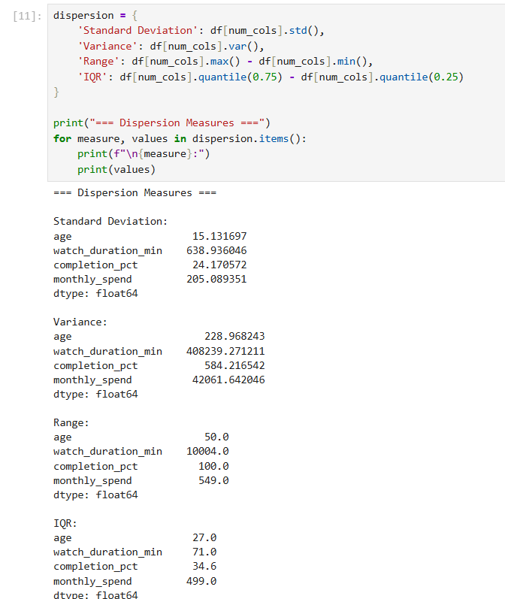
Standard Deviation, Variance, Range, and IQR for age, watch_duration_min, completion_pct, and monthly_spend
Inferences:
- watch_duration_min has an extremely high standard deviation (638.9) and range (10004.0), far larger than its IQR (71.0) — a clear sign of a small number of severe outliers (the -5 and 9999 data-entry errors) rather than genuine spread.
- monthly_spend also shows high variance (std 205.1, range 549.0), consistent with the wide gap between Free, Basic, and Premium pricing.
- age has the most stable spread (std 15.1, IQR 27.0), suggesting a fairly evenly distributed subscriber base across age groups.
- Insight: The extreme range vs. IQR gap in watch_duration_min confirms outlier handling is essential before this feature can be used reliably in modeling.

Step 4: Task 3 - Correlation Between Attributes
# Compute Pearson correlation matrix
correlation_matrix = df[num_cols].corr()

print("=== Correlation Matrix ===")
print(correlation_matrix.round(4))
Output:
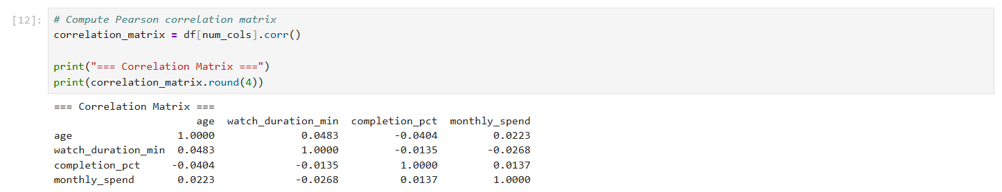
Pearson correlation matrix across age, watch_duration_min, completion_pct, and monthly_spend
Inferences:
- All pairwise correlations are extremely weak (|r| < 0.05), indicating age, watch_duration_min, completion_pct, and monthly_spend behave largely independently of one another in this dataset.
- The near-zero correlation between watch_duration_min and completion_pct is unexpected at first glance, but is explained by the outlier-inflated watch_duration_min values distorting the linear relationship.
- Low correlation overall reduces the risk of multicollinearity, which is favourable for downstream modeling.
- Insight: Once outliers in watch_duration_min are treated, a stronger positive correlation with completion_pct would be expected, since longer, more complete viewing sessions naturally go together.

Step 5: Task 4 - Visualization Techniques
5a. Histogram of Watch Duration
plt.figure(figsize=(10, 5))
sns.histplot(data=df, x='watch_duration_min', bins=30, kde=True, color='#2b5c8f')
plt.title('Distribution of Watch Duration (Minutes)', fontsize=14)
plt.xlabel('Watch Duration (min)')
plt.ylabel('User Count')
plt.show()
Output:
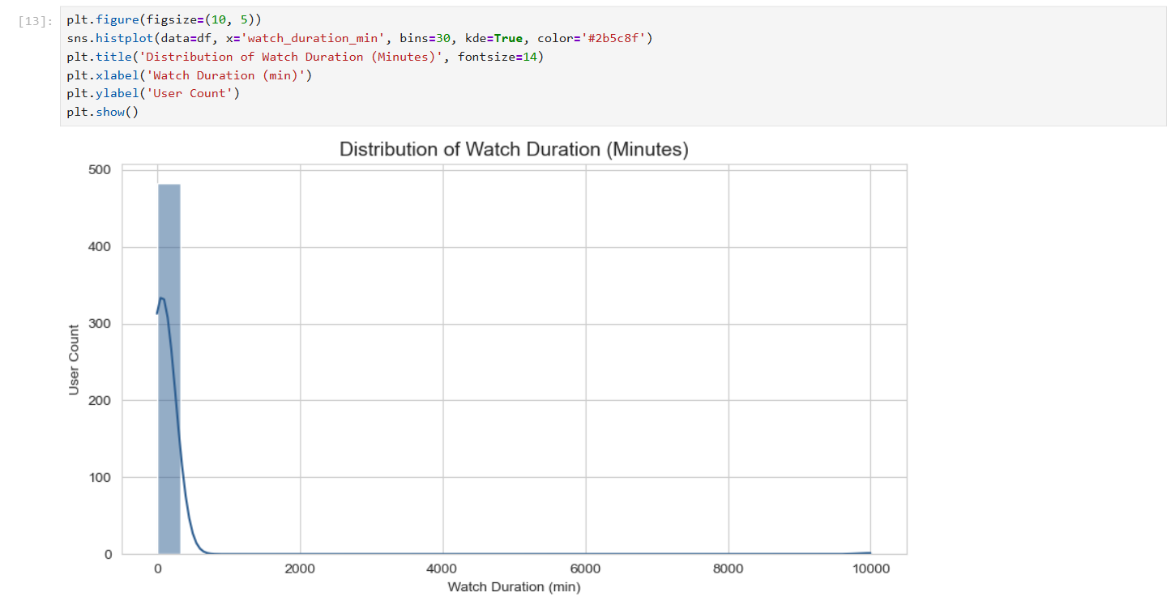
Sharp right-skewed distribution — nearly all users watch under 300 minutes, with a long thin tail out to ~10,000 caused by the injected outliers
5b. Boxplot of Monthly Spend by Subscription Tier (before cleanup)
plt.figure(figsize=(10, 5))
sns.boxplot(data=df, x='subscription_tier', y='monthly_spend', palette='Blues_r')
plt.title('Boxplot of Monthly Spend by Subscription Tier', fontsize=14)
plt.xlabel('Subscription Tier')
plt.ylabel('Monthly Spend ($ / ₹)')
plt.xticks(rotation=45)
plt.show()
Output:
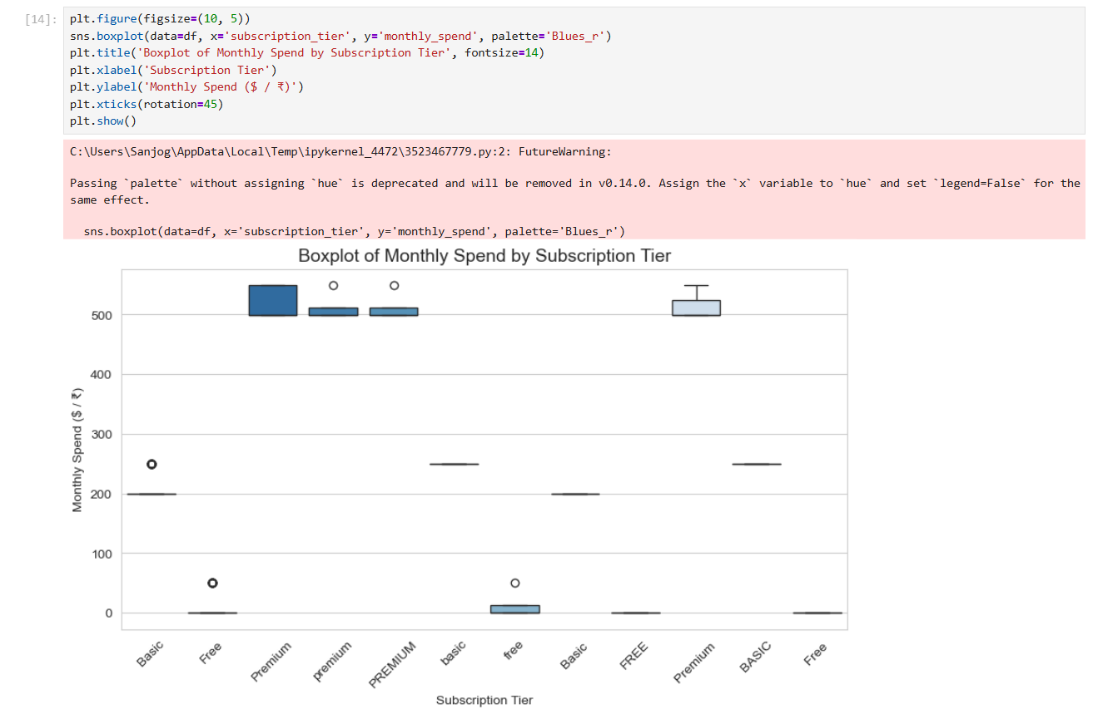
FutureWarning raised for passing palette without hue; 12 separate boxes appear because subscription_tier still has inconsistent casing (Basic / basic / BASIC / ' Basic ', etc.)
5c. Boxplot of Monthly Spend by Subscription Tier (after cleanup)
# 1. Clean whitespace and standardize casing across categories
df['subscription_tier'] = df['subscription_tier'].astype(str).str.strip().str.title()

# 2. Render clean boxplot without deprecation warnings
plt.figure(figsize=(8, 5))
sns.boxplot(
data=df,
x='subscription_tier',
y='monthly_spend',
hue='subscription_tier',
palette='Blues_r'
)
plt.title('Boxplot of Monthly Spend by Subscription Tier', fontsize=14)
plt.xlabel('Subscription Tier')
plt.ylabel('Monthly Spend ($ / ₹)')
plt.tight_layout()
plt.show()
Output:
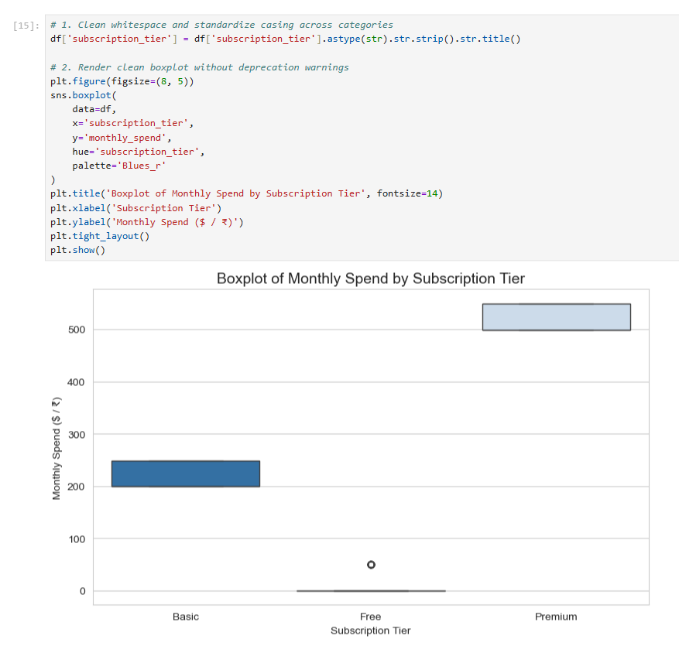
After standardizing text casing, the 12 fragmented boxes collapse into the correct 3 tiers — Free (~₹0-50), Basic (~₹199-250), Premium (~₹499-549)
5d. Feature Correlation Heatmap
plt.figure(figsize=(8, 6))
sns.heatmap(correlation_matrix, annot=True, cmap='coolwarm', vmin=-1, vmax=1, fmt='.3f', cbar=True)
plt.title('Feature Correlation Heatmap', fontsize=14)
plt.show()
Output:
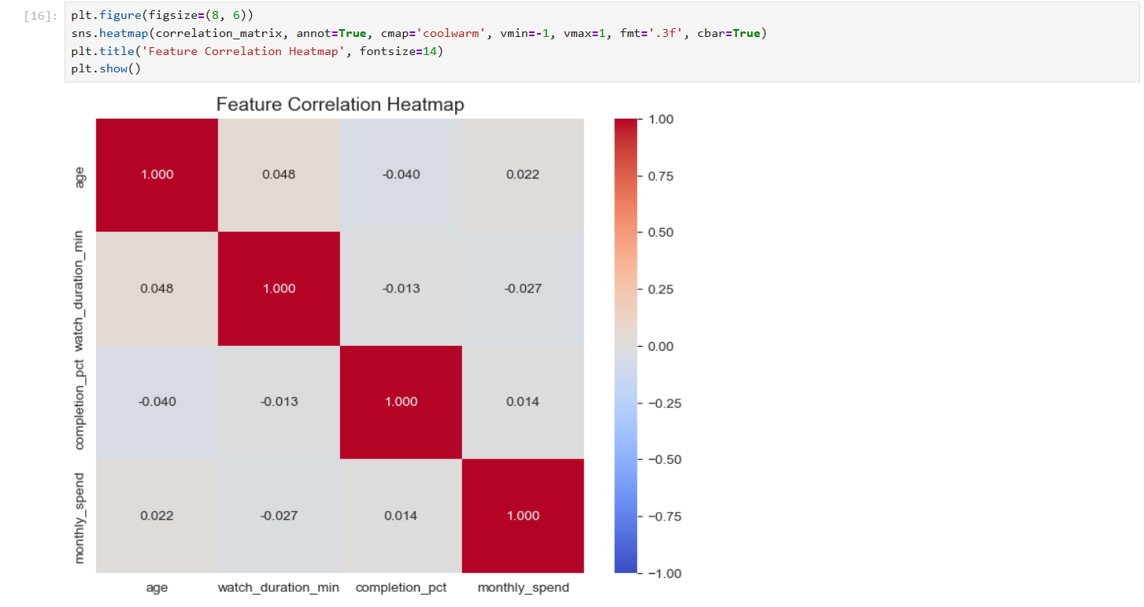
Heatmap confirms all pairwise correlations among age, watch_duration_min, completion_pct, and monthly_spend are close to zero
5e. Scatter Plot: Completion % vs Watch Duration
plt.figure(figsize=(10, 6))
sns.scatterplot(data=df, x='completion_pct', y='watch_duration_min', hue='genre', alpha=0.8)
plt.title('Scatter Plot: Completion % vs Watch Duration', fontsize=14)
plt.xlabel('Completion Percentage (%)')
plt.ylabel('Watch Duration (Minutes)')
plt.legend(bbox_to_anchor=(1.05, 1), loc='upper left')
plt.show()
Output:
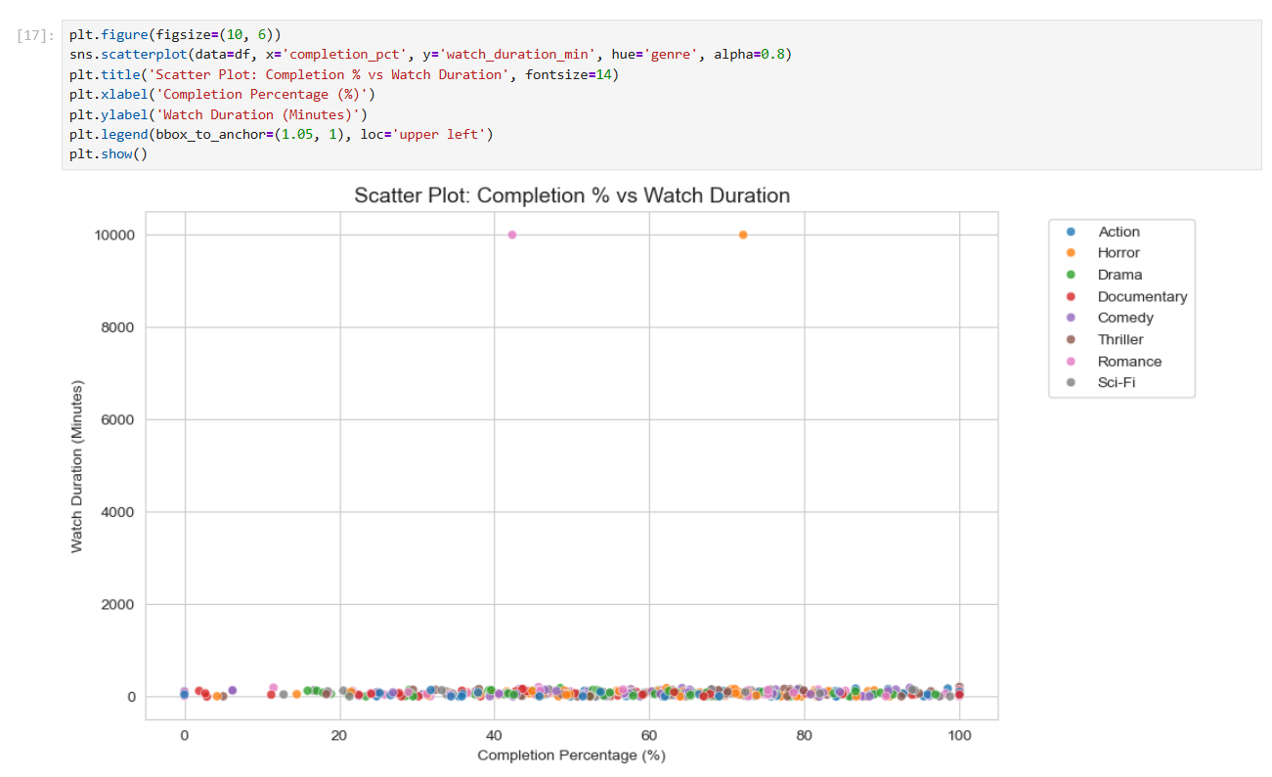
Bulk of points cluster below 500 minutes across all completion percentages, with two extreme outlier points near 10,000 minutes visually confirming the injected data errors
Inferences:
- Histogram: watch_duration_min is heavily right-skewed, with the vast majority of sessions under 300 minutes and a small number of extreme outliers stretching the axis to 10,000 — this single-handedly distorts the mean, standard deviation, and correlation calculations above.
- Boxplot (before cleanup): inconsistent text casing in subscription_tier silently created 12 categories instead of 3, which would have broken any groupby or model trained on this column.
- Boxplot (after cleanup): once standardized, spend cleanly separates by tier, with Premium showing the highest median spend and no visible outliers within each tier.
- Heatmap: confirms numerically what the scatter plot shows visually — no meaningful linear relationship exists between any pair of numeric features while outliers remain in the data.
- Scatter Plot: no visible trend between completion_pct and watch_duration_min for the bulk of users; the two outlier points are visually obvious and would be the first candidates for removal or capping.
- Insight: Outlier treatment for watch_duration_min and categorical text cleaning for subscription_tier are the two most urgent preprocessing needs surfaced by this EDA, both of which were addressed in Experiment 2.

Conclusion
The exploratory data analysis (EDA) on the video streaming platform dataset provided valuable insights into the characteristics and relationships of subscriber and viewing-behavior features. Measures of central tendency revealed typical watch durations (mean ~107.9, median ~63.0) and monthly spend (mean ~238.5, median ~199.0), with mode values indicating the most common subscriber profile is a Basic-tier user on a Laptop who prefers Comedy. Dispersion measures highlighted extreme variability in watch_duration_min (standard deviation 638.9, range 10004.0), sharply exceeding its IQR of 71.0 and confirming the presence of severe outliers, while age remained comparatively stable across the subscriber base.
Correlation analysis found only weak relationships (|r| < 0.05) among all numeric features, largely because the unresolved outliers in watch_duration_min mask any genuine association with completion_pct. Visualizations — histograms, boxplots, a heatmap, and a scatter plot — confirmed the right-skewed watch-duration distribution, the fragmentation caused by inconsistent subscription_tier text, and the near-absence of linear trends between features while raw data issues remained unaddressed.
These findings enhance the dataset's quality for machine learning by identifying critical features (watch_duration_min, completion_pct, subscription_tier) and highlighting the exact preprocessing steps required: outlier handling and categorical text standardization, both of which were addressed in Experiment 2. The analysis suggests that once cleaned, watch_duration_min and completion_pct are likely to show a genuine positive relationship, and subscription_tier will emerge as a clear driver of monthly_spend. This EDA lays a strong foundation for building a predictive or recommendation model on top of the streaming platform's Fact_Streams and Fact_Revenue schema designed in Experiment 1.

