Name: Bhavesh Punjabi
Roll no : 40

Experiment 1 – Design Star and Snowflake Schema

Aim
To design Two Star Schemas and a Snowflake Schema for a Video Streaming Platform (OTT / content-streaming analytics) using a suitable fact table and dimension tables.

Objective
- To understand the concept of Data Warehouse Schema.
- To design a Star Schema.
- To design a Snowflake Schema.

Theory
→ What is Data Warehouse Schema ?
Data warehouse schema is the logical blueprint that shows how data is organized, connected, and used for analysis in a data warehouse. It defines the tables, keys, relationships, and rules that help BI tools and analysts query data consistently.
What it includes :
- Fact tables: store measurable business events, like streams, purchases, or subscriptions.
- Dimension tables: store descriptive details, like user, content, or date.
- Relationships: connect facts and dimensions so analytical queries work correctly.

Star Schema
A star schema is a way of organizing data in a data warehouse for reporting and analytics. It is called a star schema because the structure looks like a star: a central fact table is connected to several surrounding dimension tables.

Structure of Star Schema ( Streaming Activity ) :
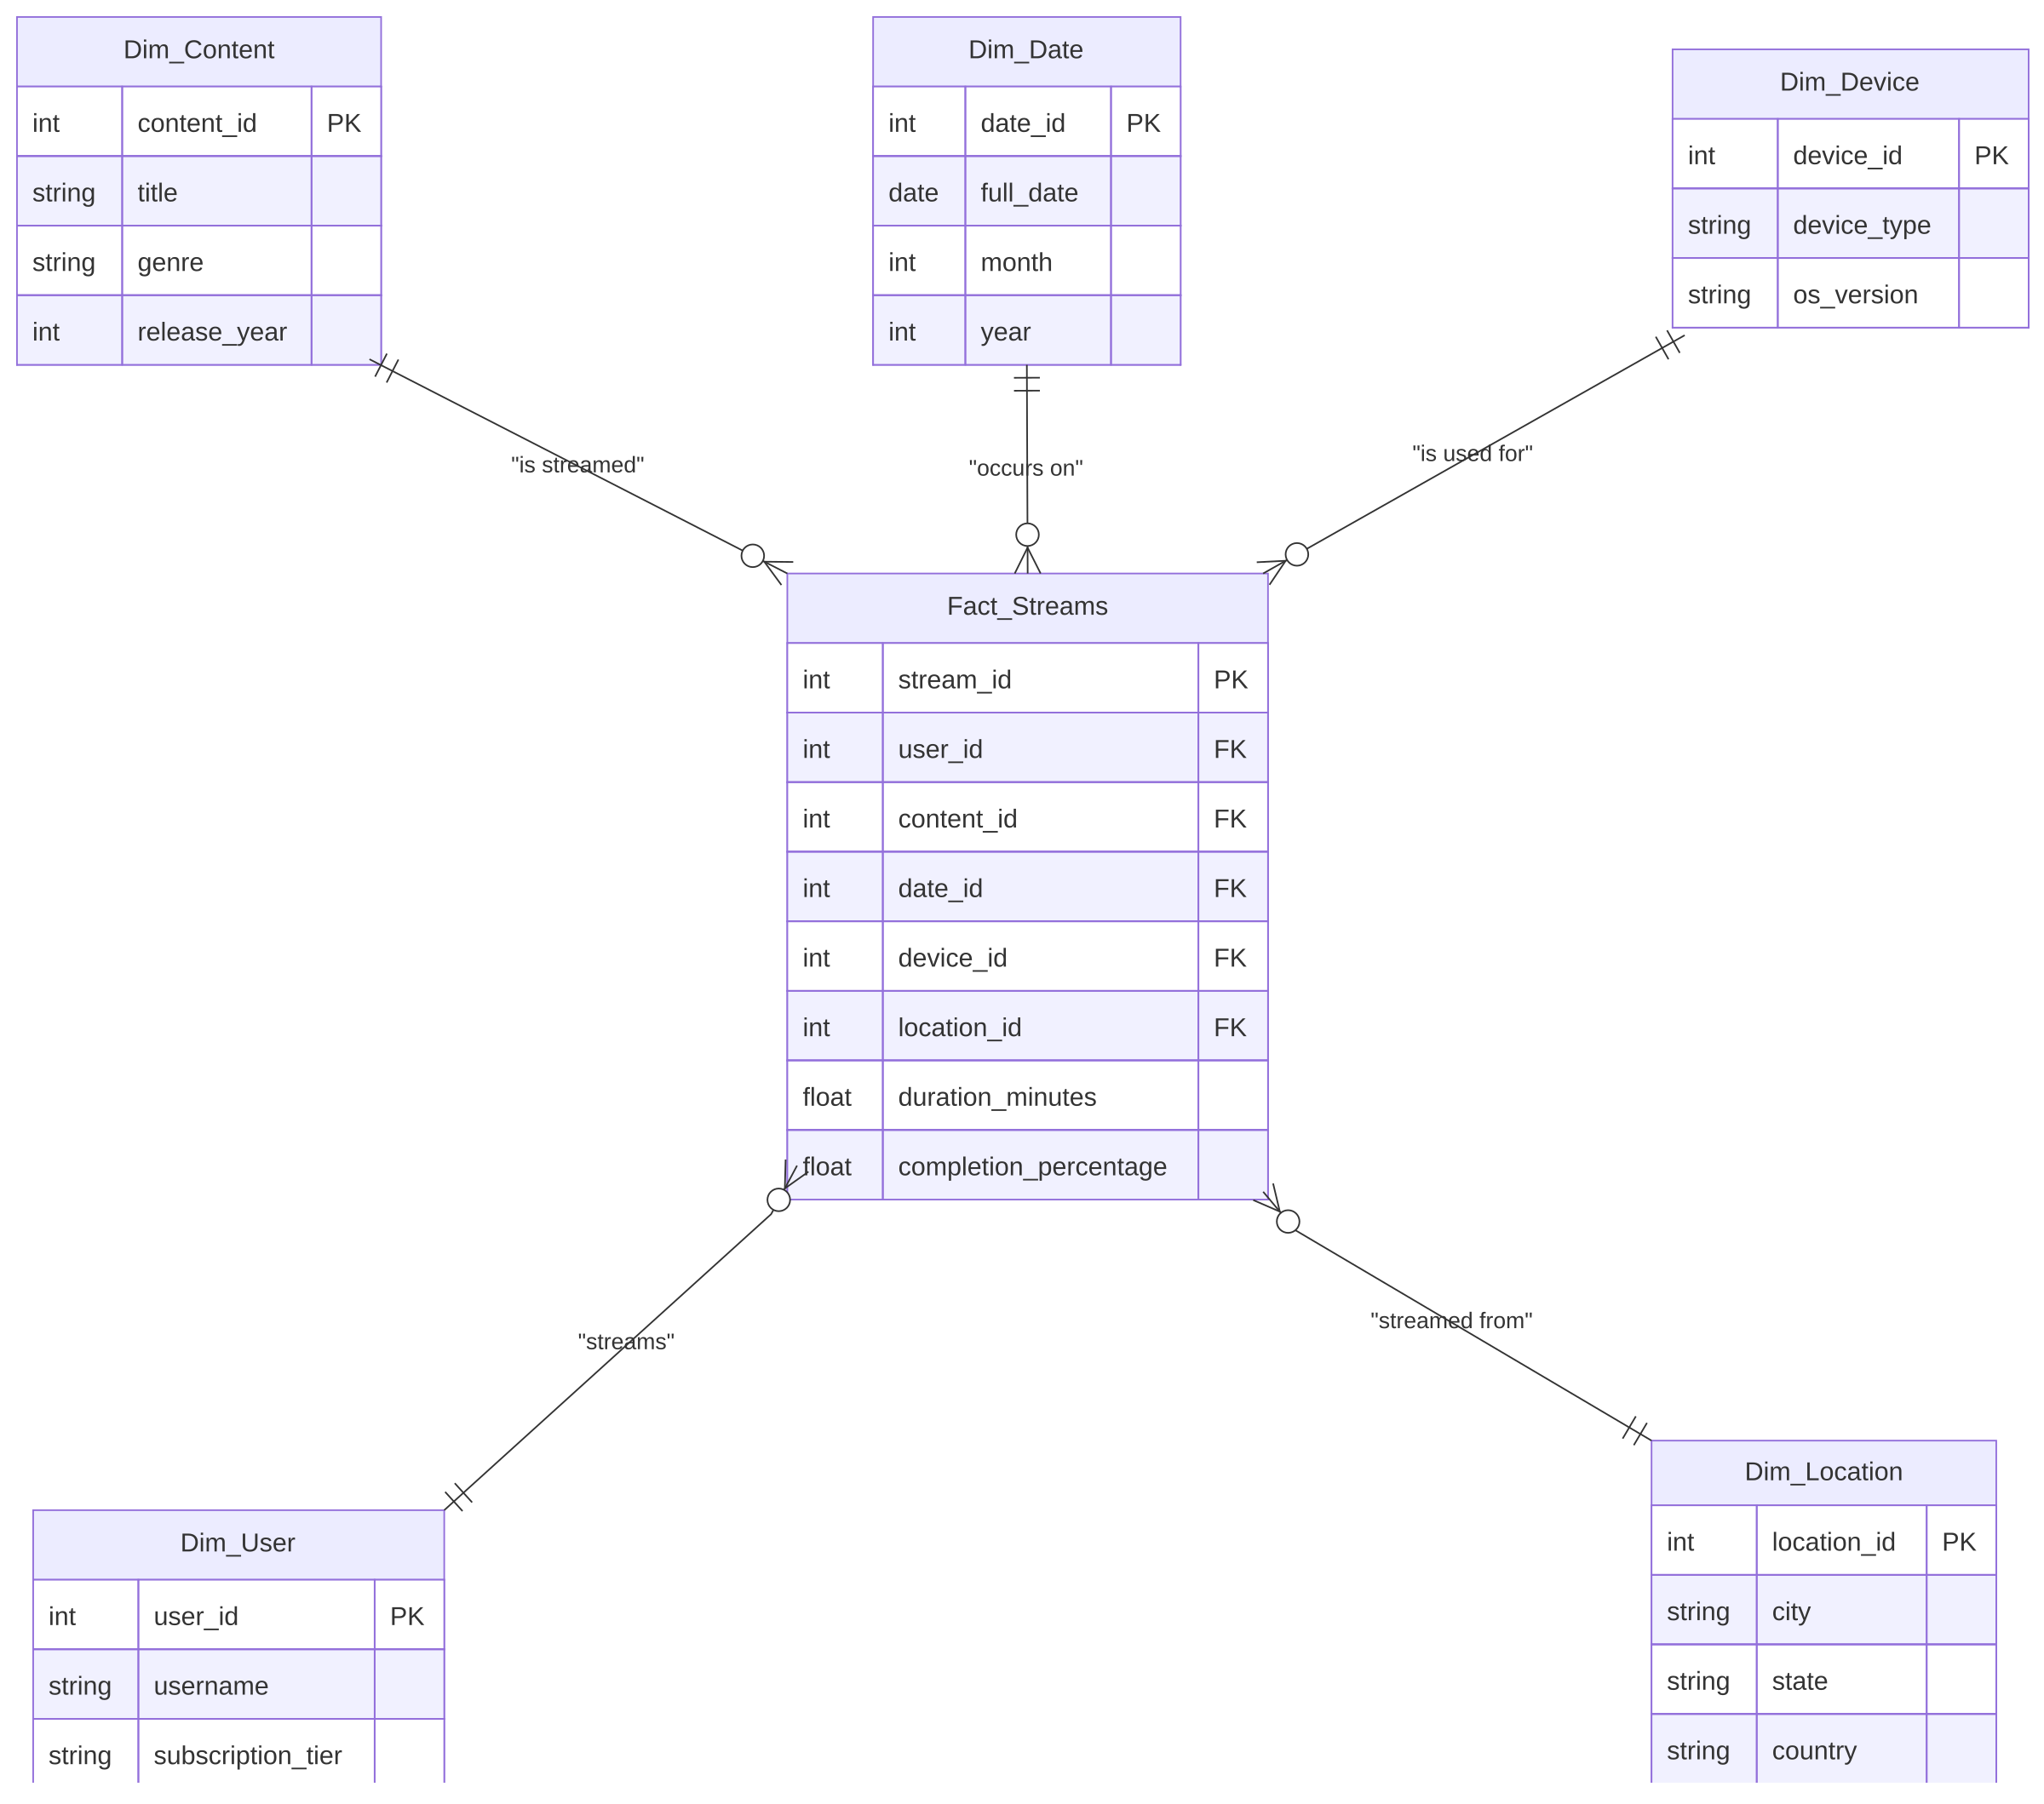

Fact Table :
Fact_Streams
Column | Description
stream_id | Primary Key
user_id | Foreign Key
content_id | Foreign Key
date_id | Foreign Key
device_id | Foreign Key
location_id | Foreign Key
duration_minutes | Total minutes watched in the session
completion_percentage | Percentage of content completed

Dimension Tables
Dim_User
Column | Description
user_id | Primary Key
username | Display name of the subscriber
subscription_tier | Free / Basic / Premium plan
Dim_Content
Column | Description
content_id | Primary Key
title | Title of the movie / show / episode
genre | Genre of the content
release_year | Year the content was released
Dim_Date
Column | Description
date_id | Primary Key
full_date | Date of the stream
month | Month
year | Year
Dim_Device
Column | Description
device_id | Primary Key
device_type | Mobile / Smart TV / Laptop / Tablet
os_version | Operating system version of the device
Dim_Location
Column | Description
location_id | Primary Key
city | City the stream originated from
state | State
country | Country

Structure of Star Schema ( Revenue )
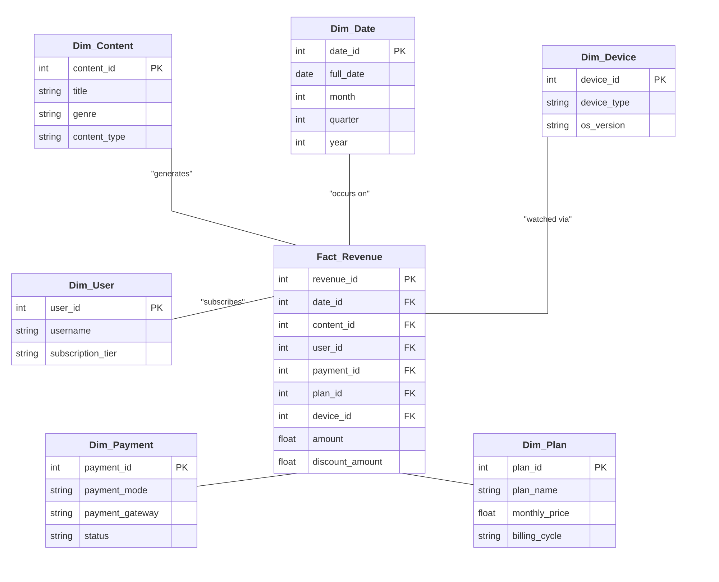

Fact Table:
Fact_Revenue
Column | Description
revenue_id | Primary Key
date_id | Foreign Key
content_id | Foreign Key
user_id | Foreign Key
payment_id | Foreign Key
plan_id | Foreign Key
device_id | Foreign Key
amount | Revenue amount for the transaction
discount_amount | Discount applied on the transaction

Dimension Tables :
Dim_Date
Column | Description
date_id | Primary Key
full_date | Date of transaction
month | Month
quarter | Quarter
year | Year
Dim_Content
Column | Description
content_id | Primary Key
title | Title of the content generating revenue
genre | Genre of the content
content_type | Movie / Series / Documentary
Dim_User
Column | Description
user_id | Primary Key
username | Subscriber name
subscription_tier | Free / Basic / Premium plan
Dim_Payment
Column | Description
payment_id | Primary Key
payment_mode | Card / UPI / Wallet / Netbanking
payment_gateway | Gateway used for the transaction
status | Success / Failed / Refunded
Dim_Plan
Column | Description
plan_id | Primary Key
plan_name | Name of the subscription plan
monthly_price | Price of the plan per month
billing_cycle | Monthly / Quarterly / Annual
Dim_Device
Column | Description
device_id | Primary Key
device_type | Mobile / Smart TV / Laptop / Tablet
os_version | Operating system version of the device

2 . Snowflake Schema
A Snowflake Schema is a data warehouse schema design where dimension tables are normalized into smaller, separate sub-dimension tables. It extends the Star Schema structure to reduce data redundancy and save storage space by organizing attributes into hierarchical relationships.

Structure:
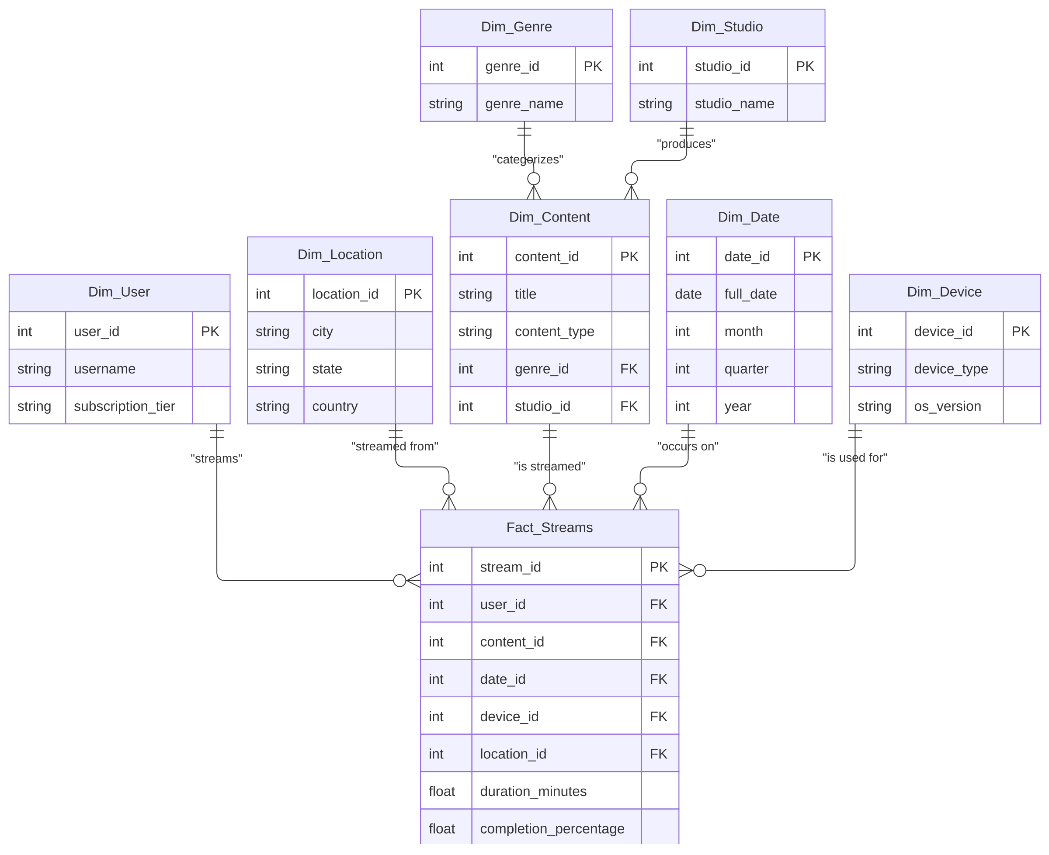

Main Difference :
Star schema uses a central fact table directly linked to fully denormalized dimension tables, forming a star-like shape. All dimensional data is stored in a single table, which means fewer joins and faster query performance, but at the cost of data redundancy and higher storage usage.
Snowflake schema is an extension of the star schema where dimension tables are further normalized into sub-dimension tables. For example, instead of storing genre and studio details directly inside the Content dimension, each is broken out into its own Dim_Genre and Dim_Studio table linked hierarchically. This reduces redundancy and saves storage, but requires more joins, making queries more complex and relatively slower.
Result :
Thus, the Star Schemas and Snowflake Schema for the Video Streaming Platform were successfully designed by identifying the Streaming Activity & Revenue Fact Tables and their corresponding Dimension Tables.

