SUMMER TRAINING/INTERNSHIP REPORT
(Term Aug-Dec 2026)

ON

SMART EXAM SEATING &
TIMETABLE ALLOCATOR
(Graph Coloring, Backtracking, and Priority-Queue based Scheduling System)
Submitted by:
Sanjogdeep Singh

Guide Name: Achala D Sagar

Registration No- 12417237
B.Tech CSE

Lovely Professional University, Phagwara


DECLARATION

I, Sanjogdeep Singh, Registration Number 12417237, student of B.Tech Computer Science and Engineering at Lovely Professional University, hereby declare that the work presented in this report, titled “Smart Exam Seating & Timetable Allocator,” is a record of my own work carried out during the 45-Day Summer Training Program in Data Structures & Algorithms conducted by Splen Technologies & Education Pvt. Ltd. The content of this report has not been submitted, in part or in full, for the award of any other degree or diploma of this or any other institution.
I further declare that all sources of information used in the preparation of this report have been duly acknowledged.

Date: 20-08-2026
Signature: Sanjogdeep Singh
Sanjogdeep Singh (12417237)

CERTIFICATE



ACKNOWLEDGEMENT
I would like to express my sincere gratitude to Splen Technologies & Education Pvt. Ltd. for providing me the opportunity to undergo the 45-Day Summer Training Program in Data Structures & Algorithms.
I would also like to thank the School of Computer Science and Engineering, Lovely Professional University, for providing the academic framework within which this training and project were undertaken.
Finally, I acknowledge the standard references and documentation — including the C++ Standard Library documentation and established Data Structures and Algorithms textbooks — that supported the technical understanding required to complete the project described in this report.

Sanjogdeep Singh
Registration No. 12417237

TABLE OF CONTENTS
S.No. | Topic | Page No.
 | Cover Page | -
 | Declaration | i
 | Certificate | ii
 | Acknowledgement | iii
 | Table of Contents | iv
1. | Introduction of Organization | 1
2. | Summer Training Course / Internship Content Detail | 2
3. | Summer Training / Internship Project Detail | 3
 | 3.1 Introduction | 3
 | 3.2 Objective and Scope | 4
 | 3.3 System Overview and Architecture | 5
 | 3.4 Algorithms and Data Structures Used | 6
 | 3.5 Implementation Details | 8
 | 3.6 Sample Execution and Results | 10
 | 3.7 Building and Running the Program | 12
 | 3.8 The HTML Visualizer | 14
 | 3.9 Testing | 15
 | 3.10 Conclusion and Future Scope | 18
4. | SOURCE CODE/ SYSTEM SNAPSHOTS | 19
5. | References | 21

- INTRODUCTION OF ORGANIZATION

SpleN Technologies and Education Pvt. Ltd. is a technology training and education organization focused on developing technical and professional skills among students and professionals. The organization aims to bridge the gap between academic learning and industry requirements by providing practical and industry-oriented training.
The organization offers various learning programs through campus-based, online, hybrid, workshops, bootcamps, and professional upskilling programs. Its training approach emphasizes practical learning, projects, mentorship, technical skills, and professional development. The organization operates in the E-learning and technology training domain and provides training in areas related to emerging technologies and professional skills.
The training program focused on building a strong practical foundation in core Data Structures and Algorithms concepts, culminating in an independent project in which the trainee was required to design and implement a complete C++ application demonstrating multiple DSA techniques applied together to a single real-world problem. An important aspect of technical training is the development of problem-solving and analytical thinking skills. Data Structures and Algorithms play an important role in this area because they provide systematic methods for organizing data and solving computational problems efficiently. Training in DSA helps learners understand how different algorithms and data structures can be selected and applied according to the requirements of a problem. Practical implementation also helps students understand concepts such as algorithm efficiency, time complexity, memory usage, and optimization.

2. SUMMER TRAINING COURSE / INTERNSHIP CONTENT DETAIL
The 45-day training program was structured around the core Data Structures and Algorithms curriculum typically expected of a Computer Science undergraduate, with an emphasis on translating theoretical concepts into working C++ implementations. The broad topics covered during the program included:
- Fundamentals of C++ for DSA: pointers, references, structures, and classes.
- Linear data structures: arrays, linked lists, stacks, and queues.
- Non-linear data structures: trees, binary search trees, and graphs.
- Searching and sorting algorithms, and their time-complexity trade-offs.
- Recursion and backtracking as a general problem-solving technique.
- Greedy algorithms and an introduction to dynamic programming.
- Graph algorithms, including traversal and graph coloring.
- Priority queues and heap-based data structures.
- Asymptotic (Big-O) time and space complexity analysis.
The final phase of the program required each trainee to identify a real-world problem and design an original C++ project that combined at least two or more of the above techniques into one coherent, working application, forming the basis of Chapter 3 below.

3.SUMMER TRAINING/INTERNSHIP PROJECT DETAIL

3.1. Introduction

Examination management is one of the most operationally demanding recurring tasks in any academic institution. Every semester, administrators must reconcile three separate and often competing requirements: no student may be double-booked into two exams occurring at the same time; every exam's enrolled students must be physically accommodated in available rooms without overcrowding or grossly under-using capacity; and, within any given room, students must be seated in a manner that discourages copying, most commonly by ensuring that no two students from the same class, section, or batch are seated next to one another.
When performed manually, this process is time-consuming, error-prone, and difficult to verify for correctness — an administrator has no simple way to confirm that a manually-drawn seating chart is genuinely free of adjacent same-batch pairs, or that a hand-built timetable could not have been compressed into fewer exam days. This project addresses all three problems computationally, by modelling each one as a well-established problem in Data Structures and Algorithms (DSA), and by using verifiable algorithms — rather than manual judgement — to both produce and check the resulting schedule.
The system is implemented as a single, self-contained C++17 console application. It accepts three plain CSV files as input (student enrollment records, subject/exam definitions, and room definitions) and produces two output files: a human-readable text report intended for direct reading or printing, and a structured JSON export intended for consumption by a companion HTML visualizer that renders the computed seating charts graphically in a web browser.

3.2. Objectives and Scope

3.2.1 Objectives
- To model real institutional exam-scheduling constraints as standard, well-studied DSA problems: graph coloring, constraint satisfaction, and bin packing.
- To implement a fast greedy algorithm for initial timetable construction, and a separate backtracking search to independently verify whether the greedy result is optimal.
- To implement a backtracking constraint-satisfaction search that guarantees, wherever a solution exists, a seating arrangement with zero same-batch adjacency.
- To implement an efficient room-allocation strategy using a priority queue, minimizing wasted seating capacity across rooms of differing sizes.
- To produce output in both a human-readable and a machine-readable format, enabling both direct inspection and further visualization.
- To keep the implementation fully data-driven and general-purpose, with no hardcoded assumptions about the number of students, subjects, rooms, or batches.

3.2.2 Scope
Dimension | Coverage in this Project
Input data | Arbitrary number of students, subjects, and rooms, supplied via CSV files
Timetable scheduling | Conflict-graph construction and coloring (greedy + backtracking verification)
Room allocation | Priority-queue-driven bin packing of students into rooms by remaining capacity
Seating arrangement | Backtracking constraint satisfaction with 8-directional adjacency checking
Output | Plain-text report (report.txt) and structured JSON export (report.json)
Visualization | A companion HTML page that loads report.json and renders colour-coded seat grids
Out of scope | Multi-day timetabling, invigilator assignment, and live database integration are noted as future work but not implemented in this version

3.3. System Overview and Architecture
The application follows a straightforward pipeline architecture: data is read from disk, passed through three independent processing stages in sequence, and the results of each stage are written to two output files. The three processing stages correspond to the three algorithmic modules described in Section 4.
data/students.csv ---\
data/subjects.csv ----> [ CSVReader ] ---> in-memory model
data/rooms.csv ---/ |
v
[ TimetableScheduler ]
graph coloring: greedy + backtracking
|
v
[ RoomAllocator ]
priority-queue bin packing
|
v
[ SeatingAllocator ]
backtracking CSP (per room)
|
v
output/report.txt + output/report.json
|
v
(optional) HTML visualizer reads report.json
The implementation is organised as four principal classes plus a driving main() function:
Class | Responsibility
CSVReader | Parses students.csv, subjects.csv, and rooms.csv into Student, Exam, and Room structures
TimetableScheduler | Builds the subject conflict graph and computes exam-slot assignments via greedy coloring and backtracking verification
RoomAllocator | Assigns each exam's enrolled students to one or more rooms using a capacity-ordered priority queue
SeatingAllocator | For a given room and its occupant batch counts, computes a conflict-free seat-to-batch assignment via backtracking

3.4. Algorithms and Data Structures Used

3.4.1 Graph Coloring
A graph G = (V, E) consists of a set of vertices V and a set of edges E connecting pairs of vertices. A proper coloring of G assigns a label (“color”) to every vertex such that no two vertices joined by an edge share the same color. The smallest number of colors for which a proper coloring exists is called the graph's chromatic number, and computing it exactly is an NP-hard problem in general — no algorithm is known that solves it efficiently for all graphs.
This project applies graph coloring in two independent places:
- Timetable scheduling: each subject is modelled as a vertex. An edge is added between two subjects whenever at least one student is enrolled in both — such subjects conflict and cannot be examined in the same time slot. The “color” assigned to each vertex is its exam time slot.
- Seating arrangement: each seat in a room is modelled as a vertex. An edge is added between two seats that are physically adjacent, including diagonally (an 8-directional adjacency, or “Moore neighbourhood”). The “color” assigned to each seat is the batch of the student seated there.

Greedy Coloring
The greedy strategy processes vertices in decreasing order of degree (i.e., the most-constrained vertices, those with the most conflicts, are handled first), and assigns each vertex the lowest-numbered color not already used by any of its already-colored neighbours. This method is fast (polynomial time) and always produces a valid coloring, but it is not guaranteed to use the minimum possible number of colors — it is a heuristic, not an exact algorithm.
GREEDY-COLOR(graph):
order vertices by degree, descending
for each vertex v in that order:
find the lowest color not used by any already-colored neighbour of v
assign that color to v
return number of distinct colors used

Backtracking Verification
To determine whether the greedy result actually used the minimum number of colors, the program separately attempts to color the same graph using exactly one fewer color than greedy required, via exhaustive backtracking search (see Section 4.2). If this search fails to find any valid coloring, the greedy result is proven optimal for this instance; if it succeeds, a strictly better schedule exists. This project always uses the greedy result as the schedule that is finally reported (since it is guaranteed valid), and reports the outcome of the backtracking check as supporting evidence of its quality.

3.4.2 Backtracking (Constraint Satisfaction Search)
Backtracking is a general algorithmic technique for solving constraint satisfaction problems by incrementally constructing candidate solutions, and abandoning (“backtracking on”) a candidate as soon as it is determined that it cannot possibly lead to a valid complete solution, rather than continuing to extend it needlessly. This avoids the cost of a full brute-force enumeration in most practical cases, although its worst-case time complexity remains exponential.
BACKTRACK(partial_solution):
if partial_solution is complete:
return SUCCESS
for each candidate value c for the next decision point:
if c is consistent with partial_solution:
extend partial_solution with c
if BACKTRACK(partial_solution) == SUCCESS:
return SUCCESS
remove c from partial_solution // the actual 'backtrack' step
return FAILURE
This project uses backtracking in two places, both instrumented to count the number of “states explored” (i.e., the number of candidate assignments attempted), giving a direct, reportable measure of search effort:
- Timetable slot verification, as described in Section 4.1.2, where the decision points are subjects (ordered most-constrained-first) and the candidate values are time slots.
- Seating allocation, where the decision points are seats (visited in row-major order) and the candidate values are student batches. A seat may only be assigned a batch if (a) that batch still has unseated students remaining, and (b) no already-assigned neighbouring seat (of the up to eight surrounding it) already holds that batch. If no batch can be validly placed at a seat, the seat is left explicitly empty and the search proceeds — this permits the algorithm to still succeed even when a batch's population does not exactly fill the available seats.

3.4.3 Priority Queue
A priority queue is an abstract data type that supports efficient retrieval of the highest- (or lowest-) priority element without requiring the entire collection to be re-sorted after every insertion or removal. It is conventionally implemented using a binary heap, a complete binary tree stored in an array, in which every parent node's priority is at least as great as (for a max-heap) both of its children's. Both insertion and removal-of-maximum operate in O(log n) time, compared to O(n log n) for repeatedly re-sorting a list.
This project uses C++'s std::priority_queue (a max-heap) to solve the room-allocation problem for each exam time slot, using the following largest-first greedy bin-packing strategy:
ALLOCATE-ROOMS(exams_in_slot, rooms):
sort exams_in_slot by enrolled student count, descending
push every room onto a max-heap, keyed by remaining capacity
for each exam in that order:
while exam still has unplaced students AND heap is not empty:
pop the room with the greatest remaining capacity
place as many of the exam's remaining students there as fit
reduce that room's remaining capacity accordingly
if capacity remains, push the room back onto the heap
This is the classical “largest item into largest available bin” greedy heuristic for bin packing. Because a room's remaining capacity changes after every placement, a plain sorted list would need to be re-sorted repeatedly; the heap instead supports an efficient “find current largest” operation throughout, including a lazy-deletion pattern to handle the fact that a room's priority (capacity) changes after it is reinserted.

3.4.4 Why These Three Techniques Were Combined
The three techniques were deliberately selected to represent three distinct classes of algorithmic problem commonly taught in a Data Structures and Algorithms course, and to demonstrate that they can be combined coherently within a single realistic application rather than treated as isolated textbook exercises:
- Graph coloring addresses “these entities are mutually exclusive and cannot share a group” constraints (subjects that cannot share a slot; seats that cannot share a batch).
- Backtracking addresses “search exhaustively for a valid assignment, or prove that none exists” problems, where correctness matters more than speed.
- The priority queue / greedy approach addresses “repeatedly make the locally optimal choice” efficiency problems, where an approximate but fast answer is acceptable.
Pairing a fast greedy heuristic with an exhaustive backtracking check (used twice in this project, for both the timetable and implicitly within the seating module) also illustrates a broader algorithmic design principle: heuristic and exact methods need not be treated as mutually exclusive choices, but can be combined so that the exact method verifies or bounds the quality of the heuristic's output without always incurring the full cost of exhaustive search.

3.5. Implementation Details

3.5.1 Data Model
Structure | Fields
Student | id, name, batch, subjects (list of enrolled subject codes)
Exam | code, name, studentIds (set), slot (assigned exam-slot index)
Room | id, name, rows, cols (capacity = rows × cols)

3.5.2 Input File Formats
Three CSV files are read from a data/ directory relative to the executable:
- data/students.csv — columns: id, name, batch, subjects (semicolon-separated subject codes).
- data/subjects.csv — columns: code, name.
- data/rooms.csv — columns: id, name, rows, cols.
None of these files' sizes are hardcoded anywhere in the source; the program adapts automatically to however many rows each file contains.

3.5.3 Output File Formats
output/report.txt contains a fully human-readable account of the computed timetable, per-slot room allocations, and per-room seating charts, formatted with plain-text tables and separators suitable for direct reading or printing.
output/report.json contains the same computed results as structured, machine-readable data: overall statistics, the timetable's greedy and backtracking-verification results, the per-slot exam groupings, and, for every room-exam allocation, a full two-dimensional seat grid in which every occupied seat records both the student's batch and their actual name. This file is consumed directly by the companion HTML visualizer described in Section 8, so that the visual seating chart shown in the browser is guaranteed to reflect the program's actual computed output rather than a separately maintained copy.

3.5.4 Error Handling
The program validates, at start-up, that all three input CSV files can be successfully opened, and reports a clear error message (rather than crashing or silently producing an empty report) if any is missing. Similarly, the output directory is created automatically if it does not already exist, since C++'s file-stream classes are only able to create files inside an existing directory and cannot create the directory itself.

3.6. Sample Execution and Results
Using a representative dataset of 24 students distributed across 3 batches (CSE-A, CSE-B, CSE-C), 6 subjects, and 3 examination rooms of varying capacity, the program was executed and produced the following results.

3.6.1 Timetable Output
EXAM SEATING & TIMETABLE ALLOCATOR
------------------------------------------------------------
Loaded 24 students, 6 subjects, 3 rooms.
TIMETABLE (Graph Coloring)
------------------------------------------------------------
Slots required by greedy Welsh-Powell coloring: 3 (0.0026 ms)
Backtracking check with 2 slots: NOT POSSIBLE (10 states explored, 0.0014 ms)
Slot 1: SUB1 (Data Structures and Algorithms), SUB5 (Artificial Intelligence)
Slot 2: SUB2 (Database Management Systems), SUB6 (Engineering Mathematics)
Slot 3: SUB3 (Operating Systems), SUB4 (Computer Networks)
This result confirms that three exam slots are genuinely necessary: the backtracking search explored 10 alternative two-slot colorings and found every one of them invalid, proving that the greedy algorithm's three-slot result was already optimal for this dataset, rather than merely being the first valid result it happened to find.

3.6.2 Room Allocation and Seating Output
SLOT 1 - ROOM & SEATING ALLOCATION
------------------------------------------------------------
Exam SUB1:
Room R3 (Hall C, 16/20 seats used)
Seating (batch-conflict-free): SUCCESS (34 states explored)
Seat map (batch labels):
CSE-A CSE-C CSE-A CSE-C
---- ---- ---- ----
CSE-A CSE-C CSE-A CSE-C
---- ---- ---- ----
CSE-A CSE-C CSE-A CSE-C
Every occupied seat in this map has no same-batch neighbour among any of the up to eight surrounding positions, satisfying the seating constraint exactly. The alternating fully-empty rows are not an inefficiency or a defect: when only two batches occupy a room, a strict checkerboard pattern is the only seat assignment that can achieve zero same-batch adjacency, and the algorithm correctly identifies and applies it rather than approximating the constraint.

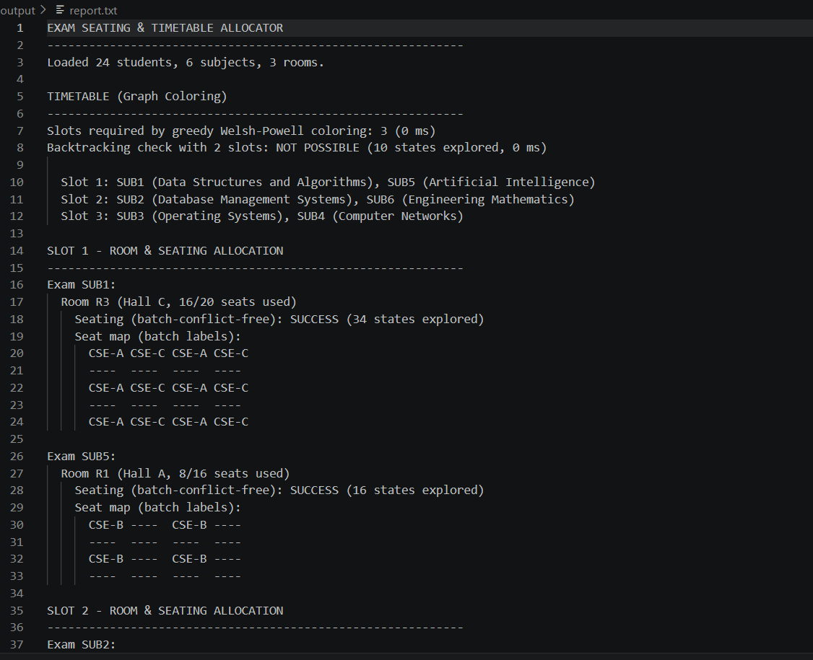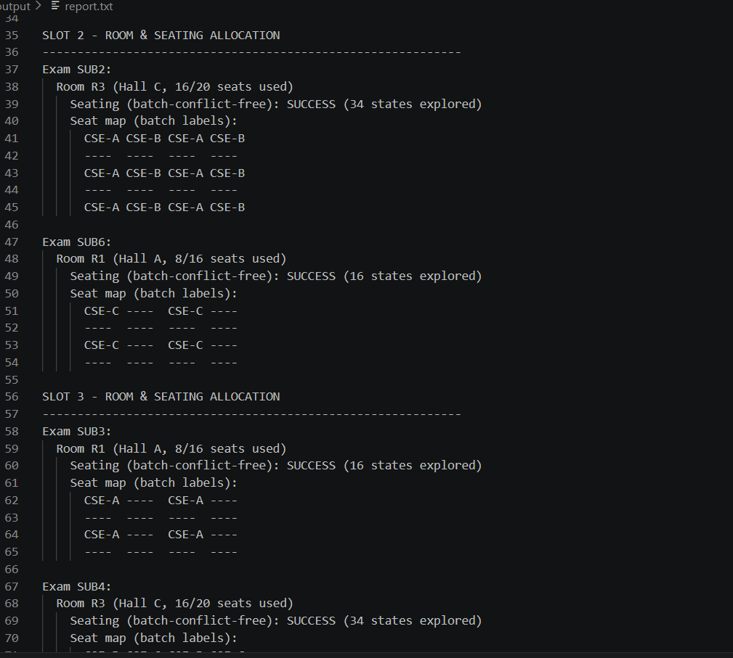
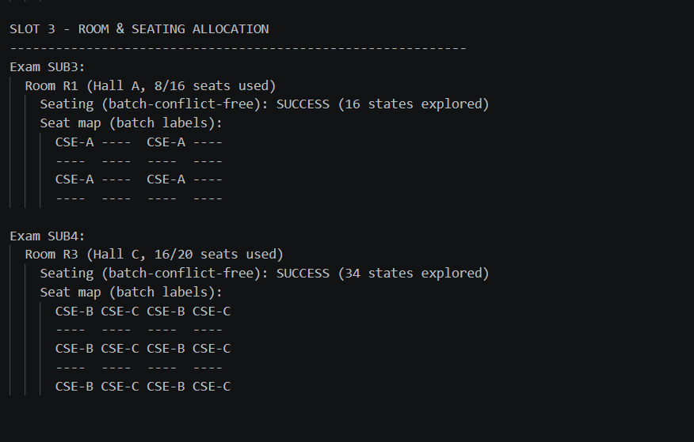

3.6.3 Overall Results Summary
Metric | Result
Total students / subjects / rooms | 24 / 6 / 3
Exam slots required (greedy) | 3, confirmed optimal by backtracking
Rooms with successful conflict-free seating | All rooms across all slots
Typical backtracking search size (seating) | 16–34 states explored per room
Typical backtracking search size (timetable check) | 10 states explored

3.7. Building and Running the Program
The program is implemented as a single C++17 source file with no external dependencies beyond the standard library, so it can be compiled with a single command:
g++ -std=c++17 -Wall -Wextra -O2 allocator.cpp -o allocator
./allocator
On execution, the program reads the three CSV files from the data/ subdirectory, performs all three algorithmic stages described in Section 4, and writes output/report.txt and output/report.json. Both the output directory and the output files themselves are created automatically if they do not already exist; the program does not require any file to be pre-created manually.

3.8. The HTML Visualizer
As a supporting component, a standalone HTML page was developed to render the seating charts graphically rather than as plain text. This page performs no computation of its own — it contains no reimplementation of the graph-coloring, backtracking, or priority-queue logic. Instead, it reads output/report.json (selected by the user via a file picker, to avoid browser same-origin restrictions on local files) and renders the exact seats, batches, and student names already computed by the C++ program, ensuring that the visual output is always a faithful reflection of the program's real results rather than a separately maintained approximation.
Each room is displayed as a grid of coloured tiles, one per seat, coloured by student batch; hovering over any seat reveals the corresponding student's name. Rooms in which the backtracking search succeeded are marked with a clearly visible confirmation, allowing a viewer to verify at a glance that every displayed seating chart is genuinely conflict-free.
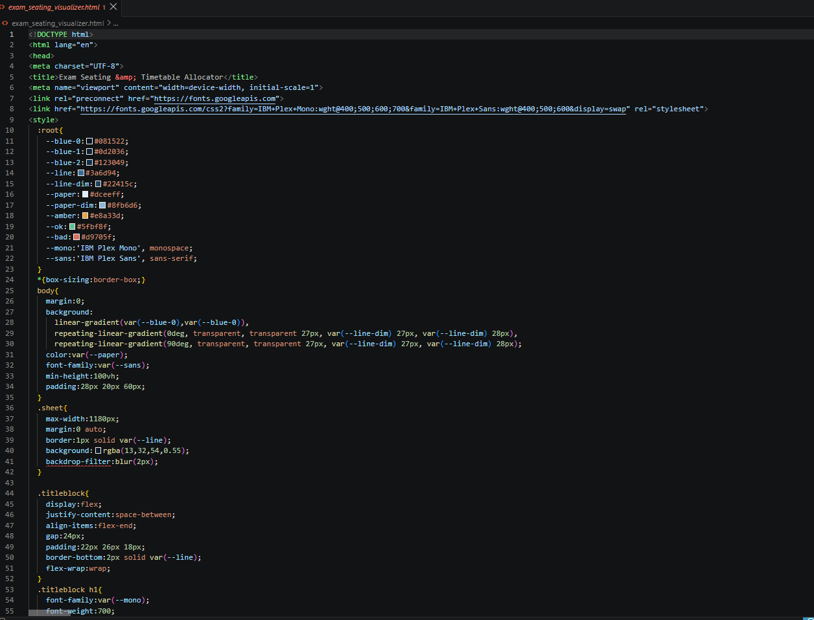

3.9. Testing
The following test scenarios were used to validate correctness during development:
Test Case | Expected Behaviour | Result
Standard 24-student, 6-subject, 3-room dataset | Valid 3-slot timetable; all rooms seated conflict-free | Pass
Backtracking check with one fewer slot than greedy used | Search exhaustively fails, proving optimality | Pass
Single-batch room (only one batch present) | Checkerboard seating with alternating empty seats | Pass
Missing data/ directory | Clear error message instead of a crash | Pass
Missing output/ directory | Directory created automatically before writing | Pass
Adding a new batch/student and re-running | Timetable, allocation, and seating recompute correctly with no code changes | Pass

3.10. Conclusion and Future Scope

3.10.1 Conclusion
This project demonstrates that a realistic institutional scheduling problem — examination timetabling, room allocation, and conflict-free seating — can be modelled precisely and solved reliably using standard Data Structures and Algorithms techniques: graph coloring, backtracking-based constraint satisfaction, and priority-queue-driven greedy bin packing. Rather than treating these as independent textbook exercises, the project applies all three within a single coherent pipeline, and further demonstrates the practical value of pairing a fast greedy heuristic with an exhaustive backtracking search to gain verifiable confidence in the heuristic's optimality, an approach that has broader applicability beyond this specific problem domain.

3.10.2 Future Scope
- Invigilator assignment as a further graph-coloring or bipartite-matching extension, ensuring no invigilator is assigned to two simultaneous exams.
- Support for multi-day timetables and exam-type-specific room constraints, such as reserving computer labs for practical examinations.
- A native graphical desktop interface (for example, using SFML) rendering seating charts directly, as a complement to the existing HTML/JSON visualizer.
- Persisting input and output data in a relational database rather than flat CSV/JSON files, to support larger institutions and concurrent access.
- Extending the seating constraint to also account for physical classroom features such as broken seats or restricted-view positions.

4.SOURCE CODE/ SYSTEM SNAPSHOTS
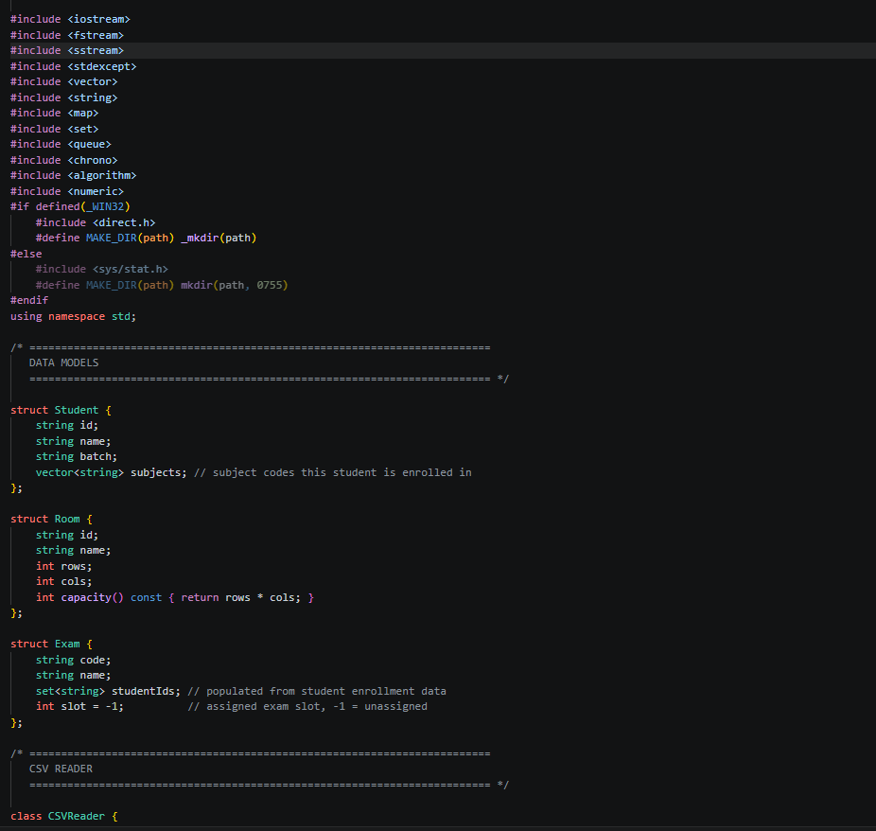 | 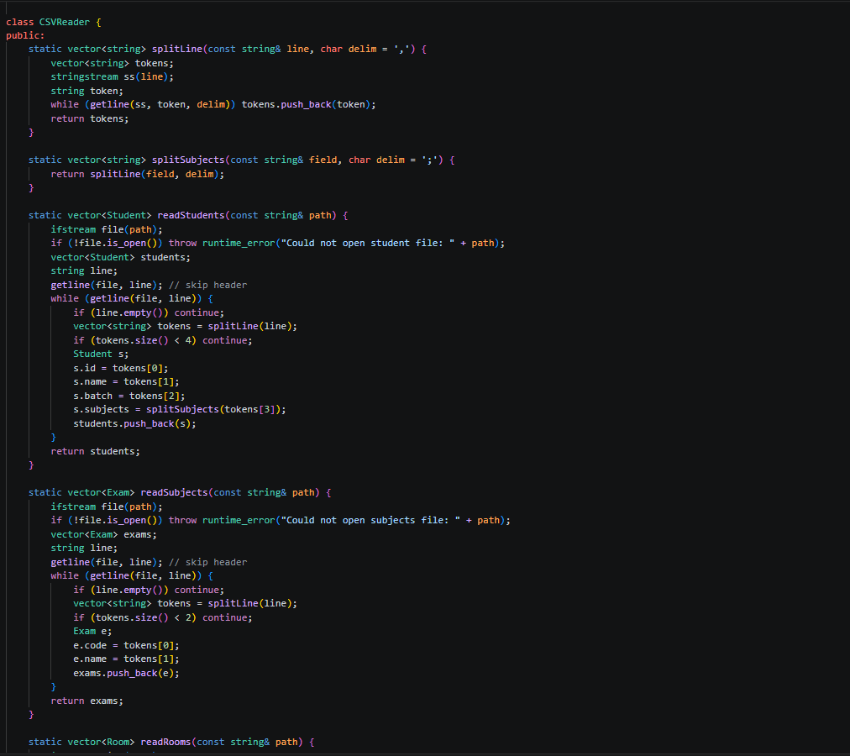
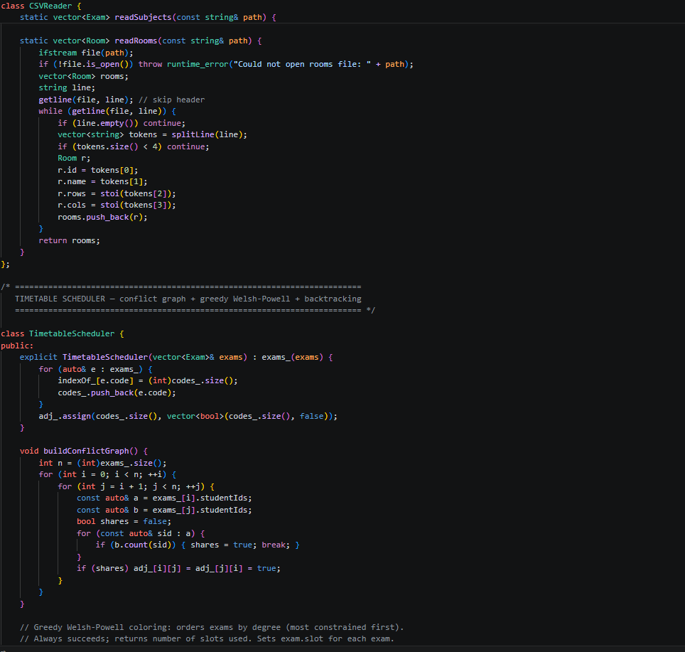 | 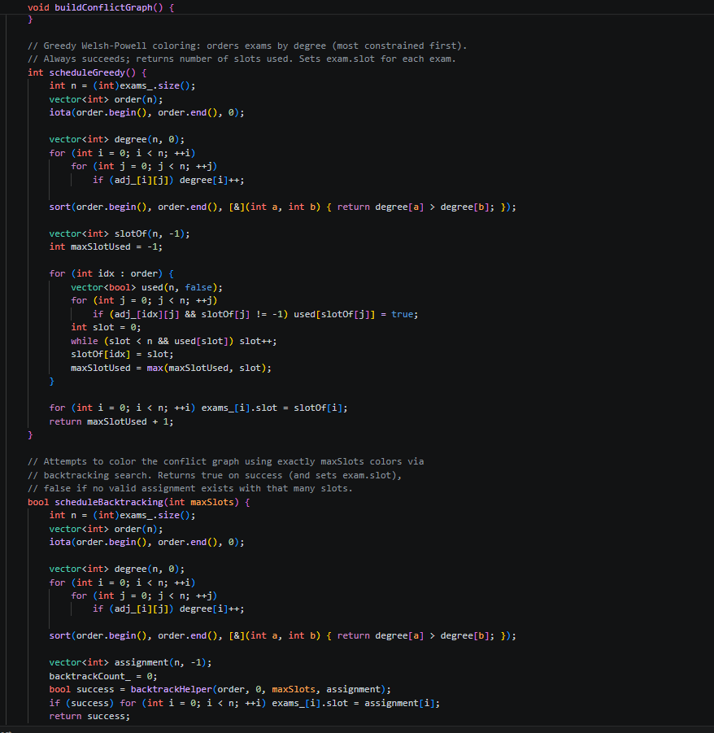

5.References
- T. H. Cormen, C. E. Leiserson, R. L. Rivest, and C. Stein, Introduction to Algorithms, 3rd ed. Cambridge, MA: MIT Press, 2009.
- D. J. A. Welsh and M. B. Powell, “An upper bound for the chromatic number of a graph and its application to timetabling problems,” The Computer Journal, vol. 10, no. 1, pp. 85–86, 1967.
- S. S. Skiena, The Algorithm Design Manual, 2nd ed. London: Springer, 2008.
- cppreference.com, “std::priority_queue,” C++ Standard Library documentation. [Online]. Available: https://en.cppreference.com/w/cpp/container/priority_queue.
- cppreference.com, “std::filesystem,” C++ Standard Library documentation. [Online]. Available: https://en.cppreference.com/w/cpp/filesystem.

