Assignment 1: Draw your Home Network Topology and explain how you are accessing the RPS Lab environment.

# Home Network Topology:

* Tool Used for drawing: draw.io
* External link to show drawn image: <https://viewer.diagrams.net/?tags=%7B%7D&lightbox=1&highlight=0000ff&layers=1&nav=1#G1hPj1iu2Z_i6vK6bUMMAYN3AUKTCvIq9b>

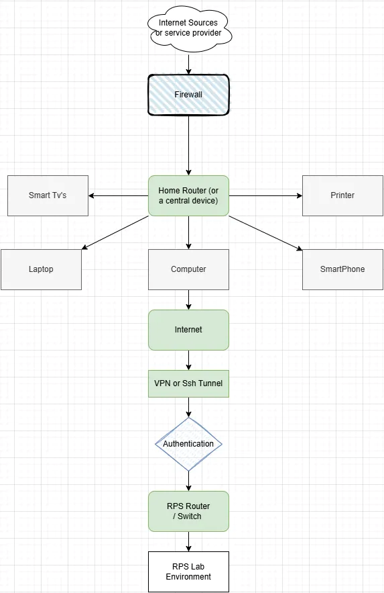Diagram: The Home topology and connection to RPS Lab.

# Explaining Details of Home Topology and connection to RPS Lab:

1. **Internet Source:** It can be a ISP (internet service provider) which is used to provide necessary connection to the internet, so that our Home appliances can connect with external sources.
2. **Firewall:** Usually It position before a home router so that it can protect the user’s private network with network traffic, malicious requests, only trusted sources can be provided.
3. **Home Router (or Central Hub):** IT acts as a central hub for home network. This can provide a network connection through wires or wireless wi-fi system. So that Smartphones, laptops, computers, printers can be connected seamlessly.   
   Primarily It do follow things:
   1. **NAT (Network Address Translation**): converts private IP of different devices to a single public IP address.
   2. **DHCP (Dynamic Host Configuration Protocol):** Assigns IP addresses dynamically to devices on home network.
4. **Devices:** There can be multiple devices are connected with Central Hub Like computer, laptop, smartphone, smart TV’s etc. which can be used to connect with other networks.
5. **Internet:** The use of internet on computer help to connect our device to any external services. In our case we have connected our computer with internet and tried to connect to servers of RPS and make a seamless connection between both networks.
6. **VPN or SSH tunnel:** Provides a secure channel for connecting to the RPS Lab environment over the internet. It Encrypts your data during transmission, protecting it from interception and Ensures authentication, so only authorized users can access the RPS Lab. Hence This establishes a direct, secure connection to the lab environment.
7. **Authentication:** It Ensures that only verified users can access the RPS Lab so a login Id and password is provided and it will connect to RPS Server
8. **RPS ROUTER/ Switch:** Now it works as the entry point to the RPS Lab's internal network and Manages connections between authenticated users and lab resources and Routes requests to specific machines or services within the lab.
9. **RPS Lab environment:** Finally, the authenticated user will access routed Lab machine from central hub so that user can use Lab features.

Assignment 2: Identify a real-world application for both parallel computing and networked systems. Explain how these technologies are used and why they are important in that context.

# Real-world app for parallel computing & networked systems:

**Parallel Computing:**

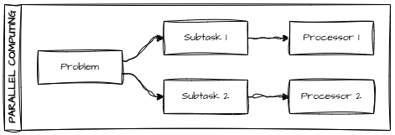

* It is a computing architecture where:
  + Multiple processes execute multiple tasks simultaneously to solve a single problem.
  + To get results, we divide tasks into multiple processes.
  + Can use multiple CPUs at a time or a GPU.
* Examples:
  + Generative AI, Weather forecasting, Finite element analysis.
* Applications:
  + Multi-core processors, GPU in AI & games, weather forecasting.

**Networked System:**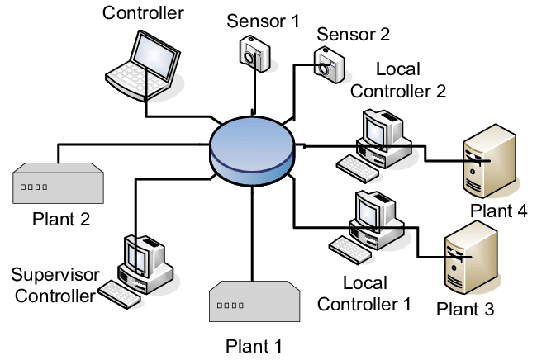

* It connects multiple devices to share resources & services over a network of LAN or the internet.
* Rather than a single CPU, multiple devices are connected.
* DeviceCommunication with TCP/IP, HTTP.
* Applications:
  + mail, web browsing, file sharing, video conferencing.

# Real world applications

**Ex:**

* **Amazon EC2 instance:**
* They connect multiple clusters of EC2 instances.
* Shared parallel computations and also share data to these networks.
* **YouTube / Netflix streaming:**
  + While uploading and live streaming:
    - Video & audio are encoded and transcoded in many sizes & formats.
  + These processes run for many formats, so parallel tasks are running.
  + At the same time, these are distributed to many users over the internet.
  + So that they can find & watch them using servers.
* **Online multiplayer games:**
  + Each task of physics simulation, AI decisions, etc., is taken in a different thread.
  + Many users can communicate with each other and view some of the different angles, etc., at the same time.