MOSFET

Definition:The MOSFET (Metal Oxide Semiconductor Field Effect Transistor) transistor is a semiconductor device which is widely used for switching and amplifying electronic signals in the electronic devices.  The MOSFET is a core of integrated circuit and it can be designed and fabricated in a single chip because of these very small sizes.  The MOSFET is a four terminal device with source(S), gate (G), drain (D) and body (B) terminals.

The MOSFET works by electronically varying the width of a channel along which charge carriers flow (electrons or holes).  The charge carriers enter the channel at source and exit via the drain. The width of the channel is controlled by the voltage on an electrode is called gate which is located between source and drain. It is insulated from the channel near an extremely thin layer of metal oxide. The MOS capacity present in the device is the main part

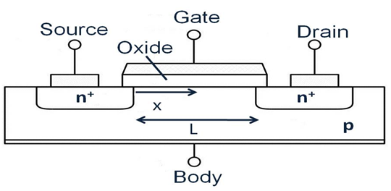

* Depletion Type   –   the transistor requires the Gate-Source voltage, ( VGS ) to switch the device “OFF”. The depletion mode MOSFET is equivalent to a “Normally Closed” switch.

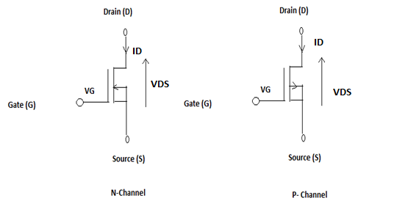

* Enhancement Type   –   the transistor requires a Gate-Source voltage, ( VGS ) to switch the device “ON”. The enhancement mode MOSFET is equivalent to a “Normally Open” switch.

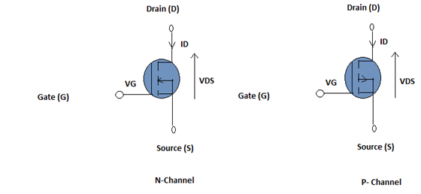

### Operation of MOSFET:

### P-Channel MOSFET: The drain and source are heavily doped p+ region and the substrate is in n-type. The current flows due to the flow of positively charged holes also known as p-channel MOSFET. When we apply negative gate voltage, the electrons present beneath the oxide layer experience repulsive force and they are pushed downward in to the substrate, the depletion region is populated by the bound positive charges which are associated with the donor atoms. The negative gate voltage also attracts holes from p+ source and drain region into the channel region.

### Fig:P channel deplation & Enhancement both

### N-Channel MOSFET: The drain and source are heavily doped n+ region and the substrate is p-type. The current flows due to the flow of negatively charged electrons, also known as n-channel MOSFET. When we apply the positive gate voltage the holes present beneath the oxide layer experience repulsive force and the holes are pushed downwards in to the bound negative charges which are associated with the acceptor atoms. The positive gate voltage also attracts electrons from n+ source and drain region in to the channel thus an electron reach channel is formed.

### Fig:N channel deplation & Enhancement both

# Applications of MOSFET

### Switch A direct consequence of MOSFET working leads to their usage as a switch. A n-channel MOSFET shown by Figure 1 can act as a switching circuit when it operates in cut-off and saturation regions. This is because the MOSFET in the figure will be ON when the VGS voltage is positive, which causes the [MOSFET](https://www.electrical4u.com/mosfet-working-principle-of-p-channel-n-channel-mosfet/) to behave like a short circuit.

### mosfet as a switch

### Amplifiers  Enhancement n-channel MOSFETs are in their OFF state when no gate-to-source voltage is applied. However when biased with a suitable positive voltage, it starts to conduct allowing the flow of drain current through it.

### mosfet as an amplifier

**Chopper**  
The [switching action of MOSFETs](https://www.electrical4u.com/mosfet-as-a-switch/) can be exploited to design [chopper](https://www.electrical4u.com/chopper-dc-to-dc-converter/) circuits as shown by Figure 4. Here the DC voltage, VDC is converted into AC voltage

with the same amplitude level, VAC by biasing the MOSFET using a square voltage waveform between its gate and source terminals.

**Linear Voltage Regulators**  
Depletion type MOSFETs in source-follower configuration are used in linear voltage regulator circuits as pass [transistors](https://www.electrical4u.com/bipolar-junction-transistor-or-bjt-n-p-n-or-p-n-p-transistor/) (Figure 5). Here the source voltage, VL follows the gate voltage, VG minus the gate-to-source voltage, VGS.

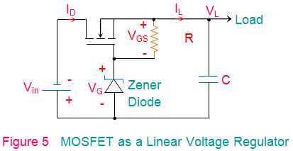

**Output characteristic**

1. **Cut-Off Region**  
   Cut-off region is a region in which the MOSFET will be OFF as there will be no [current](https://www.electrical4u.com/electric-current-and-theory-of-electricity/) flow through it. In this region, MOSFET behaves like an open switch and is thus used when they are required to function as electronic switches.
2. **Ohmic or Linear Region**  
   Ohmic or linear region is a region where in the current IDS increases with an increase in the value of VDS. When MOSFETs are made to operate in this region, they can be used as amplifiers.
3. **Saturation Region**  
   In saturation region, the MOSFETs have their IDS constant inspite of an increase in VDS and occurs once VDSexceeds the value of pinch-off [voltage](https://www.electrical4u.com/voltage-or-electric-potential-difference/) VP. Under this condition, the device will act like a closed switch through which a saturated value of IDS flows. As a result, this operating region is chosen whenever MOSFETs are required to perform switching operator.

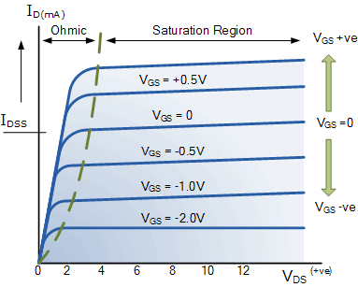

## Transfer Characteristics

The transfer characteristic relates drain current (ID) response to the input gate-source driving voltage (VGS). Since the gate terminal is electrically isolated from the remaining terminals (drain, source, and bulk), the gate current is essentially zero, so that gate current is not part of device characteristics. The transfer characteristic curve can locate the gate voltage at which the transistor passes current and leaves the OFF-state. This is the device threshold voltage (Vtn). Figure 5 shows measured input characteristics for an nMOS and pMOS transistor with a small 0.1V potential across their drain to source terminals.

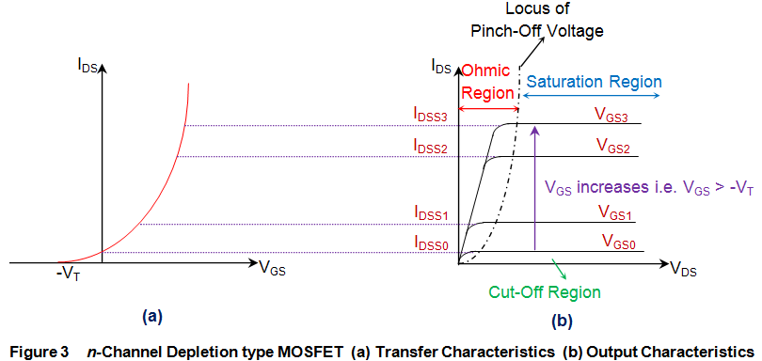

on Github: https://github.com/scoute-dich/Browser

https://github.com/hummatli/SimpleEncryptionLib

https://github.com/Templarian/MaterialDesign

https://github.com/bumptech/glide

site on Github: https://github.com/scoute-dich/Browser

https://forum.xda-developers.com/android/apps-games/app-browser-t3500091

https://github.com/scoute-dich/browser

https://github.com/scoute-dich

https://github.com/futrDevelopment

https://github.com/splinet

https://github.com/JumpingYang001

http://git.io/vUruk

http://git.io/vTHZH

http://git.io/vUruG

http://git.io/vUruO

http://git.io/vUrum

http://git.io/vUrEh