Lecture No. | Topic to be covered
Unit 1:
Introduction to OOP and java
I.1 | Fundamentals Object Oriented Programming
I.2 | Abstraction
I.3 | Objects and classes
I.4 | Encapsulation-Inheritance
I.5 | Polymorphism-OOP in Java
Unit 2:
Characteristics of Java
II.1 | Java Source File Structure – Compilation. Fundamental Programming Structures in Java
II.2 | Objects and classes
II.3 | Encapsulation-Inheritance
II.4 | Polymorphism-OOP in Java
II.5 | Defining classes in Java
II.6 | constructors, methods –access specifier
II.7 | static members -Comments, Data Types, Variables, Operators, Control Flow
II.8 | Arrays , Packages – JavaDoc Comments
Unit 3:
Inheritance and Interfaces
III.1 | Super classes and sub classes
III.2 | Protected members – constructors in sub classes
III.3 | The Object class – abstract classes and methods- final methods and classes
III.4 | Interfaces – defining an interface, implementing interface, differences between classes and interfaces
III.5 | extending interfaces – Object cloning -inner classes,  ArrayLists – Strings
Unit 4:
Exceptions Handling an I/O
IV.1 | Exceptions – Exception Hierarchy, throwing and catching exceptions  – built-in exceptions,
IV.2 | Creating own exceptions, Stack Trace Elements.
IV.3 | Input / Output Basics – Streams – Byte streams and Character
IV.4 | Streams – Reading and Writing Console – Reading and Writing Files
Unit 5:
Multithreading and Generic Programming Differences
V.1 | Between multi-threading and multitasking, thread life cycle, creating threads, synchronizing threads
V.2 | Inter-thread communication, daemon threads, and thread groups
V.3 | Generic Programming – Generic classes – generic methods
V.4 | Bounded Types – Restrictions and Limitations
Unit 6:
Event Driven Programming Graphics programming
VI.1 | Frame, Components, working with 2D shapes Using color, fonts, and images
VI.2 | Basics of event handling – event handlers – adapter classes – actions – mouse events – AWT event hierarchy
VI.3 | Introduction to Swing – layout management – Swing Components– Text Fields , Text  Areas – Buttons-Check Boxes – Radio Buttons – Lists-choices-Scrollbars – Windows – Menus – Dialog  Boxes

Note:
- Please refer to the MAKAUT portal for the updated syllabus for this course. The updated syllabus contains errors.
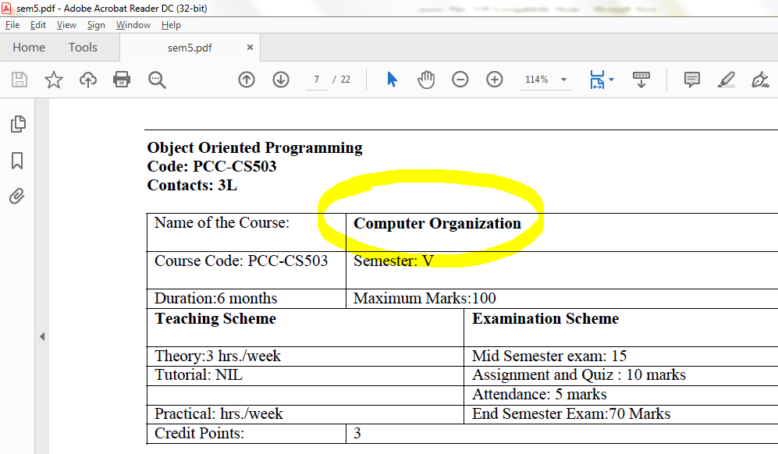
Link for the document:
http://makautexam.net/aicte_details/Syllabus/CSE/sem5.pdf

- The updated syllabus contains advance java features which can only be understood if the student already knows core java. But, the students have not learned java programming before. So, the updated syllabus is not suitable for our students. An official communication with the university is highly suggested in this regard.

- This is an old issue and has not been resolved yet. A downloaded copy of the syllabus has been attached in the email.

