5.12 Tail-Risk-Aware Distributional Agents
Section 5.3 found a mean-versus-tail trade-off between the two algorithms: DDQN had the lower mean shortfall, while PPO had the lower CVaR95 because it left less inventory to the forced market order at T. This section tests whether an agent that learns the whole cost distribution and acts on its lower tail can change that trade-off, and whether risk-sensitivity, rather than the value-based versus policy-gradient split, explains the tail difference. The design, contrasts and thresholds were fixed in a pre-registration file (docs/v2/preregistration.md) committed before any run.

5.12.1 Position in the Literature
No published deep-RL execution study that we could find optimises a tail risk measure: the execution agents in Section 2.4, including the queue-reactive DDQN of Espana et al. (2025), minimise expected cost. CVaR-optimal execution has been solved by dynamic programming in an Almgren–Chriss-type model (Min, Moallemi and Maglaras, 2022), and DDQN and PPO have been compared for limit-order placement on replayed data (Schnaubelt, 2022). The contribution is therefore the combination: to our knowledge, this is the first controlled comparison of value-based, policy-gradient and CVaR-sensitive distributional agents for optimal execution in a data-calibrated queue-reactive order book with liquidity shocks, that links tail-cost differences to forced end-of-horizon liquidation. The literature check behind this wording, with every citation tagged as verified or not, is in docs/v2/literature_check.md.

5.12.2 Agents and Protocol
QR-DDQN (Dabney, Rowland, Bellemare and Munos, 2018) replaces the Q-head of DDQN with K = 40 quantiles of the return per action, trained with the quantile Huber loss (κ = 1) and a Double-DQN target in which the online network chooses the next action with the agent's own criterion. The body, replay, ε schedule, target sync and 250k-step budget are those of DDQN. Three criteria were compared: the mean of the quantiles (risk-neutral); CVaR_α-greedy, the mean of the lowest αK quantiles with α = 0.25 (primary) or 0.1; and the threshold rule of Lim and Malik (2022), which carries a threshold c in the state (c ← c − r after each reward) and acts on E[−(c − Z)⁺]. The threshold rule was added because CVaR-greedy selection at every step optimises neither the static nor the nested CVaR of the total cost (Lim and Malik, 2022, Proposition 1); the CVaR-greedy agent is therefore described as CVaR-sensitive, not CVaR-optimal. The two tuned QR arms got the DDQN tuning grid and budget; the α = 0.1 and threshold arms reuse the CVaR(0.25) settings. DDQN and PPO were re-run with their Phase-1 settings, and every arm was trained on 'mixed' with the same ten fresh seeds (10–19), so all contrasts are paired by seed and by test episode.

5.12.3 Pre-Registered Results
Against DDQN, averaged over the six settings, the CVaR(0.25) agent changed CVaR95 of shortfall by −6.00 [−7.27, −4.59] bps (difference, 95% interval). The whole interval lies beyond the pre-registered smallest effect of interest (1.0 bps). Its mean shortfall changed by +1.42 [+1.26, +1.58] bps, so non-inferiority at the +0.3 bps margin was not shown, and its risk-adjusted objective changed by +0.48 [+0.26, +0.70] bps (higher is worse). The agent buys tail protection with mean cost; it does not achieve DDQN-like mean cost with lower tail risk. Against PPO, the differences were −3.68 [−5.62, −1.68] bps in CVaR95 and +1.20 [+1.06, +1.33] bps in mean.
Table 5.10: Agents trained on 'mixed', averaged over settings A–D3 (10 seeds each; 95% intervals by seed-then-episode bootstrap)
Agent | Mean IS (bps) | CVaR95 (bps) | Objective | Sold before T | Limit-order share
DDQN | 3.03 [2.93, 3.14] | 23.92 [22.90, 24.78] | 4.98 | 91.6% | 77%
PPO | 3.25 [3.13, 3.35] | 21.60 [20.15, 23.23] | 4.81 | 96.7% | 67%
QR-DDQN, risk-neutral | 2.92 [2.80, 3.02] | 20.91 [20.11, 21.63] | 4.80 | 94.9% | 69%
QR-DDQN-CVaR(0.25) | 4.45 [4.30, 4.58] | 17.93 [17.16, 19.00] | 5.46 | 99.6% | 20%
QR-DDQN-CVaR(0.1) | 4.66 [4.52, 4.76] | 18.25 [17.50, 19.02] | 5.66 | 99.7% | 9%
QR-DDQN, threshold CVaR(0.25) | 4.56 [4.50, 4.63] | 19.89 [18.84, 20.81] | 6.08 | 87.8% | 19%
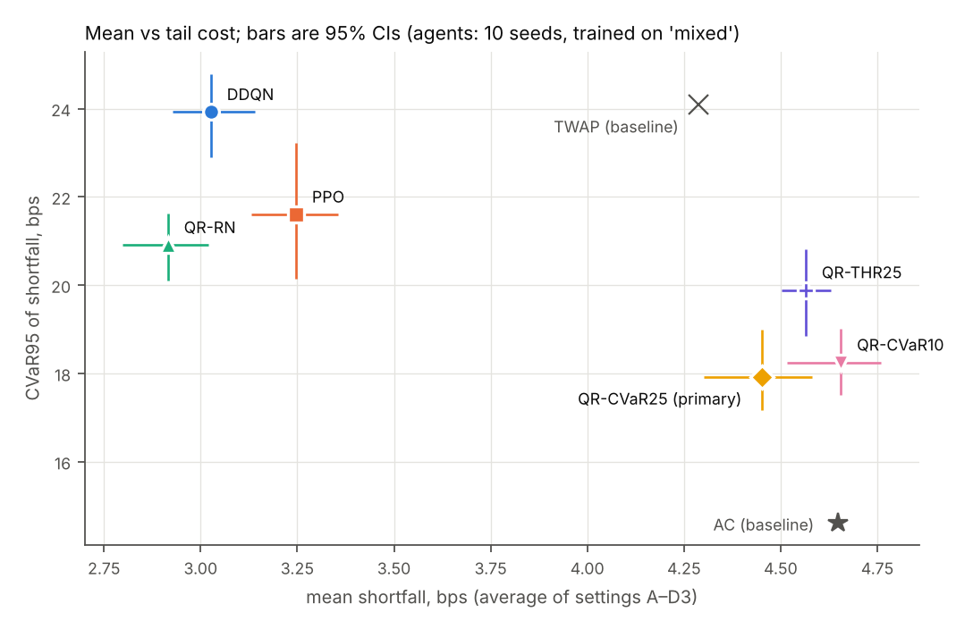
Figure 5.8: Mean shortfall against CVaR95, averaged over the six settings, with 95% intervals. TWAP and Almgren–Chriss are shown for reference.
The CVaR agent does not dominate the classical benchmarks either. The Almgren–Chriss schedule has a mean of 4.65 bps and a CVaR95 of 14.62 bps averaged over the settings, against 4.45 and 17.93 bps for the CVaR(0.25) agent: a front-loaded deterministic schedule still has the thinnest tail in this simulator. In the per-setting results (out_v2/report/per_setting.csv) the Almgren–Chriss CVaR95 is below the CVaR(0.25) agent's in every one of the six settings. Lowering α to 0.1 changed CVaR95 by +0.32 [−0.50, +1.24] bps relative to α = 0.25.

5.12.4 Mechanism: the Forced Sweep
Acting on the lower tail removes the forced sweep. DDQN left 8.4% of the order to the market order at T on average, PPO 3.3% and the CVaR(0.25) agent 0.4%. To do so, the CVaR agent switched from passive to marketable orders (limit-order share 77% for DDQN, 20% for CVaR(0.25)) and front-loaded: at the D2 shock it held 2% of the order, against 19% for DDQN and 10% for PPO. This is the risk-averse behaviour Almgren–Chriss predicts, and paying the spread on more of the order is where the extra mean cost comes from. The tail is where the sweep lands: in DDQN's worst 5% of episodes the forced order sold 46% of X, against 6% in its other episodes, and the episode-level correlation between the forced share and the shortfall was 0.83. For the CVaR(0.25) agent the same shares were 7% and 0.1%.
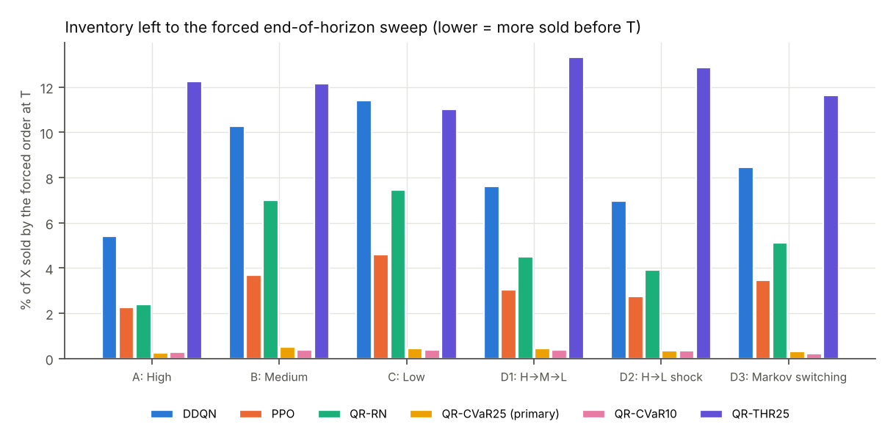
Figure 5.9: Share of the order sold by the forced market order at T, by setting and agent.
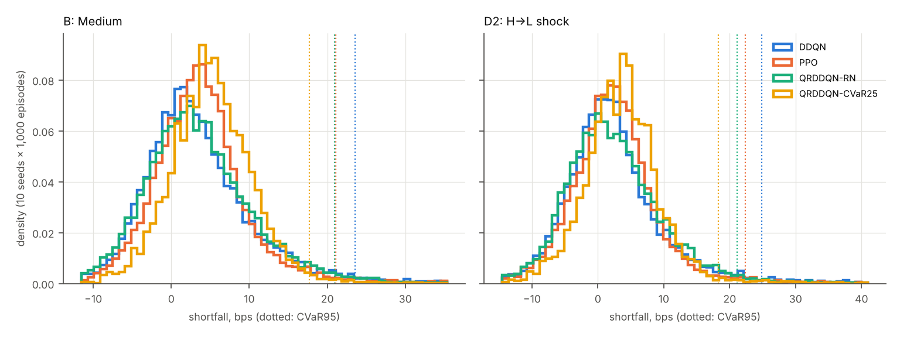
Figure 5.10: Distribution of shortfall in settings B and D2 (10 seeds × 1,000 episodes per agent); dotted lines mark each agent's CVaR95.

5.12.5 What Learning a Distribution Adds
The risk-neutral QR-DDQN, which isolates the effect of learning a distribution, matched DDQN's mean (−0.11 [−0.26, +0.03] bps) with a lower CVaR95 (−3.01 [−4.17, −1.65] bps). That arm's tuning, however, selected four times as many gradient updates as DDQN (train_freq 1 instead of 4), so the comparison is confounded. An exploratory control, not pre-registered, re-ran it with DDQN's update rate on the same seeds: the tail difference to DDQN shrank to −0.91 [−1.98, +0.14] bps and the mean difference was +0.11 [−0.05, +0.29] bps. At equal hyperparameters, the CVaR criterion alone moved CVaR95 by −5.09 [−6.32, −3.86] bps and the mean by +1.31 [+1.15, +1.45] bps. The tail reduction therefore comes from the risk criterion, not from learning a distribution; the extra updates are a separate, untested explanation for the first arm's gain.
The threshold rule, the method that targets static CVaR, did not beat the simpler CVaR-greedy rule: its CVaR95 differed by +1.96 [+0.57, +3.22] bps (Holm-adjusted p = 0.47), it left 12.2% of the order to the sweep, and its objective was the worst of the QR arms. We do not have an explanation we could test; a likely factor is that the learned quantiles that set its threshold are miscalibrated. At t = 0 in setting B, the CVaR(0.25) agent's learned lower-quartile mean of the return was −11.35 bps against −13.68 bps realised, so the learned distribution understates the tail, as Prasad (2026) reports for distributional agents in games.
Across the three simulator variants of Section 5.8 (faster resilience, 0.5 s latency, three times the fees; settings B and D2, 500 episodes), the CVaR(0.25) agent's CVaR95 change against DDQN ranged from −6.16 to −5.67 bps and its mean change from +1.35 to +1.49 bps, so the trade-off holds under each (out_v2/report/sensitivity.csv).

5.12.6 Answer and Limitations
The open question of Section 5.11 was whether the DDQN/PPO tail gap is algorithmic or caused by the setup. Within one value-based agent, changing only the action-selection criterion moved the forced-sweep share and CVaR95 by more than the DDQN–PPO gap, so the tail is governed by how risk-averse the policy is, not by value-based versus policy-gradient learning as such. The trade-off itself did not go away: both CVaR-greedy agents and the threshold agent cut the tail and paid for it in mean shortfall. The one arm that cut the tail at no mean cost, the risk-neutral QR-DDQN, lost most of that gain at DDQN's update rate.
- One stock and one day, in a simulator whose volatility is 14–37% too high (Section 5.1); tail estimates at the 95% level rest on 50 episodes per run.
- Ten seeds per arm and four tuning configurations per tuned arm; α and K were fixed, not tuned.
- CVaR-greedy selection is a heuristic for static CVaR; the threshold rule that targets it was weaker here, possibly because its learned quantiles understate the tail.
- The risk-neutral QR-DDQN control at DDQN's update rate was added after the main results and is exploratory.
- The objective's λ′ was not changed; a risk-averse DDQN with a larger λ′ is the obvious missing comparator and is left for the next phase.

References added in this section
Bäuerle, N. and Ott, J. (2011). Markov decision processes with average-value-at-risk criteria. Mathematical Methods of Operations Research, 74(3), 361–379.
Dabney, W., Rowland, M., Bellemare, M. G. and Munos, R. (2018). Distributional reinforcement learning with quantile regression. AAAI 2018. arXiv:1710.10044.
Espana, T., Hafsi, Y., Lillo, F. and Vittori, E. (2025). Reinforcement learning in queue-reactive models: application to optimal execution. arXiv:2511.15262.
Lim, S. H. and Malik, I. (2022). Distributional reinforcement learning for risk-sensitive policies. Advances in Neural Information Processing Systems 35 (NeurIPS 2022).
Min, S., Moallemi, C. C. and Maglaras, C. (2022). Risk-sensitive optimal execution via a conditional value-at-risk objective. Working paper, Columbia University.
Prasad, H. (2026). Auditing the risk claims of distributional reinforcement learning. arXiv:2607.11607.
Schnaubelt, M. (2022). Deep reinforcement learning for the optimal placement of cryptocurrency limit orders. European Journal of Operational Research, 296(3), 993–1006.

