**Ansible Assignment - 1**

● Setup Ansible cluster with 3 nodes

● On slave1 install java

● On slave 2 install mysql-server

Creating 3 Nodes:

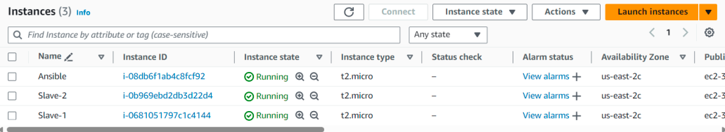

Making SSH connection to slave:

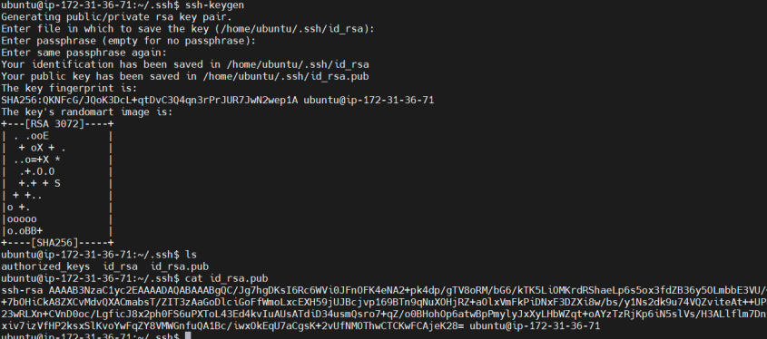

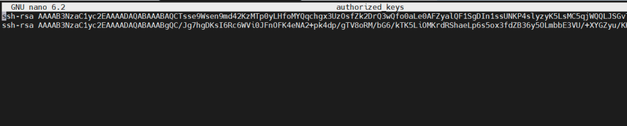

Installing Ansible on Master:

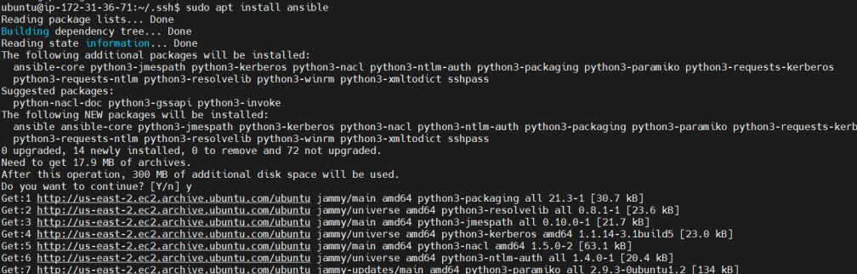

Adding Slave IP’s on Master Host:

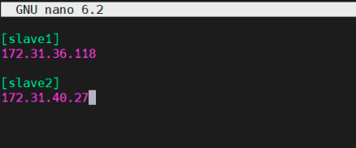

Pinging to all Slave nodes:

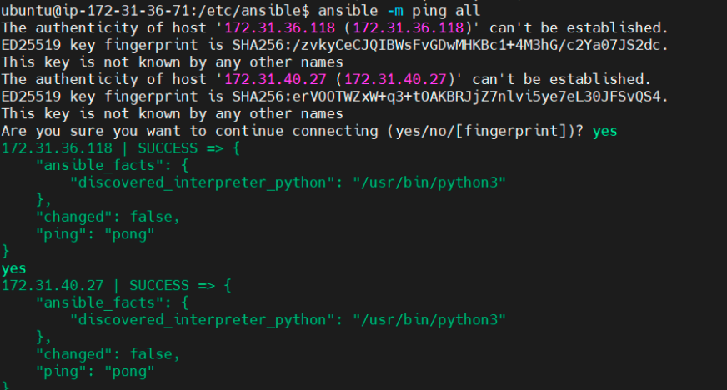

Creating playbook.yml

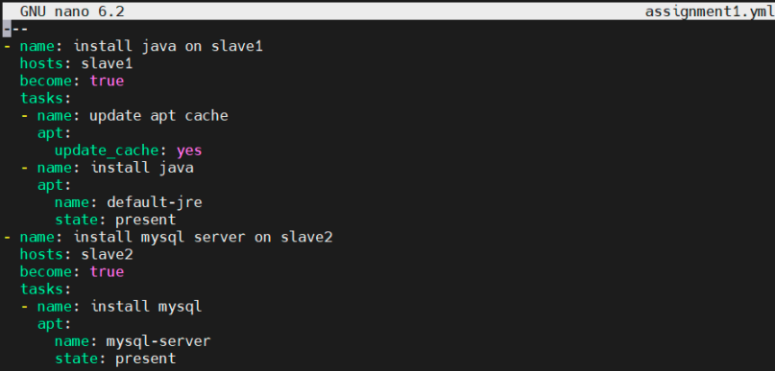

Executing yaml file:

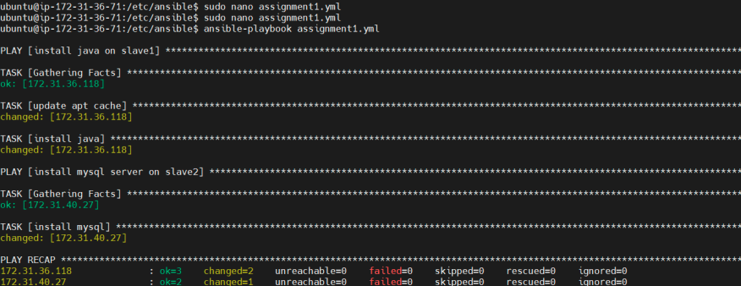

Installing Java on Slave node 1:

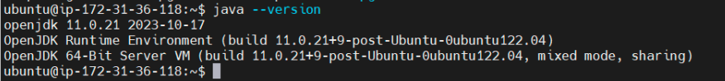

Installing Mysql on Slave node 2:



**Ansible Assignment - 2**

● Create a script which can add text “This text has been added by custom script” to /tmp.1.txt

● Run this script using Ansible on all the hosts

Creating playbook.yml

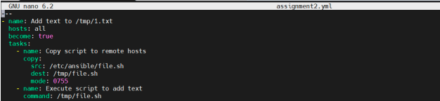

Creating .sh file:

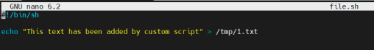

Executing yaml file:

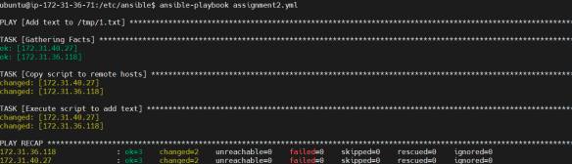

Script got added to path /tmp on slave 1 & 2:

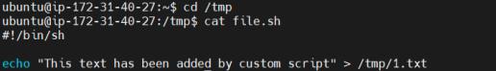



**Ansible Assignment - 3**

● Create 2 Ansible Roles

● Install apache2 on slave1 using one role and nginx on slave2 using the other role

Adding IP on Host:



Pinging Slave nodes:

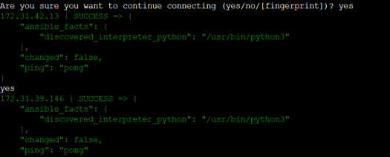

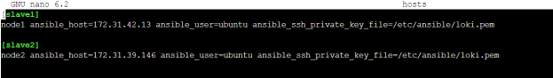

Installing tree and downloading Ansible apache2 galaxy

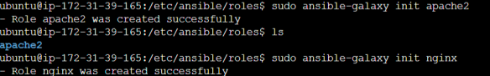

Adding files in main.yml :



Creating install.yml > /etc/ansible/roles/apache2/tasks/

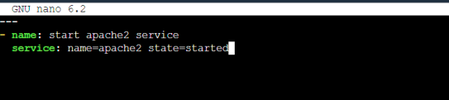

Creating service.yml > /etc/ansible/roles/apache2/tasks/

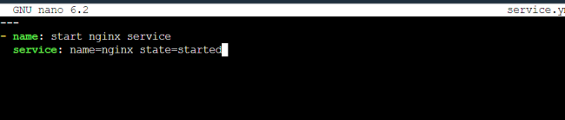

Creating install.yml for nginx > /etc/ansible/roles/nginx/tasks/

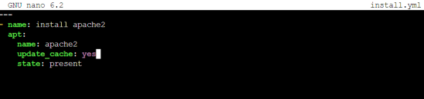

Creating service.yml for nginx > /etc/ansible/roles/nginx/tasks/



Creating playbook.yml

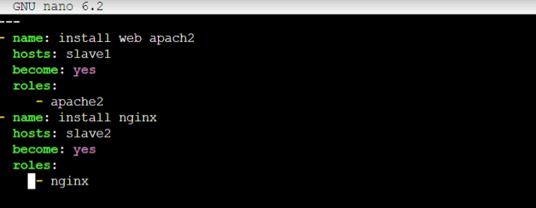

Adding port:

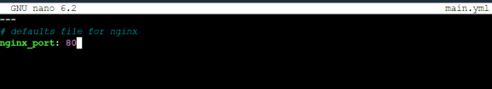

Installation of apache2 on slave1 and Nginx on slave2:

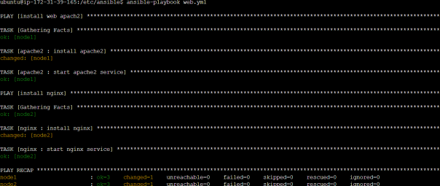

Apache and nginx Service running on web:

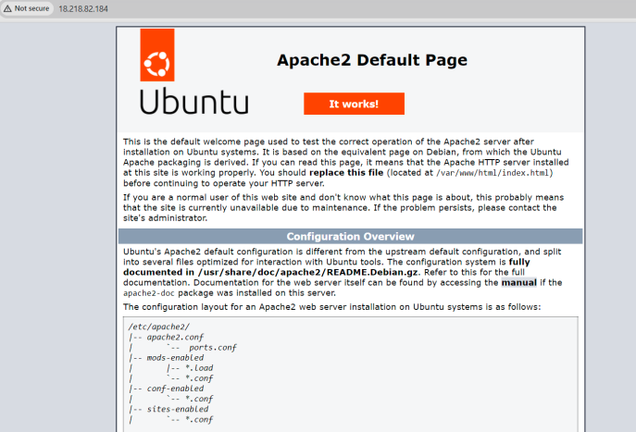



**Ansible Assignment - 4**

● Use the previous deployment of ansible cluster

● Configure the files folder in the role with index.html which should be replaced with the original index.html

Adding files inside main.yml



Creating install.yml file

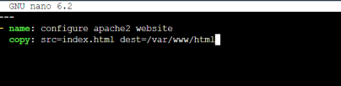

Creating html file



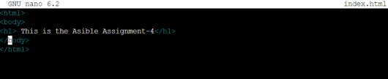

Creating playbook.yml file

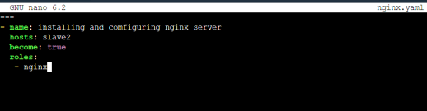

Executing yaml:

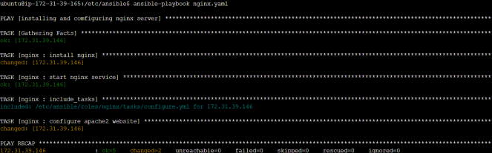

The execution was successful. Nginx custom website successfully running:



**Ansible Assignment - 5**

● Create a new deployment of ansible cluster of 5 nodes

● Label 2 nodes as test and other 2 as prod

● Install java on test nodes

● Install mysql-server on prod nodes

Creating 5 nodes 1 master and 4 slaves:

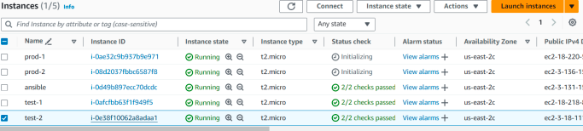

Grouping the salves as test and prod:

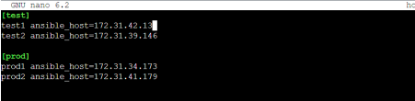

Making ssh connection:

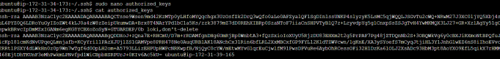

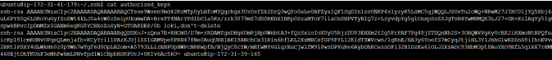

Pinging successful to test

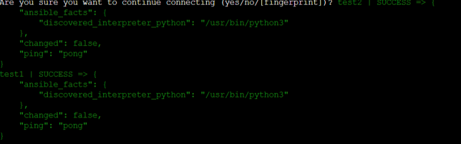

Pinging successful to prod:



Installing playbook.yml

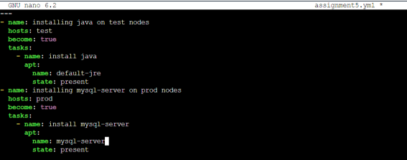

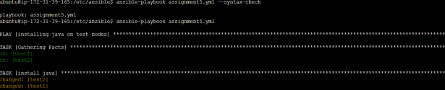

Installation of java to test was completed.

Installation of mysql-server to prod was completed.

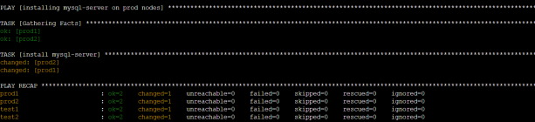

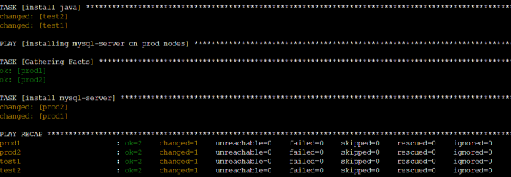

Mysql is running on prod2

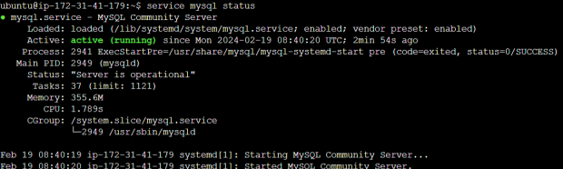

Mysql is running on prod-1

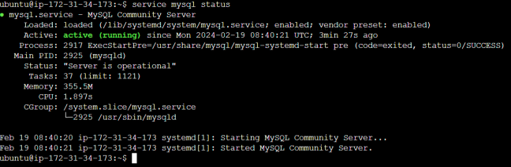

Java installed on test





**Ansible CASE STUDY**

You are a Devops Engineer and the organization you are working on needs to set up two configuration management server groups. One for Apache another for Nginx. Being a Devops Engineer it is your task to deal with this configuration management issue. Let us see the tasks that you need to perform using Ansible.

1. Create two Server Groups. One for Apache and another for Nginx.

2. Push two html files with their server information.

Make sure that you don’t forget to start the services once the installation is done. Also send post installation messages for both the server groups. Using Ansible Roles accomplish the above the tasks. Also, once the Apache server configuration is done you need to install Java on that server group using ansible role in a playbook.

Created 3 instance 1 master and 2 nodes:



Making ssh connection to nodes:







Adding node IP on master ansible Hosts:

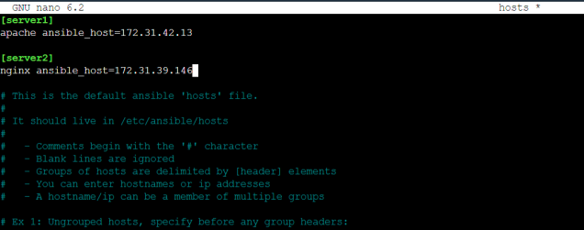

Pinging all the nodes—its successful

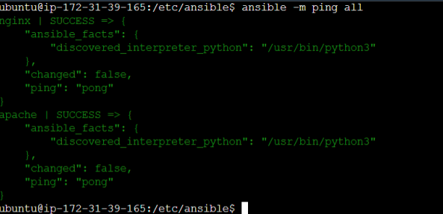

---sudo apt install tree

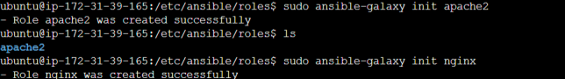

Installing tree:



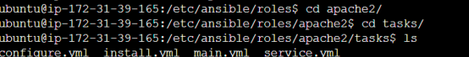

Apache2 and java installation setup:

Adding files to main.yml



Creating install.yml

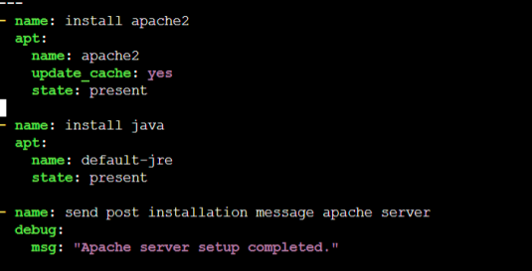

Creating service.yml

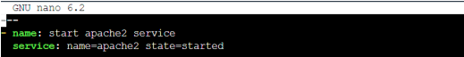

Creating Configure.yml

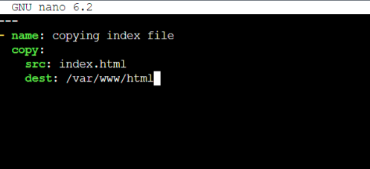

Inside files creating index.html



Creating index.html

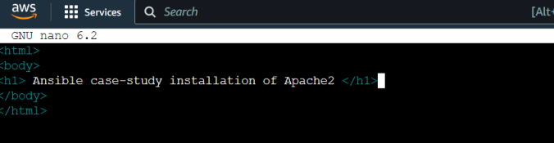

Nginx installation setup:



Adding files to main.yml in (nginx)



Creating install.yml

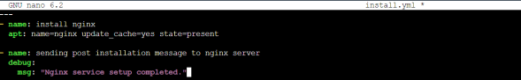

Creating Service.yml

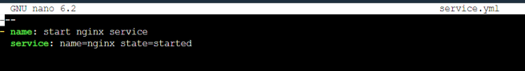

Creating Configure.yml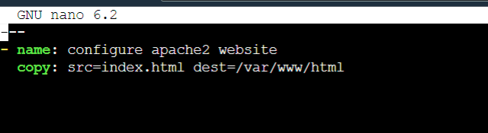



Creating index.html

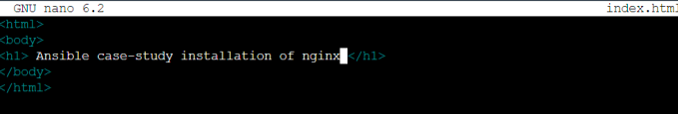

Creating Playbook.yml file to execute all

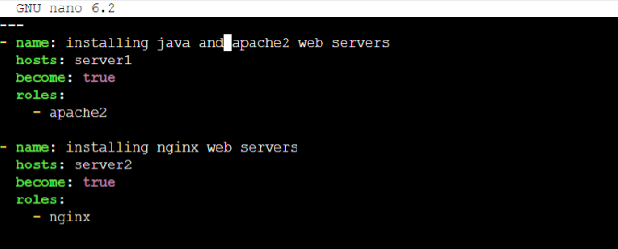

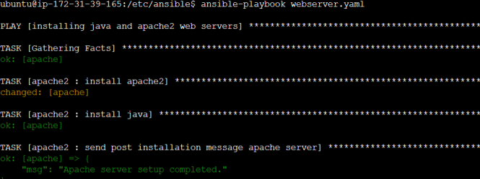

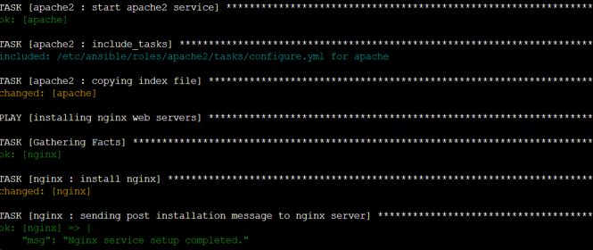

Apache and java installed on server1.

Nginx installed on server2.

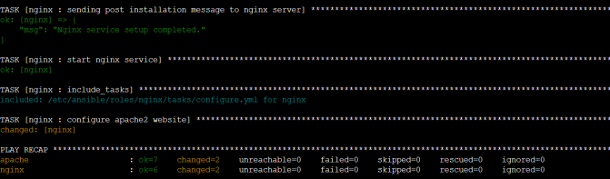

Viewing Apache2 custom website



Java installation completed on server 1

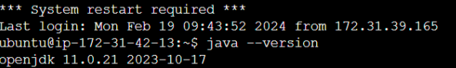

Apache2 its running on server-1

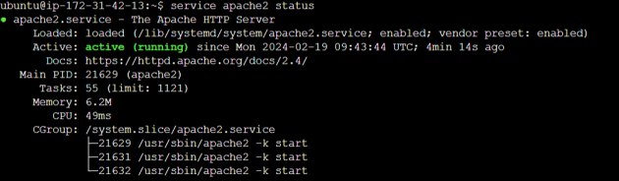

Viewing Nginx custome website



Nginx is running on server2

