**Docker – I Assignment – 1**

● Pull ubuntu container

● Run this container, and map port 80 on the local

● Install apache2 on this container

● Check if you are able to access the apache page on your browser.

Creating directory and pulling ubuntu image :

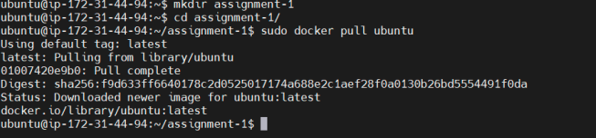

Running container on port 80:

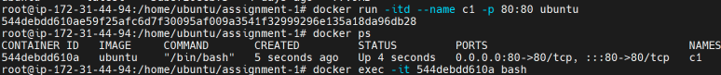

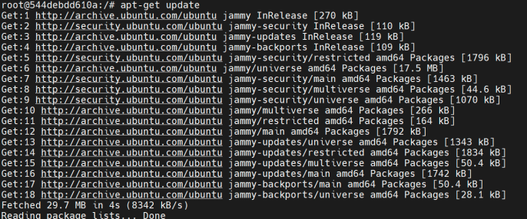

Installing Apache on Ubuntu Container:

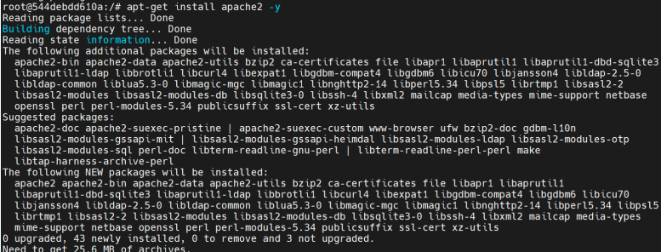

Status check and starting of Apache:

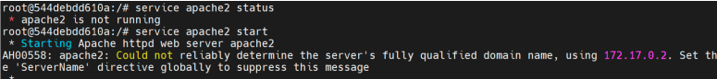

Apache running on port-80:

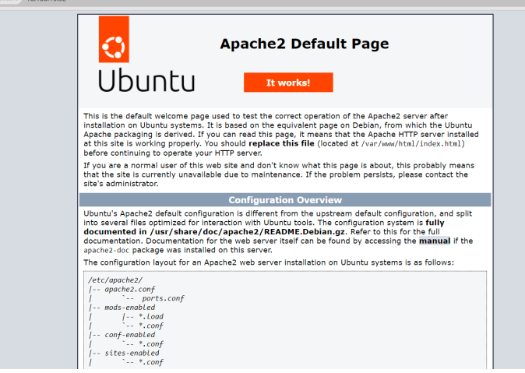

**Docker I Assignment – 2**

● Save the image created in Assignment 1 as a Docker image

● Launch container from this new image and map the port to 81

● Go inside the container and start the apache2 service

● Check if you are able to access it on the browser

Creating image using previous container:

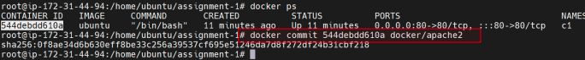

Running Container on port 81:

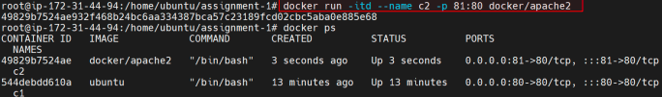

Checking apache2 and starting the service:

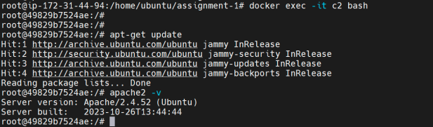

Checking port 81 for Apache service:

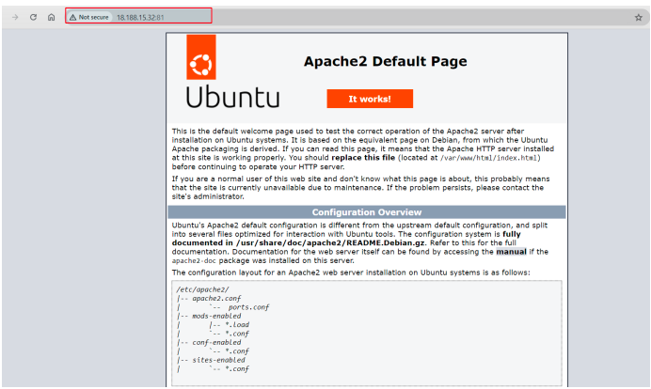

**Docker I Assignment – 3**

● Use the saved image in the previous assignment

● Upload this image on Dockerhub

● On a separate machine pull this dockerhub image, and launch it on port 80

● Start the apache2 service

● Verify if you are able to see the apache2 service

Logging in to DockerHub and pushing the image:

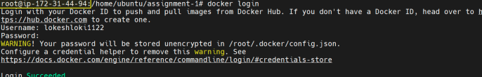

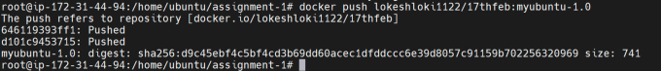

Using Different machine to pull the image from Dockerhub:

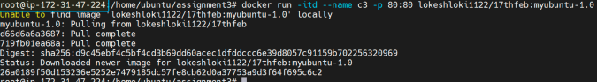

Running the container and staring the Apache service:

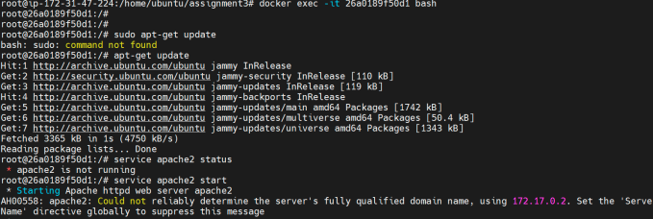

Verifying port 80:

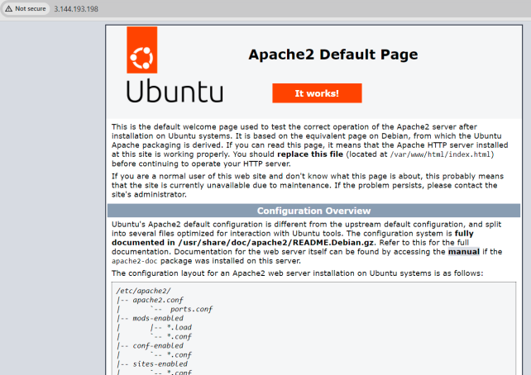

**Docker I Assignment – 4**

Create a dockerfile with the following specs:

● Ubuntu container

● Apache2 installed

● Apache2 should automatically run once the container starts

Dockerfile content:

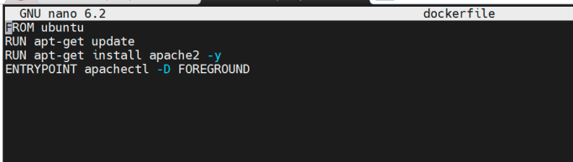

Creating Docker image: (**docker build .-t docker4**)

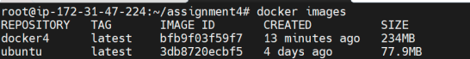

Running container on port 80:

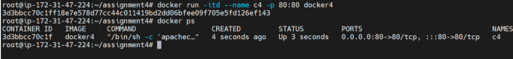

Apache running @ port 80

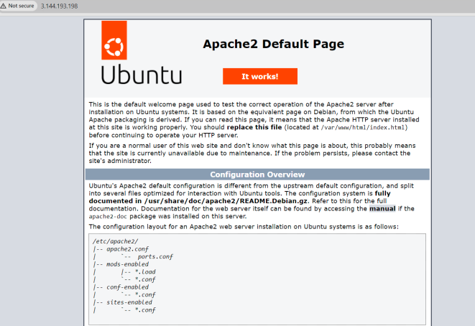

**Docker I Assignment – 5**

● Create a sample HTML file

● Use the Dockerfile from the previous task

● Replace this sample HTML file inside the docker container with the default page

Creating index.html

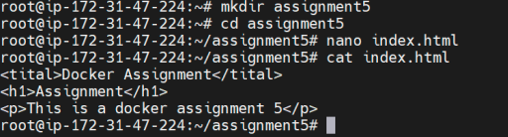

Running same container from previous Assignment with html file created above.



On port 80 able to see the content of html:

