## **Tasks**

### **Exploratory data analysis (EDA)**

(Please refer to the **ipynb** format file)

1) Total row count

2) Data Type of columns

3) Check for missing values

4) Unique value counts

5) Top-selling products

6) Revenue by product category

7) Monthly sales trend

8) Sales by region

9) Repeat vs One-time Customers

### **SQL Queries**

**1)Customer Repeat Purchases:** Identify pairs of orders placed by the same customer within 30 days of each other. Return the customer_id, order_id of the first order, order_id of the second order, and the date difference in days.

**Solution**:

SELECT *

FROM

( SELECT

customer_id,

order_id AS first_order_id,

LEAD(order_id) OVER (PARTITION BY customer_id ORDER BY order_date) AS second_order_id,

DATE_DIFF('day', order_date, LEAD(order_date) OVER (PARTITION BY customer_id ORDER BY order_date)) AS day_difference

FROM ecommerce_sales ) t

WHERE day_difference <= 30

order by customer_id

**Explanation** : This outer query shows only the rows where a customer placed two orders within 30 days. It uses a subquery called t to find and compare those orders.

SubqueryExplanation:

**customer_id**: Picks the customer’s ID to group their orders.

**order_id AS first_order_id**: The current order made by the customer.

**second_order_id** : Finds the next order made by the same customer.

**day_difference** : Calculates how many days passed between the current order and the next one.

This subquery creates a list showing each customer’s order and how soon they ordered again.

**Output:**

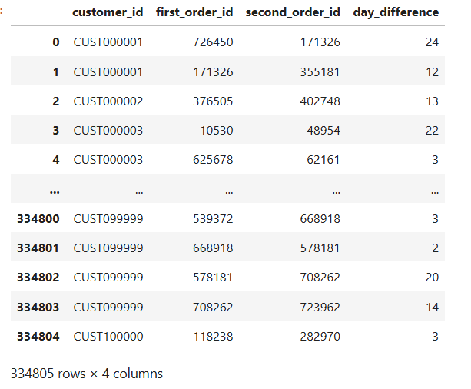

**2)Products with Similar Prices**: Find pairs of products in the same category where the unit_price differs by less than 10% (i.e., |price1 - price2| / price1 < 0.1). Return the product_id and unit_price for both products, and the percentage price difference.

**Solution**:

WITH ordered_products AS (

SELECT

product_id,

product_category,

unit_price,

LEAD(product_id) OVER (PARTITION BY product_category ORDER BY unit_price) AS next_product,

LEAD(unit_price) OVER (PARTITION BY product_category ORDER BY unit_price) AS next_price

FROM ecommerce_sales

)

SELECT

product_category,

product_id AS product_id_1,

next_product AS product_id_2,

unit_price AS unit_price_1,

next_price AS unit_price_2,

ABS(unit_price - next_price) / unit_price AS price_diff_ratio

FROM ordered_products

WHERE ABS(unit_price - next_price) / unit_price < 0.1

order by product_category

**Explanation** :

Common Table Expression (CTE): ordered_products

* The CTE pulls data from the ecommerce_sales table.
* It groups (partitions) the products by product_category.
* Within each category, products are sorted by unit_price.
* The LEAD() function is used to get:
  + The next product's ID (next_product)
  + The next product's price (next_price)

This helps create pairs of products that are next to each other in price within the same category.

Main Query:

* Selects data from the ordered_products CTE.
* Gets each product’s category, ID, and price, along with the next product’s ID and price.
* Calculates how different the prices are using:  
  **(absolute price difference) ÷ (current product’s price)**
* Keeps only the product pairs where the price difference is less than 10%.
* Sorts the final results by product_category.

**Output** :

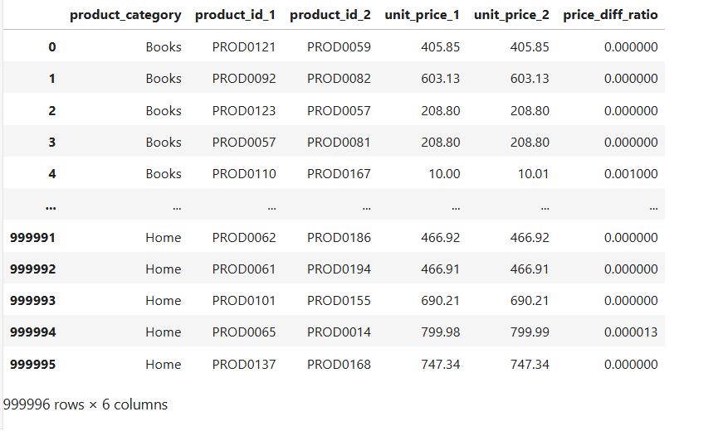

**3)Top Customers by Region**: For each region, identify the top 3 customers based on total sales (total_price). Return the region, customer_id, total sales, and their rank within the region.

**Solution :**

select * from (

SELECT

region,

customer_id,

SUM(total_price) AS total_sales,

DENSE_RANK() OVER (PARTITION BY region ORDER BY SUM(total_price) DESC) AS sales_rank

FROM ecommerce_sales

GROUP BY region, customer_id )

where sales_rank <= 3

order by region , sales_rank

**Explanation** :

* **FROM**: Reads data from the ecommerce_sales table.
* **GROUP BY:** Groups the data by region and customer_id.
* **SUM**: Calculates total sales (SUM(total_price)) for each customer in each region.
* **DENSE_RANK():** Ranks customers within each region based on their total sales (highest first).
* **Subquery output:** Creates a temporary table with columns: region, customer_id, total_sales, and sales_rank.
* **WHERE:** Keeps only the top 3 customers per region (sales_rank <= 3).
* **ORDER BY:** Sorts the final results by region and sales_rank.
* **SELECT:** Returns all columns from the filtered, sorted data.

**Output :**

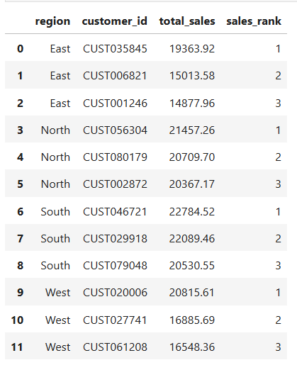

**4)Running Total Sales by Category**: Calculate the running total of total_price for each product_category over time, ordered by order_date. Return product_category, order_date, total_price, and the running total.

**Solution :**

**1st Approach:** Add up total_price by product_category and order_date, then calculate the running total each day (Please refer output section)

WITH DailySales AS (

SELECT

product_category,

order_date,

SUM(total_price) AS daily_total

FROM

ecommerce_sales

GROUP BY

product_category,

order_date

)

SELECT

product_category,

order_date,

daily_total,

SUM(daily_total) OVER (

PARTITION BY product_category

ORDER BY order_date

ROWS BETWEEN UNBOUNDED PRECEDING AND CURRENT ROW

) AS running_total

FROM

DailySales

ORDER BY

product_category,

order_date

**Explaination :**

* **CTE Execution (DailySales)**:  
  Runs first, grouping data by product_category and order_date, and calculates daily_total as the sum of total_price.
* **FROM (outer query)**:  
  Reads from the DailySales CTE result.
* **Window Function**:  
  Calculates a running total of daily_total for each category, ordered by date.
* **Window Frame**:  
  Adds up all values from the first date to the current date in the same category.
* **SELECT**:  
  Returns product_category, order_date, daily_total, and running_total.
* **ORDER BY**:  
  Sorts the final result by product_category and order_date.

**OUTPUT :**

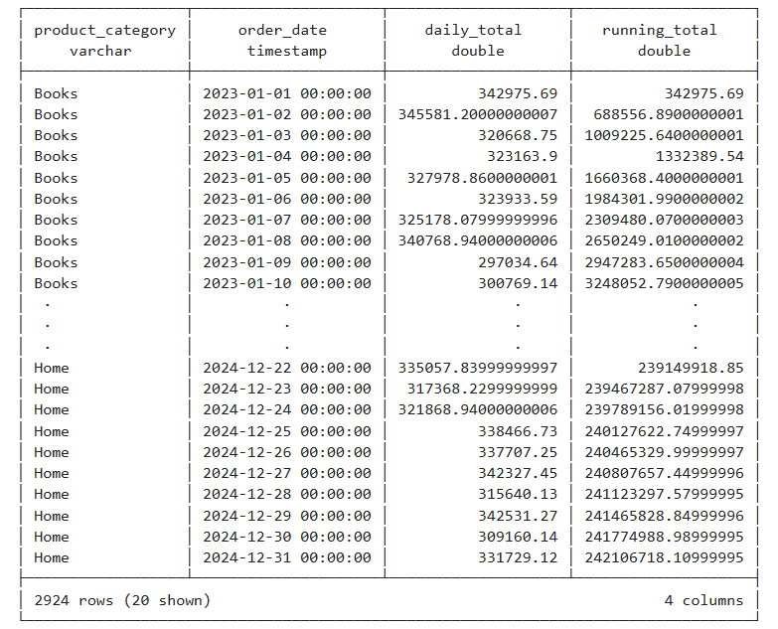

**2nd Approach**: Running total per individual order (including multiple orders on the same day)

SELECT

product_category,

order_date,

total_price,

SUM(total_price) OVER (

PARTITION BY product_category

ORDER BY order_date, total_price

ROWS BETWEEN UNBOUNDED PRECEDING AND CURRENT ROW

) AS running_total

FROM

ecommerce_sales

ORDER BY

product_category,

order_date,

running_total

**Explaination :**

* **FROM**: Gets all rows from the ecommerce_sales table.
* **Window Function (SUM OVER):**
  + Calculates a running total of total_price.
  + Groups data by product_category.
  + Sorts each group by order_date and total_price.
  + Adds up prices from the start to the current row.
* **SELECT**: Returns product_category, order_date, total_price, and the running_total.
* **ORDER** **BY**: Sorts the final output by product_category, order_date, and running_total.

