**PowerPulse: Household Energy UsageForecast**

**Skills Takeaway From This Project**

* Data Preprocessing
* Feature Engineering
* Regression Modeling
* Evaluation Metrics

**Domain**

Energy and Utilities

**Data Understanding and Exploration**

* Load and explore the dataset to understand its structure, variables, and quality.
* Performing exploratory data analysis (EDA) to identify patterns, correlations, and outliers.

The figure shows the correlations:

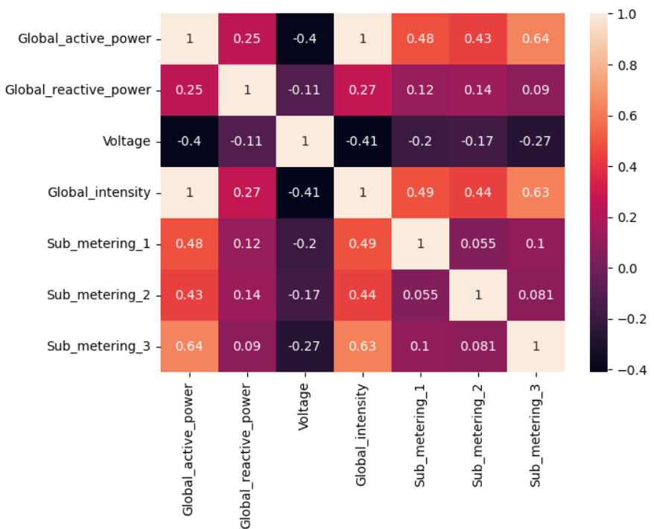

The graph shows the outliers in the target column:

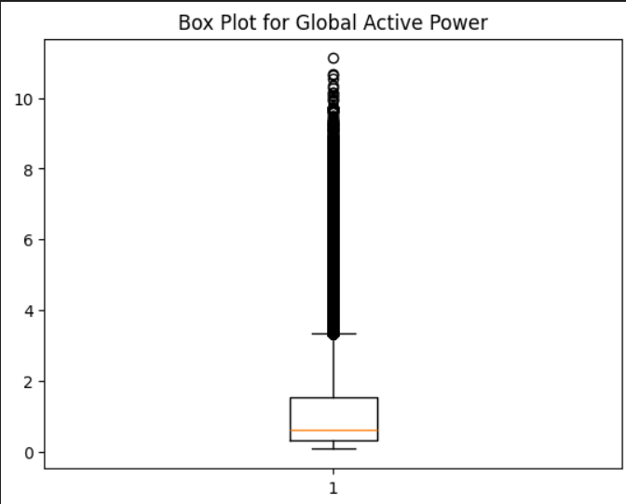

**Data Preprocessing**

* Handle missing data points.
* Scaling the data for better model performance.

**Model Selection and Training**

* Splitting the dataset into training and testing sets.
* Train regression models such as Linear Regression, Decision Tree , Random Forest and Gradient Boosting.

**Model Evaluation**

* Evaluating models using appropriate metrics like RMSE, MAE, R-squared.
* Comparing model performance and selecting the best-performing model.