

**AMC ENGINEERING COLLEGE,**

**DEPARTMENT OF MASTER OF COMPUTER APPLICATIONS**

# **HANGMAN DEATH WORLD**

**REPORT FOR ASSIGNMENT 1**

**SUBMITTED BY**

**SANJAY M**

**1AM24MC091**

**UNDER THE GUIDANCE**

**OF**

**MANASA S**

**ASSISTANT PROFESSOR**

**DEPARTMENT OF MCA**

**AMCEC**

**Index**

|  |  |  |
| --- | --- | --- |
| **Sl. No** | **Title** | **Page No** |
| **1.** | **Introduction** | **1** |
| **2.** | **Objective** | **2** |
| **3.** | **Tools And Technologies** | **3** |
| **4.** | **Design and Implementation** | **4** |
| **5.** | **Snapshots** | **5-6** |
| **6.** | **Conclusion** | **7** |

1. **Introduction**

The Hangman Death Game is a digital version of the classic word-guessing game "Hangman", implemented using web technologies. This game challenges users to guess a hidden word letter by letter while visually depicting the consequences of wrong guesses. The main objective is to complete the word before the entire hangman figure is drawn, combining both education and entertainment in a chilling death-themed visual presentation.

This game offers a spooky atmosphere with dark-themed visuals and intuitive gameplay, ideal for practicing vocabulary in an engaging format.

1. **Objectives**

**The primary objectives of this project are:**

* To recreate the classic Hangman game using HTML, CSS, and JavaScript.
* To deliver an interactive user experience with visual feedback through canvas-based hangman drawings.
* To improve logic-building and DOM manipulation skills in JavaScript.
* To provide a restartable and user-friendly interface that encourages repeated gameplay.
* To demonstrate web development concepts including event handling, canvas drawing, dynamic content generation, and user interaction design.

1. **Tools and Technologies**

• **HTML5:** Used for structuring the web pages (home and game page).

• **CSS3:** For styling the UI, background visuals, buttons, and game components.

• **JavaScript (Vanilla JS):** Handles game logic such as:

* Random word generation.
* Button interactivity and event handling.
* Drawing the hangman figure dynamically using the <canvas> element.
* Updating the word display and checking game completion.

• **Canvas API:** Used to visually represent the hangman being drawn.

• **Image Assets:** Background images enhance the immersive dark theme.

• **Browser Environment:** No backend or server-side logic is used, making it a lightweight and self-contained project.

1. **Design and Implementation**

**4.1. UI/UX Design**

* Home Page (index.html):
  + Displays the game title and a large red "Start Game" button.
  + Dark, immersive background image to match the "death" theme.
  + Centered content for clean visual balance.
* Game Page (hangman.html):
  + A <canvas> element displays the hangman figure.
  + An area shows the current word in progress using underscores.
  + A dynamic keyboard of letter buttons allows user interaction.
  + Feedback messages inform players of win/loss status.
  + Restart and Home buttons appear conditionally based on game outcome.

**4.2. Game Logic**

* Word Selection: A word is randomly chosen from a predefined list.
* Letter Input: When a user clicks a letter:
  + It is checked against the selected word.
  + If correct, the letter is revealed in the appropriate positions.
  + If incorrect, a body part is drawn on the canvas.
* Canvas Drawing: Progressive drawing of the hangman for each wrong guess.
* End Conditions:
  + Victory: All letters guessed correctly.
  + Defeat: All hangman parts drawn.
* Restart/Home Controls: Once the game ends, users can restart or return to the homepage.

**4.3. CSS Enhancements**

* Background and overlay filters create a dark, horror-like effect.
* Button hover animations and disabled states enhance interactivity.
* Layout responsiveness ensures the game looks good on various devices.

1. **Snapshots**

* **Home page:**

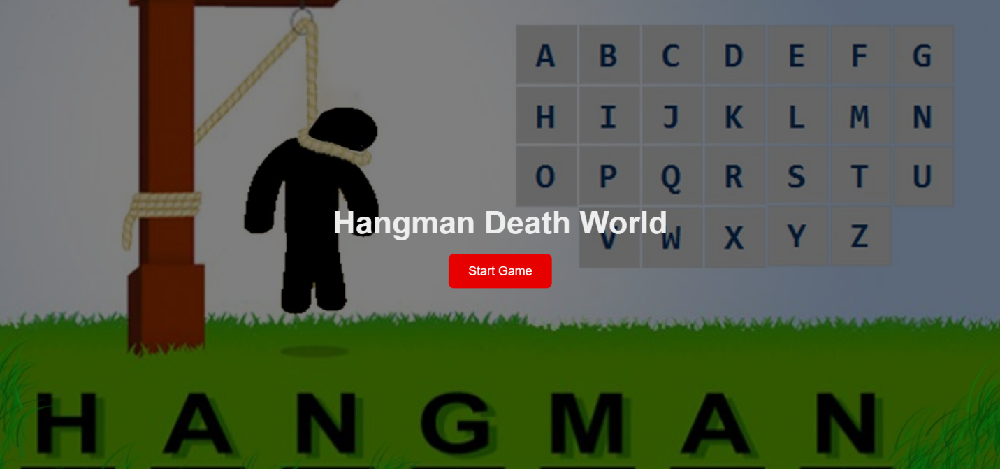

* **Starting page:**

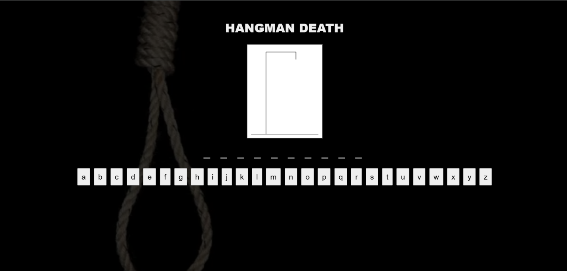

* 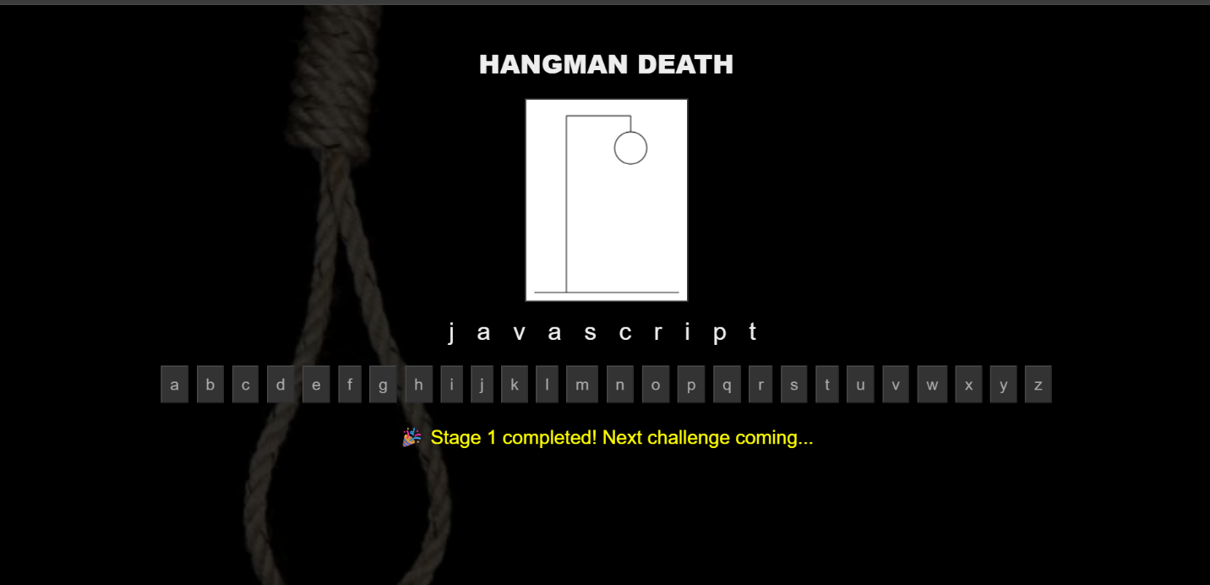**Game Completion page:**
* **If game loose:**

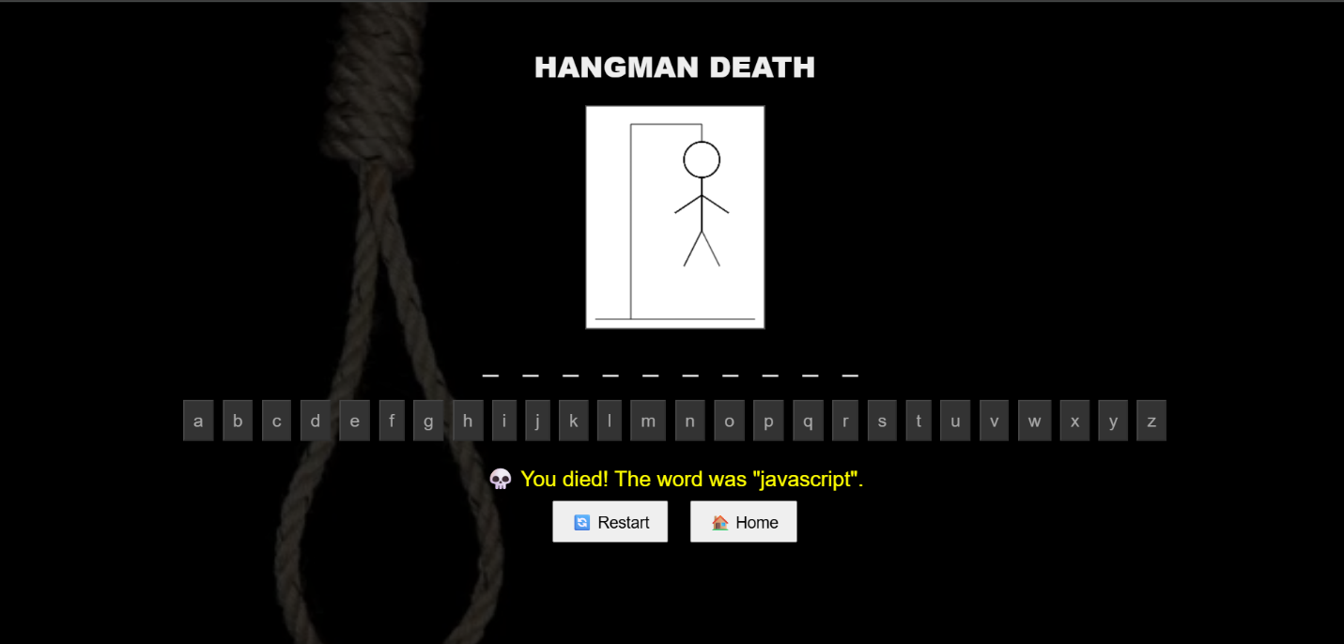

1. **Conclusion**

The *Hangman Death Game* is a successful recreation of a timeless game with a unique theme and modern interface. It combines educational content with game mechanics and offers an intuitive user experience. Through this project, several essential web development concepts were applied and reinforced, including DOM manipulation, canvas-based graphics, conditional UI rendering, and responsive styling.

This project lays a solid foundation for further enhancements such as:

* Backend integration to save scores.
* Word categories or difficulty levels.
* Timer-based challenges or multiplayer mode.