|  |  |
| --- | --- |
| Gender | Count |
| Female | 10 |
| Male | 7 |
| Other | 9 |
| B | 6 |

**Pie Chart**

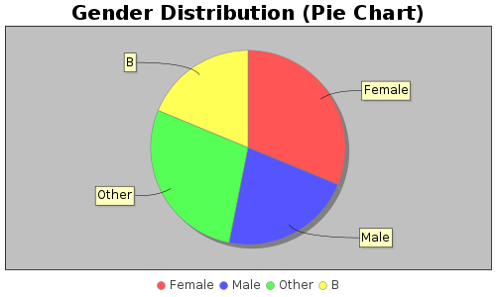

**Bar Chart**

