**Covid-19 Pandemic Analysis**

**A PROJECT REPORT**

***Submitted by***

# Sanju (22BCA10430)

***in partial fulfillment for the award of the degree of***

**BACHELOR OF COMPUTER APPLICATIONS**

# IN

UNIVERSITY INSTITUTE OF COMPUTING



**CHANDIGARH UNIVERSITY**

April, 2025



# BONAFIDE CERTIFICATE

Certified that this project report **“Covid-19 Pandemic analysis”** is the bonafide work of “**Sanju”** who carried out the project work under my/our supervision.

|  |  |
| --- | --- |
| **SIGNATURE**  Dr. Kavita Gupta  Head of Department  UIC - BCA | **SIGNATURE**  Mr. Gagandeep Chawala  Project Supervisor  UIC - BCA |

Submitted for the project viva-voce examination held on

**INTERNAL EXAMINER EXTERNAL EXAMINER**

# Abstract

The COVID-19 pandemic has significantly impacted global health, economies, and daily life since its outbreak in late 2019. Understanding the progression of the virus through data analysis is essential for monitoring trends, assessing policy impacts, and guiding public health responses. This project involves the systematic analysis of COVID-19 data using Microsoft Excel to uncover meaningful insights into the spread, mortality, and recovery patterns of the virus across several countries. By utilizing various Excel tools such as pivot tables, graphs, and formulas, this analysis enables us to observe trends over time, compare data between countries, calculate mortality and recovery rates, and visualize daily new cases and deaths. The ultimate goal of this project is to transform raw data into actionable information that can inform decision-making and enhance understanding of the pandemic’s global dynamics.

# TABLE OF CONTENT

Abstract ..................................................................................................................... 03

CHAPTER 1. Introduction ....................................................................................... 05

CHAPTER 2. Overview ........................................................................................... 06

CHAPTER 3. Dataset ............................................................................................... 07

CHAPTER 4. Output ............................................................................................... 08

CHAPTER 5. Conclusion ........................................................................................ 10

# Introduction

The novel coronavirus disease (COVID-19) emerged as one of the most disruptive global health crises in recent history. With its rapid spread across continents, it prompted nations to take unprecedented measures in terms of healthcare preparedness, lockdowns, and vaccination drives. As the pandemic evolved, the need for real-time data analysis and reporting became critical for tracking its impact, understanding its dynamics, and informing policy decisions.

In this project, we focus on leveraging the capabilities of Microsoft Excel to perform detailed analysis of COVID-19 data across multiple countries over a span of days. Excel, with its robust features for data visualization and computation, serves as an ideal platform for such exploratory data analysis at the beginner level. Through the application of statistical calculations, conditional formatting, and pivot tables, we aim to derive insights on infection rates, mortality, recovery, and trends.

# Overview

The project is designed to analyze daily reported COVID-19 statistics for a selected group of countries including the USA, India, Brazil, Spain, and Italy. The data spans over several consecutive days and includes metrics such as total cases, new daily cases, total deaths, new deaths, total recovered, and active cases.

Key objectives of this analysis include:

* Understanding the growth of COVID-19 cases over time
* Comparing the impact between different countries
* Calculating key ratios such as mortality and recovery rates
* Identifying peaks in infection rates
* Visualizing trends through charts and graphs

Microsoft Excel was used to process and analyze the dataset using several built-in tools such as:

* **Pivot Tables**: To summarize and group data by country and date
* **Line Charts and Bar Graphs**: To visualize the trend of daily cases and deaths
* **Formulas**: To compute derived metrics like mortality rate and recovery rate
* **Conditional Formatting**: To highlight significant spikes or drops in data

This comprehensive approach ensures a structured and visual representation of the pandemic's development and its country-specific effects.

# Dataset

The dataset used in this project is manually curated to represent realistic and illustrative COVID-19 statistics between April 1 and April 8, 2020. The dataset includes the following columns for each country on each day:

* **Date**: The calendar date of the report
* **Country**: The name of the country
* **Total Cases**: The cumulative number of confirmed cases to date
* **New Cases**: The number of new confirmed cases reported on that day
* **Total Deaths**: The cumulative number of deaths due to COVID-19
* **New Deaths**: The number of new deaths reported on that day
* **Total Recovered**: The total number of people who have recovered from the virus
* **Active Cases**: The number of active infections on that day

The dataset includes data for five countries—USA, India, Brazil, Spain, and Italy—spanning eight days. It was saved and analyzed in Excel format, with all calculations, visualizations, and reports generated within the same workbook.

Derived columns were added using formulas to calculate:

* **Mortality Rate = Total Deaths / Total Cases**
* **Recovery Rate = Total Recovered / Total Cases**

These derived metrics help in assessing the severity and effectiveness of response in each country.

# Output

The output of the analysis includes both numerical and visual results derived from the Excel dataset:

1. **Pivot Tables**:
   * Summarized total and new cases by country o Tracked daily case growth o Compared total deaths and recoveries across countries

1. **Charts**:
   * **Line Charts** to show the growth of daily new cases and deaths for each country over time. o **Bar Charts** to compare cumulative totals between countries on the final day.

1. **Derived Metrics**:
   * **Mortality Rates** varied across countries, with Italy and Spain showing higher values.
   * **Recovery Rates** were lowest in the initial days and increased gradually, reflecting healthcare capacity and reporting delays.

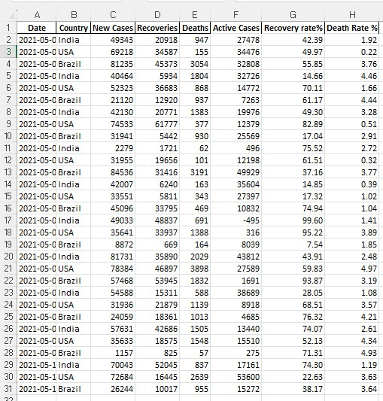

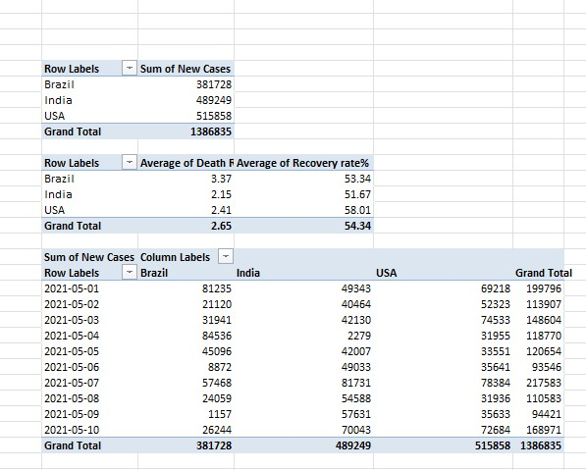

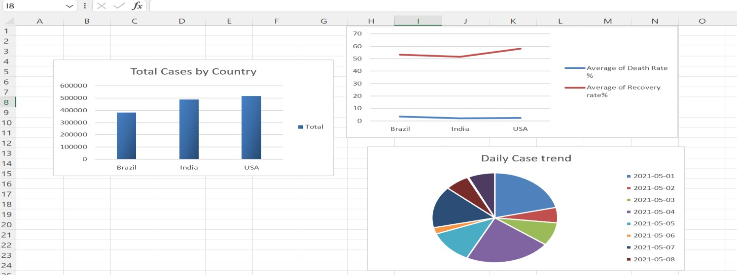

# Conclusion

The COVID-19 analysis project successfully demonstrates how Microsoft Excel can be used as a powerful tool for data analysis even with large datasets. By collecting, organizing, and analyzing pandemic-related data, we were able to gain valuable insights into how the virus spread and impacted different countries over time.

From calculating recovery and mortality rates to visualizing trends through graphs, this project highlighted the importance of data-driven approaches in understanding public health crises. While the dataset used is limited and illustrative, the methods applied can be extended to real-time data from sources like WHO or Johns Hopkins University.

Through this analysis, we not only reinforced Excel skills but also recognized how crucial data analysis is in informing decisions during global emergencies. This project stands as a foundational example of how accessible tools can contribute meaningfully to serious global issues through structured data insight.