AI Assisted Coding
Assignment 10.3
Name: Sanju Hallticket:2303A52313

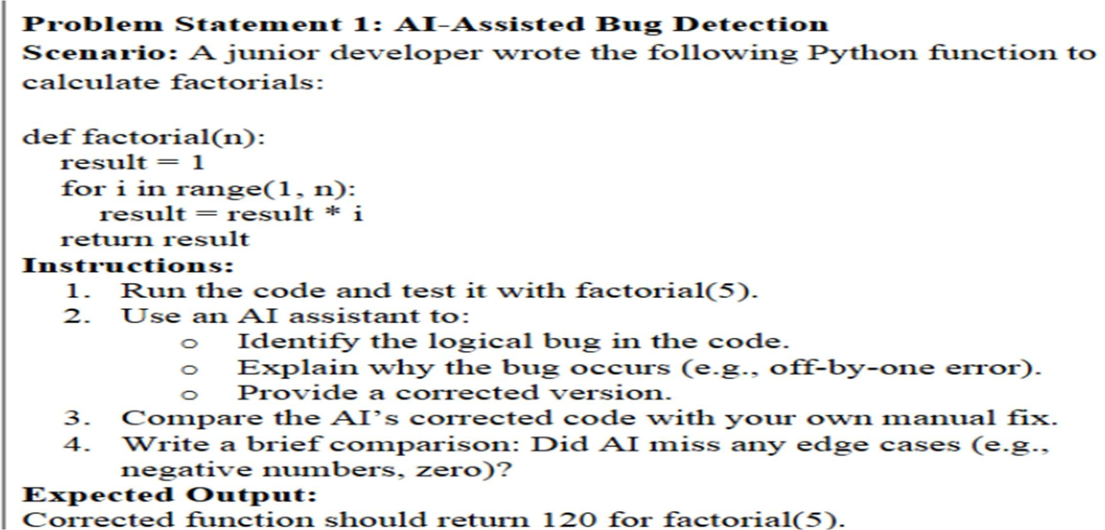
Task_01 :

Prompt:
"""assume you are a developer, debug this code to find the error and fix it def factorial(n):
result = 1
for i in range(1, n):
result = result * i return result
also explain why the error occurs and how we correct it and test the corrected code with factorial(5)
"""
Output:

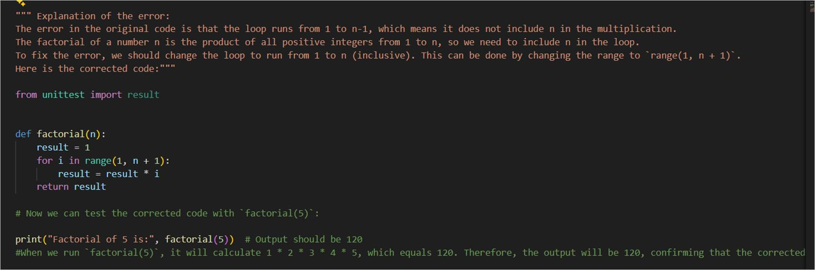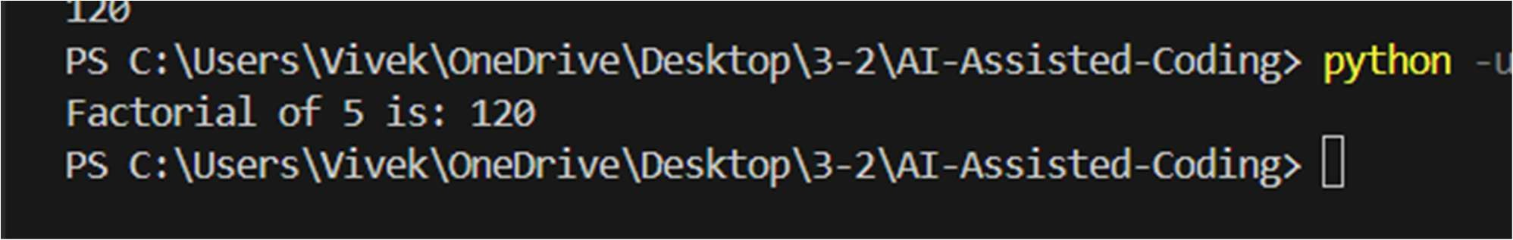

Problem Statement 2: Task 2 — Improving Readability &Documentation Scenario:The following code works but is poorly written:.
def calc(a, b, c):
if c == "add":
return a + b elif c == "sub":
return a - b
elif c == "mul":
return a * b elif c == "div":
Instructions:
- Use AI to:
  - Critique the function’s readability, parameter naming, and lack of documentation.
  - Rewrite the function with:
- Descriptive function and parameter names.
- A complete docstring (description, parameters, return value, examples).
- Exception handling for division by zero.
- Consideration of input validation.
- Compare the original and AI-improved versions.
- Test both with valid and invalid inputs (e.g., division by zero, non-string operation).
Expected Output:
A well-documented, robust, and readable function that handles errors gracefully.

Prompt
assume you are a developer whose task is to improve readability and documentation the below code is poorly written:
def calc(a, b, c):
if c == "add":
return a + b elif c == "sub":
return a - b
elif c == "mul":
return a * b elif c == "div":
critique the function readability , parameter naming rewrite the function with: descriptive function and parameter names
complete docstring
exception handling for division by zero consideration of input validation and last test with both valid and invalid inputs “””
Output:
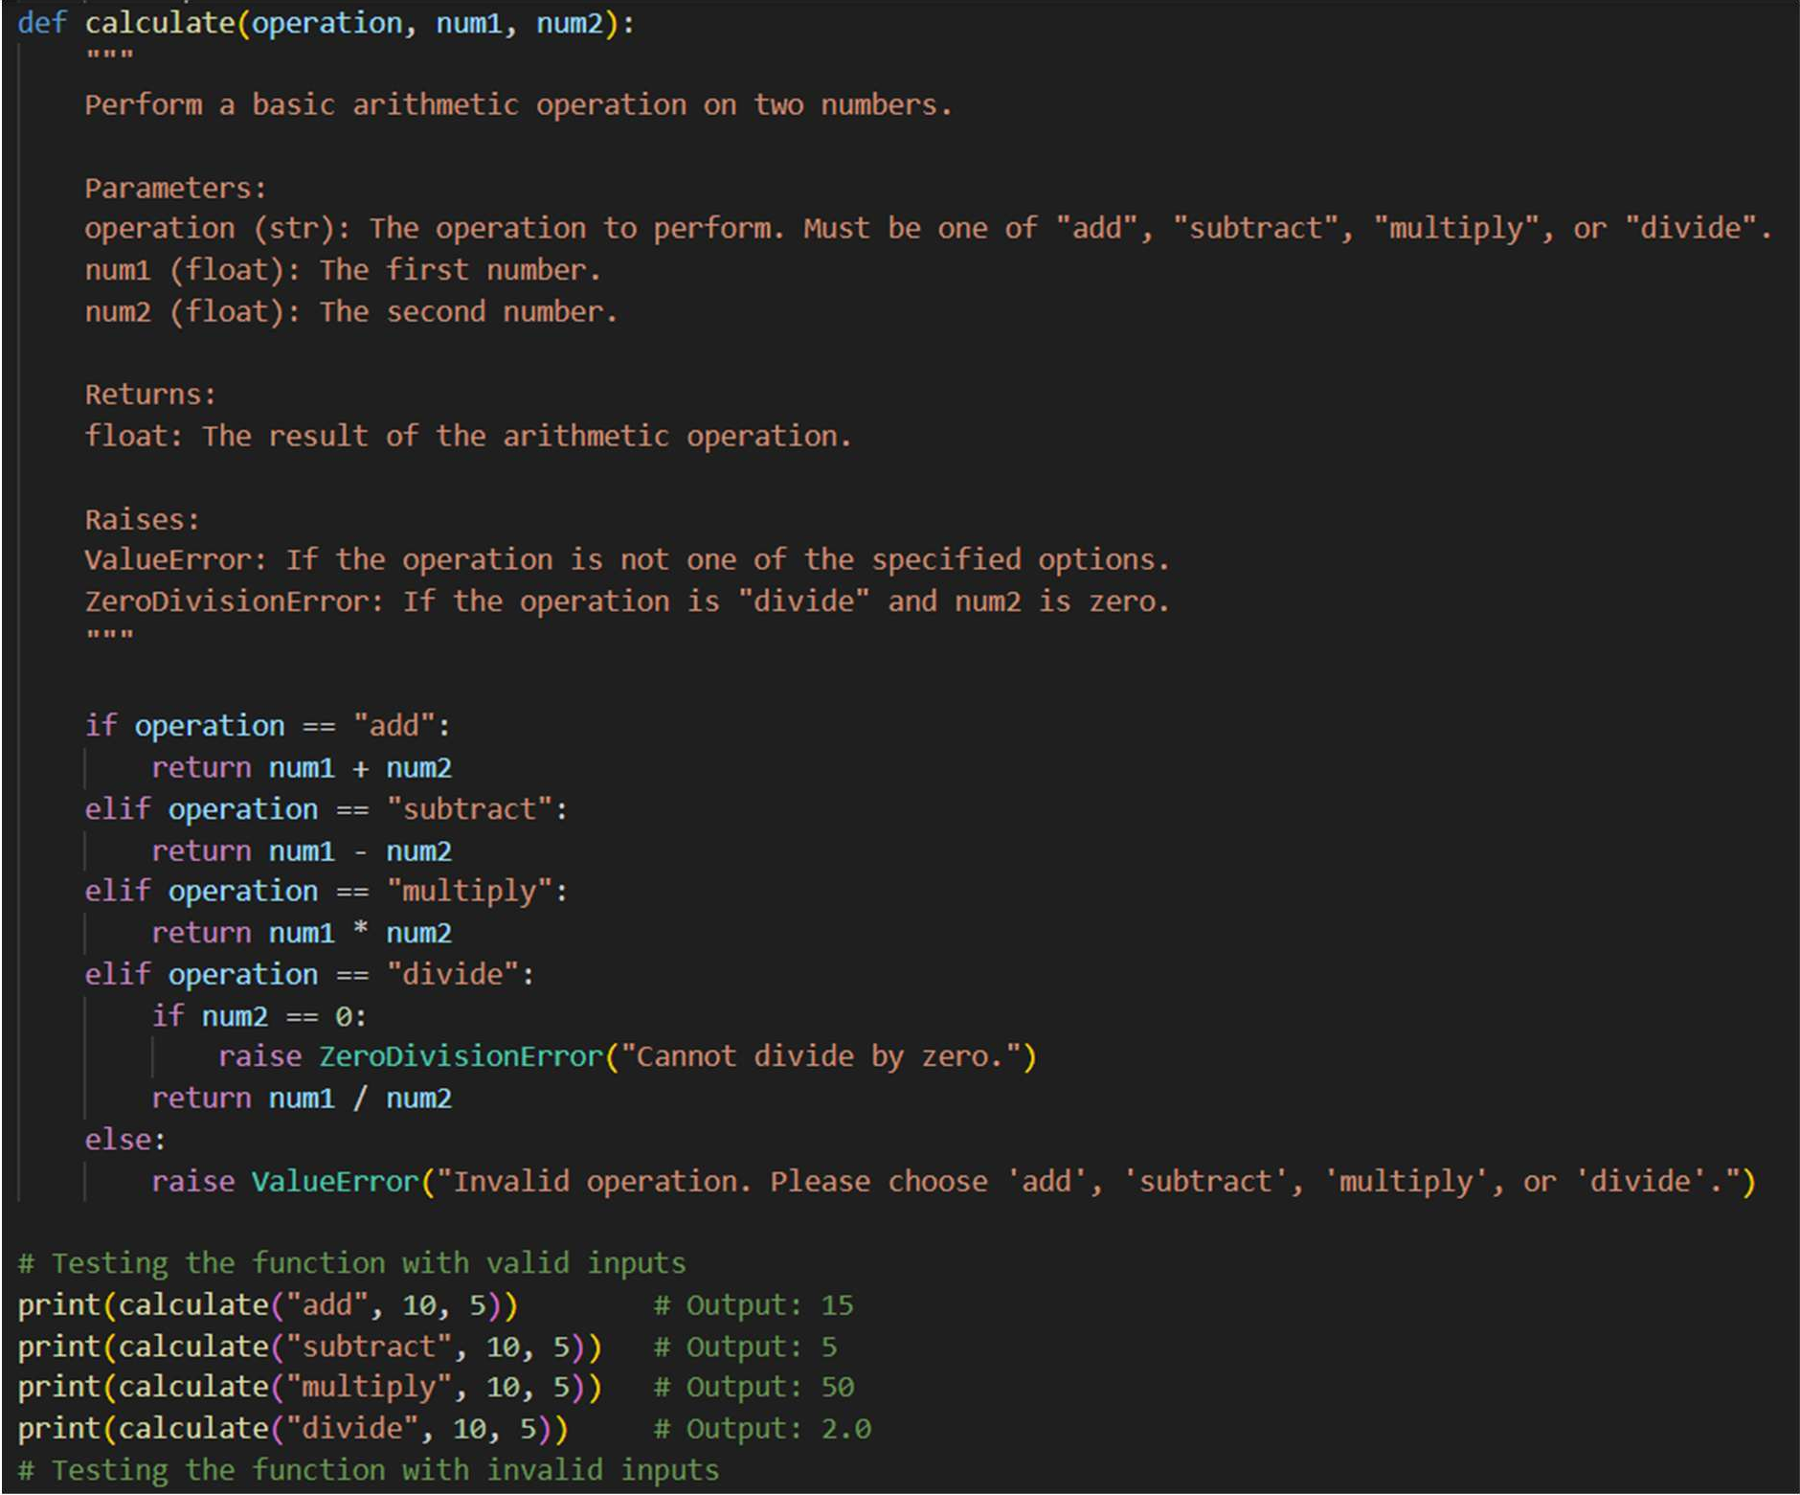

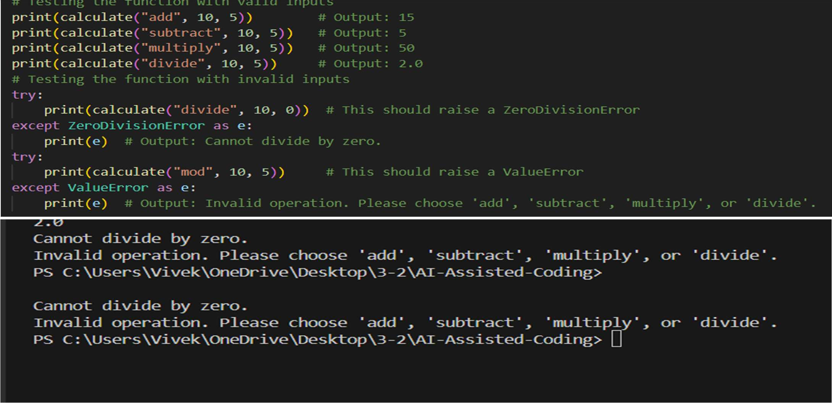

Task_03:
Scenario: A team project requires PEP8 compliance. A developer submits: def Checkprime(n):
for i in range(2, n):
if n % i == 0:
return False return True Instructions:
- Verify the function works correctly for sample inputs.
- Use an AI tool (e.g., ChatGPT, GitHub Copilot, or a PEP8 linter with AI explanation) to:
  - List all PEP8 violations.
  - Refactor the code (function name, spacing, indentation,naming).
- Apply the AI-suggested changes and verify functionality is preserved.
- Write a short note on how automated AI reviews could streamline code reviews in large teams.
Expected Output:
A PEP8-compliant version of the function, e.g.: def check_prime(n):
for i in range(2, n): if n % i == 0: return False
return True

Prompt:
Act as a strict Python code reviewer and review the following code for correctness Given this code:
def Checkprime(n):
for i in range(2, n):
if n % i == 0:
return False return True Tasks:
Quickly verify correctness using sample inputs (2, 3, 4, 9, 11, 1, 0, negatives) and point out any logical issues. List all PEP8 violations (naming, indentation, spacing, structure).
Refactor the code to be fully PEP8 compliant: Rename the function
Fix indentation and spacing Show the final corrected code.
Confirm functionality is preserved after refactoring. """
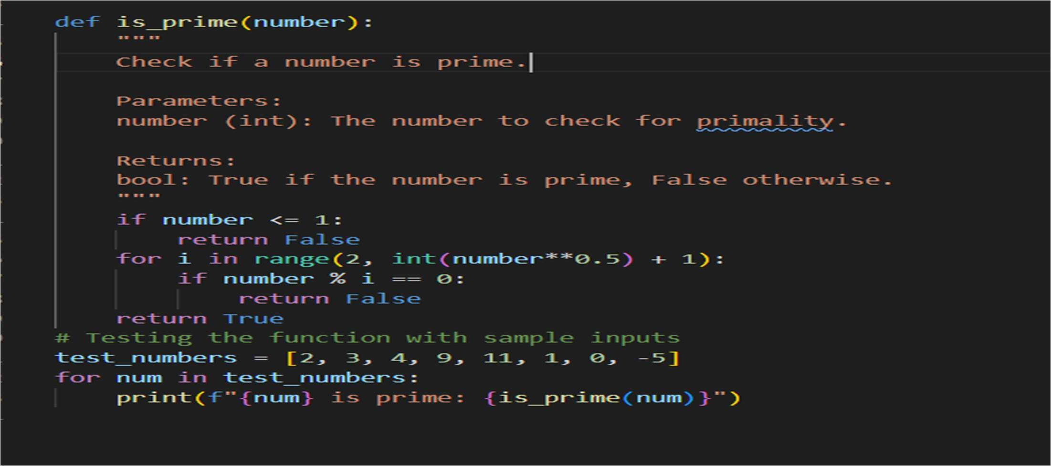
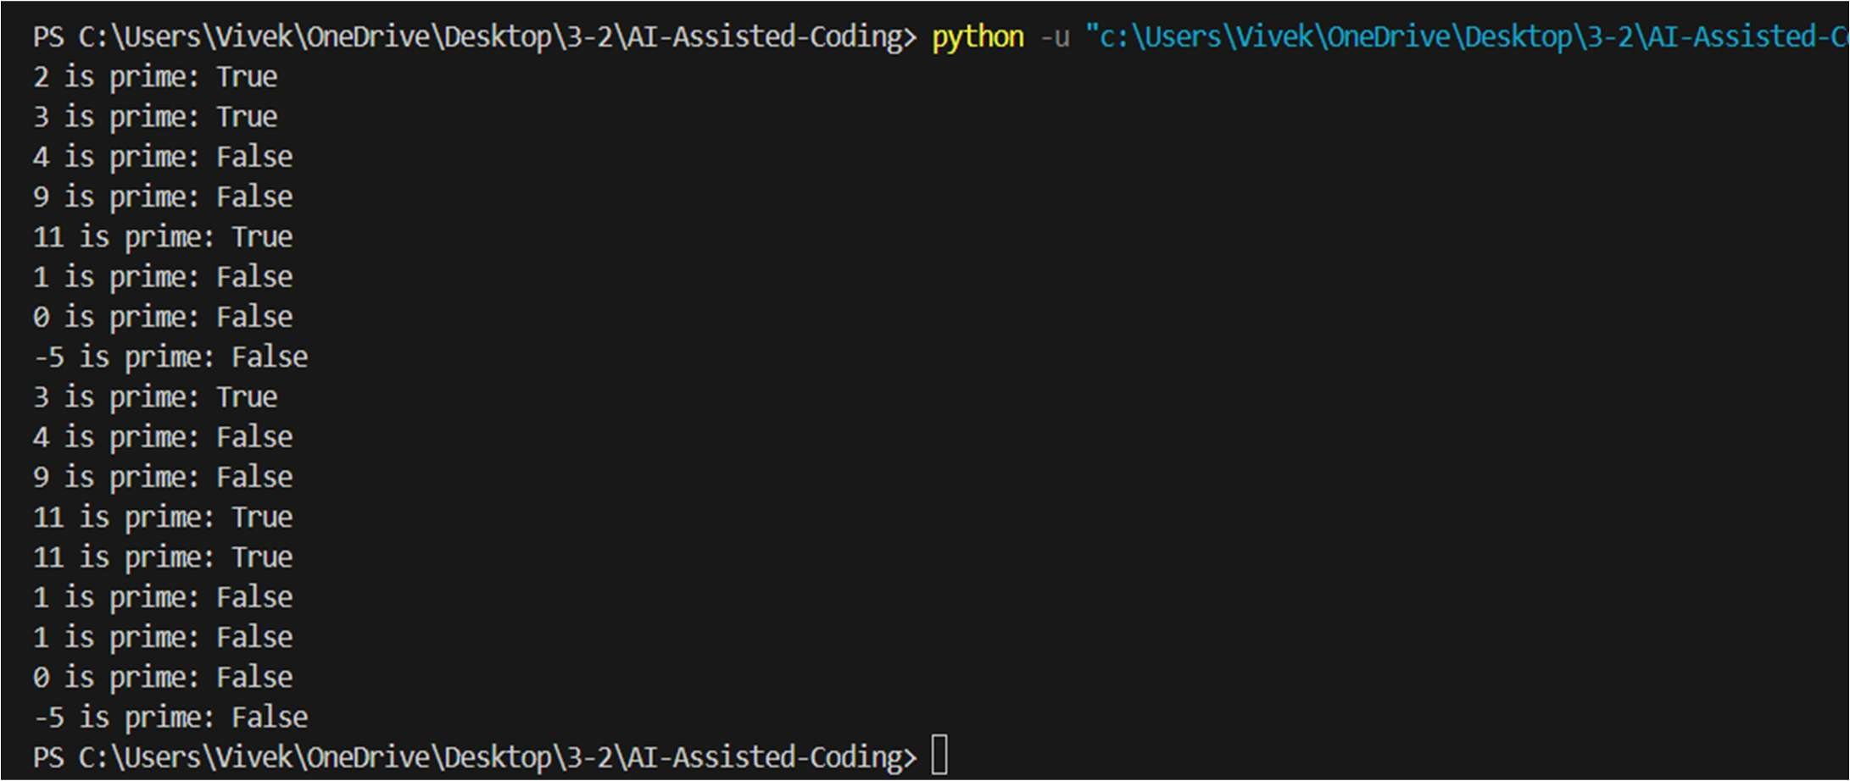
Output:

Task_04:
Problem Statement 4: AI as a Code Reviewer in Real Projects Scenario:
In a GitHub project, a teammate submits:
def processData(d):
return [x * 2 for x in d if x % 2 == 0] Instructions:
- Manually review the function for:
  - Readability and naming.
  - Reusability and modularity.
  - Edge cases (non-list input, empty list, non-integer elements).
- Use AI to generate a code review covering:
- Better naming and function purpose clarity.
- Input validation and type hints.
- Suggestions for generalization (e.g., configurable multiplier).
- Refactor the function based on AI feedback.
- Write a short reflection on whether AI should be a standalone reviewer or an assistant. Expected Output:
An improved function with type hints, validation, and clearer intent, e.g.:
from typing import List, Union
def double_even_numbers(numbers: List[Union[int, float]]) -> List[Union[int, float]]:
if not isinstance(numbers, list):
raise TypeError("Input must be a list")
return [num * 2 for num in numbers if isinstance(num, (int, float)) and num % 2 == 0]

Prompt:
Optimized Prompt
Act as a senior Python engineer reviewing code in a real GitHub project. Given this function submitted by a teammate:
def processData(d):
return [x * 2 for x in d if x % 2 == 0] Do the following:
Manual review:
Evaluate readability and naming.,modularity.
Identify edge cases (non-list input, empty list, non-integer elements, etc.). suggest better function and variable names and clarify the function’s purpose. Add input validation and proper type hints.
Suggest how to generalize the function Refactor the code based on the review: Provide a clean, production-quality version. Include type hints and validation.

Output:

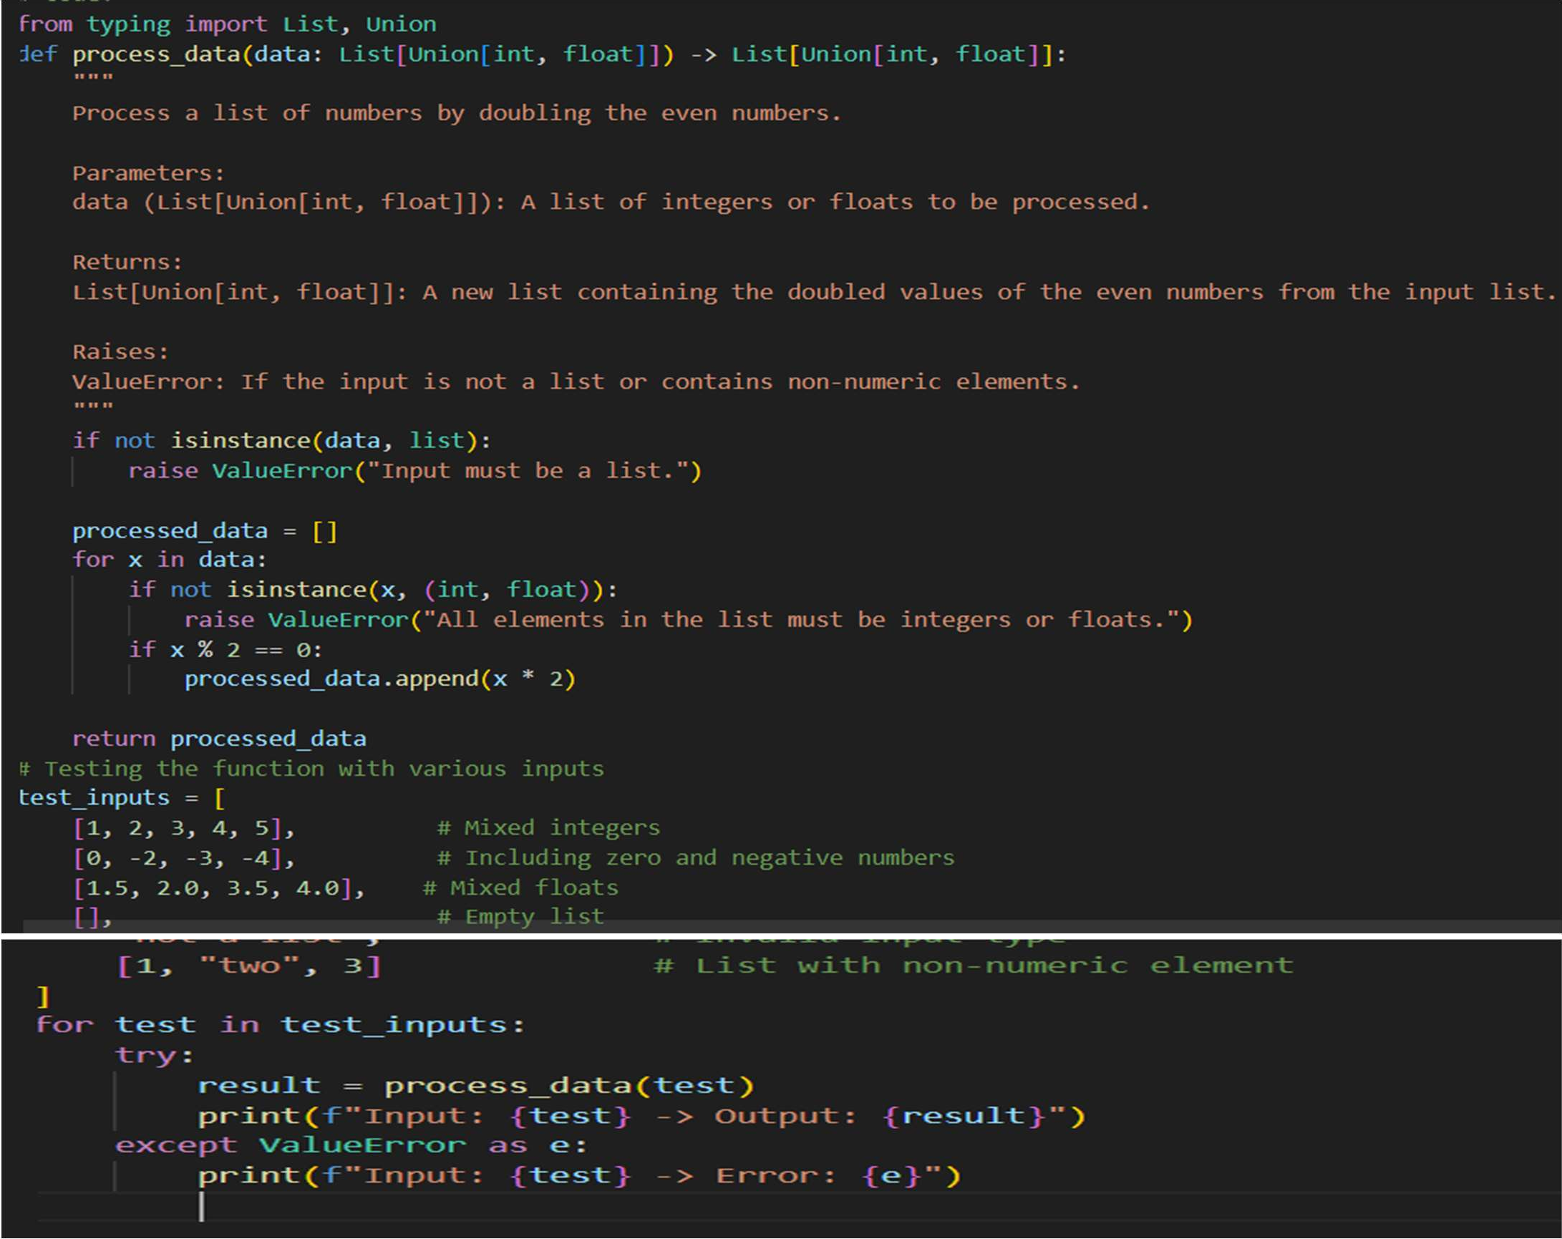
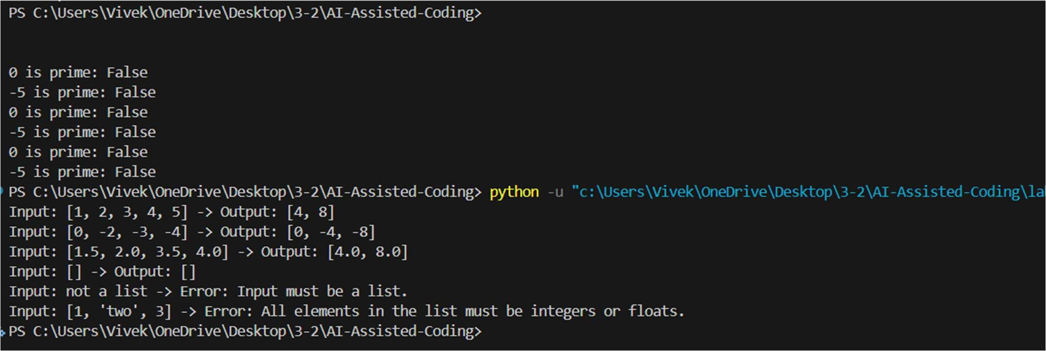
Output:

Task_05:
Problem Statement 5: — AI-Assisted Performance Optimization Scenario: You are given a function that processes a list of integers, but it runs slowly on large datasets:
def sum_of_squares(numbers):
total = 0
for num in numbers:
total += num ** 2 return total Instructions:
- Test the function with a large list (e.g., range(1000000)).
- Use AI to:
  - Analyze time complexity.
  - Suggest performance improvements (e.g., using built-in functions, vectorization with NumPy if applicable).
  - Provide an optimized version.
- Compare execution time before and after optimization.
- Discuss trade-offs between readability and performance. Expected Output:
An optimized function, such as:
def sum_of_squares_optimized(numbers):
return sum(x * x for x in numbers)

Prompt:
Act as a performance-focused Python engineer. Given this function:
def sum_of_squares(numbers): total = 0
for num in numbers: total += num ** 2
return total
Do the following:
Test this function conceptually with a large input (e.g., range(1_000_000)) and explain why it becomes slow. Use performance-oriented reasoning to:
Suggest optimizations using Python built-ins and/or better iteration patterns. Mention alternatives like NumPy (when appropriate) and explain when they help. Provide an optimized version of the function.
Compare the expected execution time before vs after optimization."""
Output:
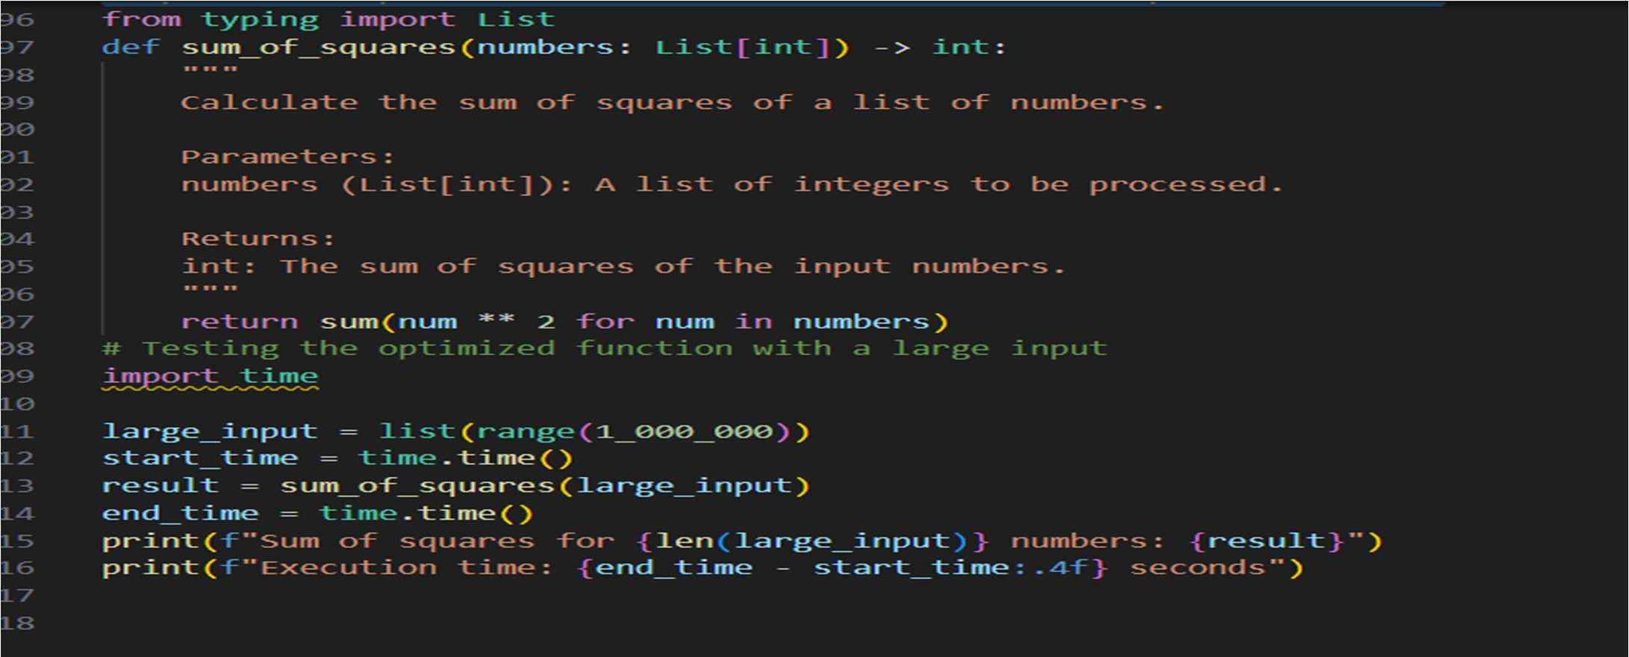

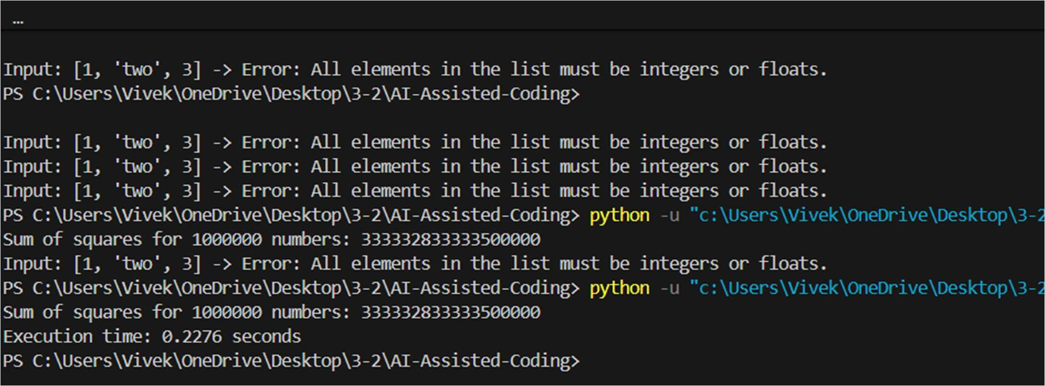
Output:

