ASSIGNMENT – 11.3 HT.NO: 2303A52313

Name: Sanju Ch

BATCH: 45

TASK – 01:

Question:
SR University’s student club requires a simple Contact Manager Application to store members’ names and phone numbers. The system should support efficient addition, searching, and deletion of contacts.
Tasks
- Implement the contact manager using arrays (lists).
- Implement the same functionality using a linked list for dynamic memory allocation.
- Implement the following operations in both approaches:
  - Add a contact
  - Search for a contact
  - Delete a contact
- Use GitHub Copilot to assist in generating search and delete methods.
- Compare array vs. linked list approaches with respect to:
  - Insertion efficiency
  - Deletion efficiency

Prompt:
Generate a python program for a Smart Contact Manager. Implement it using Arrays and Linked Lists.
Each contact should store name and phone number. Include operations:
Add contact Search contact

Delete contact
Use menu-driven user input and keep the code simple for beginners.
Also add a short comparison of arrays vs linked lists for insertion and deletion.

Generated Code:
class Contact:
def init (self, name, phone): self.name = name
self.phone = phone class Node:
def init (self, contact): self.contact = contact self.next = None
class ContactManager: def init (self):
self.head = None
def add_contact(self, name, phone): new_contact = Contact(name, phone) new_node = Node(new_contact)
if not self.head: self.head = new_node return
current = self.head while current.next:
current = current.next current.next = new_node
def search_contact(self, name): current = self.head
while current:
if current.contact.name == name:

return current.contact.phone current = current.next
return "Contact not found." def delete_contact(self, name):
current = self.head previous = None while current:
if current.contact.name == name: if previous:
previous.next = current.next else:
self.head = current.next return "Contact deleted."
previous = current current = current.next
return "Contact not found." def main():
manager = ContactManager() while True:
print("\nSmart Contact Manager") print("1. Add Contact")
print("2. Search Contact") print("3. Delete Contact") print("4. Exit")
choice = input("Enter your choice: ") if choice == '1':
name = input("Enter contact name: ")
phone = input("Enter contact phone number: ") manager.add_contact(name, phone)

print("Contact added.") elif choice == '2':
name = input("Enter contact name to search: ") result = manager.search_contact(name) print(f"Phone number: {result}")
elif choice == '3':
name = input("Enter contact name to delete: ") result = manager.delete_contact(name) print(result)
elif choice == '4': print("Exiting...") break
else:
print("Invalid choice. Please try again.") if name == " main ":
main() """
Comparison of Arrays vs Linked Lists for Insertion and Deletion:
- Insertion:
  - Arrays: Inserting an element in the middle of an array requires shifting all subsequent elements, which can be time-consuming (O(n) in the worst case).
  - Linked Lists: Inserting an element in a linked list is more efficient as it only requires updating a few pointers (O(1) if inserting at the beginning or end).
- Deletion:
  - Arrays: Deleting an element from an array also requires shifting all subsequent elements to fill the gap, which can be time-consuming (O(n) in the worst case).
  - Linked Lists: Deleting an element from a linked list is more efficient as it only requires updating a few pointers (O(1) if deleting the first or last element).
Overall, linked lists are more efficient for insertion and deletion operations compared to arrays, especially when dealing with large datasets or when the size of the dataset is not known in advance. However, arrays provide faster access to elements due to their contiguous

memory allocation, making them more suitable for scenarios where random access is required."""

OUTPUT:
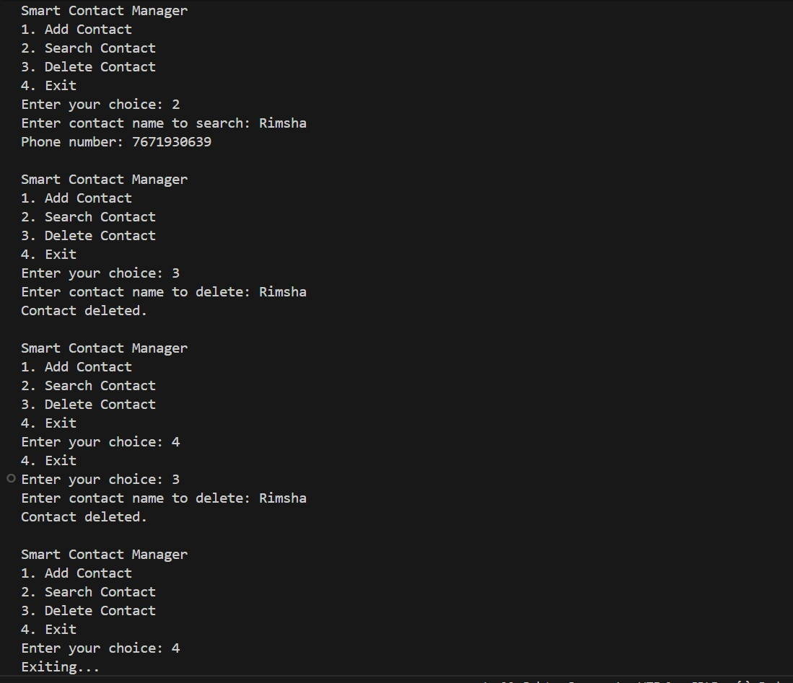
Explanation:
This program implements a Smart Contact Manager using a linked list in Python. It allows users to add, search, and delete contacts, where each contact stores a name and phone number. The menu-driven main() function lets the user interact with these operations until they choose to exit.

TASK – 02:

Question:
The SRU Library manages book borrow requests. Students and faculty submit requests, but faculty requests must be prioritized over student requests.
Tasks
- Implement a Queue (FIFO) to manage book requests.
- Extend the system to a Priority Queue, prioritizing faculty requests.
- Use GitHub Copilot to assist in generating:
o enqueue() method
o dequeue() method

- Test the system with a mix of student and faculty requests.

Prompt:
Write a simple python program for a Library Book Request System. Use:
Queue (FIFO) for book requests
Priority Queue where faculty requests are processed before student requests Each request should include name and role (student/faculty).
Implement enqueue() and dequeue() methods and keep the code very simple for beginners.

Generated Code:
class BookRequest:
def init (self, name, role): self.name = name
self.role = role
class LibraryRequestSystem: def init (self):
self.queue = []
def enqueue(self, name, role):
request = BookRequest(name, role) self.queue.append(request)
def dequeue(self): if not self.queue:
return "No requests in the queue." # Process faculty requests first
for i in range(len(self.queue)):
if self.queue[i].role == 'faculty': return self.queue.pop(i)
# If no faculty requests, process student requests return self.queue.pop(0)
def main():

system = LibraryRequestSystem() while True:
print("\nLibrary Book Request System") print("1. Add Book Request")
print("2. Process Book Request") print("3. Exit")
choice = input("Enter your choice: ") if choice == '1':
name = input("Enter your name: ")
role = input("Enter your role (student/faculty): ") system.enqueue(name, role)
print("Book request added.") elif choice == '2':
result = system.dequeue()
if isinstance(result, BookRequest):
print(f"Processing request for {result.name} ({result.role}).") else:
print(result) elif choice == '3':
print("Exiting...") break
else:
print("Invalid choice. Please try again.") if name == " main ": main()

Output:

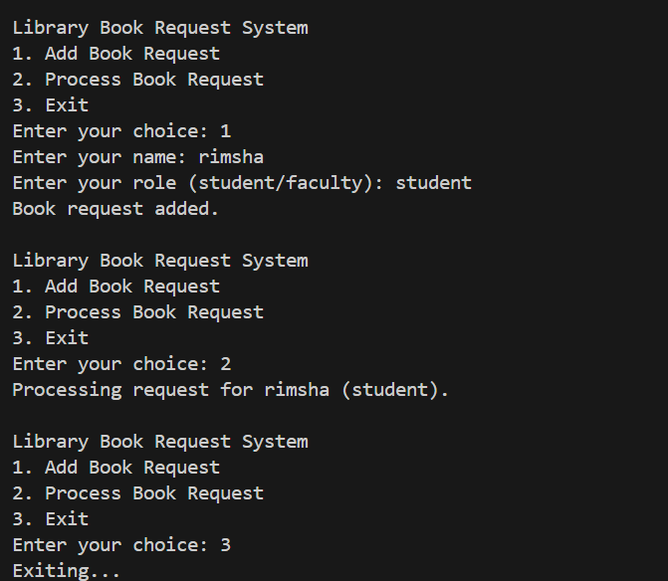
Explanation:
This program implements a Library Book Request System using a queue. Users can add book requests with their name and role (student or faculty). When processing requests, faculty requests are given priority over student requests.

TASK – 03:

Question:
SR University’s IT Help Desk receives technical support tickets from students and staff. While tickets are received sequentially, issue escalation follows a Last-In, First-Out (LIFO) approach.
Tasks
- Implement a Stack to manage support tickets.
- Provide the following operations:
o push(ticket)
o pop()
o peek()
- Simulate at least five tickets being raised and resolved.
- Use GitHub Copilot to suggest additional stack operations such as:
  - Checking whether the stack is empty

  - Checking whether the stack is full (if applicable)

Prompt:
Write a simple python program for an IT Help Desk Ticket System using a Stack (LIFO). Each ticket should contain ticket ID and issue description.
Implement operations:
push() to add a ticket pop() to resolve a ticket
peek() to view the latest ticket check if the stack is empty or full
Simulate at least five tickets and keep the code simple with comments for beginners.

Generated Code:
class Ticket:
def init (self, ticket_id, description): self.ticket_id = ticket_id self.description = description
class HelpDesk:
def init (self, capacity): self.stack = [] self.capacity = capacity
def push(self, ticket_id, description): if len(self.stack) >= self.capacity:
print("Stack is full. Cannot add more tickets.") return
ticket = Ticket(ticket_id, description) self.stack.append(ticket) print(f"Ticket {ticket_id} added.")
def pop(self):
if not self.stack:
print("Stack is empty. No tickets to resolve.")

return
ticket = self.stack.pop()
print(f"Resolving ticket {ticket.ticket_id}: {ticket.description}") def peek(self):
if not self.stack:
print("Stack is empty. No tickets to view.") return
ticket = self.stack[-1]
print(f"Latest ticket {ticket.ticket_id}: {ticket.description}") def is_empty(self):
return len(self.stack) == 0 def is_full(self):
return len(self.stack) >= self.capacity def main():
help_desk = HelpDesk(capacity=5) # Simulating ticket creation
help_desk.push(1, "Cannot connect to Wi-Fi.") help_desk.push(2, "Computer is running slow.") help_desk.push(3, "Software installation request.") help_desk.push(4, "Printer not working.") help_desk.push(5, "Email not syncing.")
# Attempting to add another ticket when stack is full help_desk.push(6, "Keyboard not responding.")
# Viewing the latest ticket help_desk.peek()
# Resolving tickets help_desk.pop() help_desk.pop()
# Checking if stack is empty

print("Is the stack empty?", help_desk.is_empty()) # Resolving remaining tickets
help_desk.pop() help_desk.pop()
help_desk.pop() # Attempting to pop from an empty stack # Checking if stack is empty
print("Is the stack empty?", help_desk.is_empty()) if name == " main ":
main()

Output:
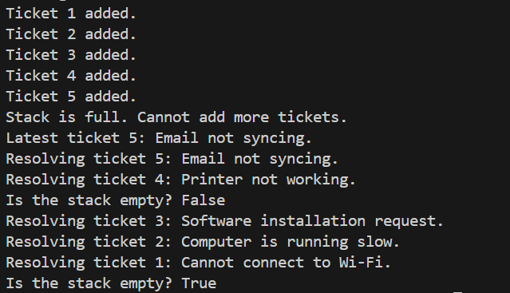

Explanation:
This program simulates a Help Desk Ticket System using a stack (LIFO – Last In, First Out). Tickets are added with an ID and description, and the most recently added ticket is resolved first. It also checks if the stack is full or empty and allows viewing the latest ticket using peek().

TASK – 04:

Question:
To implement a Hash Table and understand collision handling. Task Description
Use AI to generate a hash table with:

- Insert
- Search
- Delete Starter Code
class HashTable:
pass

Prompt:
Generate a simple Hash Table program with operations:
Insert Search Delete
Use collision handling with chaining. Start with this code:
class HashTable: pass
Write simple python code, with well-commented methods.""" class HashTable:

Generated Code:
class HashTable:
def init (self, size=10):
# Initialize the hash table with a specified size self.size = size
self.table = [[] for _ in range(size)] # Create a list of empty lists for chaining def hash_function(self, key):
# Simple hash function to calculate the index for a given key return hash(key) % self.size
def insert(self, key, value):
# Insert a key-value pair into the hash table index = self.hash_function(key)

# Check if the key already exists in the chain at the index for i, (k, v) in enumerate(self.table[index]):
if k == key:
self.table[index][i] = (key, value) # Update existing key return
self.table[index].append((key, value)) # Add new key-value pair def search(self, key):
# Search for a value by its key in the hash table index = self.hash_function(key)
for k, v in self.table[index]: if k == key:
return v # Return the value if key is found return None # Return None if key is not found
def delete(self, key):
# Delete a key-value pair from the hash table index = self.hash_function(key)
for i, (k, v) in enumerate(self.table[index]): if k == key:
del self.table[index][i] # Remove the key-value pair from the chain return True # Return True if deletion is successful
return False # Return False if key is not found def main():
hash_table = HashTable()
# Inserting key-value pairs into the hash table hash_table.insert("name", "Alice") hash_table.insert("age", 30) hash_table.insert("city", "New York")
# Searching for values by keys
print("Name:", hash_table.search("name")) # Output: Alice

print("Age:", hash_table.search("age")) # Output: 30 print("City:", hash_table.search("city")) # Output: New York
print("Country:", hash_table.search("country")) # Output: None (not found) # Deleting a key-value pair
print("Deleting 'age':", hash_table.delete("age")) # Output: True
print("Searching for 'age' after deletion:", hash_table.search("age")) # Output: None (not found)
if name == " main ": main()

Output:
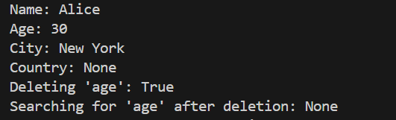
Explanation:
This program implements a Hash Table in Python to store key–value pairs using a hash function. It supports insert, search, and delete operations, and handles collisions using chaining (lists at each index). The main() function demonstrates adding, searching, and deleting data from the hash table.

TASK – 05:

Question:
Design a Campus Resource Management System with the following features:
- Student Attendance Tracking
- Event Registration System
- Library Book Borrowing
- Bus Scheduling System
- Cafeteria Order Queue Student Tasks

- Choose the most appropriate data structure for each feature.
- Justify your choice in 2–3 sentences.
- Implement one selected feature using AI-assisted code generation.

Prompt:
Design a Campus Resource Management System with the following features:
  - Student Attendance Tracking
  - Event Registration System
  - Library Book Borrowing
  - Bus Scheduling System
  - Cafeteria Order Queue
- Choose the most appropriate data structure for each feature. write python code snippets for each feature using the chosen data structure. and print outputs for each feature to demonstrate their functionality.
- Justify your choice in 2–3 sentences.

Generated Code:
# Student Attendance Tracking - Using a Set to store unique student IDs class AttendanceTracker:
def init (self):
self.attendance = set() # Using a set to store unique student IDs def mark_attendance(self, student_id):
self.attendance.add(student_id) # Add student ID to the set def get_attendance(self):
return self.attendance # Return the set of attended student IDs
# Event Registration System - Using a List to store event registrations class EventRegistration:
def init (self):
self.registrations = [] # Using a list to store event registrations def register(self, name):
self.registrations.append(name) # Add participant name to the list

def get_registrations(self):
return self.registrations # Return the list of registered participants
# Library Book Borrowing - Using a Dictionary to store book availability class Library:
def init (self):
self.books = {"Book A": True, "Book B": True, "Book C": True} # Using a dictionary to store book availability
def borrow_book(self, book_name):
if self.books.get(book_name, False):
self.books[book_name] = False # Mark the book as borrowed return f"{book_name} has been borrowed."
return f"{book_name} is not available." def return_book(self, book_name):
if book_name in self.books:
self.books[book_name] = True # Mark the book as available return f"{book_name} has been returned."
return f"{book_name} does not exist in the library."
# Bus Scheduling System - Using a Queue to manage bus schedules from collections import deque
class BusSchedule: def init (self):
self.schedule = deque() # Using a queue to manage bus schedules def add_bus(self, bus_number):
self.schedule.append(bus_number) # Add bus number to the schedule def next_bus(self):
if self.schedule:
return self.schedule.popleft() # Get the next bus in the schedule return "No buses scheduled."
# Cafeteria Order Queue - Using a Queue to manage cafeteria orders

class CafeteriaOrderQueue: def init (self):
self.orders = deque() # Using a queue to manage cafeteria orders def place_order(self, order):
self.orders.append(order) # Add order to the queue def serve_order(self):
if self.orders:
return self.orders.popleft() # Serve the next order in the queue return "No orders to serve."
def main():
# Demonstrating Student Attendance Tracking attendance_tracker = AttendanceTracker() attendance_tracker.mark_attendance("Student1") attendance_tracker.mark_attendance("Student2") print("Attendance:", attendance_tracker.get_attendance())

# Demonstrating Event Registration System event_registration = EventRegistration() event_registration.register("Alice") event_registration.register("Bob")
print("Event Registrations:", event_registration.get_registrations())

# Demonstrating Library Book Borrowing library = Library() print(library.borrow_book("Book A"))
print(library.borrow_book("Book A")) # Attempt to borrow the same book again print(library.return_book("Book A"))

# Demonstrating Bus Scheduling System

bus_schedule = BusSchedule() bus_schedule.add_bus("Bus 1")
bus_schedule.add_bus("Bus 2")
print("Next Bus:", bus_schedule.next_bus())

# Demonstrating Cafeteria Order Queue cafeteria_queue = CafeteriaOrderQueue() cafeteria_queue.place_order("Order 1")
cafeteria_queue.place_order("Order 2") print("Serving Order:", cafeteria_queue.serve_order()) print("Serving Order:", cafeteria_queue.serve_order())
print("Serving Order:", cafeteria_queue.serve_order()) # Attempt to serve when no orders are left
if name == " main ": main()

Output:
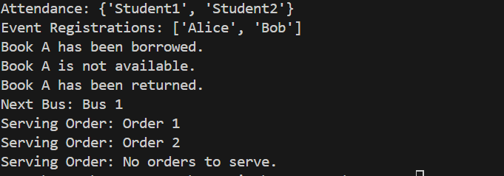
Explanation:
This program demonstrates different Python data structures for real-life systems: a set for student attendance, a list for event registrations, a dictionary for library book availability, and queues (deque) for bus scheduling and cafeteria orders. The main() function shows how each system works by adding, retrieving, and processing data.

