AI Assisted Coding
Assignment 14.3
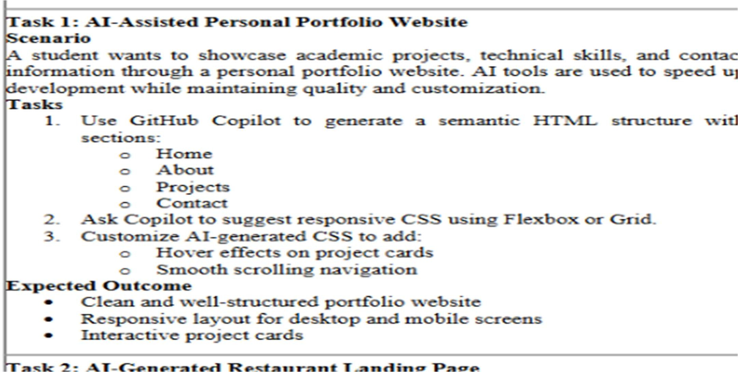
Name: Sanju Hallticket:2303A52313

CODE:
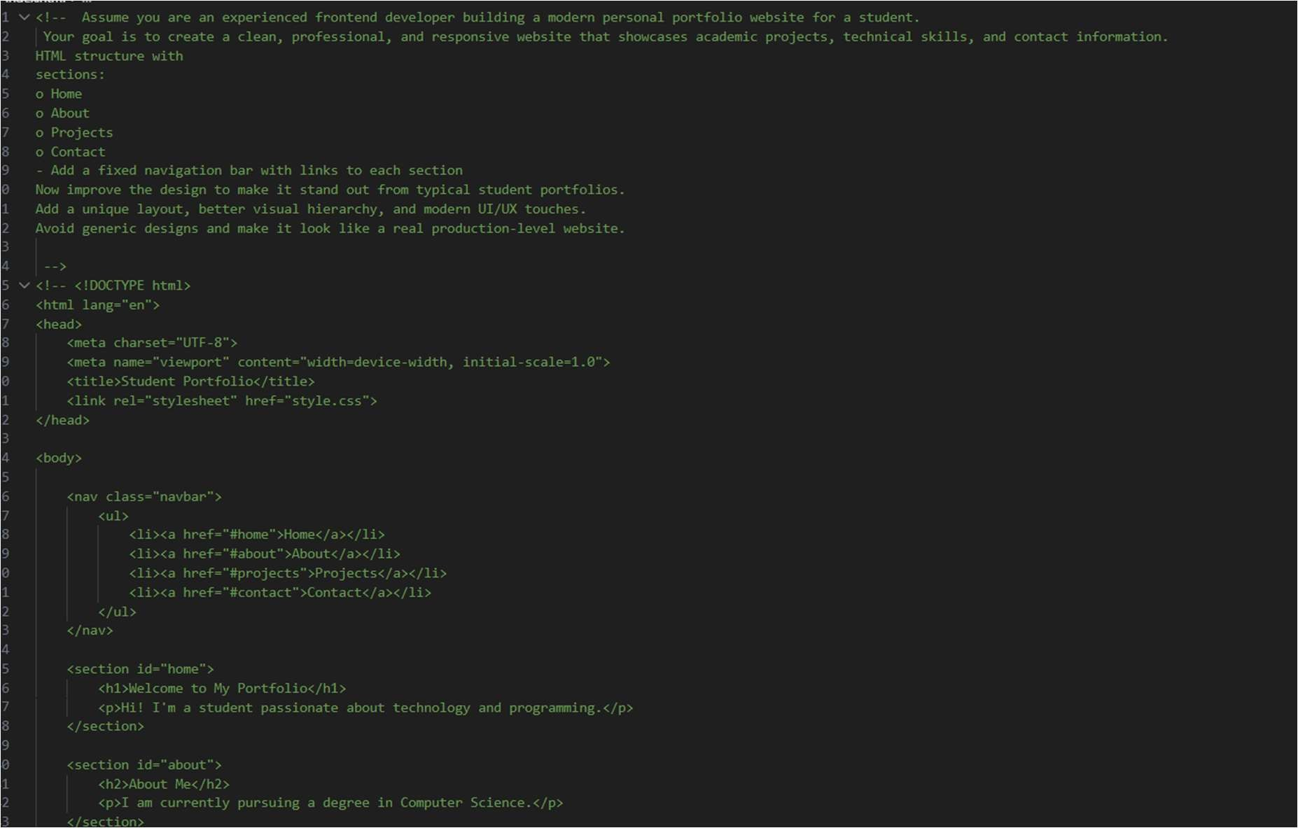

Output:
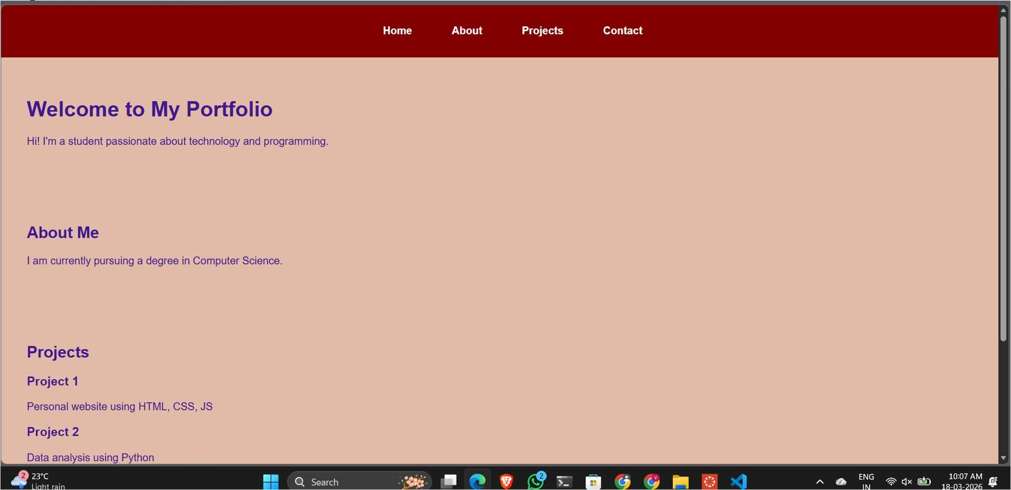

Task 2: AI-Generated Restaurant Landing Page Scenario
A local restaurant requires a simple yet attractive landing page to display its offerings. The developer uses AI assistance to rapidly generate UI components.
Tasks
- Use Copilot to create a navigation bar with links:
  - Home
  - Menu
  - Gallery
  - Contact
- Generate a menu section styled with CSS cards.
- Implement a JavaScript-based image slider for the gallery using Copilot suggestions.
- Customize animations or transitions for better user experience. Expected Outcome
- Fully functional restaurant landing page
- Responsive navigation bar
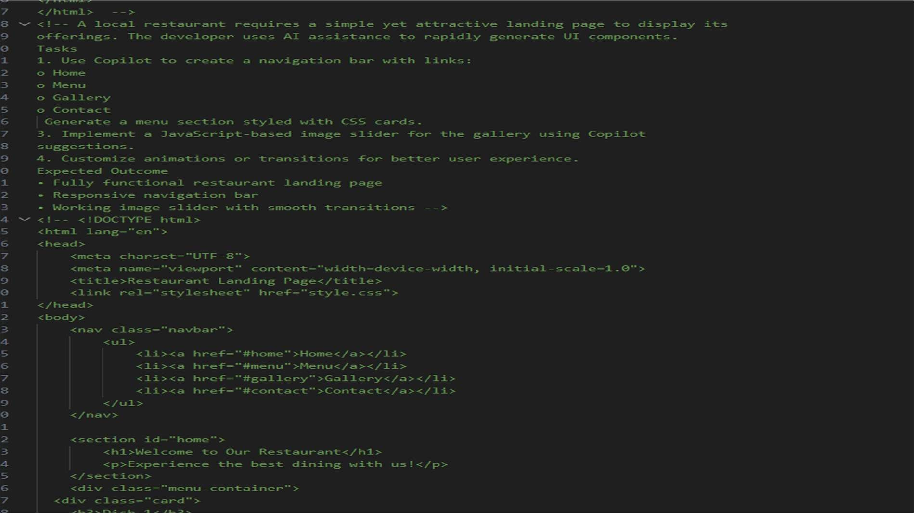
- Working image slider with smooth transitions CODE:

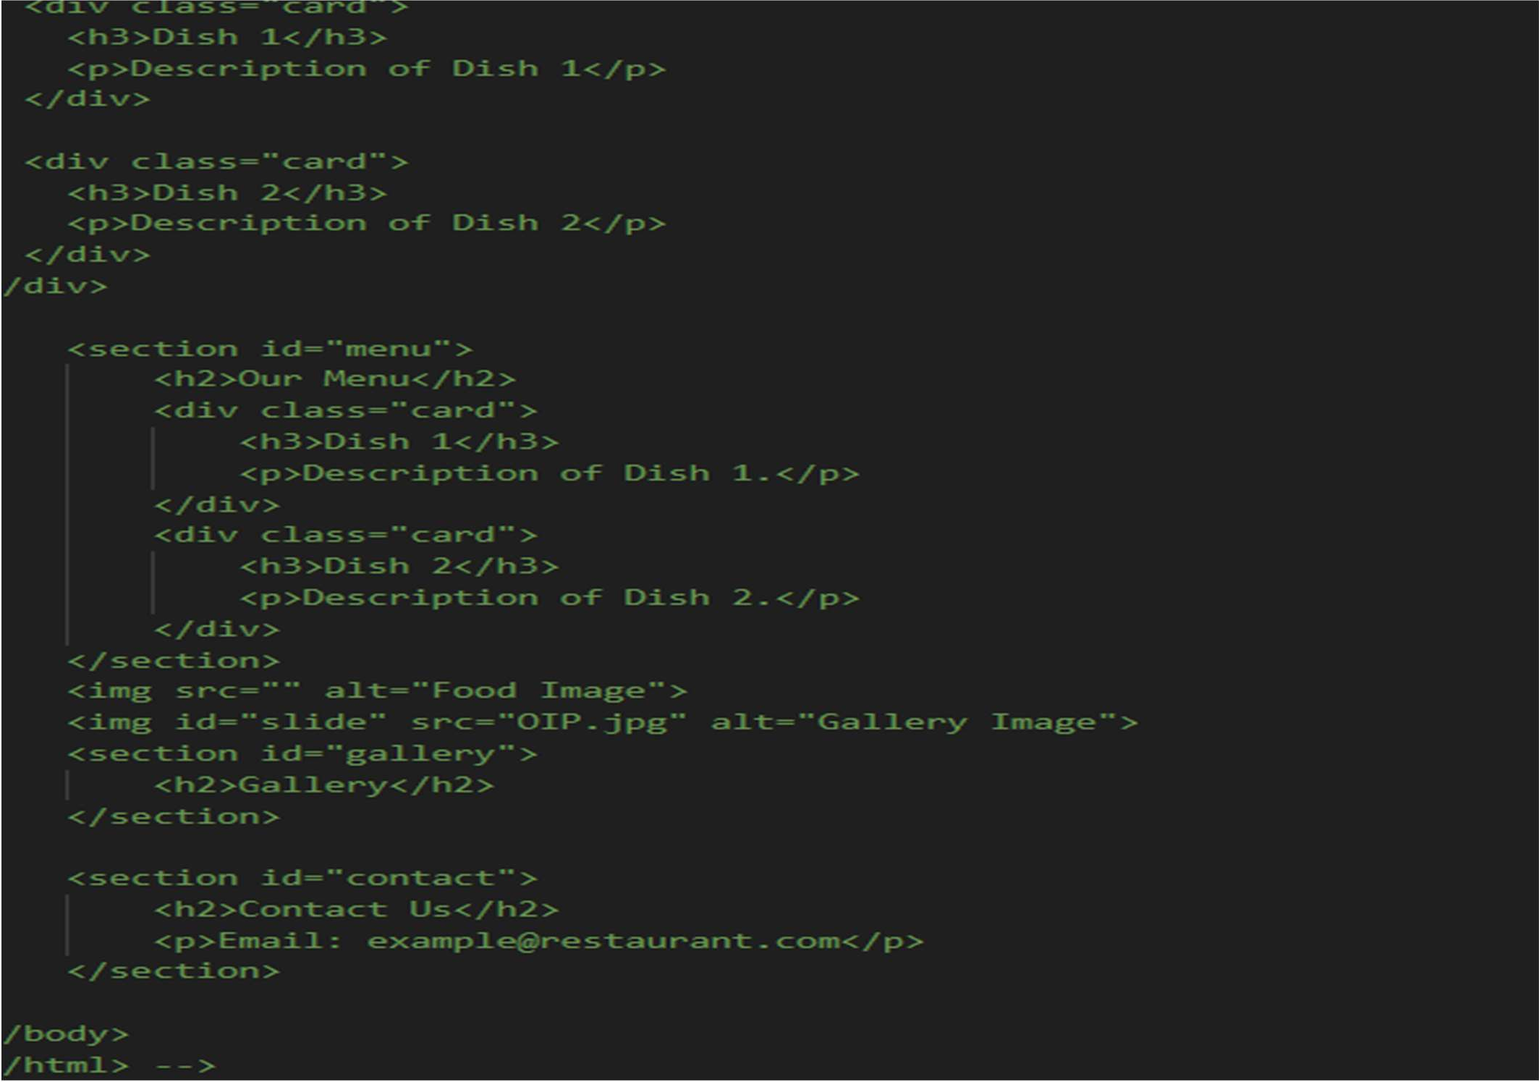
Output:
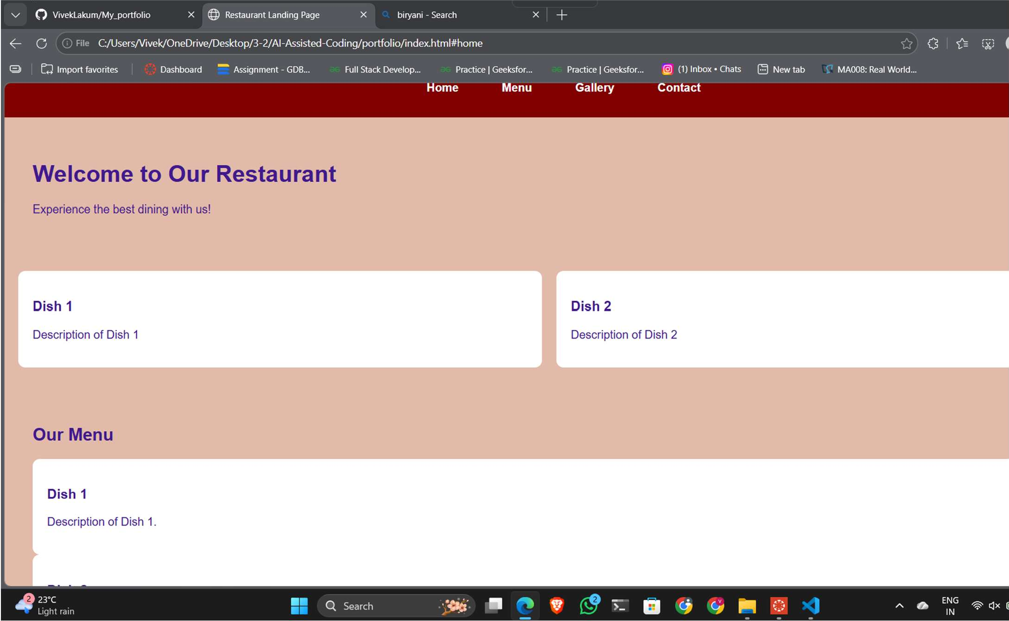

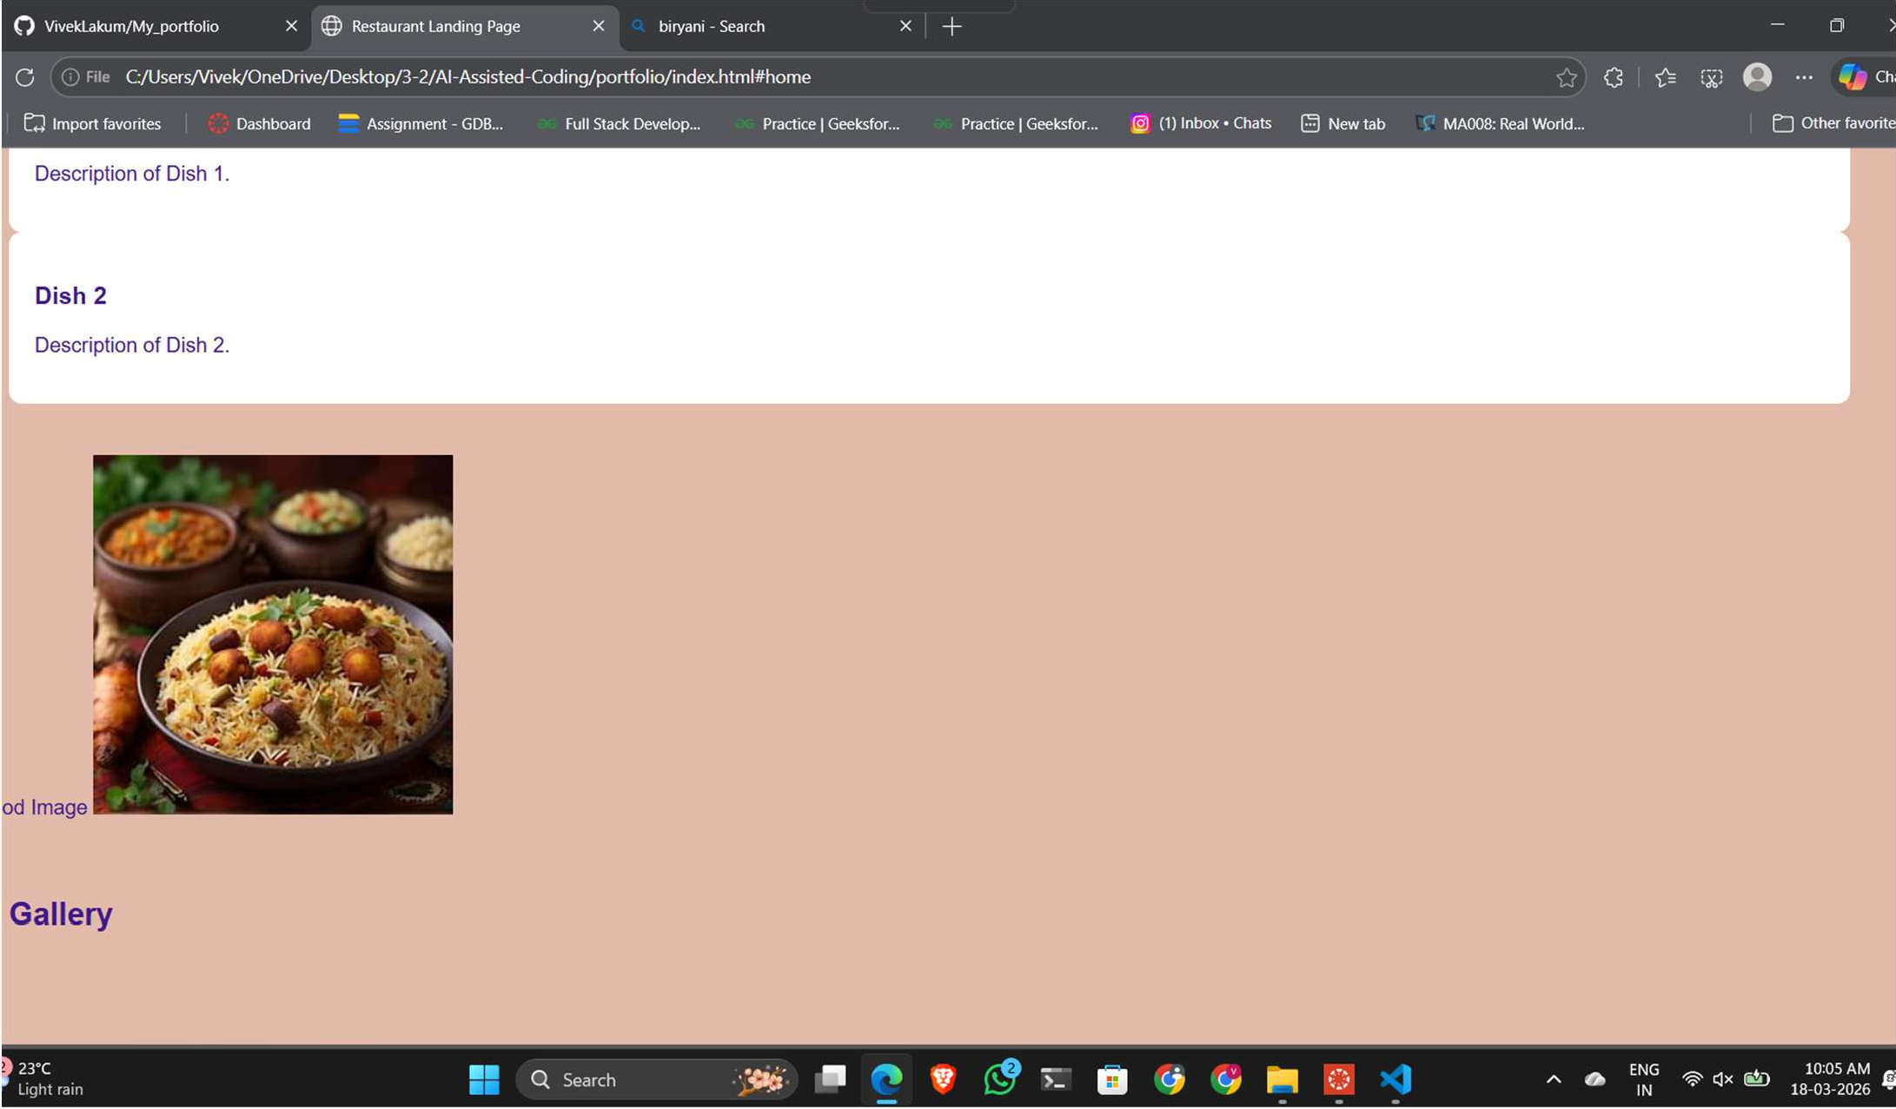

Task 3: AI-Powered Event Registration Form Scenario
SR University is hosting a technical fest and requires an online registration formwith real-time validation to ensure accurate user input. Tasks
- Ask Copilot to generate an HTML form with the following fields:
  - Name
  - Email
  - Phone Number
  - Department
  - Event Selection
- Use AI assistance to style the form using CSS for readability and accessibility.
- Implement JavaScript validation using Copilot:
  - Email format validation
  - Phone number length validation
  - Required field checks Expected Outcome
- User-friendly and visually appealing form
- Real-time validation messages
- Prevention of invalid submissions

CODE:

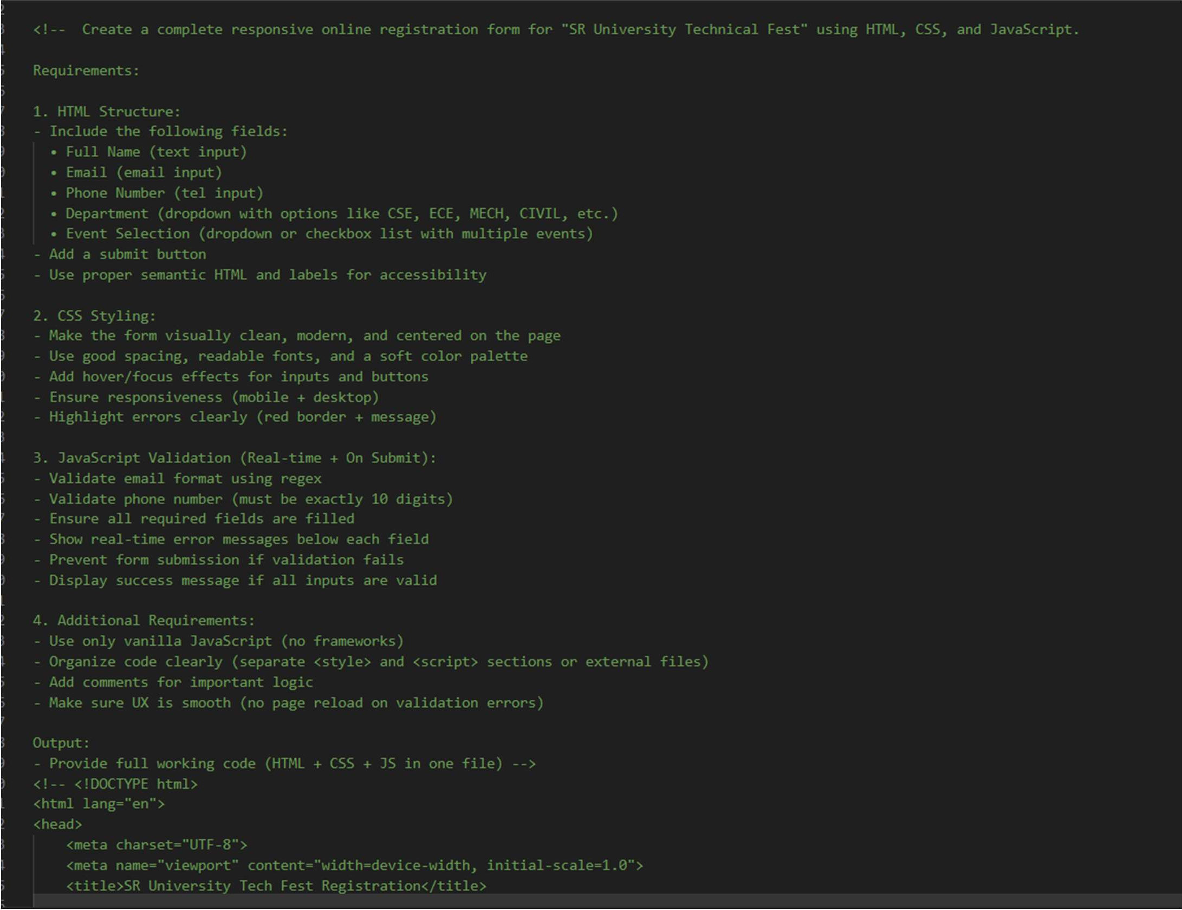

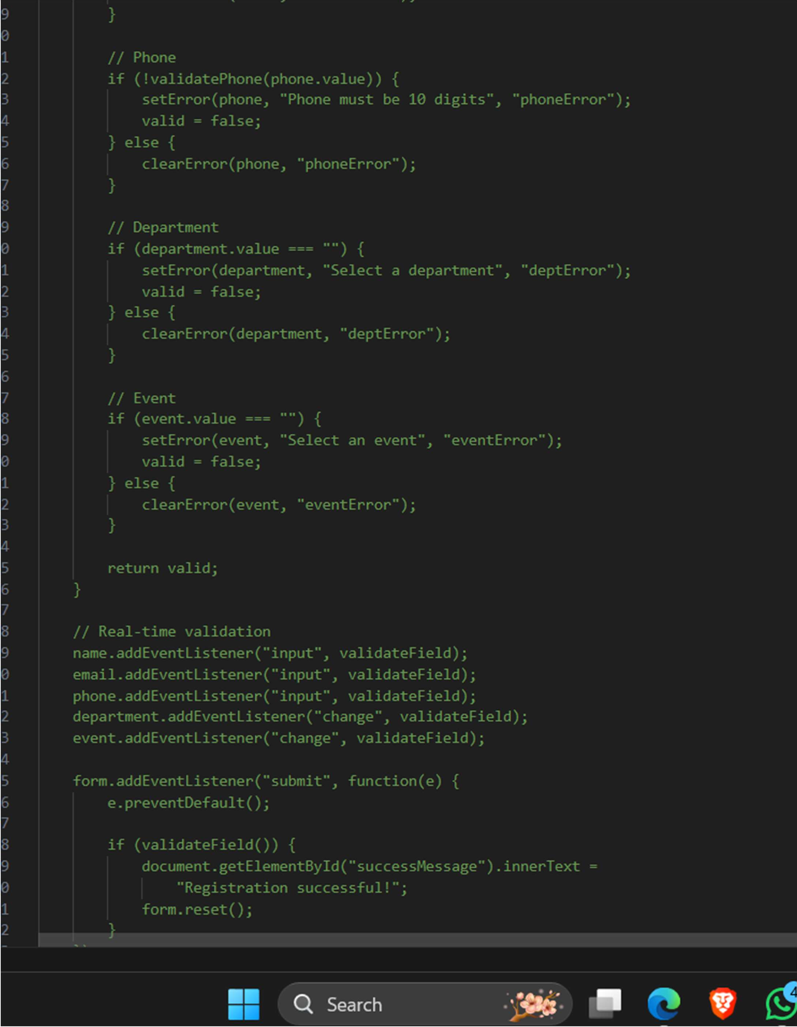

Output:

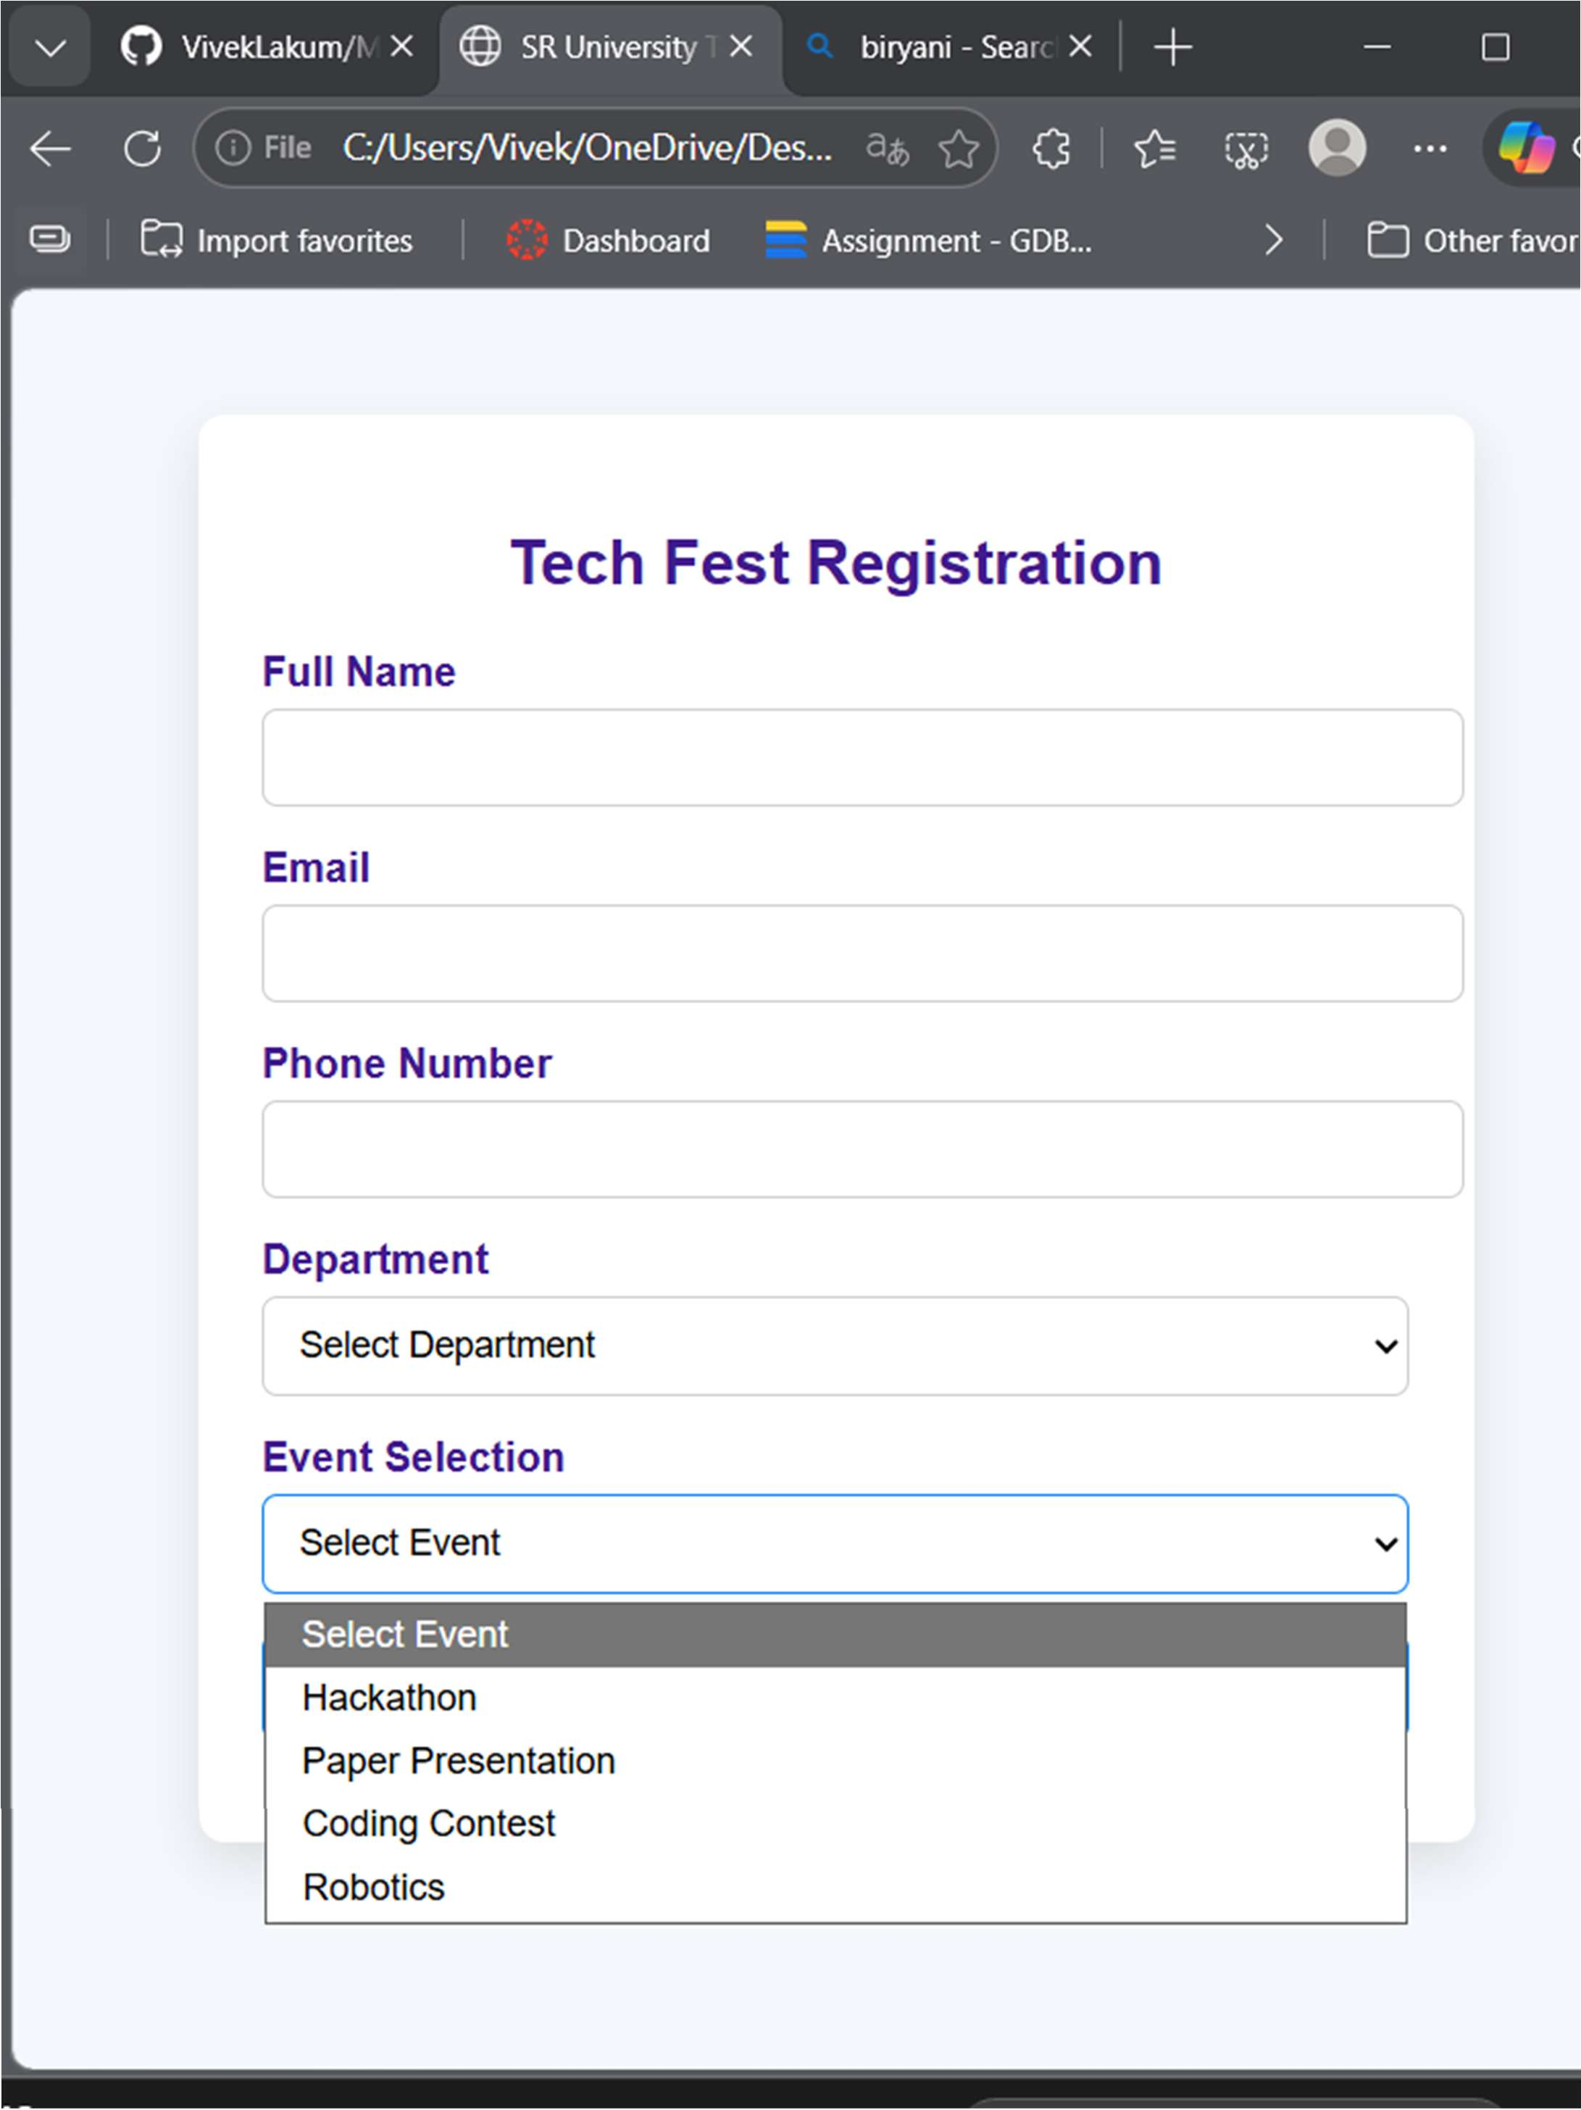

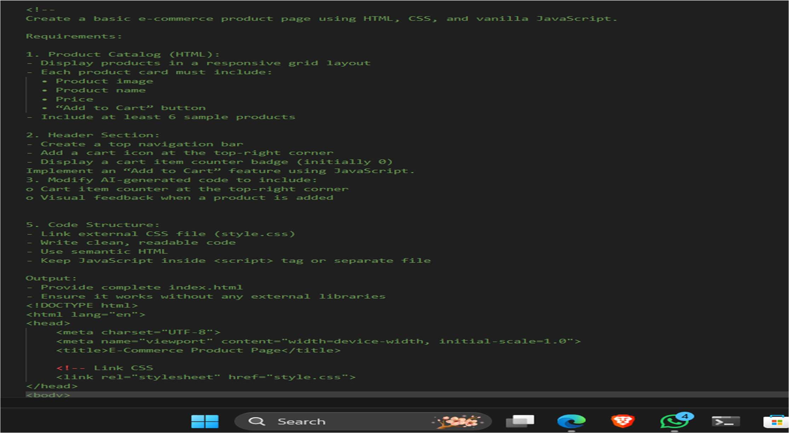

Task 4: AI-Assisted E-Commerce Product Page Scenario
A startup is developing a basic e-commerce product page to showcase products and manage simple cart functionality.
Tasks
- Use Copilot to generate a grid-based product catalog using HTML and CSS.
- Implement an “Add to Cart” feature using JavaScript.
- Modify AI-generated code to include:
  - Cart item counter at the top-right corner
  - Visual feedback when a product is added Expected Outcome
- Functional product catalog
- Working cart counter
- Interactive user experience

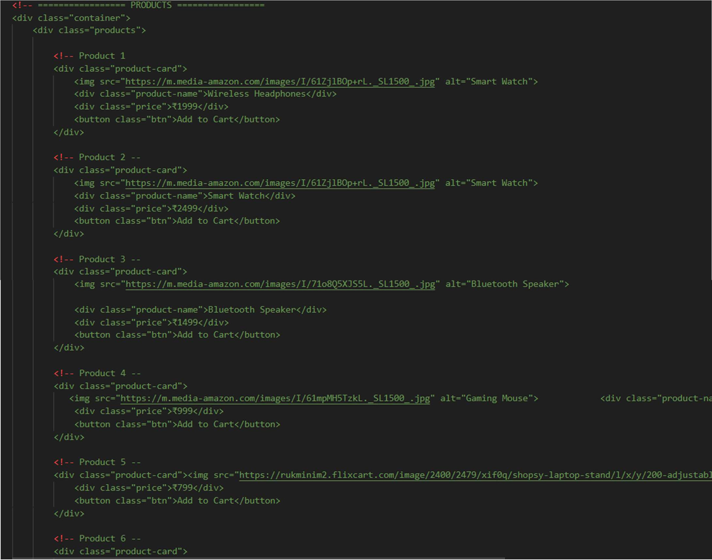

Output:
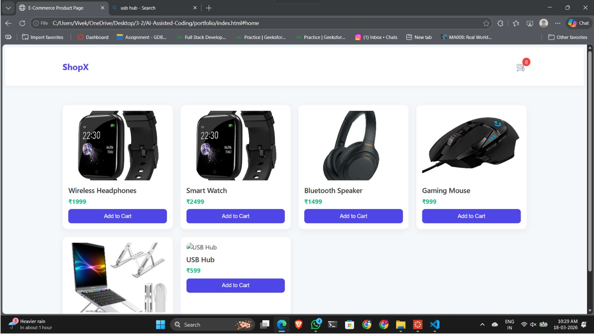

Task 5: Create a Responsive Web Page Layout Instructions:
- Design a basic web page layout with a header, main content area, and footer using HTML and CSS.
- Use AI to assist in generating responsive CSS for different screen sizes.
- Ensure the layout is clean and visually organized. Expected Output:
- A responsive web page with:
- Header with navigation links
- Main section with placeholder text/images
- Footer with copyright or contact info
- Layout adapts correctly to desktop, tablet, and mobile screen sizes.

CODE:
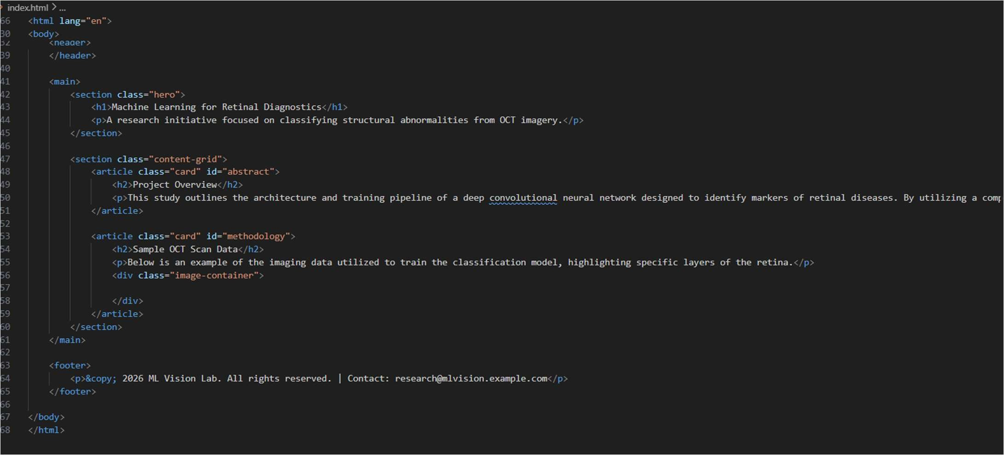
.
..
.
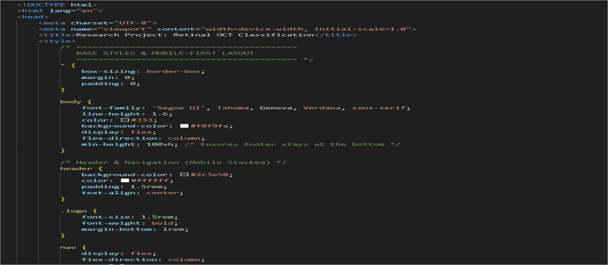

Output:

