Assignment 7.5
Name: Sanju ch
Ht no: 2303A52313
Batch No: 45

Task 1:
(Mutable Default Argument – Function Bug)
Task: Analyze given code where a mutable default argument causes unexpected behavior. Use AI to fix it.
# Bug: Mutable default argument
def add_item(item, items=[]):
items.append(item)
return items
print(add_item(1))
print(add_item(2))
Expected Output: Corrected function avoids shared list bug.

Prompt:Debug the error

Code:
def add_item(item, items=None):
if items is None:
items = []
items.append(item)
return items

print(add_item(1))
print(add_item(2))

Output:

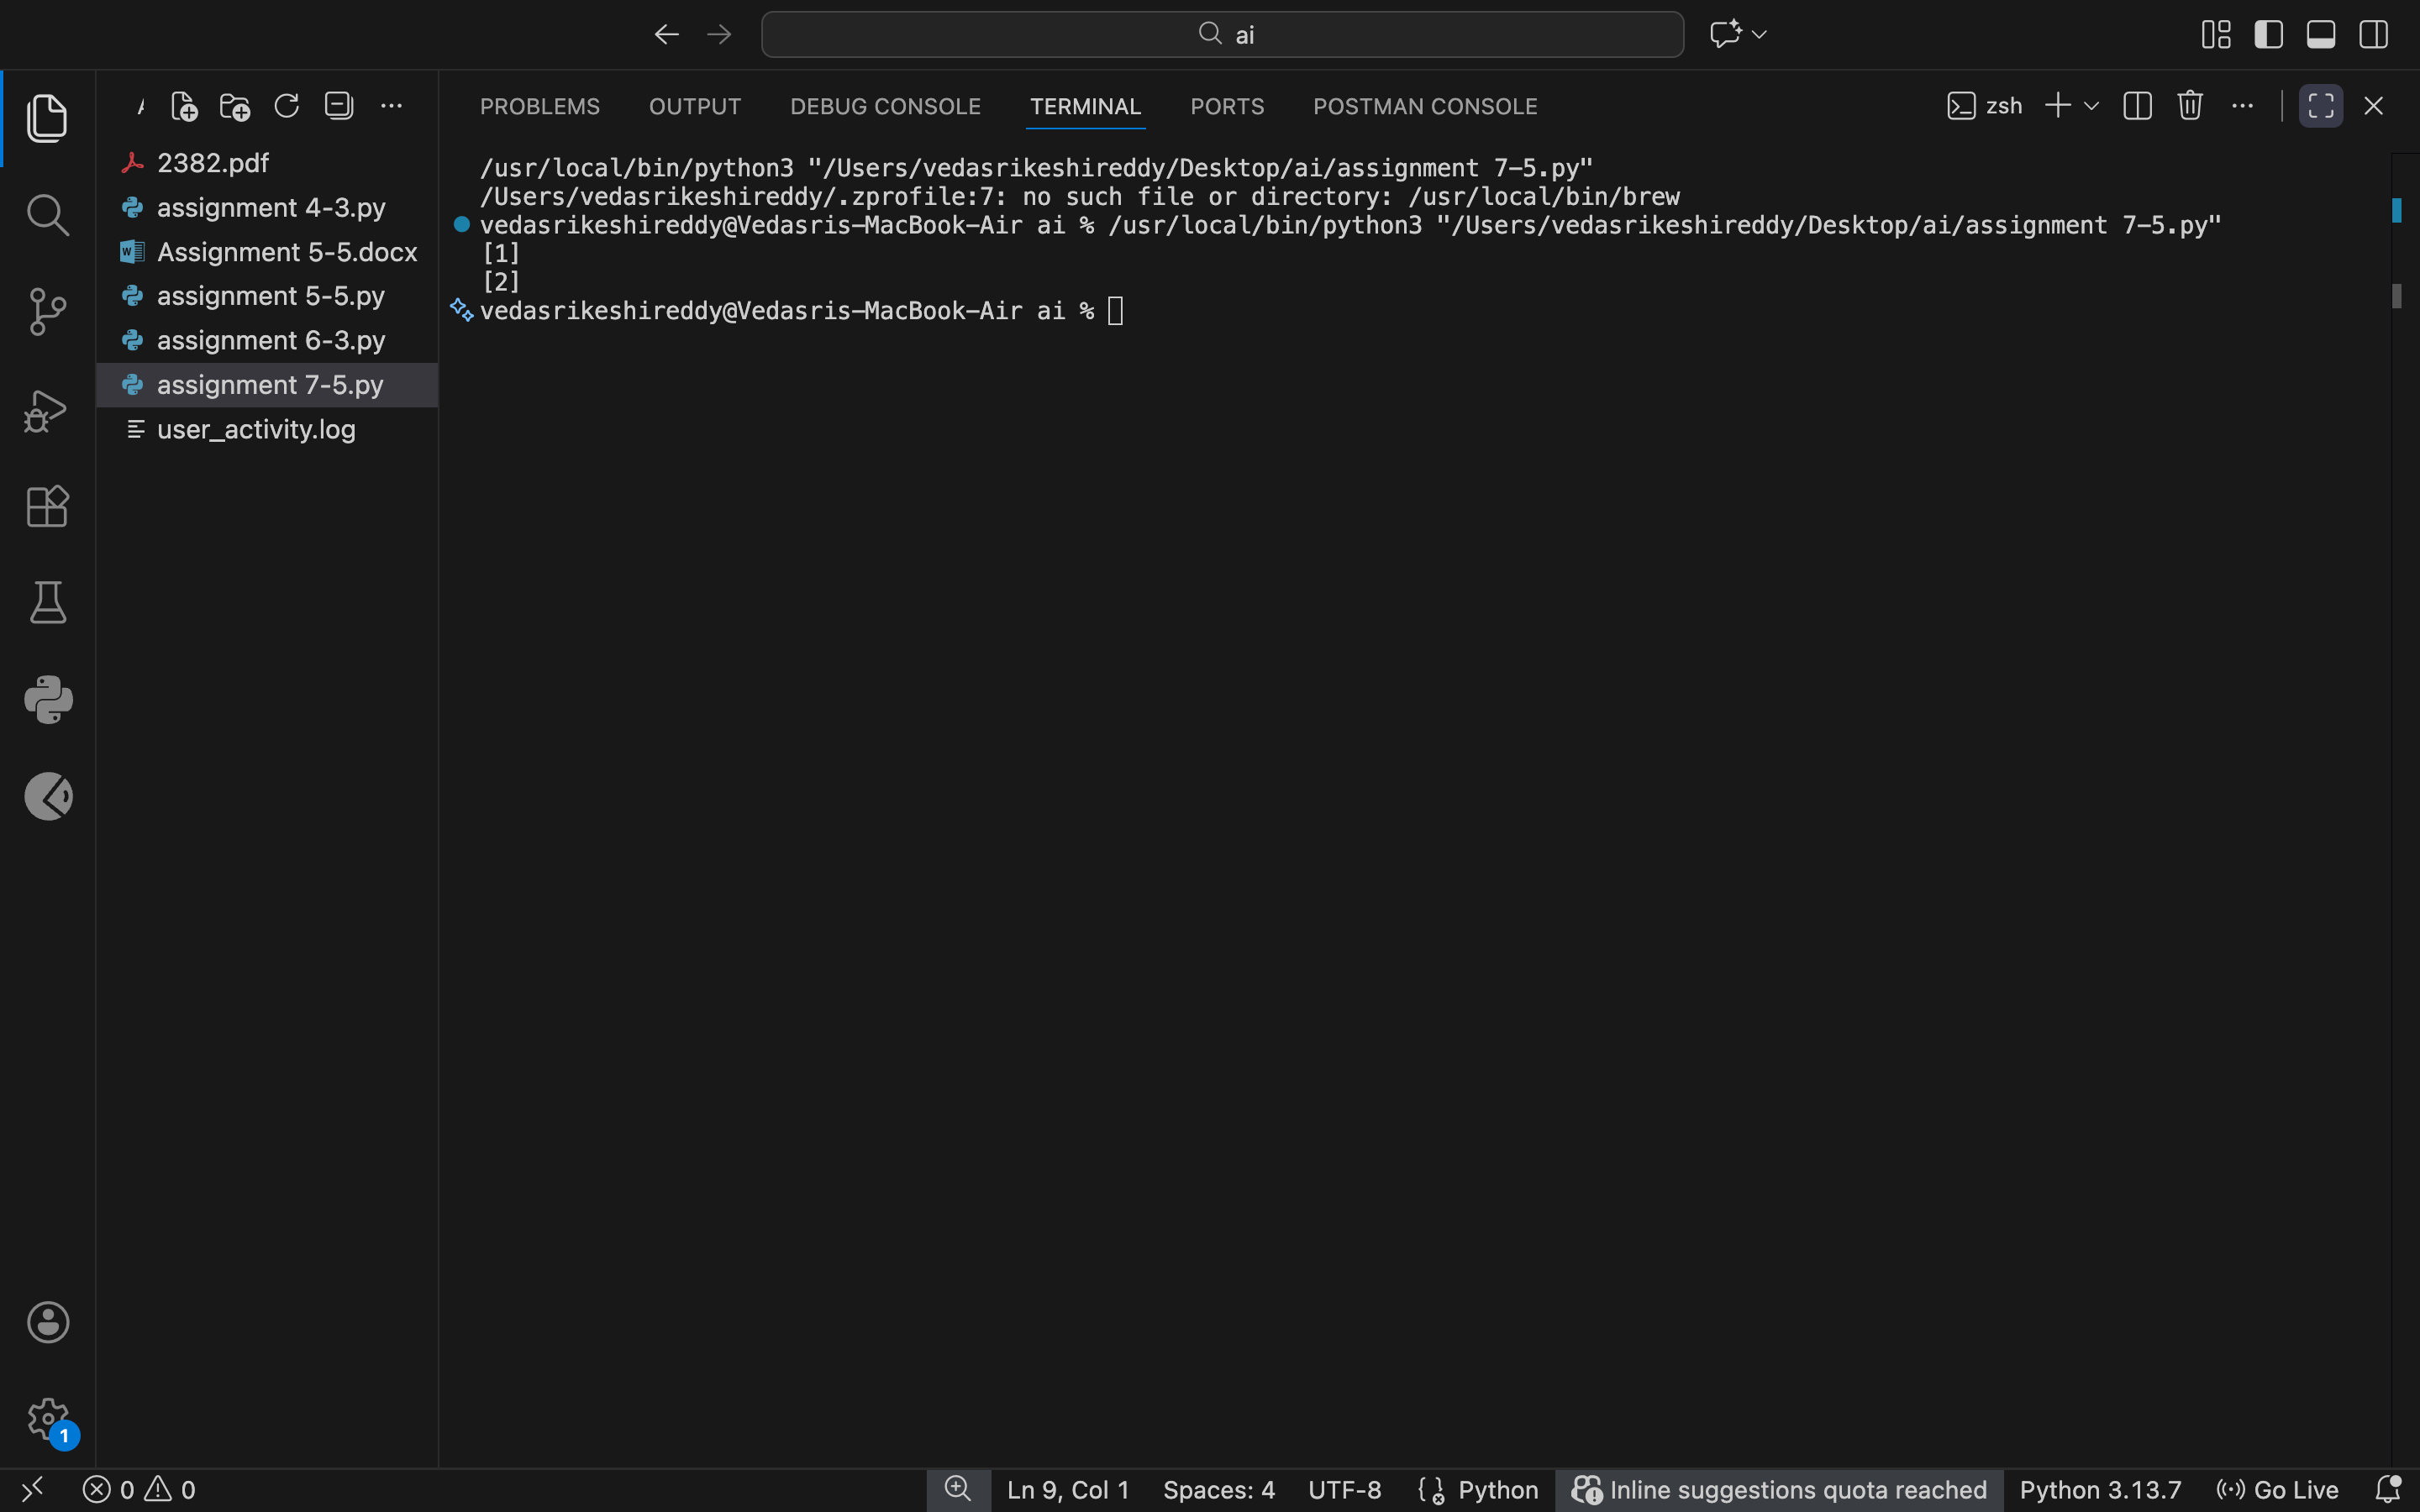

Justification:
The bug happens because the same list is reused every time the function is called. By using `None` and creating a new list inside the function, each call gets a fresh list. This prevents unexpected shared data.

Task 2
(Floating-Point Precision Error)
Task: Analyze given code where floating-point comparison fails. Use AI to correct with tolerance.
# Bug: Floating point precision issue
def check_sum():
return (0.1 + 0.2) == 0.3
print(check_sum())
Expected Output: Corrected function

Prompt:
Fix the floating point precision error

Code:
import math

def check_sum():
return math.isclose(0.1 + 0.2, 0.3)

print(check_sum())

Output:
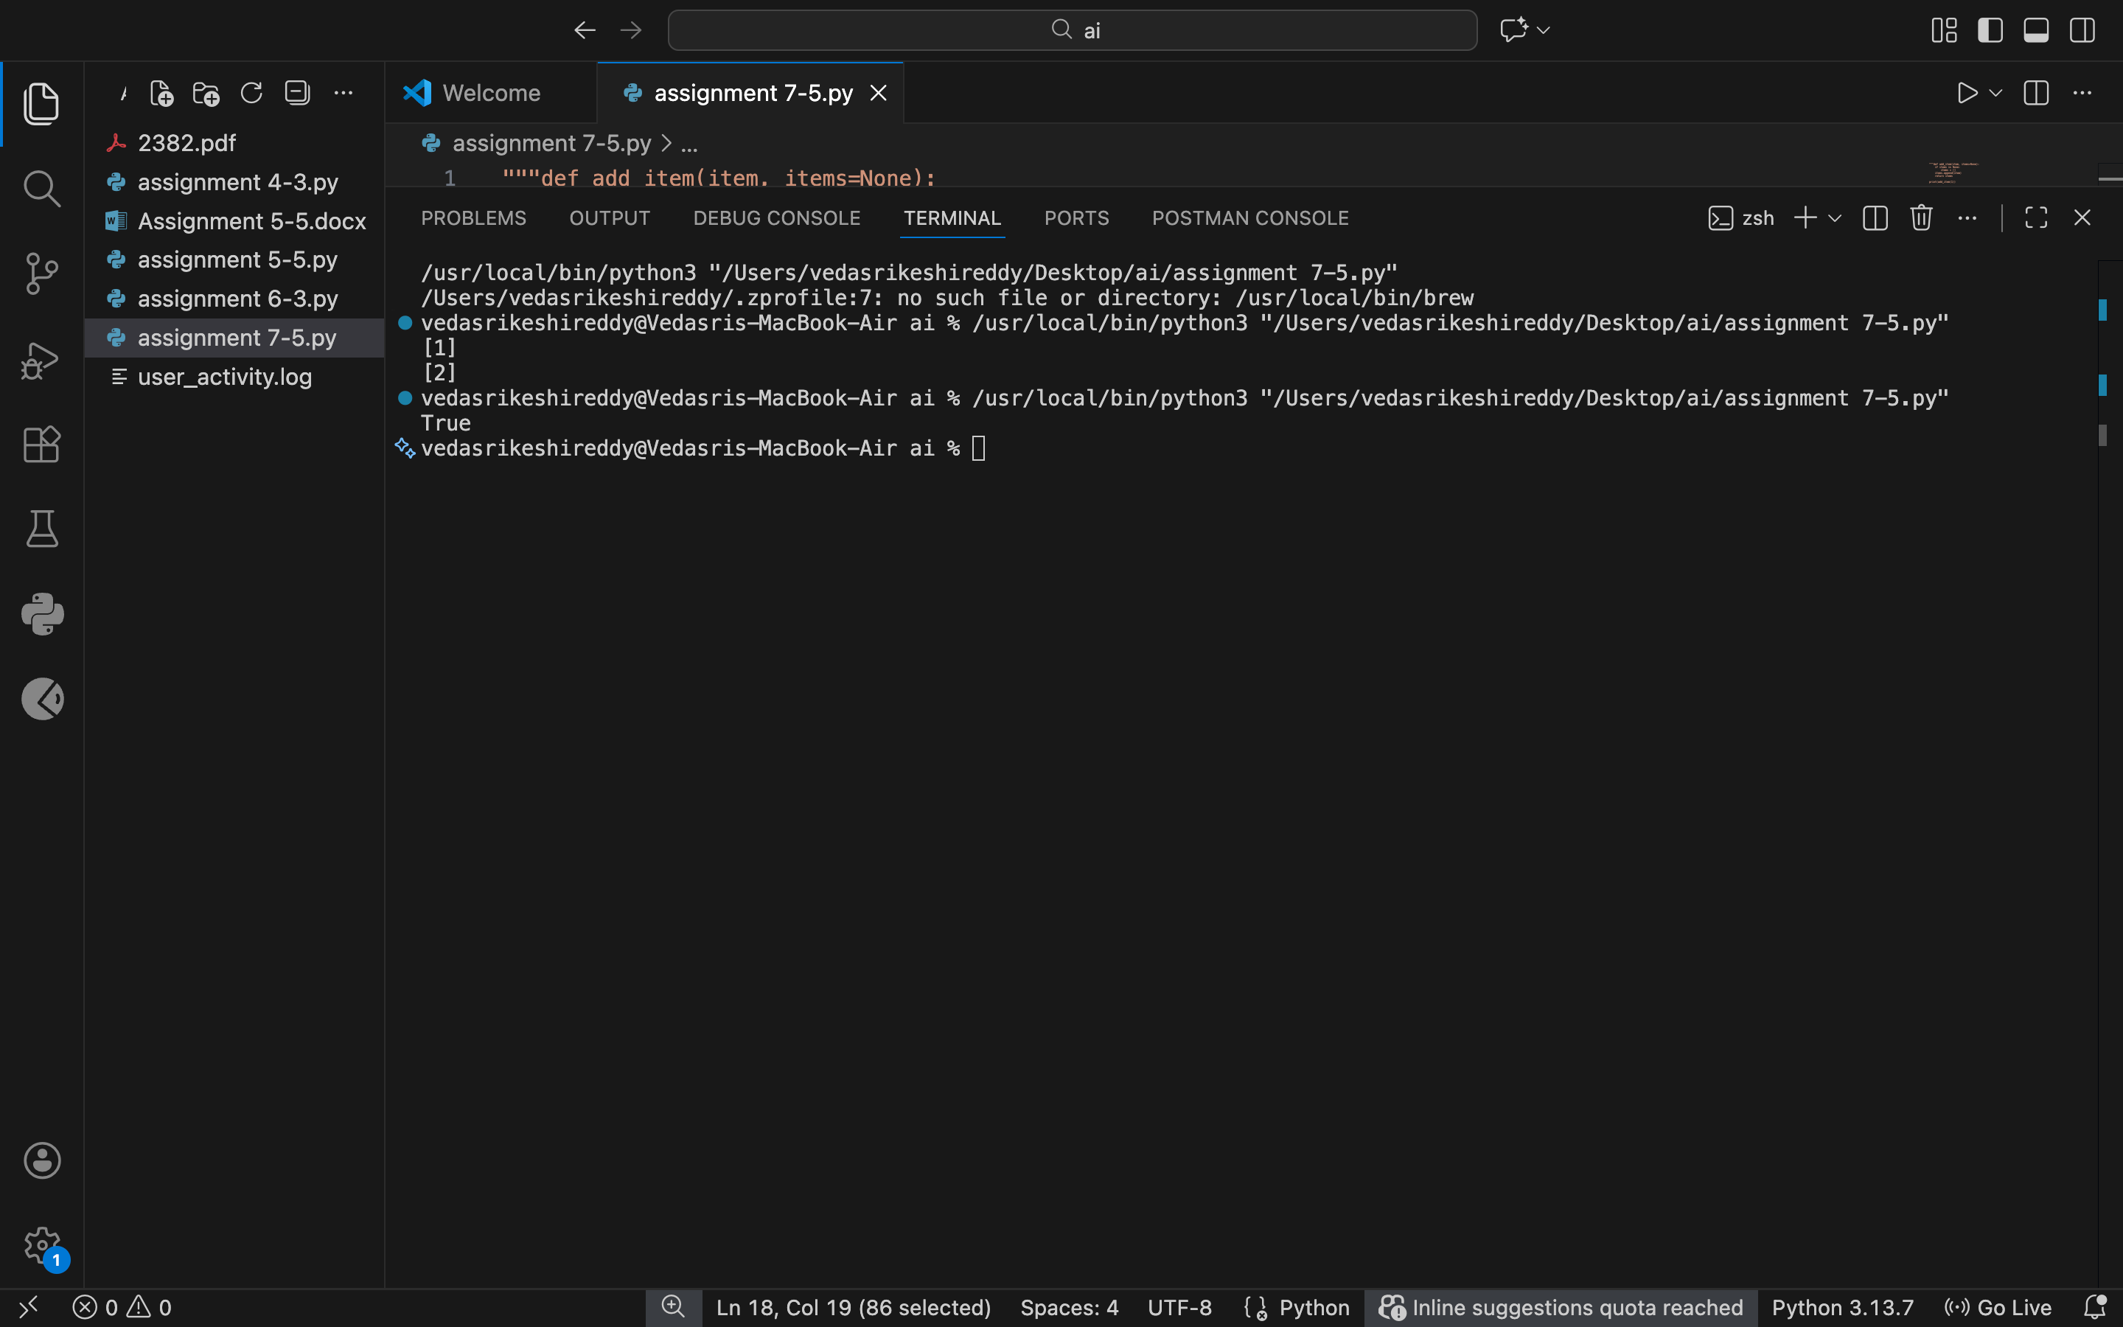

Justification:
Floating-point numbers are not stored exactly in memory, which causes direct comparisons to fail. Using a small tolerance helps compare values safely and gives accurate logical results.

Task 3
(Recursion Error – Missing Base Case)
Task: Analyze given code where recursion runs infinitely due to missing base case. Use AI to fix.
# Bug: No base case
def countdown(n):
print(n)
return countdown(n-1)
countdown(5)
Expected Output : Correct recursion with stopping condition.

Prompt: fix the recursion error

Code:
def countdown(n):
if n < 0:
return
print(n)
return countdown(n-1)

countdown(5)

Output:

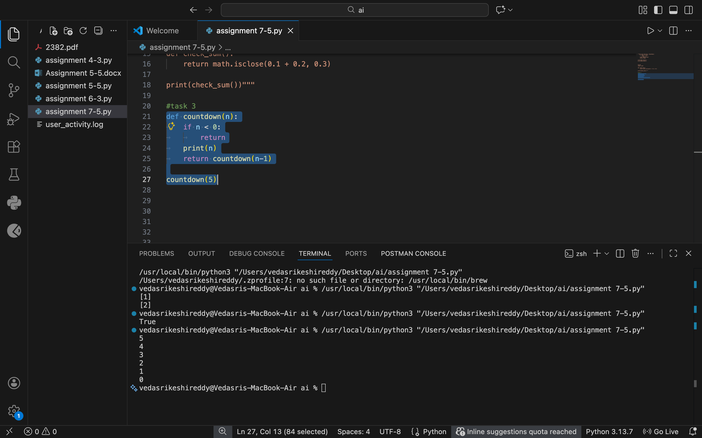

Justification:
Without a base case, the function keeps calling itself forever. Adding a stopping condition ensures the recursion ends properly and avoids stack overflow errors.

Task 4
Analyze given code where a missing dictionary key causes error. Use AI to fix it.
# Bug: Accessing non-existing key
def get_value():
data = {"a": 1, "b": 2}
return data["c"]
print(get_value())
Expected Output: Corrected with .get() or error handling.

Prompt:fix the Dictionary key error

Code:
def get_value():
data = {"a": 1, "b": 2}
return data.get("c", None)

print(get_value())

Output:
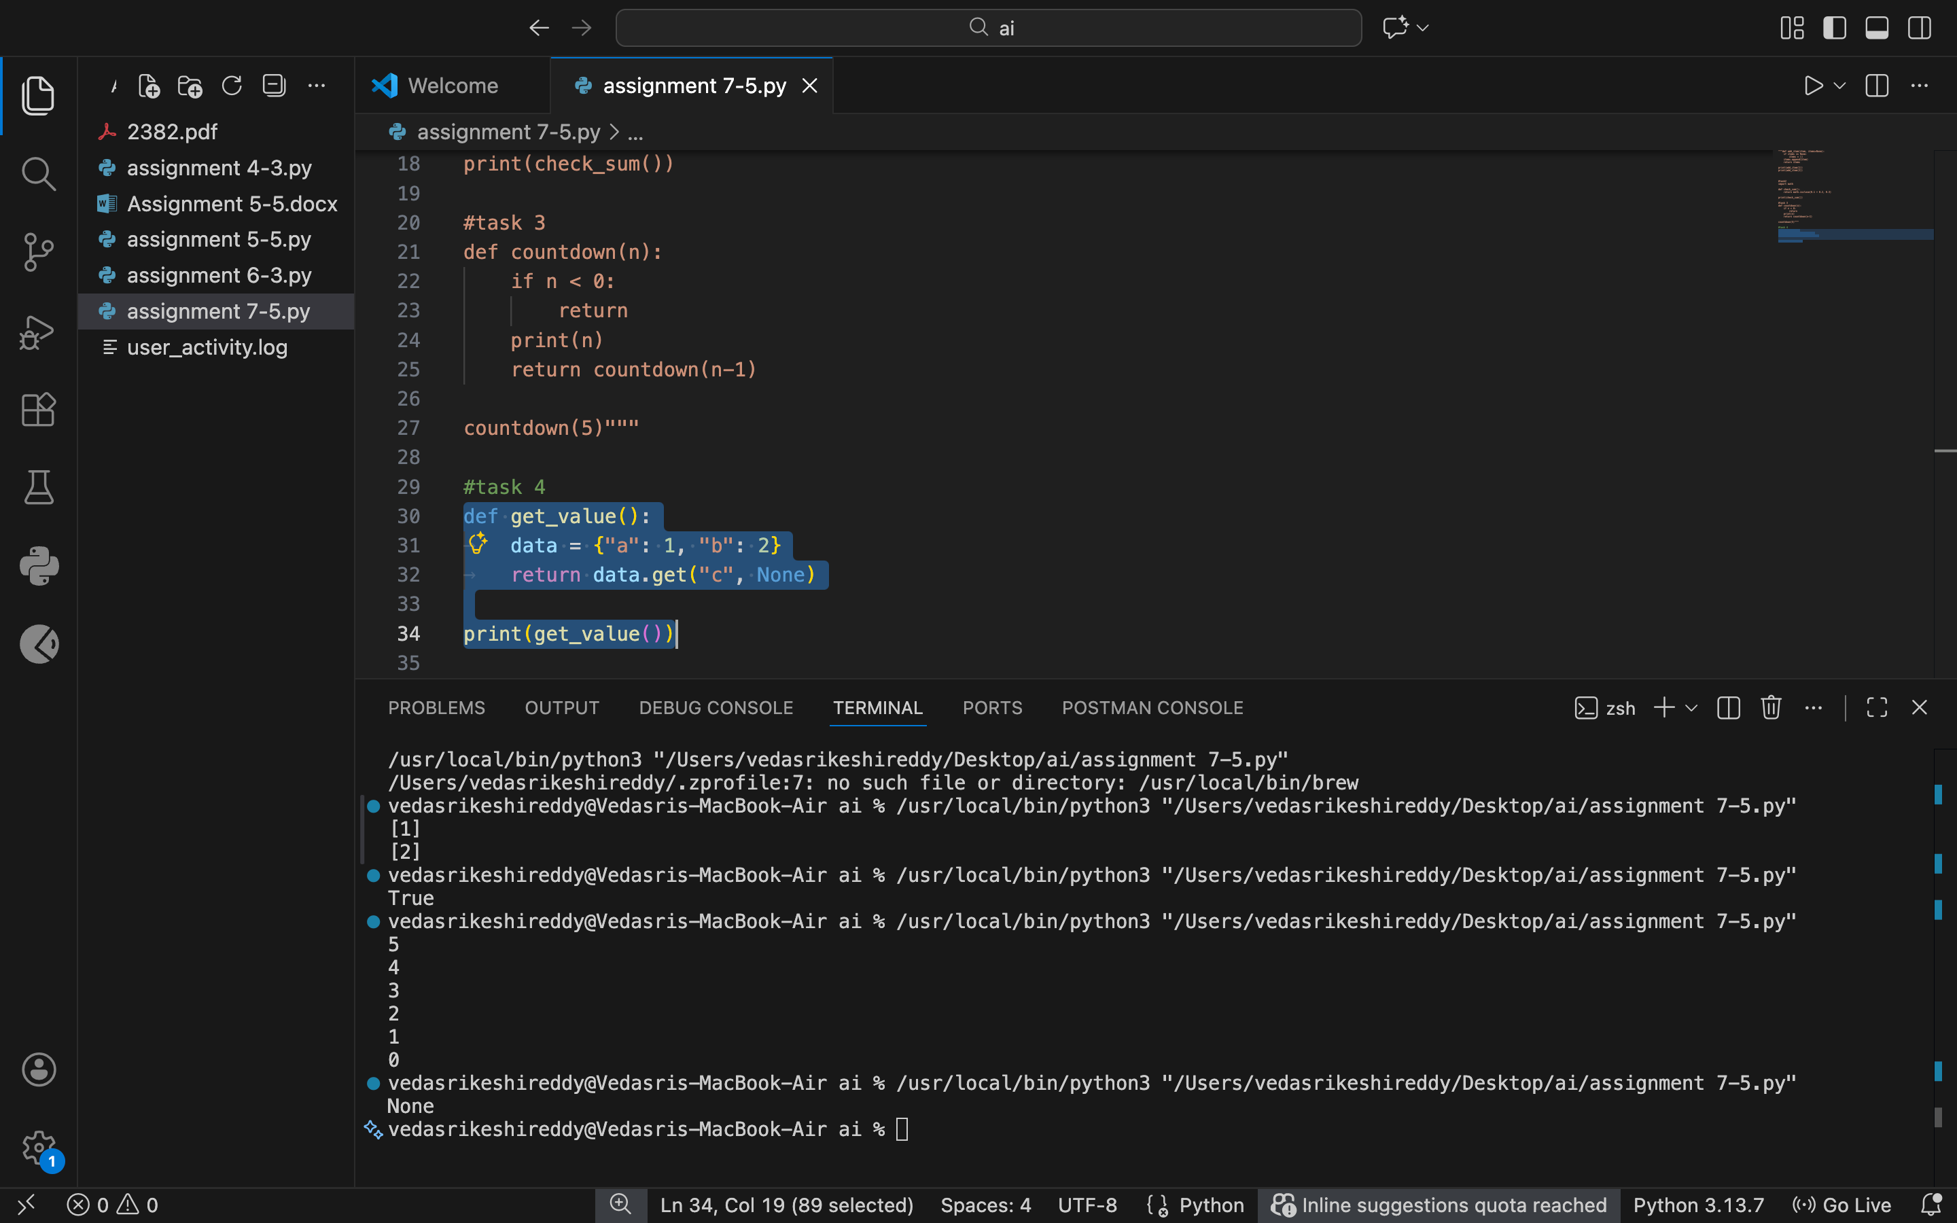

Justification:

Accessing a key that doesn’t exist causes a runtime error. Using `.get()` safely handles missing keys and prevents the program from crashing.

Task 5
Task: Analyze given code where loop never ends. Use AI to detect and fix it.
# Bug: Infinite loop
def loop_example():
i = 0
while i < 5:
print(i)
Expected Output: Corrected loop increments i.

Prompt: Fix the infinite loop.

Code:
def loop_example():
i = 0
while i < 5:
print(i)
i += 1

loop_example()

Output:

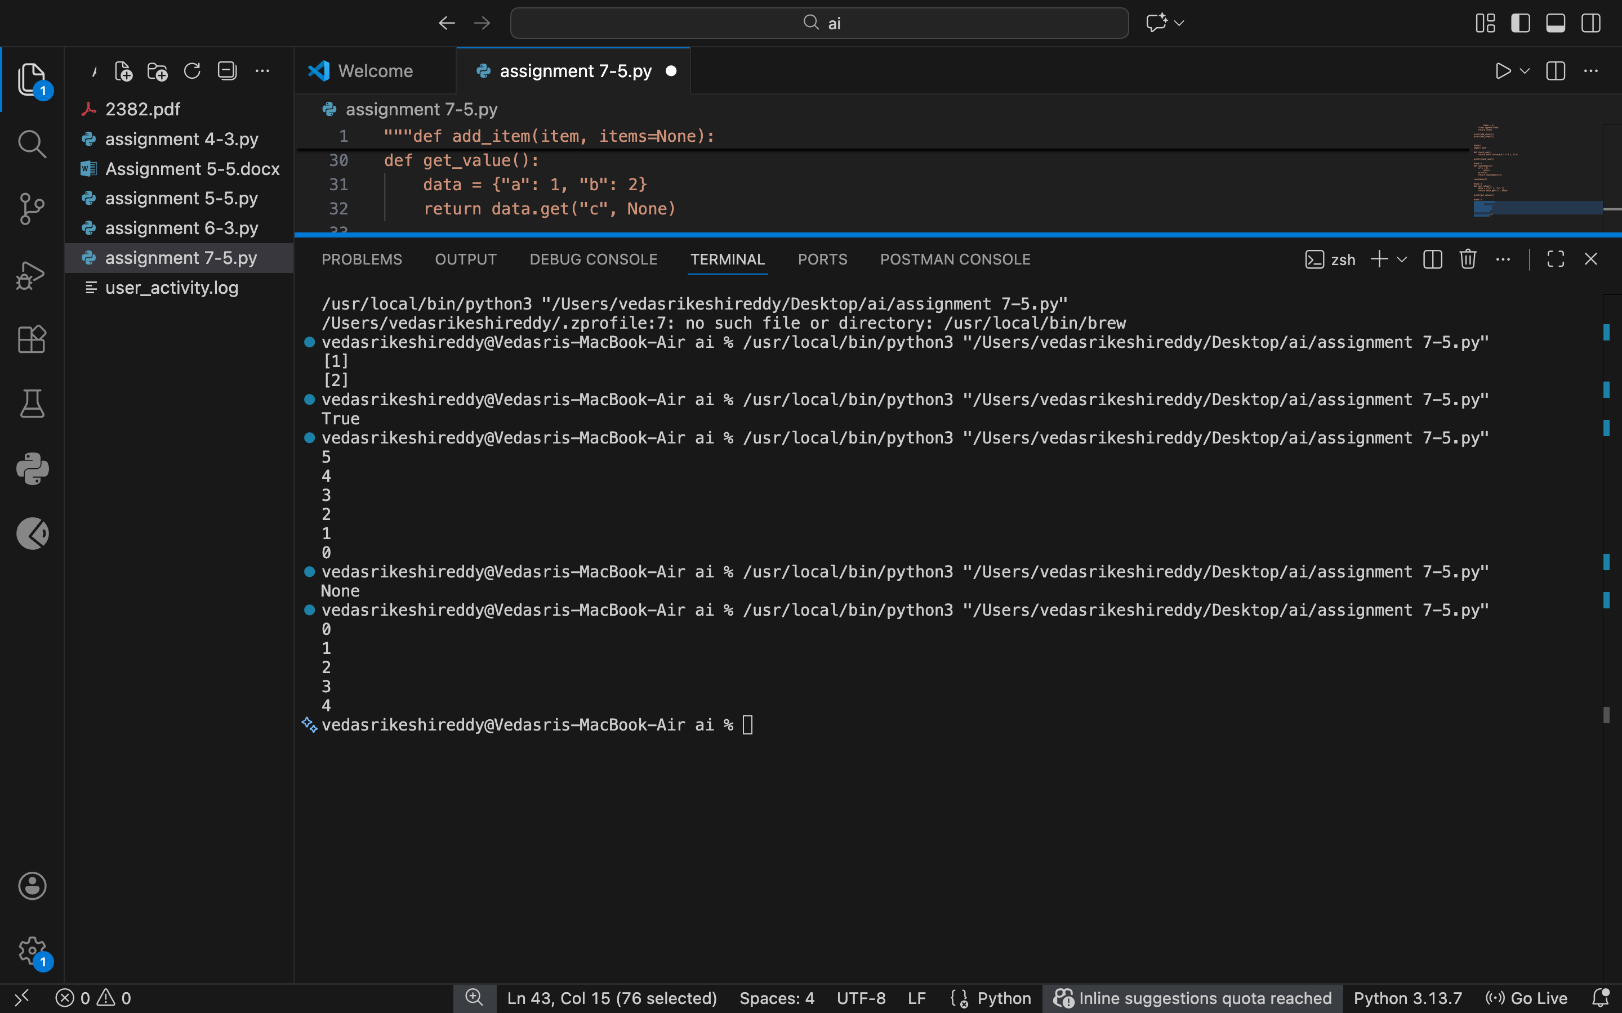

Justification:
The loop never ends because the counter variable is never updated. Incrementing the variable inside the loop allows the condition to eventually fail and stop execution.

Task 6
Task: Analyze given code where tuple unpacking fails. Use AI to fix it.
# Bug: Wrong unpacking
a, b = (1, 2, 3)
Expected Output: Correct unpacking or using _ for extra values.

Prompt:Fix the unpacking error

Code:
a, b, c = (1, 2, 3)
print(a, b, c)

Output:

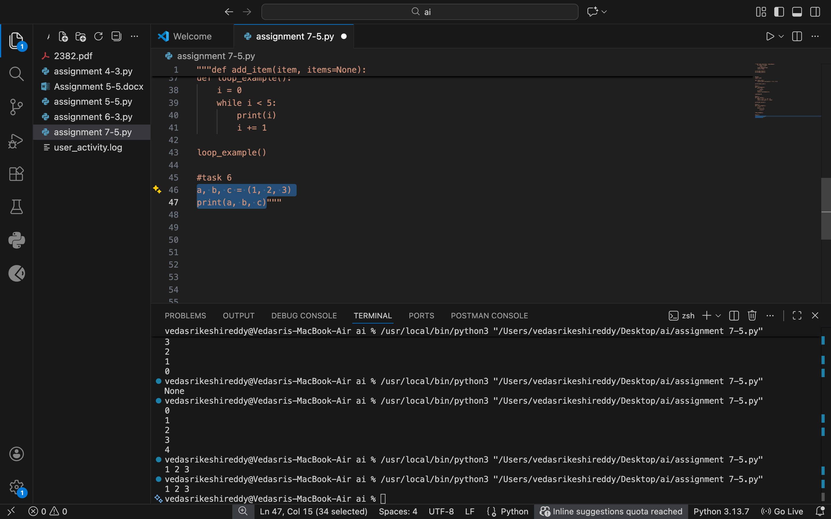

Justification:
The error occurs because there are more values than variables to unpack. Using an underscore or matching variable count correctly fixes the issue cleanly.

Task 7
Analyze given code where mixed indentation breaks execution. Use AI to fix it.
# Bug: Mixed indentation
def func():
x = 5
y = 10
return x+y
Expected Output : Consistent indentation applied.

Prompt:fix the mixed indentation

Code:
def func():
x = 5
y = 10
return x+y

print(func())

Output:
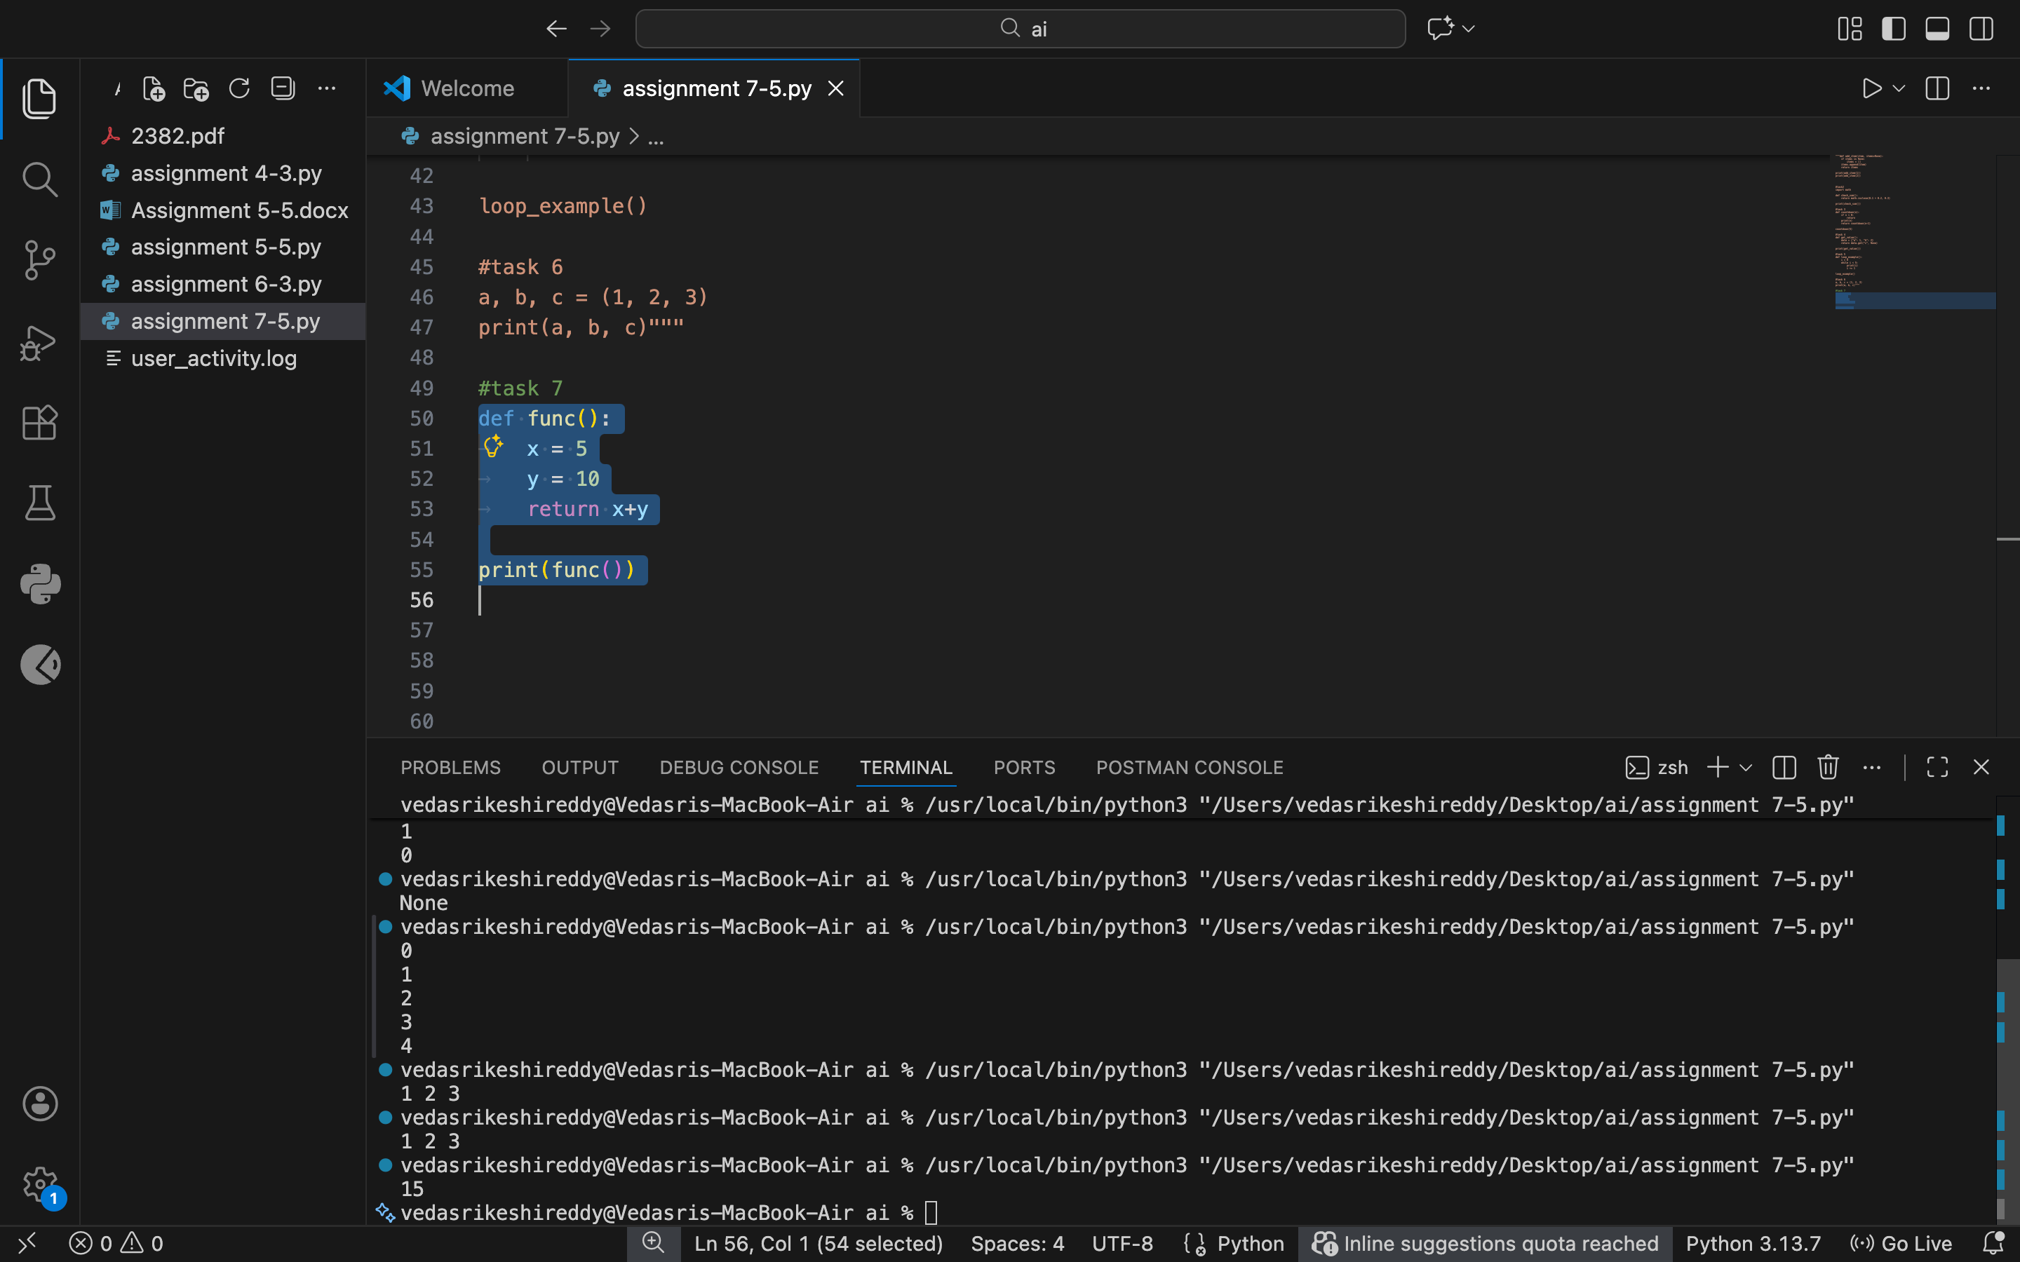

Justification:
Python relies on consistent indentation for code blocks. Fixing the indentation using spaces throughout ensures the code runs without syntax errors.

Task 8
Task: Analyze given code with incorrect import. Use AI to fix.
# Bug: Wrong import
import maths
print(maths.sqrt(16))
Expected Output: Corrected to import math
Prompt: fix the import error

Code:
import math
print(math.sqrt(16))

Output:
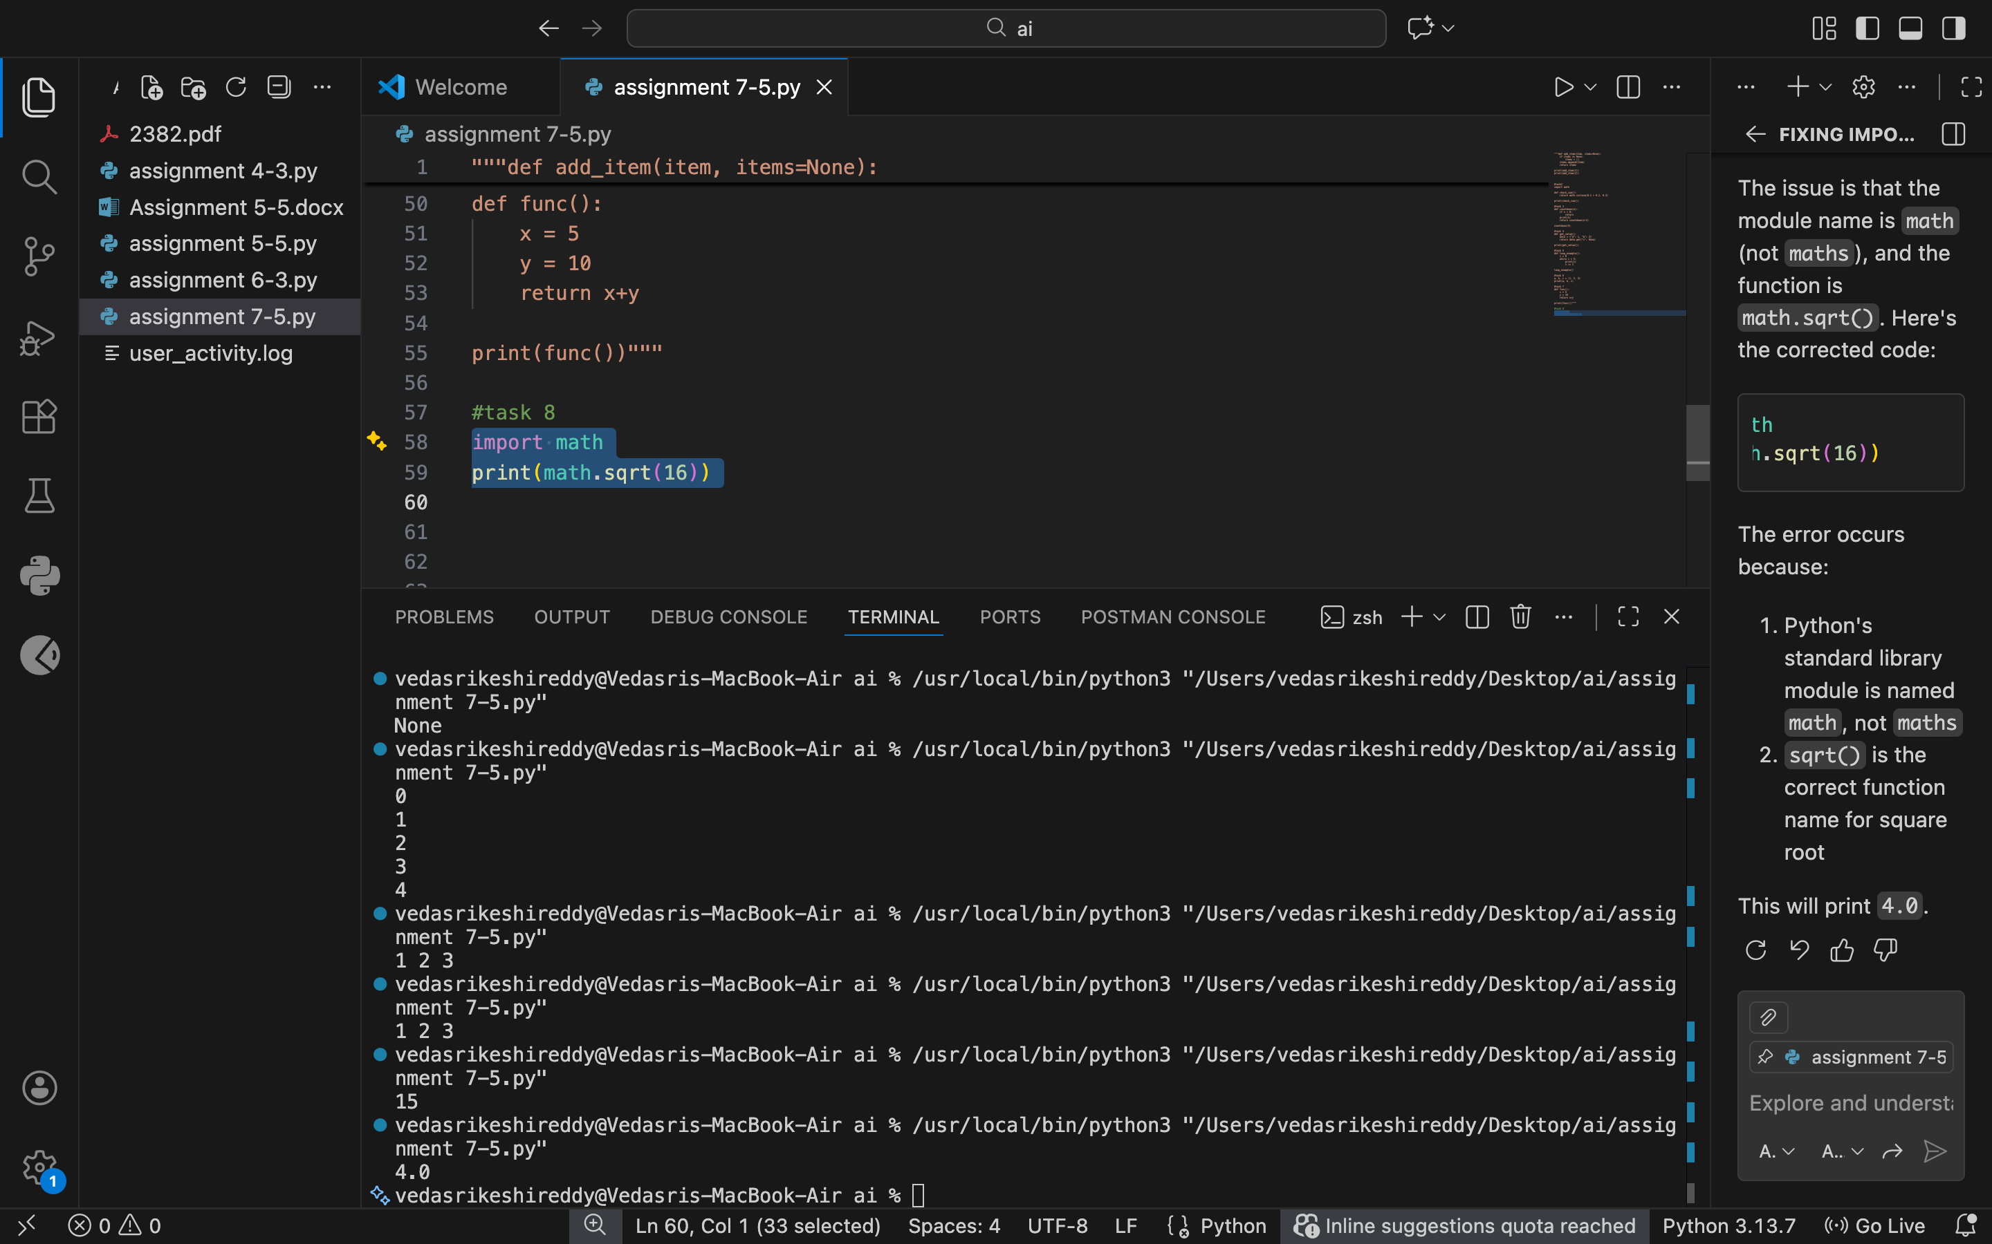

Justification:
The module name was incorrect, leading to an import failure. Correcting the module name allows Python to access the required functions properly.

Task 9
Task: Analyze given code where a return inside a loop prevents full iteration. Use AI to fix it.
# Bug: Early return inside loop
def total(numbers):
for n in numbers:
return n
print(total([1,2,3]))
Expected Output: Corrected code accumulates sum and returns after loop.

Prompt:fix the return inside a loop

Code:
def total(numbers):
sum_total = 0
for n in numbers:
sum_total += n
return sum_total
print(total([1, 2, 3]))

Output:
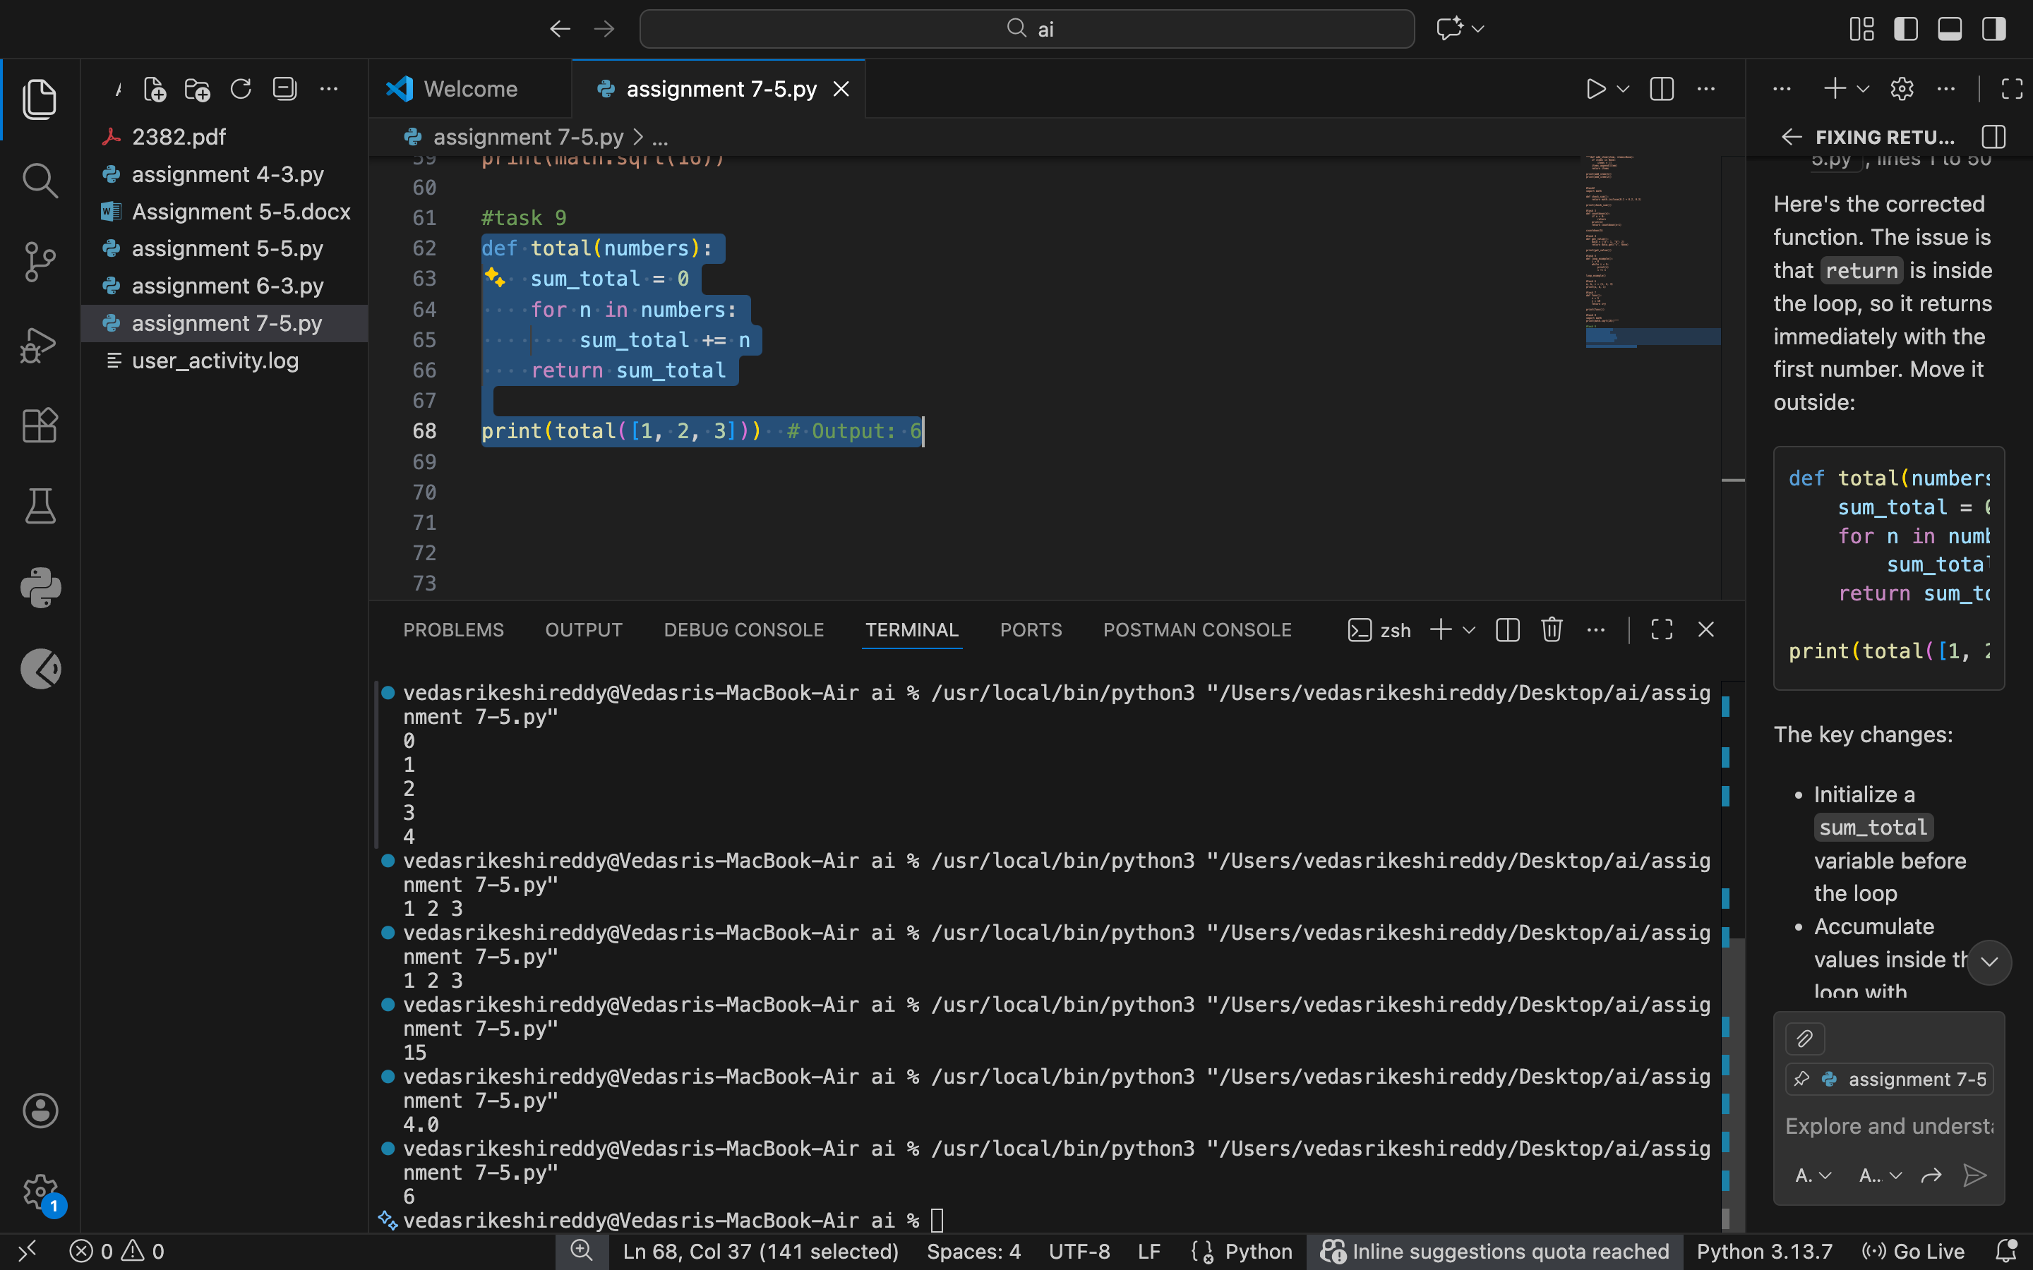

Justification:
Returning inside the loop exits the function after the first iteration. Moving the return statement outside the loop ensures all values are processed.

Task 10
Analyze given code where a variable is used before being defined. Let AI detect and fix the error.
# Bug: Using undefined variable
def calculate_area():
return length * width
print(calculate_area())
Requirements:
- Run the code to observe the error.
- Ask AI to identify the missing variable definition.
- Fix the bug by defining length and width as parameters.
- Add 3 assert test cases for correctness.
Expected Output :
- Corrected code with parameters.
- AI explanation of the bug.
Successful execution of assertions.

Prompt:
fix the name error with 3 test cases

Code:
def calculate_area(length, width):
return length * width

# Test case 1
print(calculate_area(5, 10)) # Output: 50

# Test case 2
print(calculate_area(3, 7)) # Output: 21

# Test case 3
print(calculate_area(4, 4)) # Output: 16

Output:
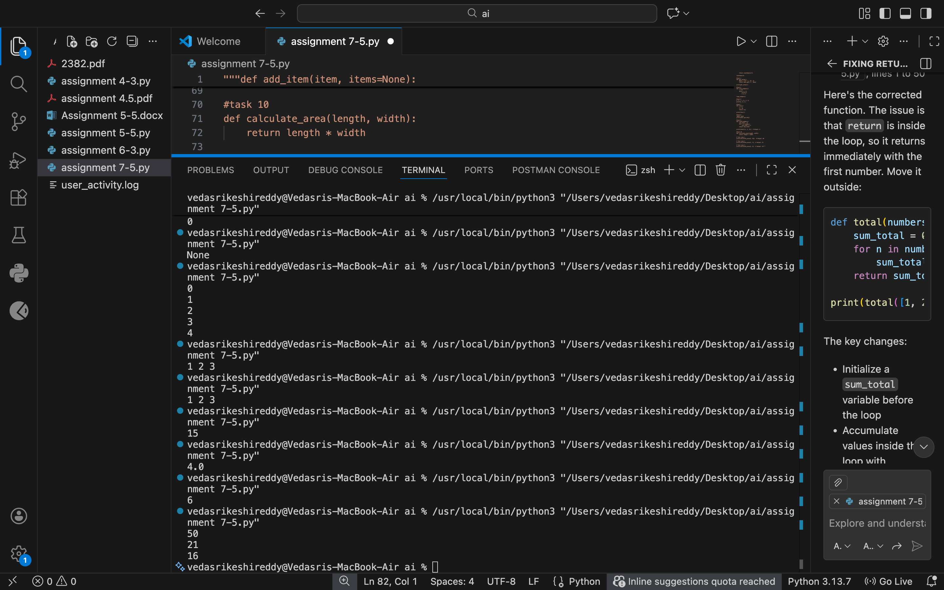

Justification:
The variables were used without being defined. Passing them as function parameters makes the function reusable and removes the name error.

Task 11
Task: Analyze given code where integers and strings are added incorrectly. Let AI detect and fix the error.
# Bug: Adding integer and string
def add_values():
return 5 + "10"
print(add_values())
Requirements:
- Run the code to observe the error.
- AI should explain why int + str is invalid.
- Fix the code by type conversion (e.g., int("10") or str(5)).
- Verify with 3 assert cases.
Expected Output #6:
- Corrected code with type handling.
- AI explanation of the fix.
Successful test validation.

Prompt:
fix the type error with 3 test cases

Code:
def add_values():
return 5 + int("10")

# Test case 1
print(add_values()) # Output: 15

# Test case 2
print(5 + int("20")) # Output: 25

# Test case 3
print(10 + int("5")) # Output: 15

Output:

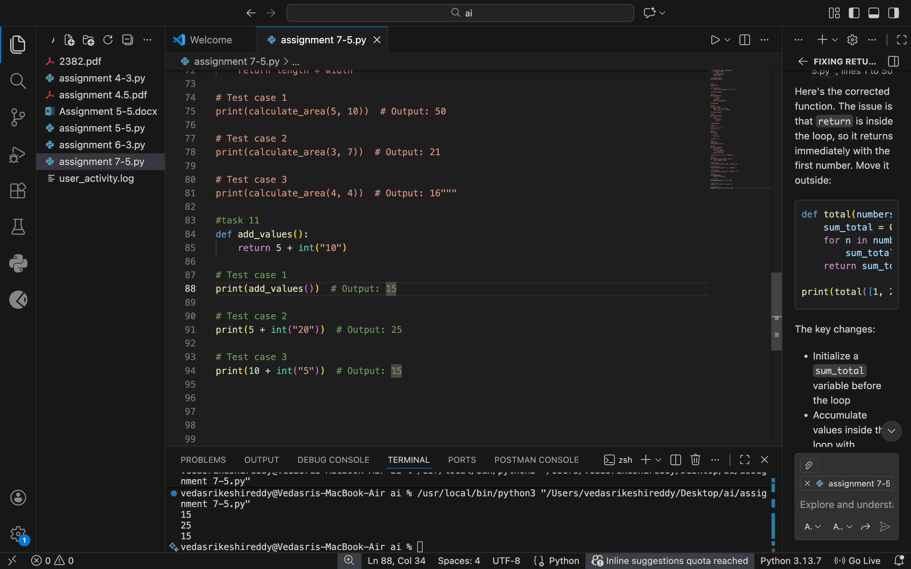

Justification:
Python does not allow adding integers and strings directly. Converting one type to match the other ensures valid operations and correct output.

Task 12
Task: Analyze code where a string is incorrectly added to a list.
# Bug: Adding string and list
def combine():
return "Numbers: " + [1, 2, 3]
print(combine())
Requirements:
- Run the code to observe the error.
- Explain why str + list is invalid.
- Fix using conversion (str([1,2,3]) or " ".join()).
- Verify with 3 assert cases.
Expected Output:
- Corrected code
- Explanation
- Successful test validation

Prompt:
fix the type error with 3 testcases

Code:
def combine():
return "Numbers: " + str([1, 2, 3])

# Test case 1
print(combine()) # Output: Numbers: [1, 2, 3]

# Test case 2
print("Numbers: " + str([4, 5, 6])) # Output: Numbers: [4, 5, 6]

# Test case 3
print("Numbers: " + str([7, 8, 9])) # Output: Numbers: [7, 8, 9]

Output:
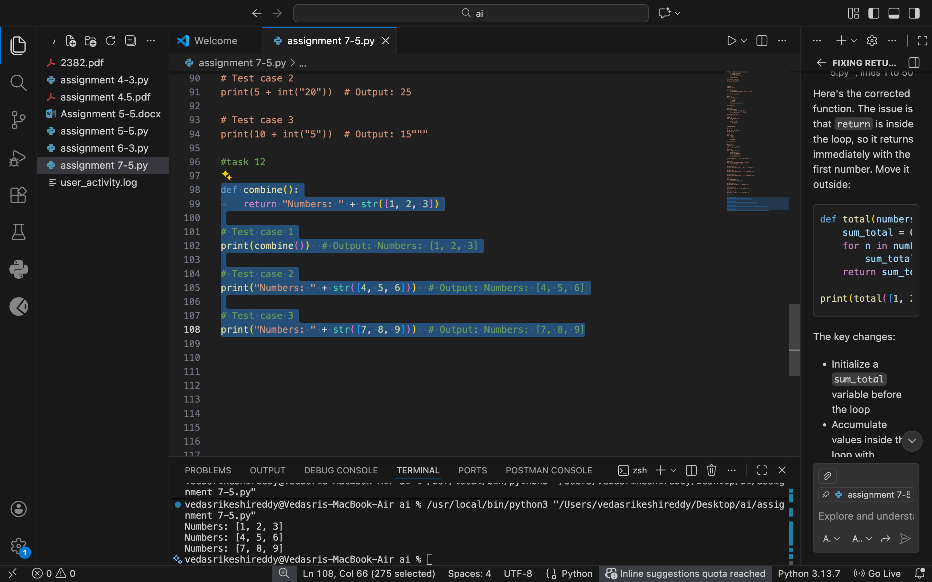

Justification:
Strings and lists cannot be concatenated directly. Converting the list to a string or joining its elements resolves the type mismatch.

Task 13
Task: Detect and fix code where a string is multiplied by a float.
# Bug: Multiplying string by float
def repeat_text():
return "Hello" * 2.5
print(repeat_text())
Requirements:
- Observe the error.
- Explain why float multiplication is invalid for strings.
- Fix by converting float to int.
- Add 3 assert test cases.

Prompt:
fix the typeerror with 3 examples

Code:
ef repeat_text():
return "Hello" * int(2.5)

# Test case 1
print(repeat_text()) # Output: HelloHello

# Test case 2
print("Hi" * int(3.7)) # Output: HiHiHi

# Test case 3
print("Python" * int(1.9)) # Output: Python

Output:
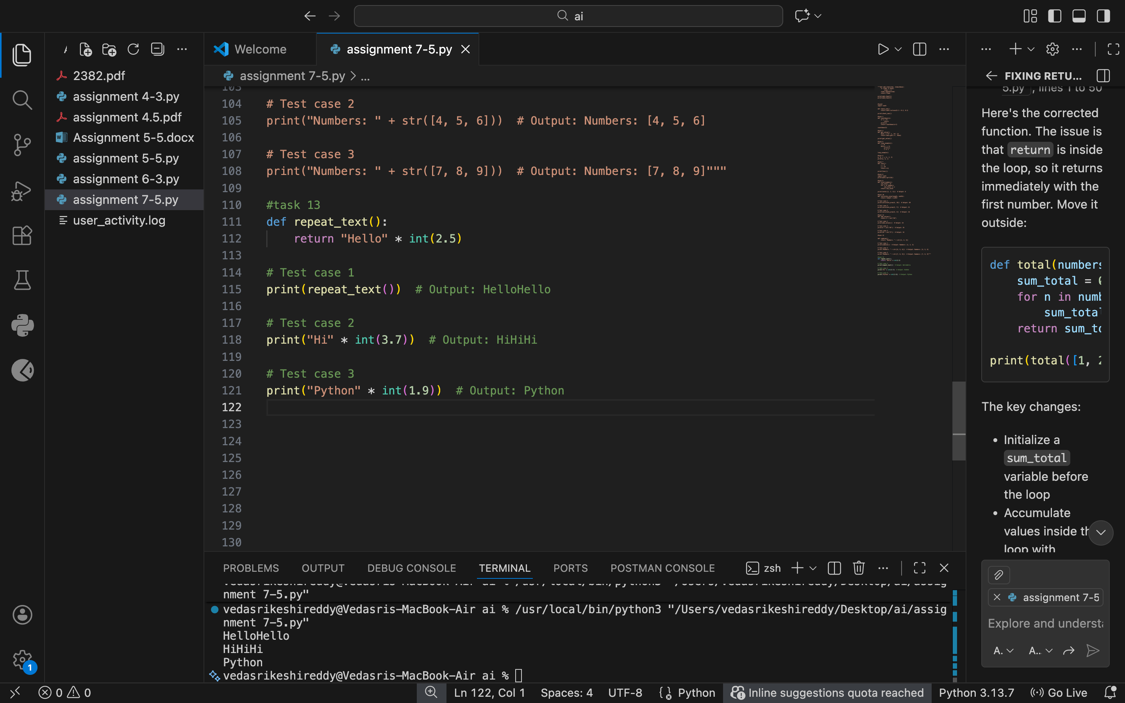

Justification:
Strings can only be multiplied by integers, not floats. Converting the float to an integer makes repetition valid and predictable.

