Wireframe Documentation Amazon Food Sales Data Analysis

Revision Number: 1.0 Last date of revision: 18/4/2024

Sanjudevi Gupta

# Contents

1. Dashboard 3
   1. Cards 3
   2. Revenue by Quarter 3
   3. Revenue by Country 4
   4. Top 5 products 5
   5. Product sales by country Wise 5
   6. Data Table of countries based on month , item type ,order priority , cost and revenue 6
   7. Latest Date 7
   8. Clear filters 7

# Dashboard

# 

* 1. Cards

The card slicers that shows Unit sold, Cost, Profit, Revenue.

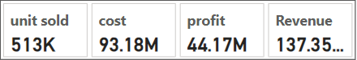

* 1. Revenue by quarter

The area chart for monthly, yearly and quarterly sales

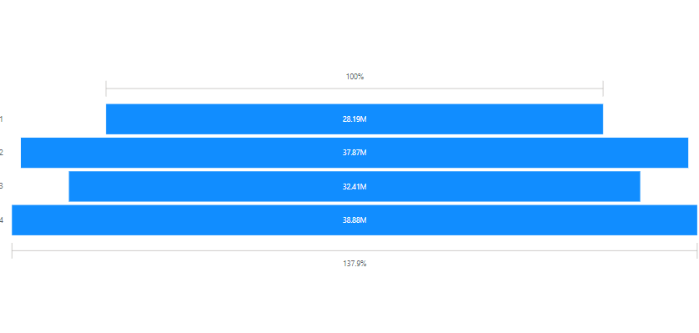

* 1. Revenue by Country

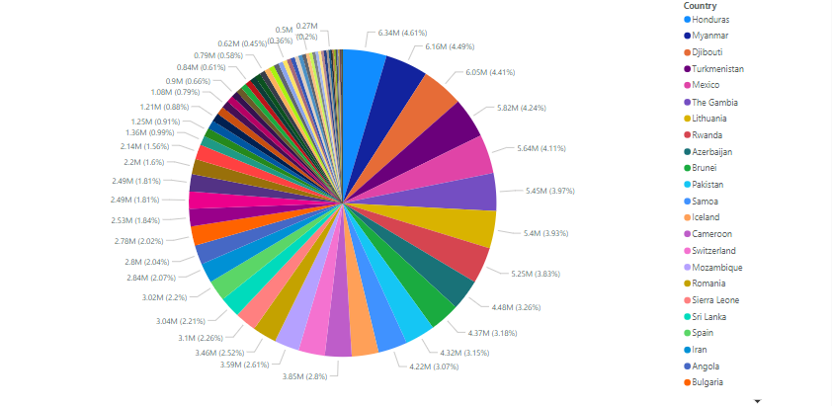

* 1. Top 5 products

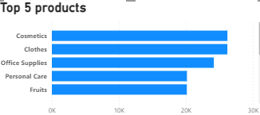

* 1. Product sales by country wise

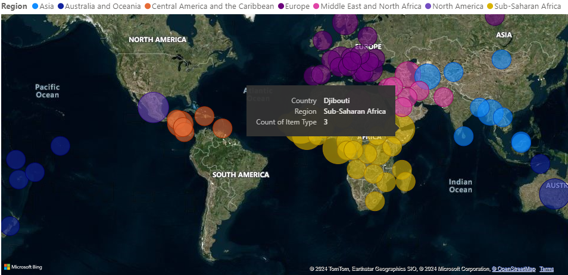

1.6 Data Table of countries based on month , item type ,order priority , cost and revenue

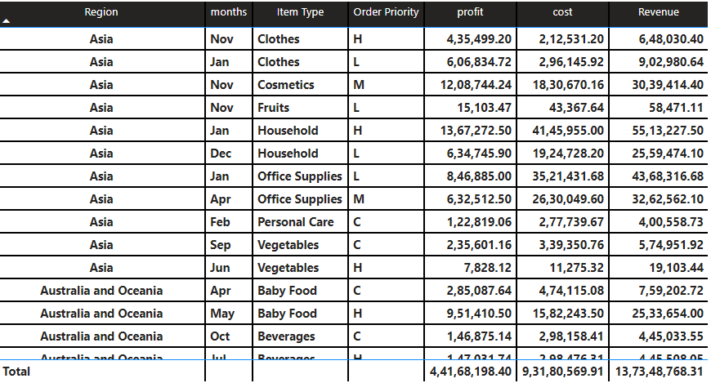

1.7 It’s show the latest date



1.8 Clear filter’s

