PROJECT
Project Title:
HematoVision: Advanced Blood Cell Classification Using Transfer Learning

Team Id: LTVIP2026TMIDS38170
Team Members:
Sanjeeva Reddy Muvva (Team Leader)
Nithin Pamarthi
Nasanuru Bharath
Pemmakkagari Manohar Reddy

Phase-1: Brainstorming & Ideation
Objective:
To develop an AI-powered blood cell classification system using transfer learning that enhances diagnostic accuracy, reduces manual analysis time, and supports healthcare applications such as automated diagnostics, remote consultations, and medical education.

Key Points:
- Problem Statement:
    - Microscopic analysis of blood cells plays a critical role in diagnosing conditions such as leukemia, anemia, and infections. However, manual analysis is time-consuming and subject to human error.
    - HematoVision utilizes transfer learning to classify blood cell types from microscopic images accurately. By integrating Al into hematovision system enhances diagnostic speed, precision, and reliability, supporting early disease detection and improves patient outcomes.
- Proposed Solution:
    - An AI-powered application that uses transfer learning to accurately classify blood cells from microscope images in real-time.
    - It helps doctors by providing quick, reliable results, reducing manual effort and improving the speed and accuracy of diagnosis.
- Target Users:
    - Pathologists and lab technicians who need quick and accurate blood cell analysis.
    - Hospitals and diagnostic centres aiming to automate blood smear classification.
    - Doctors offering remote consultations who require fast diagnostic support.
    - Medical students and trainees learning about blood cell identification.
- Expected Outcome:
  - A functional AI-powered application that accurately classifies blood cells from images using transfer learning.
  - Provides fast, reliable diagnostic support to improve efficiency in medical analysis and education.

Phase-2: Requirement Analysis
Objective:
Define the technical and functional requirements for the HematoVision application.
Key Points:
- Technical Requirements:
  - Programming Language: Python
NumPy, Pandas, Scikit-learn, Matplotlib, SciPy, ● Python Packages:
Seaborn, TensorFlow, Flask
  - Frameworks: Flask for web integration, TensorFlow for deep learning
  - Pre-trained Model: VGG16 (used for transfer learning)
  - Development Tools: Command Line (pip install)
- Functional Requirements:
  - Ability to upload microscopic blood cell images through the web interface.
  - Classify blood cells into types like eosinophils, lymphocytes, monocytes, and neutrophils using a trained model.
  - Display classification results along with prediction confidence.
  - Provide an easy-to-use interface for doctors, students, and lab technicians.
- Constraints & Challenges:
  - Handling imbalanced data across different blood cell classes.
  - Managing low-quality or blurry microscope images that affect prediction accuracy.
  - Optimizing model size and performance for faster processing and easy deployment.
  - Ensuring the web interface is responsive and user-friendly on all devices.

Phase-3: Project Design
Objective:
Develop the architecture and user flow of the application.
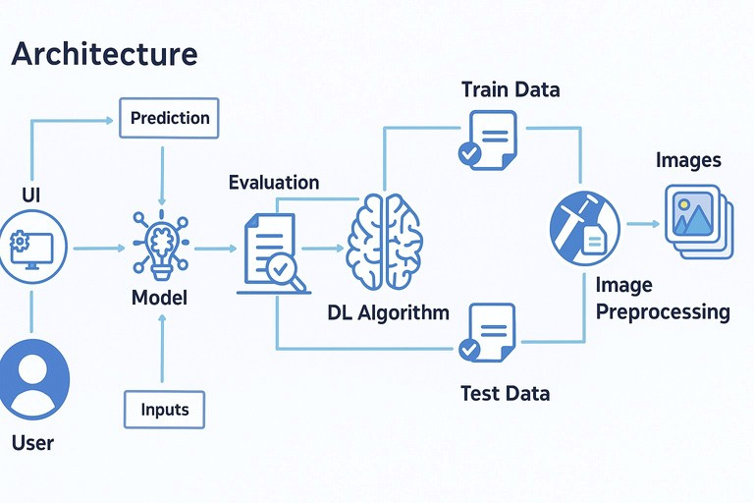
Key Points:
- System Architecture:

  - The user uploads a blood cell image through the web interface (UI).
  - The image is sent as input to the trained deep learning model.
  - The model uses a pre-trained CNN (like VGG16) to process the image and predict the blood cell type.
  - The prediction is evaluated and displayed back on the UI with confidence levels.
  - Initially, the model is built using preprocessed images from the dataset, split into training and testing sets.
  - The training data is used to fine-tune the DL algorithm using transfer learning, while test data is used for evaluation.
- User Flow:
  - Step 1: User opens the web application. ● Step 2: Uploads a microscope image of a blood smear. ● Step 3: The model processes the image and classifies the cell type. ● Step 4: The predicted cell type and confidence score are displayed. ● Step 5:User can repeat with other images or use the results for diagnostic insight.

Phase-4: Project Planning
Objective:
Breakdown development tasks for efficient completion.

Sprint

Task

Priority

Duration

Deadline

Assigned to

Dependencies

Expected
outcome
Project
environment
ready

Sprint 1

Sprint 1

Sprint 2

Sprint 2

Sprint 3

Sprint 3

Environment
Setup &
Package
Installation

Dataset

Collection &

Preprocessing

Model

Building using

Transfer

Learning

Flask Web

App

Integration

Testing &

Debugging

Final
Presentation
& Deployment

Low

High

High

High

Medium

Medium

1
hour

3
hours

4
hours

5
hours

3
hours

2
hours

Day 1

Day 1

Day 2

Day 2

Day 2

End of
Day 2
Member

4
&
1

Member
&
2
3

Member 1

Member 2

Member 3

Entire Team

Working
application

Anaconda ,
Python

Trained
Model,Flask
installed

Complete

System

Preprocessed
data,
TensorFlow

Dataset access

Working web
interface

Bug-free
and
responsive
system

Project

deployed

and

demo-ready

Clean,prepar
ed image
dataset

Trained

classification

model

🔴
🔴
🔴

🟡
🟡
🟢
Sprint Planning with Priorities
Sprint 1 - Setup & Preparation (Day 1)
🔴
High Priority
- Set up the environment using Anaconda Navigator.
- Install all required Python packages (TensorFlow, Flask, etc.).
- Collect and preprocess the blood cell image dataset.

Sprint 2 – Model Development & Integration (Day 2)
🔴

High Priority
- Build and train the blood cell classification model using transfer learning (e.g., VGG16).
- Integrate the trained model with the Flask web application.

Sprint 3 – Testing, Deployment & Submission (Day 2)
🟡
Medium Priority
- Test the app functionality, fix bugs, and improve UI responsiveness.
🟢 Low Priority
- Finalize deployment and prepare presentation/demo materials.

Phase-5: Project Development

Objective:
Implement the core features of the HematoVision application using transfer learning for blood cell classification.

Key Points:
- Technology Stack Used:
  - Frontend: HTML (via Flask templates)
  - Backend: Flask Framework
  - Deep Learning: TensorFlow with pre-trained VGG16 model
  - Programming Language: Python
- Development Process:
  - Built and trained a blood cell classification model using transfer learning (VGG16).
  - Preprocessed a dataset of 12,000 labeled blood cell images.
  - Integrated the trained model into a Flask web application.
  - Developed a user interface to upload images and display classification results with prediction confidence.
- Challenges & Fixes:
  - Challenge: Model overfitting on certain blood cell types.
Fix: Used data augmentation and dropout regularization.
  - Challenge: Large model size caused slow predictions.
Fix: Applied model optimization and saved in.h5 format for faster loading.
  - Challenge: Image quality variation.
Fix: Added preprocessing steps like resizing and normalization before prediction.

Phase-6: Functional & Performance
Objective:
Ensure that the HematoVision application performs accurately, reliably, and consistently across various test cases and environments.

Test
Case ID

TC-001

Category

Test
Scenario
Upload
image of
eosinophils

Expected
Outcome
Correct cell
type
identified with
confidence
score

Status

Tester

TC-002

TC-003

TC-004

TC-005

TC-006

Bug Fix
Validation

Functional
Testing

Functional
Testing

Deployment
Testing

Performance
Testing

UI
Responsiveness

Hosted on
local server
and
accessed
remotely

✅
Passed

Upload mixed Multi-class

✅
Passed

WBC/RBC

image

classification

displayed

correctly

Check model Results

⚠
Needs

Optimization

response

time

displayed

under 2

secods

System still

makes

reasonable

prediction

Layout

adjusts

properly on

mobile

App loads

and predicts

successfully

online

Image with

poor lighting

✅
Fixed

Test on

mobile

browser

❌
Failed

🚀
Deployed

Tester 1

Tester 2

Tester 3

Tester 2

DevOps

Developer

