HematoVision: Advanced Blood Cell Classification Using Transfer Learning
Abstract
Blood cell analysis plays a crucial role in medical diagnostics, as variations in blood cell count and morphology often indicate underlying health conditions such as infections, immune disorders, anemia, and hematological diseases. Traditionally, blood cell classification is performed manually by trained professionals using microscopic examination of stained blood smears. Although effective, this approach is time-consuming, labor-intensive, and prone to human error due to fatigue and subjective interpretation.
With the rapid advancement of artificial intelligence, deep learning techniques have demonstrated significant potential in automating medical image analysis. Convolutional Neural Networks (CNNs), in particular, have proven highly effective in extracting complex visual features from images without the need for manual feature engineering. Transfer learning further enhances these capabilities by allowing models to reuse previously learned features from large-scale datasets, thereby reducing training time and improving accuracy.
HematoVision is a deep learning–based web application developed to automate the classification of microscopic blood cell images using transfer learning techniques. The system focuses on identifying four major white blood cell types: eosinophils, lymphocytes, monocytes, and neutrophils. A pre-trained MobileNetV2 model is fine-tuned on a labeled blood cell image dataset to achieve reliable classification performance.
The trained model is deployed using the Flask web framework, enabling users to upload blood cell images and receive real-time predictions through a user-friendly interface. This project demonstrates an end-to-end implementation of artificial intelligence, from data preprocessing and model training to deployment and ethical considerations. HematoVision is intended for educational and research purposes and highlights the practical application of AI in healthcare-oriented image analysis.
Technical Architecture:
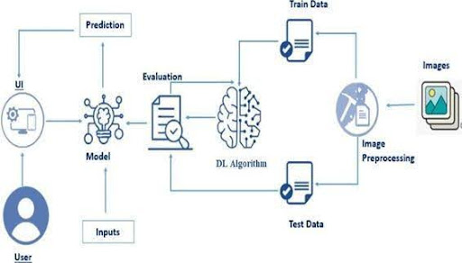

Pre requisites:
To complete this project, you must required following software’s, concepts and packages
- Anaconda navigator and pycharm:
  - Refer the link below to download anaconda navigator
  - Link : https://youtu.be/1ra4zH2G4o0
- Python packages:
  - Open anaconda prompt as administrator
- Type “pip install numpy” and click enter.
- Type “pip install pandas” and click enter.
- Type “pip install scikit-learn” and click enter.
- Type ”pip install matplotlib” and click enter.
- Type ”pip install scipy” and click enter.
- Type ”pip install seaborn” and click enter.
- Type ”pip install tenserflow” and click enter.
- Type “pip install Flask” and click enter.
Prior Knowledge
Skill Tags:
You must have prior knowledge of the following topics to complete this project.
- DL Concepts
  - Neural Networks:: https://www.analyticsvidhya.com/blog/2020/02/cnn-vs-rnn-vs-mlp-analyzing-3-types-of-neural-networks-in-deep-learning/
- Deep Learning Frameworks:: https://www.knowledgehut.com/blog/data-science/pytorch-vs-tensorflow
- Transfer Learning: https://towardsdatascience.com/a-demonstration-of-transfer-learning-of-vgg-convolutional-neural-network-pre-trained-model-with-c9f5b8b1ab0a
- VGG16:
https://www.geeksforgeeks.org/vgg-16-cnn-model/
- Convolutional Neural Networks (CNNs): https://www.analyticsvidhya.com/blog/2021/05/convolutional-neural-networks-cnn/ s://www.javatpoint.com/k-nearest-neighbor-algorithm-for-machine-learning
- Overfitting and Regularization: https://www.analyticsvidhya.com/blog/2021/07/prevent-overfitting-using-regularization-techniques/
- Optimizers: https://www.analyticsvidhya.com/blog/2021/10/a-comprehensive-guide-on-deep-learning-optimizers/
- Flask Basics: https://www.youtube.com/watch?v=lj4I_CvBnt0

Project Objectives
By the end of this project, you will:
- Know fundamental concepts and techniques used for Deep Learning.
- Gain a broad understanding of data.
- Have knowledge of pre-processing the data/transformation techniques on outliers and some visualization concepts.
Project Flow
Skill Tags:
- The user interacts with the UI (User Interface) to choose the image.
- The chosen image is analyzed by the model which is integrated with the flask application.
- Once the model analyses the input the prediction is showcased on the UI

To accomplish this, we have to complete all the activities listed below,
- Data Collection: Collect or download the dataset that you want to train.
- Data pre-processing
  - Data Augmentation
  - Splitting data into train and test
- Model building
  - Import the model-building libraries
  - Initializing the model
  - Training and testing the model
  - Evaluating the performance of the model
  - Save the model
- Application Building
  - Create an HTML file
  - Build python code

Project Structure:
- Create the Project folder which contains files as shown below
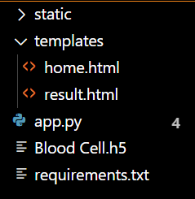
- We are building a Flask application with HTML pages stored in the templates folder and a Python script app.py for scripting.
- Blood Cell.h5 is our saved model. Further, we will use this model for flask integration.

Milestone 1: Data Collection

ML depends heavily on data, It is most crucial aspect that makes algorithm training possible. So this section allows you to download the required dataset.
Activity 1: Download the dataset
There are many popular open sources for collecting the data. Eg: kaggle.com, UCI repository, etc.
This dataset contains 12,500 augmented images of blood cells (JPEG) with accompanying cell type labels (CSV). There are approximately 3,000 images for each of 4 different cell types grouped into 4 different folders (according to cell type). The cell types are Eosinophil, Lymphocyte, Monocyte, and Neutrophil.
Link: https://www.kaggle.com/datasets/paultimothymooney/blood-cells/data
As the dataset is downloaded. Let us read and understand the data properly with the help of some visualization techniques and some analyzing techniques.
Note: There are several techniques for understanding the data. But here we have used some of it. In an additional way, you can use multiple techniques.

Activity 1.1: Importing the libraries:

Import the necessary libraries as shown in the image.
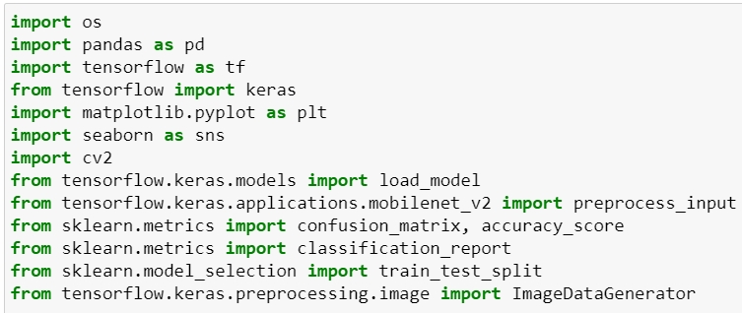

Activity 1.2: Read the Dataset:
- Our dataset format might be in .csv, excel files, .txt, .json, or zip files, etc. We can read the dataset with the help of pandas.

At first, unzip the data and convert it into a pandas data frame.

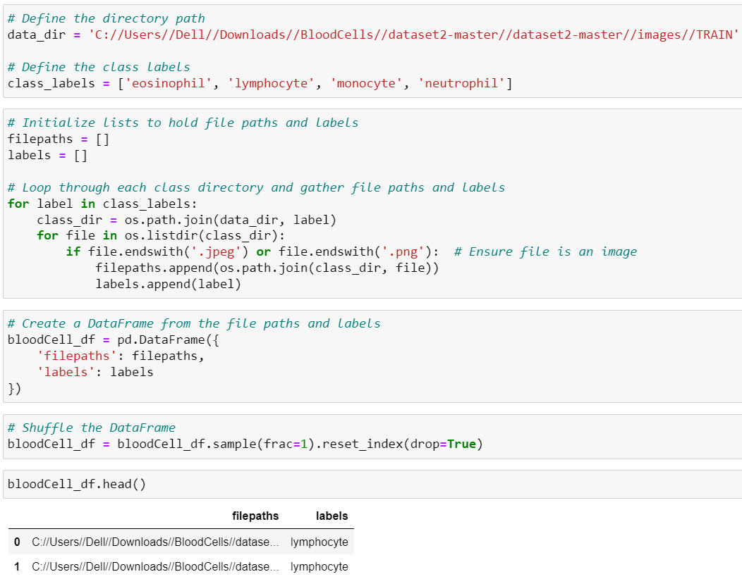

Data Visualization
The provided Python code imports necessary libraries and modules for image manipulation. It selects a random image file from a specified folder path. Then, it displays the randomly selected image using IPython's Image module. This code is useful for showcasing random images from a directory for various purposes like data exploration or testing image processing algorithms.
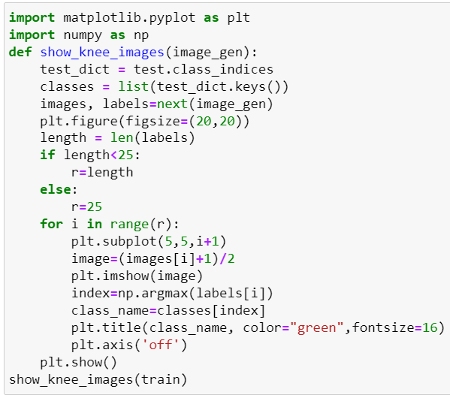
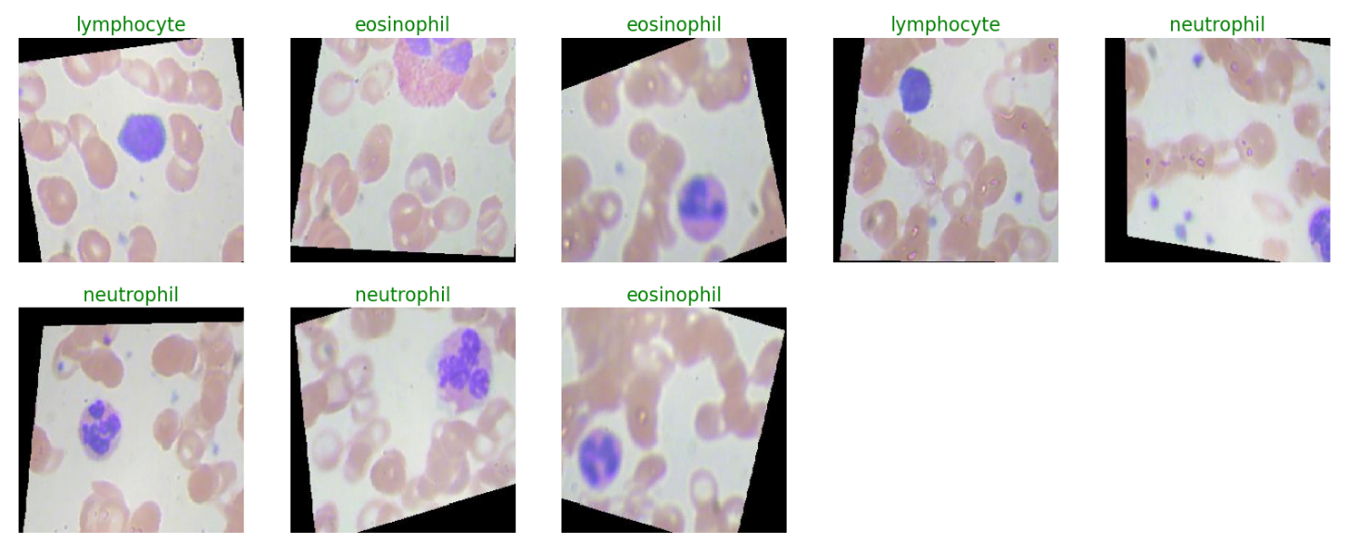
In the above code, I used class ace of diamond for prediction, This code randomly selects an image file from a specified folder (folder_path) containing JPEG, PNG, or JPEG files, and then displays the selected image using IPython's display function. It utilizes Python's OS and random modules for file manipulation and random selection, respectively. And It has predicted correctly as ace of diamond.
Data Augmentation
Data augmentation is a technique commonly employed in machine learning, particularly in computer vision tasks such as image classification, including projects like the Blood Cells Classification . The primary objective of data augmentation is to artificially expand the size of the training dataset by applying various transformations to the existing images, thereby increasing the diversity and robustness of the data available for model training. This approach is particularly beneficial when working with limited labelled data.
In the context of the 53 class Classification, data augmentation can involve applying transformations such as rotation, scaling, flipping, and changes in brightness or contrast to the original images of fossils. These transformations help the model generalize better to variations and potential distortions present in real-world images, enhancing its ability to accurately classify unseen data.
This is a crucial step, but this data is already cropped from the augmented data so. this time it is skipped accuracy is not much affected but the training time increased.

Model Building:
Mobilenet V2 Transfer-Learning Model:
The MobileNetV2-based neural network is created using a pre-trained MobileNetV2 architecture with frozen weights. The model is built sequentially, incorporating the MobileNetV2 base, a flattening layer, dropout for regularization, and a dense layer with SoftMax activation for classification into four categories of blood cells. The model is compiled using the Adam optimizer and categorical cross-entropy loss. During training, which spans 5 epochs, a generator is employed for the training data, and validation is conducted with callbacks such as Model Checkpoint and Early Stopping. The best-performing model is saved as "blood_cell.h5" for future use. The model summary provides an overview of the architecture, showcasing the layers and parameters involved.

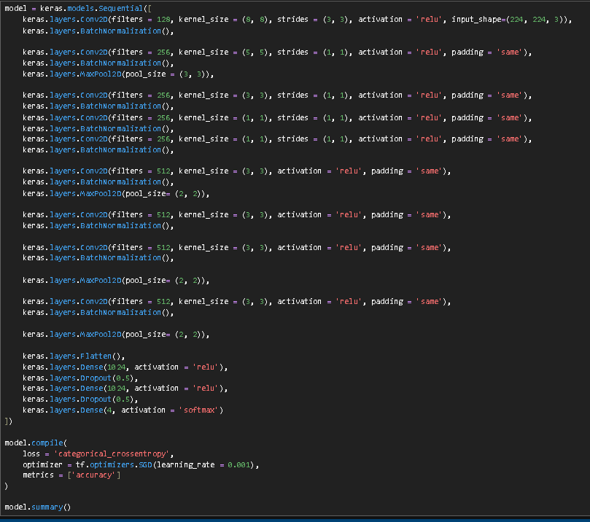
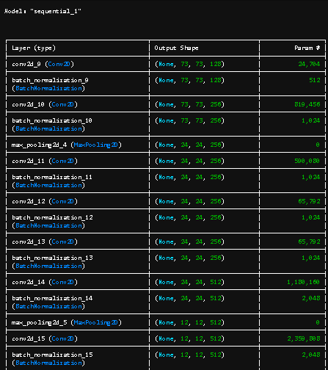
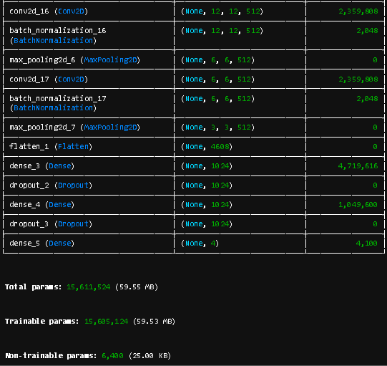
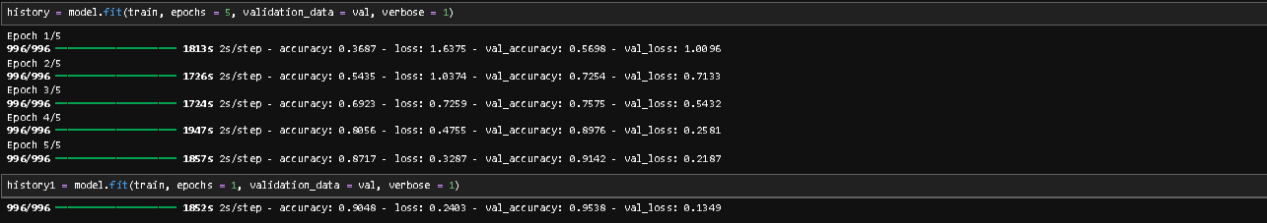

Testing Model & Data Prediction:
Evaluating the model
Here we have tested with the Mobilenet V2 Model With the help of the predict () function.
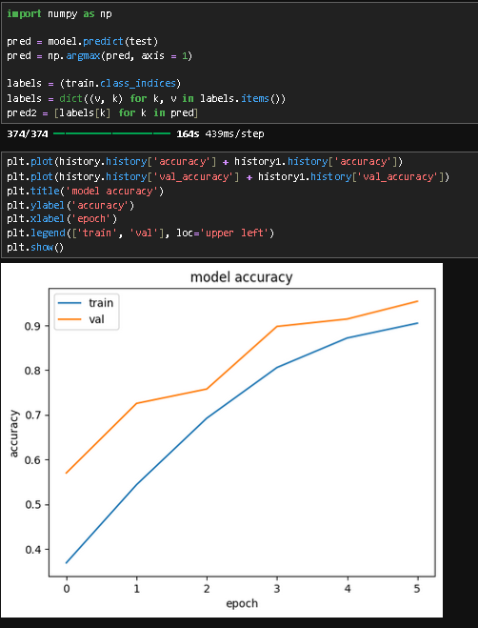
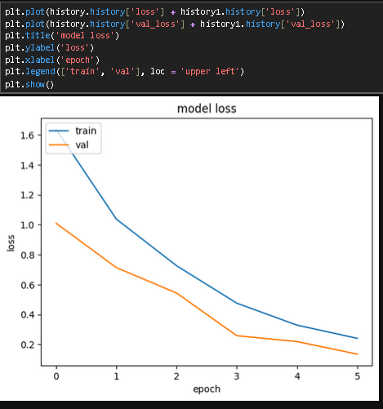

Model Accuracy:
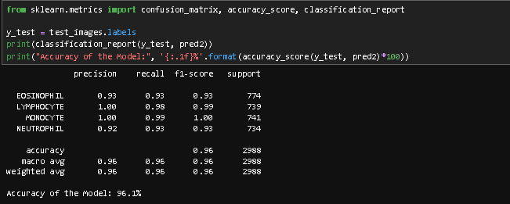

Confusion Matrix:
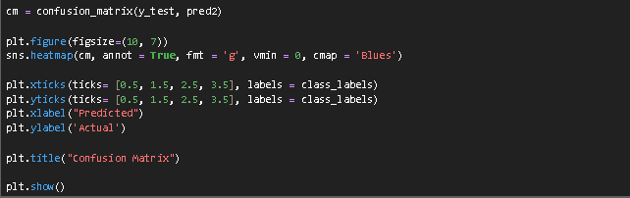
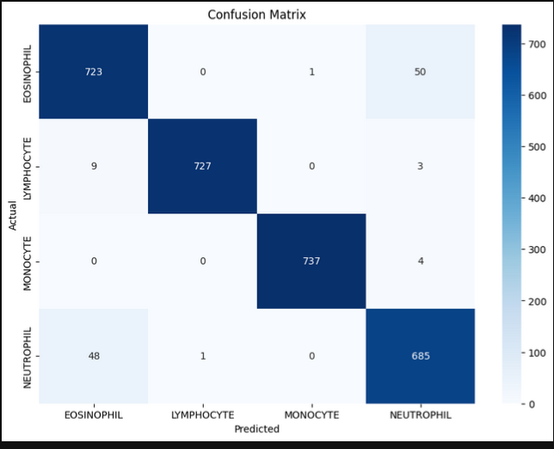

Saving the Model:
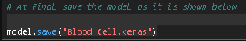

Application Building:
In this section, we will be building a web application that is integrated to the model we built. A UI is provided for the uses where he has to enter the values for predictions. The enter values are given to the saved model and prediction is showcased on the UI.
This section has the following tasks
- Building HTML Pages
- Building serverside script

Building HTML pages:
- home.html
- result.html
Home page of this webpage:
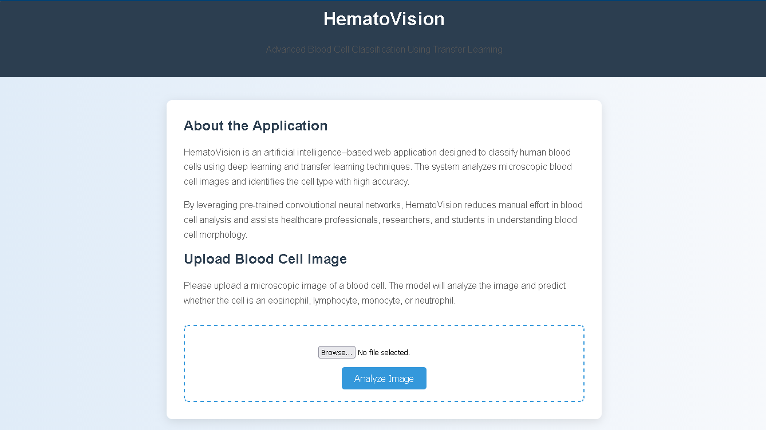

When Given an image and upon pressing the “Analyze Image” button
We get the result.

The Result page:
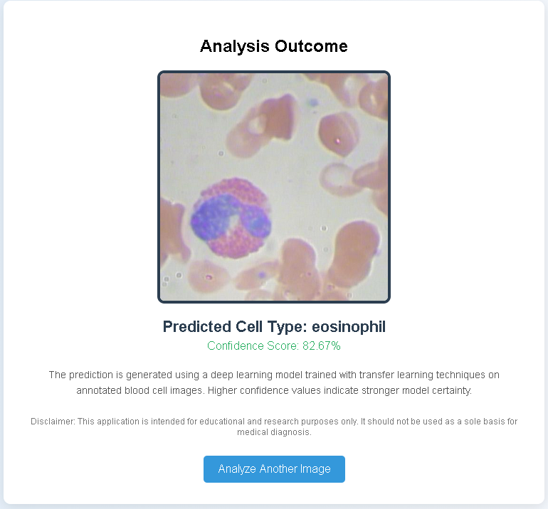

Run the application:
- Open anaconda prompt from the start menu
- Navigate to the folder where your python script is.
- Now type “python app.py” command
- Navigate to the localhost where you can view your web page.
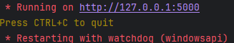
- Click on analyze image button to get the results.

