Learning Navigator
Flutter Application — Feature Documentation

Excelerate Flutter Development Internship
Team Number:11
team leader:Ansa Naseer
22-june-2026

Abstract
- Learning Navigator is a Flutter-based educational mobile application designed to help students discover learning opportunities, track progress, participate in events, and manage their educational journey through an interactive and user-friendly interface. The application integrates multiple modules, including profile management, event registration, learning path navigation, authentication, and feedback collection.
- The Profile module enables users to personalize their accounts through avatar selection, profile editing, account management, theme customization, notification preferences, and learning settings. The Events module allows students to browse upcoming workshops, webinars, and bootcamps, register through validated forms, receive enrollment confirmations, and access introductory videos and learning resources.
- Learning paths are dynamically generated from JSON data and presented through a structured roadmap consisting of interactive milestones, skill details, resources, FAQs, and career guidance. Firebase Authentication provides secure user registration, login, session management, and access control using email and password credentials. Additionally, a Feedback module enables users to submit ratings and comments through validated forms with real-time loading and success states, ensuring a consistent user experience.
- The application follows modern software development practices by utilizing Firebase services, local JSON data management, responsive Flutter UI components, and GitHub-based version control. Together, these features create a comprehensive learning platform that supports student engagement, personalized learning, skill development, and educational event participation in a centralized environment.

1. Profile Screen

lib/screens/profile_screen.dart
The Profile screen is the fourth tab of the app's bottom navigation bar. It is a stateful widget that reads the signed-in user's name, email, and (optional) photo from a shared UserData model and presents them inside a gradient header card, followed by usage statistics and grouped account menus.

1.1 Key Functionality
- Gradient header card with an avatar that can be an emoji icon or a photo chosen from the gallery via image_picker.
- “Change Avatar” bottom sheet lets the user pick a gallery photo or one of several preset emoji avatars.
- Inline “Edit Profile” button opens Edit Profile Screen and returns the updated name/email to refresh the header.
- Profile Editing View
- When a user selects "Manage Account" or clicks "Edit Profile" from the dashboard, they are navigated to the interface captured in 1000176011.jpg. This form handles critical profile updates using validation fields for:
- Full Name (Input field pre-populated with nivas)
- Email (Input field pre-populated with nivas@gmail.com)
- Phone Number (Includes country-code prefix integration)
- Change Photo Tool: An avatar wrapper that opens a local file picker or dialog to upload a custom user image.
- Quick inline rename via a pencil icon next to the user's name, using a simple alert-dialog text field.
- Stat cards summarising Paths, Skills, and total Learning hours.
- “Learning” section: Learning History, My Achievements, Course History.
- “Account” section: Settings, Send Feedback (opens an in-place feedback dialog), and Logout.
- Account Configuration
- Manage Account: Links directly to the personal details menu where profile attributes can be modified.
- Change Password: Provides a secure modal portal for updating user credentials.
- Appearance & Themes
- Dark Mode: A dynamic toggle that transitions the UI from a bright background to an optimized dark canvas, reducing eye strain and saving battery life on OLED screens.
- Theme Color: Allows the user to select an accent color to personalize core UI elements like the AppBar.
- Notifications Preference Management
- To keep users engaged without being intrusive, notifications are separated into granular channels:
- Push Notifications: Toggles immediate, device-level alerts for critical application events.
- Email Notifications: Manages asynchronous delivery of summaries, updates, and platform announcements to the user's inbox.
- Learning Reminders: Automated, scheduled triggers designed to help users maintain daily learning streaks.
- Learning Preferences
- Language: Allows localization configuration (currently defaulted to "English") to adjust the application prose dynamically.
- Logout shows a confirmation dialog and, once confirmed, clears the navigation stack and returns to the Login screen.
- The bottom navigation bar is shared across Home, Paths, Events, and Profile so users can jump directly to Events from this screen.

1.2 Files Used
File | Role
profile_screen.dart | Main profile UI, avatar picker, stat cards, account menu
edit_profile_screen.dart | Form to update name and email
models/user_data.dart | Holds the signed-in user's name, email, and profile image in memory
models/app_settings.dart | Supplies theme colour and dark-mode flag used on this screen
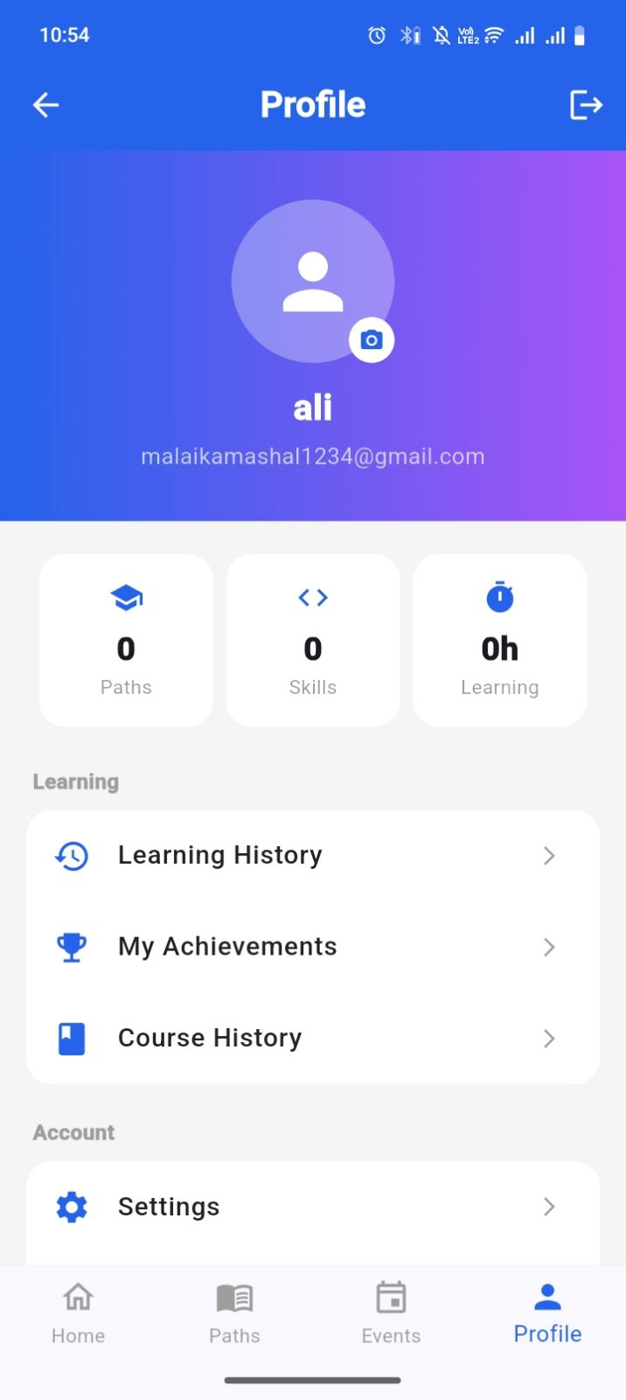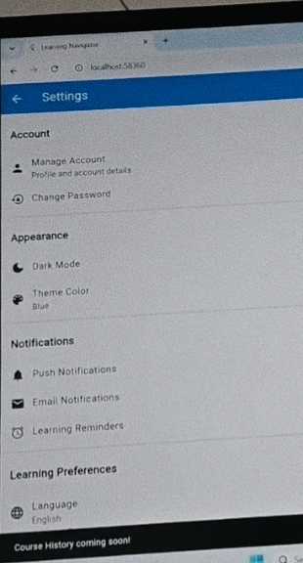

2. Events List, Registration Form & Introduction Video

This feature lets a student browse upcoming workshops/webinars, open full event details, and register through a validated form that ends with a success confirmation and an option to watch the event's introduction video.

2.1 Event List & Detail View
- Events are loaded asynchronously from assets/data/events.json through LocalData.loadEvents(); a CircularProgressIndicator is shown while loading.
- Each list card shows a type badge (Workshop / Webinar / Bootcamp), title, date, and time.
- Tapping a card opens Event Detail, which displays the full description plus “Videos” and “Resources” sections that open externally via url_launcher.
- A full-width “Register Now” button at the bottom of the detail screen opens the registration form.

2.2 Registration Form
- Collects Full Name and Email, both validated (required, and a basic email-format check).
- While submitting, the button is disabled and shows a spinner with the label “Please Wait...”, simulating a short network call.
- On success, a floating green snackbar reads “Form Submitted Successfully / You Have Been Enrolled Successfully”.

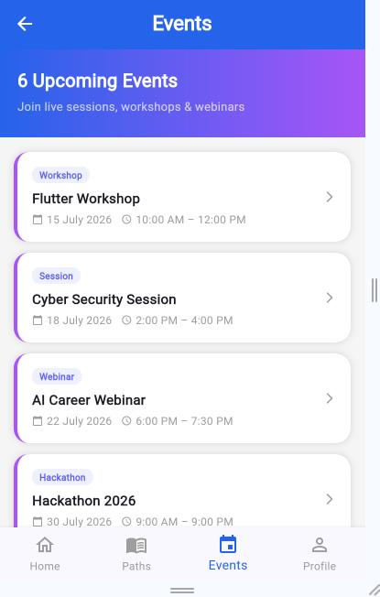

2.3 Introduction Video Flow
After the success snackbar, a confirmation dialog appears (“Enrollment Confirmed”) summarising the event the user just joined. If the event has an associated video link, a “Watch Introduction Video” button is shown; tapping it opens the event's intro video (a YouTube link sourced from events.json) in the device's external browser/YouTube app via url_launcher.
// excerpt — event_registration_screen.dart
child: _submitting
? Row(children: [CircularProgressIndicator(...), Text('Please Wait...')])
: Text('Submit Registration'),
// ... on success:
content: Column(children: [
Text('Form Submitted Successfully'),
Text('You Have Been Enrolled Successfully'),
]),

2.4 Files Used
File | Role
events_screen.dart | Event list (FutureBuilder) and Event Detail screen
event_registration_screen.dart | Registration form, waiting state, success message, intro-video dialog
services/local_data.dart | Loads events.json / programs.json / skills.json / users.json from assets
assets/data/events.json | Event records: title, date, time, type, description, video links, resource links

3. Learning Path Roadmap (JSON-Driven, Clickable)

Each learning path (e.g. Web Development, Artificial Intelligence, Mobile App Development) opens a detail screen built around a six-tab layout: Intro, Skills, Roadmap, Resources, FAQ, and Careers.

3.1 JSON Data Source
- Path metadata — title, description, duration, skill count, enrolled students, and current progress — is loaded from assets/data/programs.json via LocalData.loadPrograms() and mapped into a LearningPath model.
- The “Skills” tab lists the whatYouLearn array from the same JSON record; tapping a skill looks it up in skills.json and opens Skill Detail Screen.

3.2 Roadmap Tab — Clickable Steps
- The Roadmap tab renders an ordered list of step cards (e.g. “Step 1: HTML & CSS Fundamentals”) generated per learning path.
- Each step's completion state — Completed, In Progress, or Locked — is calculated from the path's progress value, with matching icons (check, play, lock) and colours.
- Tapping any step card navigates to Roadmap Detail Screen, showing the full description, estimated duration, and a status badge, with a “Back to Roadmap” button to return.
- A progress summary (“X of Y steps completed”) sits above the list and stays in sync with the path's stored progress.

3.3 Files & Data Used
File | Role
path_detail_screen.dart | Six-tab path detail UI; Roadmap tab + Roadmap Detail screen
models/learning_path.dart | Data model mapped from programs.json
services/local_data.dart | Reads programs.json / skills.json from the assets bundle
assets/data/programs.json | Per-path title, description, duration, progress, and skills list
skill_detail_screen.dart | Opened when a Skills-tab item is tapped
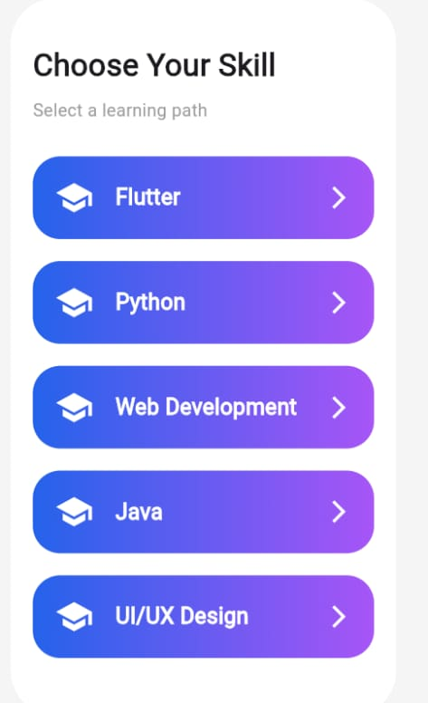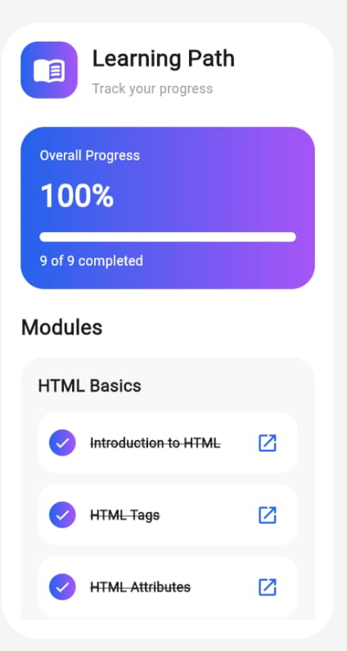
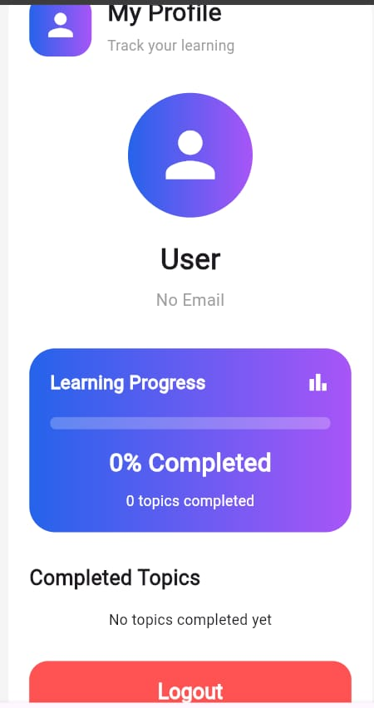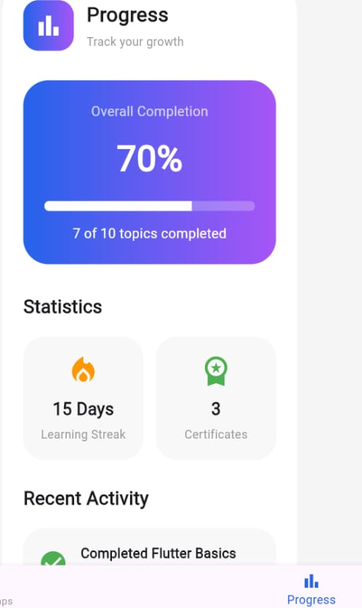

4. Firebase Login & Authentication

Sign-in is backed by Firebase Authentication (email/password). Firebase is initialised before the app runs, and an auth-state listener decides whether to show the main app or the sign-in flow.

4.1 Authentication Flow
- main() calls Firebase.initializeApp() with the generated firebase_options.dart before runApp().
- AuthChecker wraps a StreamBuilder<User?> around FirebaseAuth.instance.authStateChanges(): a loading spinner is shown while connecting, the Bottom Nav (home) screen is shown once a user session exists, and the Splash/Login flow is shown otherwise.
- LoginScreen validates that email and password are not empty, then calls AuthService().login(), which wraps FirebaseAuth.instance.signInWithEmailAndPassword().
- While the request is in flight, the Login button is replaced with a CircularProgressIndicator; on success a “Login Successful” snackbar appears and the user is routed to the main app; on failure the Firebase error message is shown in a snackbar.
- AuthService also exposes signUp(), logout() (FirebaseAuth.signOut()), and getCurrentUser() for use elsewhere in the app.

4.2 Files Used
File | Role
main.dart | Firebase initialisation; AuthChecker auth-state routing
firebase_options.dart | Generated platform configuration (FlutterFire)
screens/login_screen.dart | Email/password form, loading state, error handling
screens/signup_screen.dart | Account creation form
services/auth_service.dart | FirebaseAuth wrapper: signUp, login, logout, getCurrentUser
services/firestore_service.dart | Cloud Firestore access for signed-in user data

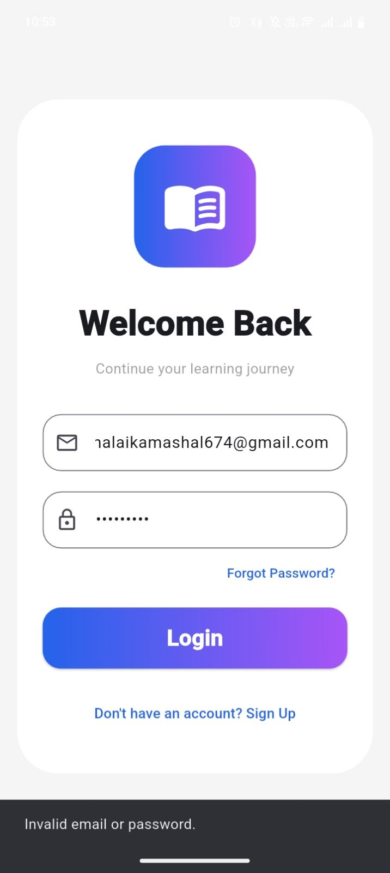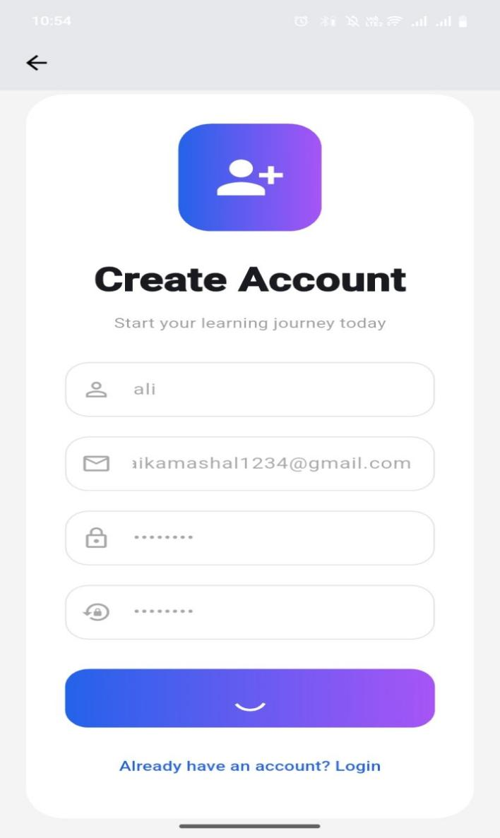

5. Feedback Module — Waiting & Submitted States

The feedback form lets a student rate their experience and leave comments. It mirrors the same waiting/submitted pattern used in event registration, so the loading and success behaviour feel consistent across the app.

5.1 Form Fields
- Name and Email, both validated (required; email format checked with a regular expression).
- A 1–5 rating slider with numbered labels above it, defaulting to 3.
- A multi-line Comments field, required before submission.

5.2 Submission Flow
- On Submit, the form is validated; if valid, the Submit button area is replaced by a centred CircularProgressIndicator while a short network call is simulated.
- All fields are disabled (enabled: !_isLoading) during submission so the user cannot edit while waiting.
- On completion, a green snackbar reads “Thank you! Feedback submitted successfully.”, then the form and rating are reset.
- The lighter-weight feedback dialog reachable from the Profile screen's “Send Feedback” menu item follows the same pattern: a text field plus a Submit button that shows “Feedback submitted. Thank you!” in a green snackbar.
// excerpt — Feedback_view.dart
_isLoading
? Center(child: CircularProgressIndicator())
: ElevatedButton(
onPressed: _submitFeedback,
child: Text('Submit Feedback'),
),
// on success:
SnackBar(content: Text('Thank you! Feedback submitted successfully.'),
backgroundColor: Colors.green)

5.3 Files Used
File | Role
Feedback_view.dart | Full feedback screen: rating slider, waiting state, success snackbar
screens/feedback_screen.dart | Lightweight Student ID / Name / Message feedback form
profile_screen.dart | Inline “Send Feedback” dialog shortcut

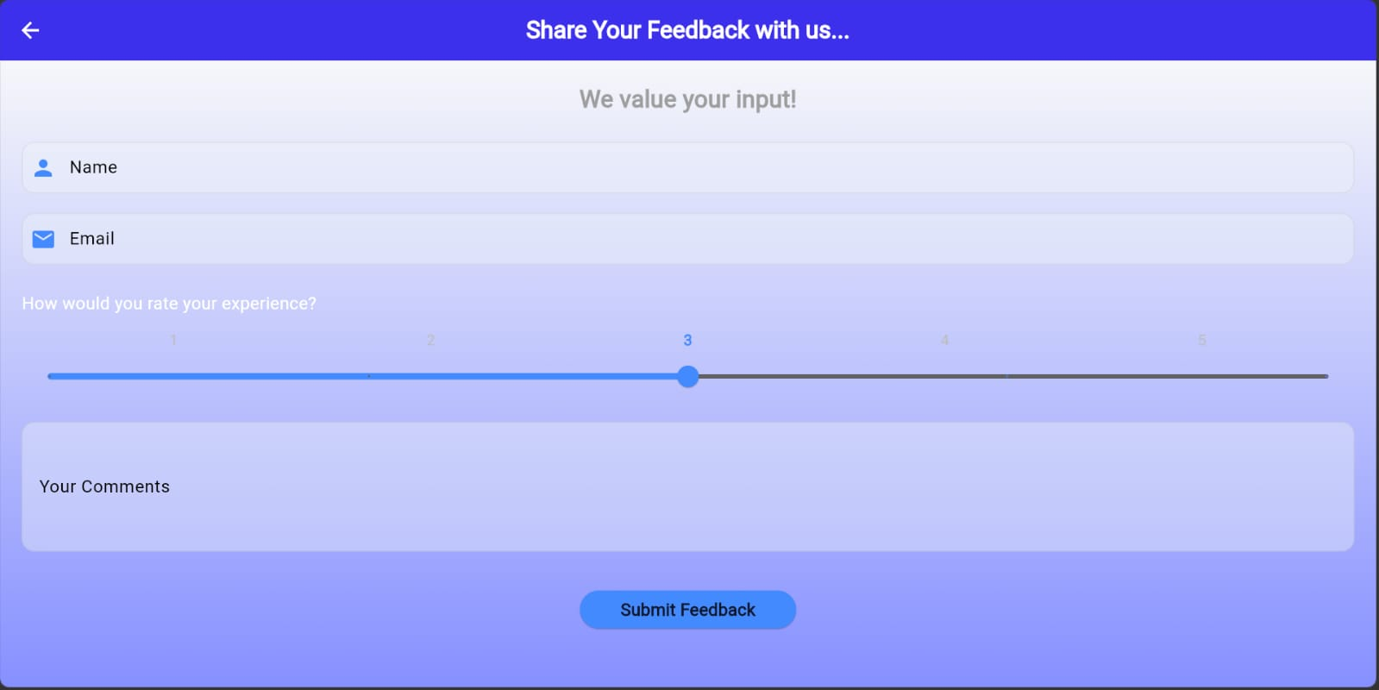

6. GitHub Repository & Version Control Update

The Learning Navigator source code is tracked with Git and pushed to GitHub so progress is backed up, versioned, and available for review as part of the Excelerate internship deliverables.

6.1 Repository
Field | Value
Repository name | learning_navigator
Repository URL | [Add GitHub repository link here]
Latest update | Profile, Events + Registration, Roadmap, Firebase Login, and Feedback features

