# HCloud and Azure Basics

# ** Describe core data concepts

# Describe types of core data workloads

## Question 1 Batch vs Stream

: For each application description, identify if it is better suited to batch or stream processing.  
  
To answer, select Batch or Stream for each application from the drop-down list.

Choose the correct options

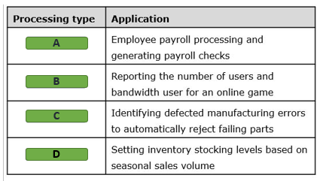

A)

1. Batch
2. Stram

B)

1. Batch
2. Stram

C)

1. Batch
2. Stram

wefhwfewfwefewhf

D)

1. Batch
2. Stram

## Question 2 Batch vs Stream

: What are two characteristics of data in batch processing? Each correct answer presents part of the solution.

Choose the correct answers

A short latency is required.

A long latency is acceptable.

Data is processed as it is generated.

Data is collected for periodic processing.

## Question 3: Batch vs Stream

Determine whether each statement applies to batch data, stream data, or both as they are implemented in Azure.  
  
To answer, select Batch, Stream, or Both from the drop-down list.

Choose the correct options

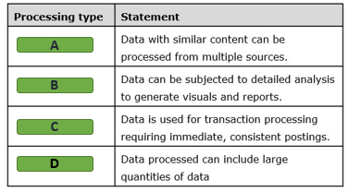

A)

1. Batch
2. Stream
3. Both

B)

1. Batch
2. Stream
3. Both

C)

1. Batch
2. Stream
3. Both

D)

1. Batch
2. Stream
3. Both

## Question 4: characteristics of relational databases

What are characteristics of relational databases?  
  
For each of the following statements, select Yes if the statement is true. Otherwise, select No.

|  |  |  |
| --- | --- | --- |
| **Statement** | **Yes** | **No** |
| Rows in the same table can have different numbers of columns. |  |  |
| A table can have any number of rows. |  |  |
| The primary key is used to enforce uniqueness on rows. |  |  |
| Normalization helps to minimize data duplication. |  |  |

## Question 5: characteristics of relational databases

You need to store structured data in a relational database.  
  
How is data organized in a relational database?

Choose the correct answer

Tables containing keys and values

Graphs containing edges and nodes

Documents containing fields and values

Tables containing rows and columns

## Question 6: Batch vs Stream

You are examining multiple datasets for stream processing.  
  
Which two datasets are best suited for stream processing? Each correct answer presents a complete solution.

Choose the correct answers

List of potential customers

Real-time data from users navigating in a website

Data from sensors and Internet of Things (IoT) devices

Sales data for the last semester

## Question 7: Batch vs Stream

You need to describe the characteristics of data used in stream processing.  
  
For each of the following statements, select Yes if the statement is true. Otherwise, select No.

|  |  |  |
| --- | --- | --- |
| **Statement** | **Yes** | **No** |
| You can process stream data at the moment it is generated. |  |  |
| You can stream a large set of data at once in stream processing. |  |  |
| You can use stream data to perform complex analytics. |  |  |

## Question: 8 Batch vs Stream

For each of the following statements, select Yes if the statement is true. Otherwise, select No.

|  |  |  |
| --- | --- | --- |
| **Statement** | **Yes** | **No** |
| You can load a large set of data at once using batch processing. |  |  |
| Batch processing requires near real-time data latency. |  |  |
| You can perform complex analytics using batch processing. |  |  |

## Question 9: characteristics of relational databases

To complete the sentence, select the appropriate option from the drop-down menu.

Choose the correct options

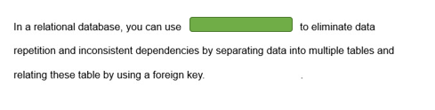

A clustered index

A primary key

Normalization

## Question 10: OLAP

The HR department in your company needs to send employee data monthly.  
  
Which type of processing should you use?

Choose the correct answer

Stream processing

Online Analytical processing (OLAP)

Online Transaction processing (OLTP)

Batch processing

## Question 11: characteristics of relational databases

You need to identify characteristics of relational databases.  
  
For each of the following statements, select Yes if the statement is true. Otherwise, select No.

|  |  |  |
| --- | --- | --- |
| **Statement** | **Yes** | **No** |
| Each row in a table contains the same set of columns. |  |  |
| Data is stored in a tabular format. |  |  |
| Different rows in the same table can share the same primary key value. |  |  |

# Describe data analytics core concepts

## Question 12: Data Analytics Techniques

A data analyst prepares a line chart that tracks sales over the past year and also shows projected sales for the coming quarter.  
  
What type of analysis is this an example of?

Choose the correct answer

Prescriptive

Diagnostic

Predictive

Descriptive

## Question 13: Data Analytics Techniques

For each of the business questions, choose the appropriate type of analysis to answer the question.  
  
To answer, drag the appropriate analysis type to each question. An analysis type may be used once, more than once, or not at all.

Drag and drop the answers

drag item 1

drag item 2

drag item 3

drag item 1

drag item 2

drag item 3

drag item 4

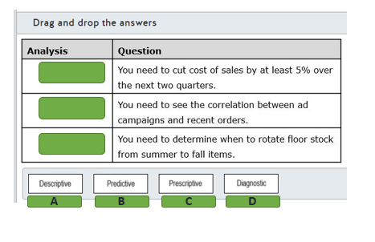

## Question 14: ETL

To complete the following sentence, select the appropriate option from the drop-down menu.

Choose the correct options

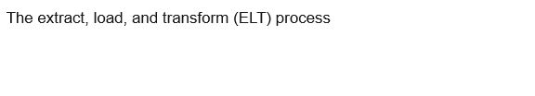

Uses a separate specialized engine for data transformation

Requires the uses of staging files as a temporary data stores

Performs transformation in the target data store

Is restricted to a relational raw data sources only

## Question 15: ETL

An extract, transform, and load (ETL) operation will extract data from an on-premises SQL Server, XML files, Azure Blob storage, and Azure Table storage. Transformation is minimal and includes filter, sorting, deduplicating, and mapping the source data to tables in an Azure SQL managed instance database. The effort to accomplish this should be kept to a minimum.  
  
Which analytic product should you use?

Choose the correct answer

Azure Synapse Analytics

SQL Server Integration Services (SSIS)

Azure Data Factory

Azure Data Share

## Question 16: ETL

You design the data ingestion for an extract, load, and transform (ELT) process to retrieve data from multiple unstructured data sources that contain logs files in text format.  
  
Which service should you use in each data ingestion step? To answer, drag the appropriate service to each step. A service may be used once, more than once, or not at all.

Drag and drop the answers

drag item 1

drag item 2

drag item 1

drag item 2

drag item 3

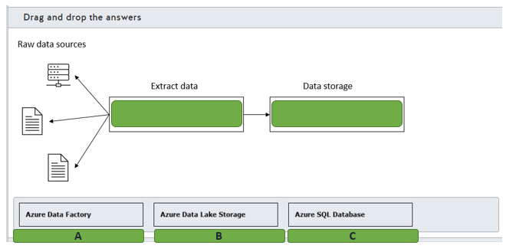

## Question 17: Data Analytics Techniques

You are evaluating the buying patterns of customers who bought a particular product.  
  
You need to know which factors influence the purchase of this particular product.  
  
Which type of analytics technique should you use?

Choose the correct answer

Predictive analytics

Prescriptive analytics

Descriptive analytics

Diagnostic analytics

## Question 18: Data Analytics Techniques

You create a chart in Power BI as shown in the exhibit to forecast the passenger count for a travel company.

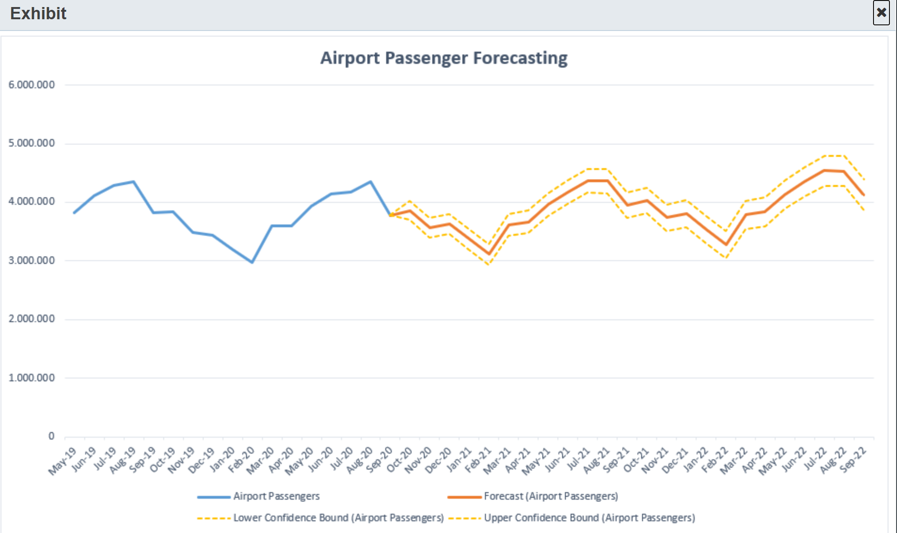  
Which analytics technique was used to create this chart?

Choose the correct answer

Predictive analytics

Diagnostic analytics

Descriptive analytics

Prescriptive analytics

## Question 19: Data Visualization and chart type

You want to build a chart to visualize the gross sales for your company's top 20 product categories.  
  
Which chart type should you use?

Choose the correct answer

Bubble chart

Bar chart

Pie chart

Doughnut chart

## Question 20: Data Visualization and chart type

To complete the sentence, select the appropriate option from the drop-down menu.

Choose the correct options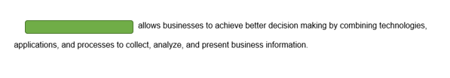

Business intelligence (BI)

Data visualization

Power BI

Reporting

## Question 21: - ETL

To complete the sentence, select the appropriate option from the drop-down menu.

Choose the correct options

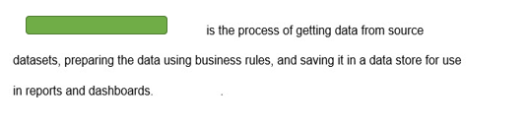

Data ingestion

Data visualization

Extract, Load, and Transform (ELT)

Extract, Transform, and Load (ETL)

## Question 22: Data Visualization and chart type

You work as a data analyst.  
  
You need to discover which factors lead to negative customer reviews about one of your company's products.  
  
Which visual type should you use?

Choose the correct answer

A line chart

A bar and column chart

A scatter chart

A key influencers chart

## Question 23: - Data Analytics Techniques

You work as a data analyst.  
  
You need to analyze the reason for the company's poor sales in the current quarter.  
  
Which data analytics technique should you use?

Choose the correct answer

Descriptive analytics

Predictive analytics

Diagnostic analytics

Cognitive analytics

# ** Describe how to work with relational data on Azure

# Describe relational data workloads

## Question 24:  describe relational data structures

Match the relational database structure descriptions with the appropriate structure.  
  
To answer, drag the appropriate structure to each description. A structure may be used once, more than once, or not at all.

Drag and drop the answers

drag item 1

drag item 2

drag item 3

drag item 1

drag item 2

drag item 3

drag item 4

drag item 5

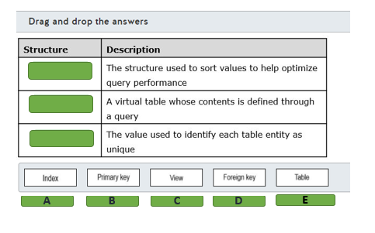

## Question 25:  Right Data Offering

Which application is best supported through use of a relational database?

Choose the correct answer

An application where users need fast, reliable access to streaming media files that vary in size between 20 GB and 5 MB.

Data gathering for a customer resource management (CRM) application must support and retain values for entities with different numbers of values.

An application that must be able to rapidly load values from different Internet of Things (IoT) sensors that are coded by time into temporary storage with the data treated as transparent.

An order processing engine for an online sales application that needs to perform high-speed online transaction processing (OLTP) operations.

## Question 26:  describe relational data structures

You design a query that joins customer, inventory, and order data. The query includes columns with calculated values.  
  
You need the query to be readily available to users. You want to maintain the normalization of your database.  
  
What should you create?

Choose the correct answer

Key

Table

View

Index

## Question 27:  describe relational data structures

You plan to implement a clustered index in an Azure SQL Database table.  
  
You need to explain the characteristics of a clustered index.  
  
For each of the following statements, select Yes if the statement is true. Otherwise, select No.

|  |  |  |
| --- | --- | --- |
| **Statement** | **Yes** | **No** |
| The clustered index defines the order in which data rows are stored and sorted in the table. |  |  |
| You can define one or more clustered indexes per table. |  |  |
| You can define nonclustered indexes after you implement a clustered index. |  |  |
| A table with an implemented clustered index is called a heap. |  |  |

## Question 28:  describe relational data structures

To complete the sentence, select the appropriate option from the drop-down menu.

Choose the correct options

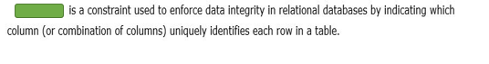

Foreign key

Heap

Primary key

## Question 29: describe relational data structures

To complete the following sentence, select the appropriate option from the drop-down menu.

Choose the correct options

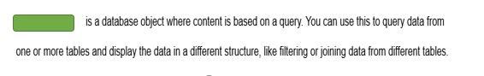

A Heap

A table

A view

An index

## Question 30: describe relational data structures

In a relational database, what is the purpose of an index?

Choose the correct answer

To improve read performance by searching for specific data in a table.

To create relationships between tables.

To query data from one or more tables and display the data in a different format.

To enforce data integrity by indicating which column uniquely identifies each row in a table.

## Question 31: Right Data Offering

You need to determine when to use a relational database.  
  
Which is the best scenario to use a relational database?

Choose the correct answer

Guarantee strong consistency while processing transactions

Large images and videos

Data in columnar format

Dynamic and semi-structured data schema

## Question 32: describe relational data structures

You need to connect each relational data structure with its description.  
  
To answer, drag the appropriate structure to each description. A structure may be used once, more than once, or not at all.

Drag and drop the answers

drag item 1

drag item 2

drag item 3

drag item 1

drag item 2

drag item 3

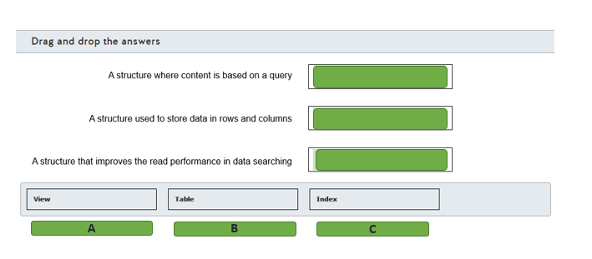

## Question 33: describe relational data structures

You have a table named Sales.  
  
Which database object should you use to achieve the following requirements?  
  
To answer, drag the appropriate object to the correct requirement. Each object may be used once, more than once, or not at all.

Drag and drop the answers

drag item 1

drag item 2

drag item 3

drag item 1

drag item 2

drag item 3

drag item 4

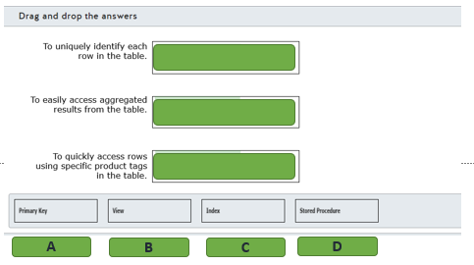

## Question 34: Right Data Offering

Which relational data store should you use for each of the following workloads?  
  
To answer, drag the appropriate data store to the correct workload. Each data store may be used once, more than once, or not at all.

Drag and drop the answers

drag item 1

drag item 1

drag item 2

drag item 1

drag item 2

drag item 3

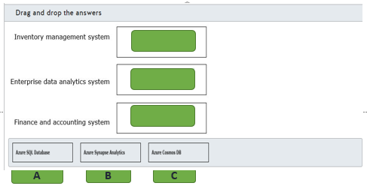

# Describe relational Azure data services

## Question 35: DB-Relational Azure data services

A company is moving its on-premises databases to Azure. The databases support custom applications. Two applications are stable only when they are used with SQL Server 2016 SP2.  
  
What should you choose?

Choose the correct answer

Azure SQL managed instance

Azure SQL Database serverless

SQL Server on virtual machine (VM)

Azure SQL Database elastic pool

## Question 36: DB-Relational Azure data services

For each of the following statements about a platform as a service (PaaS) relational database, select Yes if the statement is true. Otherwise, select No.

|  |  |  |
| --- | --- | --- |
| **Statement** | **Yes** | **No** |
| You are responsible for applying patches and updates to the database management system. |  |  |
| You can scale resources up or down without interrupting database operations. |  |  |
| You can configure custom backup schedules for full and differential backups. |  |  |

## Question 37: DB-Relational Azure data services

For each of the following statements about Azure SQL Server Managed Instance, select Yes if the statement is true. Otherwise, select No.

|  |  |  |
| --- | --- | --- |
| **Statement** | **Yes** | **No** |
| Cross-database queries are supported between databases in the same managed instance. |  |  |
| Backups from a managed instance can be restored to a different managed instance, an Azure SQL Server single server instance, or an on-premises SQL Server instance. |  |  |
| Managed Instance supports authentication through SQL authentication and Azure Active Directory (Azure AD) authentication. |  |  |

## Question 38: DB-Relational Azure data services

You need to describe the features that are present in Azure SQL Database.  
  
For each of the following statements, select Yes if the statement is true. Otherwise, select No.

|  |  |  |
| --- | --- | --- |
| **Statement** | **Yes** | **No** |
| Azure SQL Database allows you to choose the SQL Server engine version. |  |  |
| Azure SQL Database includes a fully managed backup service. |  |  |
| Azure SQL Database automatically applies security patches in the underlying operating system. |  |  |

## Question 39: PostgreSQL vs MariaDB vs MySQL

You need to describe the features that are present in Azure Database for PostgreSQL.  
  
For each of the following statements, select Yes if the statement is true. Otherwise, select No.

|  |  |  |
| --- | --- | --- |
| **Statement** | **Yes** | **No** |
| Azure Database for PostgreSQL can be deployed as a single server or as a cluster. |  |  |
| Azure Database for PostgreSQL enforces Transport Layer Security (TLS) connections by default. |  |  |
| Azure Database for PostgreSQL supports Azure Active Directory (Azure AD) authentication. |  |  |

## Question 40: Synapse

To complete the following sentence, select the appropriate option from the drop-down menu.

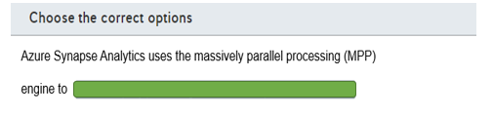

Distributed query processing across the compute nodes

Distributed query processing across the control nodes

Move data across compute nodes to run queries in parallel

## Question 41: DB-Relational Azure data services

You need to evaluate the relational database platform as a service (PaaS) and the infrastructure as a service (IaaS) solutions in Azure.  
  
For each of the following statements, select Yes if the statement is true. Otherwise, select No.

|  |  |  |
| --- | --- | --- |
| **Statement** | **Yes** | **No** |
| IaaS database solutions reduce the administrative overhead for managing security patches and updates. |  |  |
| PaaS database solutions provide built-in high availability. |  |  |
| PaaS database solutions give you full control to configure the underlying operating system. |  |  |

## Question 42: DB-Relational Azure data services

You are evaluating Azure data services.  
  
You need to classify each service type as infrastructure as a service (IaaS), platform as a service (PaaS), or software as a service (SaaS) offering.  
  
To answer, drag the appropriate service type to each service. A service type may be used once, more than once, or not at all.

Drag and drop the answers

drag item 1

drag item 2

drag item 2

drag item 1

drag item 2

drag item 3

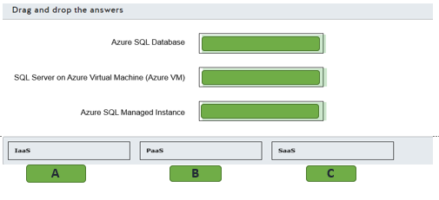

## Question 43: DB-Relational Azure data services

Your manager asks you to plan the migration of an MS SQL Server 2019 on-premises database to a cloud service.  
  
You need to choose an offering that can minimize cost and administration.  
  
Which database solution should you use?

Choose the correct answer

SQL Server on Azure virtual machine

Azure SQL database

Azure SQL managed instance

Azure database for MariaDB

## Question 44: DB-Relational Azure data services

You work as an Azure Database administrator.  
  
You need to identify characteristics of relational Azure data services.  
  
Which two options should you use for Platform-as-a-Service (PaaS) relational data services? Each correct answer presents a complete solution.

Choose the correct answers

SQL Server on Azure Virtual Machines

Azure SQL Database Managed Instance

Azure SQL Database

Azure Cosmos DB

# Identify basic management tasks for relational data

## Question 45: Security

Your company has a large mobile workforce. Users have a mobile application that needs to connect to an Azure SQL Managed Instance database.  
  
What should you configure?

Choose the correct answer

Public endpoint

Point-to-site VPN connections and a private endpoint

Database-level firewall rules

Server-level firewall rules

## Question 46: Security

Complete each sentence by selecting the correct Azure SQL Database and Managed Instance security features from the drop-down list.

Choose the correct options

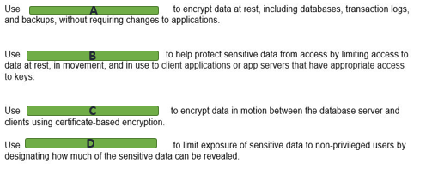

A)

1. Always encrypted
2. Dynamic data masking
3. Transparent data encryption (TDE)
4. Transport layer security (TLS)

B)

1. Always encrypted
2. Dynamic data masking
3. Transparent data encryption (TDE)
4. Transport layer security (TLS)

C)

1. Always encrypted
2. Dynamic data masking
3. Transparent data encryption (TDE)
4. Transport layer security (TLS)

D)

1. Always encrypted
2. Dynamic data masking
3. Transparent data encryption (TDE)
4. Transport layer security (TLS)

## Question 47: Query Tools

For each of the following statements, select Yes if the statement is true. Otherwise, select No.

|  |  |  |
| --- | --- | --- |
| **Statement** | **Yes** | **No** |
| Azure Data Studio can query an Azure SQL Database from a computer that runs Windows, Linux, or MacOS. |  |  |
| Azure Data Studio can export query results as CSV, JSON, XLSX. |  |  |
| Azure Data Study can provide client statistics and live query statistics. |  |  |

## Question 48: Query Tools

For each of the following statements, select Yes if the statement is true. Otherwise, select No.

|  |  |  |
| --- | --- | --- |
| **Statement** | **Yes** | **No** |
| You can use Azure Data Studio to connect with Azure Database for PostgreSQL. |  |  |
| You can use SQL Server Management Studio (SSMS) to connect with Azure Synapse Analytics. |  |  |
| You can use MySQL Workbench to connect with Azure Database for MariaDB. |  |  |

## Question 49: Security

You are connected to an Azure SQL Database from your laptop in the company.  
  
A few hours later you try to reconnect to the database from your home using the same laptop. However, you cannot connect to the database.  
  
You need to investigate the most probable cause preventing you from accessing the database from your home.  
  
Which is the most probable cause?

Choose the correct answer

A server-level firewall

An Azure Active Directory (AD) access token

An account access key rotation

An Azure role-based access control (RBAC) role

## Question 50: Query Tools

You need to identify which relational database management tool matches the descriptions.  
  
Which tool matches each? To answer, select the appropriate options from the drop-down menus.

Choose the correct options

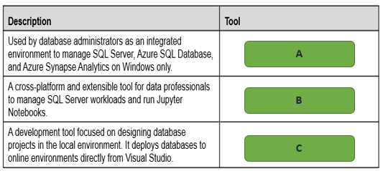

A)

1. Azure data studio
2. SQL Server Data Tools (SSDT)
3. SQL Server Management Studio (SSMS)

B)

1. Azure data studio
2. SQL Server Data Tools (SSDT)
3. SQL Server Management Studio (SSMS)

C)

1. Azure data studio
2. SQL Server Data Tools (SSDT)
3. SQL Server Management Studio (SSMS)

## Question 51: Security

Your team uses SQL Server Management Studio (SSMS) to manage your company's Azure SQL Databases.  
  
For compliance reasons, the security team recommends that everybody in your team use multi-factor authentication (MFA) when connecting to the Azure SQL database.  
  
Which authentication method should you use?

Choose the correct answer

SQL Server authentication

Azure Active Directory (Azure AD) authentication

Certificate authentication

Windows authentication

## Question 52: Methods of provisioning

Your team developes a solution that uses Azure SQL Database. The solution is created in a development Azure subscription.  
  
You need to recreate the solution in your company production subscription. You want to use minimum effort.  
  
What should you use?

Choose the correct answer

Azure Resource Manager (ARM) templates

Azure command-line interface (CLI)

Azure PowerShell

Azure portal

## Question 53: Security

You work as an Azure data administrator.  
  
You provision the following relational data services: Azure SQL Database, Azure Database for MySQL, and Azure Database for PostgreSQL.  
  
Which port should you open for outbound traffic to connect to each data service from your corporate network? To answer, select the appropriate port from the drop-down menus.

Choose the correct options

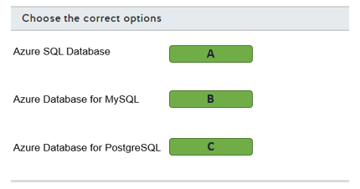

A)

1. 1433
2. 2383
3. 3306

B)

1. 1433
2. 2383
3. 3306

C)

1. 2383
2. 3306
3. 5432

## Question 54: Query Tools

You need to describe attributes of Azure Data Studio.  
  
For each of the following statements, select Yes if the statement is true. Otherwise, select No.

|  |  |  |
| --- | --- | --- |
| **Statement** | **Yes** | **No** |
| It has a query editor that can return results in JSON format. |  |  |
| It is supported by both Windows and macOS. |  |  |
| It supports Always On database configurations. |  |  |

# Describe query techniques for data using SQL language

## Question 55: Query Techniques

Which command is a Data Manipulation Language (DML) command?

Choose the correct answer

ALTER

UPDATE

CREATE

DROP

## Question 56: Query Techniques

Which SQL command should you use to remove a database table and its content from a database?

Choose the correct answer

ALTER

UPDATE

DELETE

DROP

## Question 57: Query Techniques

Part of the SalesSummary table is shown in the exhibit. SalesAvg_view is a view that you want to create based on SalesSummary.

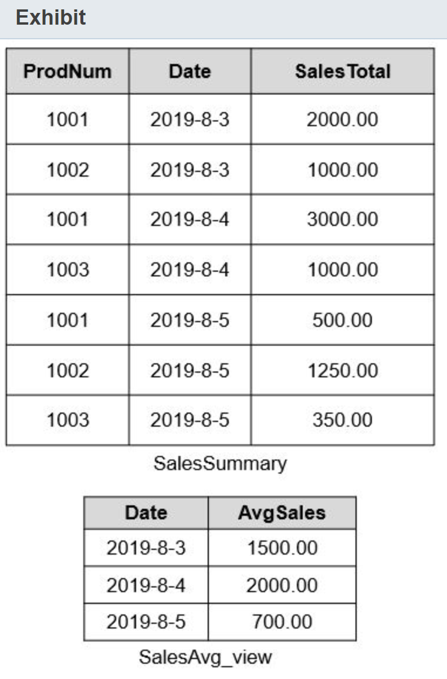  
  
How should you complete the command string? To answer, select the correct commands from the drop-down lists.

Choose the correct options

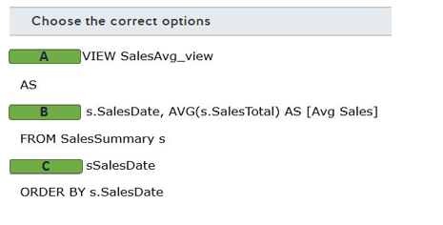

A)

1. Alert
2. Create
3. Group By
4. Select
5. Update

B)

1. Alert
2. Create
3. Group By
4. Select
5. Update

C)

1. Alert
2. Create
3. Group By
4. Select
5. Update

## Question 58: Query Techniques

You manage an Azure SQL Database in your Azure subscription.  
  
You need to identify a Data Manipulation Language (DML) SQL statement.  
  
Which statement is a DML statement?

Choose the correct answer

INSERT

ALTER

CREATE

DROP

## Question 59: Query Techniques

You manage an Azure SQL Database in your Azure subscription.  
  
You need to identify a Data Definition Language (DDL) SQL statement.  
  
Which statement is a DDL statement?

Choose the correct answer

ALTER

SELECT

DELETE

INSERT

## Question 60: Query Techniques

You have a table named Products in an Azure SQL Database. The table contains the data as shown in the exhibit.

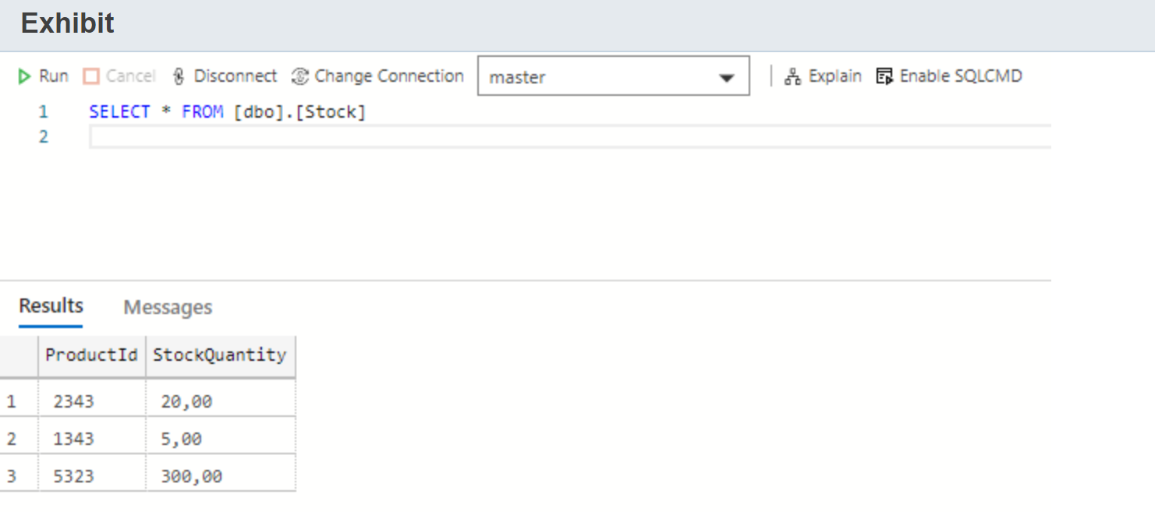

You need to set the stock quantity of product with ID 5323 to 250.  
  
Which SQL statement should you use?

Choose the correct answer

CREATE

INSERT

TRUNCATE

UPDATE

## Question 61: Query Techniques

You have a table named Inventory in an Azure SQL Database.  
  
You need to query this table to return the total inventory quantity per product as shown in the exhibit.

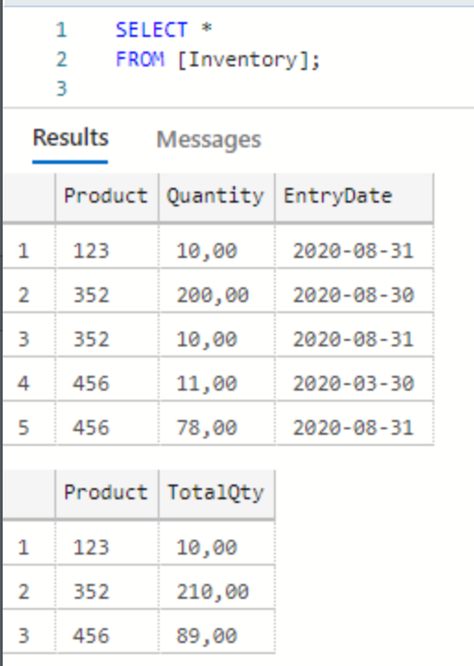

How should you complete the SQL query? To answer, drag the appropriate statement to each placeholder. A statement may be used once, more than once, or not at all.

Drag and drop the answers

drag item 1

drag item 2

drag item 3

drag item 1

drag item 2

drag item 3

drag item 4

drag item 5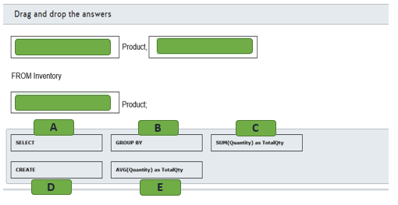

## Question 62: Query Techniques

You have an Azure Database for MySQL that is used to store employee salaries. The table structure is shown in the exhibit.

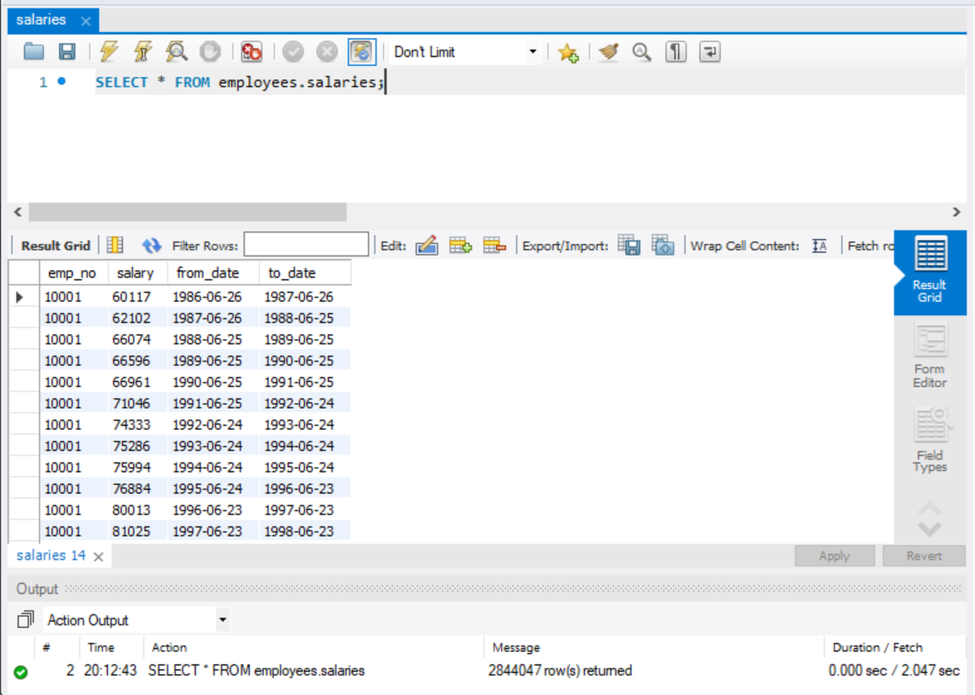  
  
You need to query the top 10 salaries.  
  
How should you complete the SQL query? To answer, select the appropriate options from the drop-down menus.

Choose the correct options

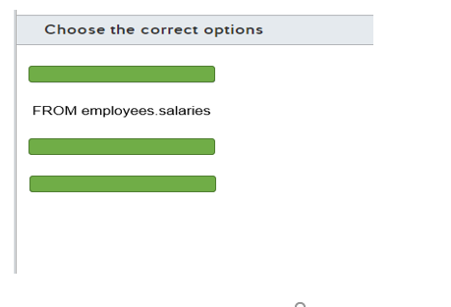

A)

1. SELECT*
2. SELECT MAX(salary)
3. SELECT TOP(10)*

B)

1. ORDER BY salary
2. ORDER BY salary ASC
3. ORDER BY salary DESC

C)

1. DESC;
2. LIMIT 10;
3. LIMIT 1, 10;

## Question 63: Query Techniques

You have an Azure Database for PostgreSQL named finance in your Azure subscription.  
  
You create a command-line interface (CLI) script to automate an administrative task. The script needs to connect and query some data from the finance database.  
  
You need to determine an appropriate CLI tool.  
  
Which CLI tool should you use?

Choose the correct answer

Azure CLI

psql

pgAdmin

sqlcmd

## Question 64: Query Techniques

You need to relate the SQL statements with their associated group.  
  
To answer, select the appropriate statement from the drop-down menus.

Choose the correct options

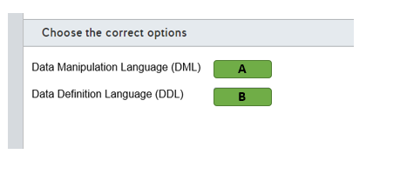





A)

1. ALTER
2. GRANT
3. INSERT

B)

1. ALTER
2. GRANT
3. INSERT

## Question 65: Query Techniques

You have a table named Orders as shown in the exhibit.

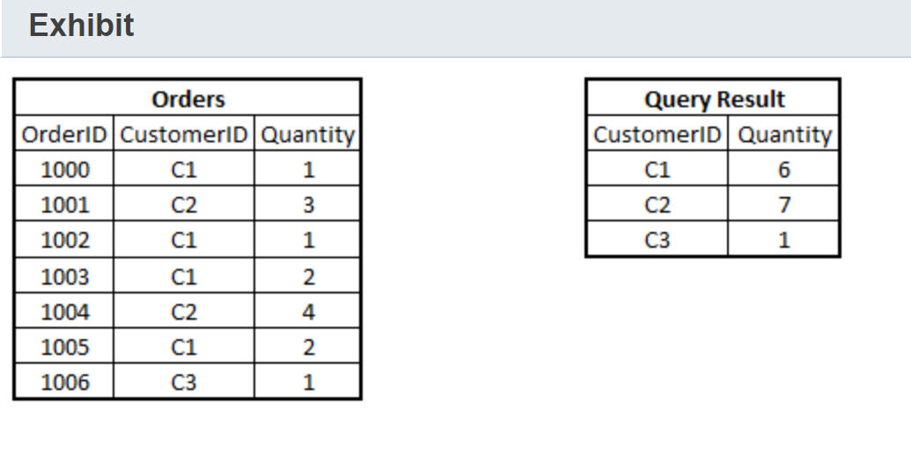  
  
You need to find the total quantity ordered by each customer as shown in the exhibit query results.  
  
What should you do to complete the query? To answer, select the appropriate options from the drop-down menus.

Choose the correct options

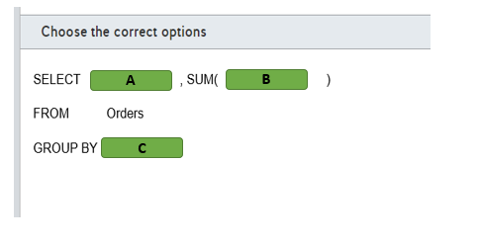

A)

1. CustomerID
2. OrderID
3. Quantity

B)

1. CustomerID
2. OrderID
3. quantity

C)

1. CustomerID
2. OrderID
3. quantity

# ** Describe how to work with non-relational data on Azure

# Describe non-relational data workloads

## Question 66: NoSQL Basics

What type of data is JavaScript Object Notation (JSON) format data an example of?

Choose the correct answer

Semi-structured

Structured

Unstructured

Relational

## Question 67: NoSQLBasics

For each of the following statements, select Yes if the statement is true. Otherwise, select No.

|  |  |  |
| --- | --- | --- |
| **Statement** | **Yes** | **No** |
| Each document in a document database typically contains all data for a single entity. |  |  |
| Documents in a document database use the same data schema for all documents. |  |  |
| Documents in a document database support relationships enforced between documents. |  |  |

## Question 68: NoSQL Basics

Your company is writing an application that will receive real-time data with variable data fields from multiple sources. The application should be able to write the data to a data store as quickly as possible. Data will be keyed with an incremental index, and it will be treated as transparent by the application.  
  
Which type of data store should you use?

Choose the correct answer

Column-family

Table

Key/value

Graph

## Question 69: NoSQLBasics

You are designing a database for a new social media platform. The solution must support complex relationship analysis, including values such as age, location, pets, and musical preferences.  
  
What type of data store should you use?

Choose the correct answer

Document

Columnar

Graph

Object

## Question 70: NoSQL Basics

Match the non-relational data descriptions with the appropriate data store.  
  
To answer, drag the data store to each description. A data store may be used once, more than once, or not at all.

Drag and drop the answers

drag item 1

drag item 2

drag item 3

drag item 1

drag item 2

drag item 3

drag item 4

drag item 5

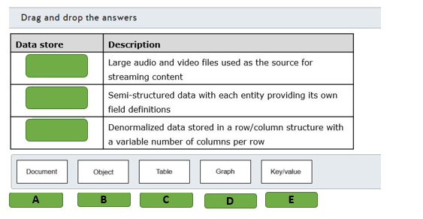

## Question 71: NoSQL Basics

Your company is developing a social media platform for pets. This application needs to handle complex relationships between pets, their owners, and their interests.  
  
You need to recommend the most appropriate data store for this application.  
  
Which data store should you recommend?

Choose the correct answer

Columnar data store

Key-value data store

Graph data store

Document data store

## Question 72: NoSQL Basics

You need to recommend a data store that is optimized to store and retrieve text files, videos, and images.  
  
The data store must store metadata about the file, its contents, and a unique ID for each file.  
  
Which type of data store should you recommend?

Choose the correct answer

Graph

Key-value

Document

Object

## Question 73: NoSQL Basics

You need to implement a non-relational data store for a new application. The application needs to store data in JSON format with a flexible schema. All the entity details should be stored together in the same structure.  
  
Which type of non-relational data store should you use?

Choose the correct answer

graph

document

object

key/value

## Question 74: NoSQL Basics

You need to evaluate which non-relational data store to use for each scenario.  
  
To answer, drag the appropriate data store to each scenario. Each data store may be used once, more than once, or not at all.

Drag and drop the answers

drag item 1

drag item 2

drag item 3

drag item 1

drag item 2

drag item 3

drag item 4

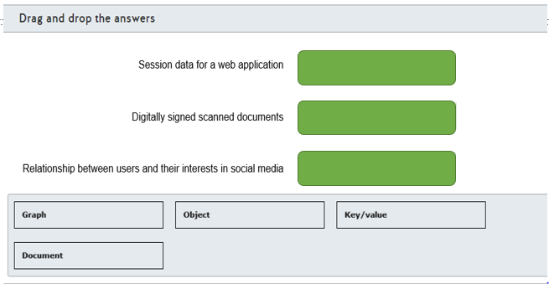

## Question 75: NoSQL Basics

You have an application that stores information in the format shown in the exhibit.

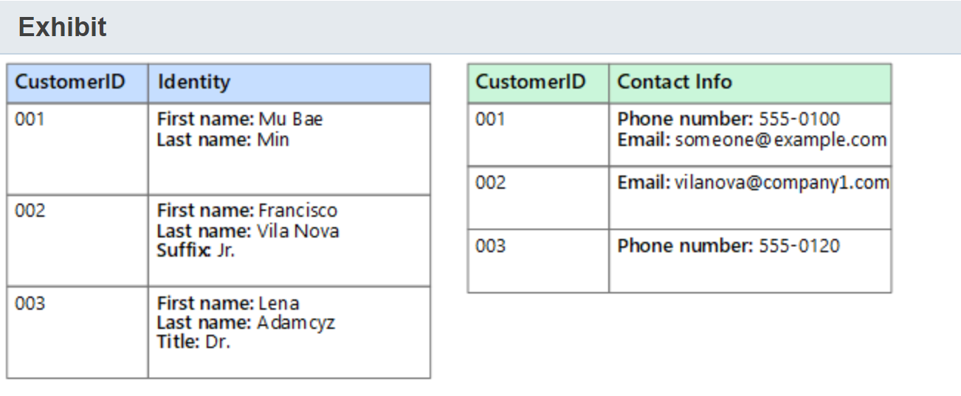

You need to recommend the most appropriate data store for this application.  
  
Which type of data store should you use?

Choose the correct answer

object

relational

key/value

columnar

## Question 76: NoSQL Basics

Your company has an e-commerce platform. The platform needs to store generated HTML for high traffic pages in temporary caching storage.  
  
You need to recommend a type of data store to be able to retrieve the data quickly.  
  
Which type of data store should you recommend?

Choose the correct answer

document

columnar

graph

key/value

## Question 77: NoSQL Basics

You need to evaluate the characteristics of non-relational data.  
  
For each of the following statements, select Yes if the statement is true. Otherwise, select No.

|  |  |  |
| --- | --- | --- |
| **Statement** | **Yes** | **No** |
| You need to define a schema on non-relational data. |  |  |
| You can use non-relational data to store data that has a highly variable structure. |  |  |
| You can use indexing with non-relational data in a similar way to an index in a relational database. |  |  |

## Question 78: NoSQL Basics

To answer, select the appropriate options from the drop-down menus.

Choose the correct options

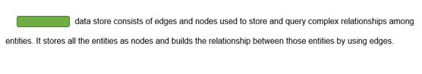

A key/value

A columnar

A graph

An object

## Question 79: NoSQL Basics

You work as a data engineer.  
  
Which two data stores types are non-relational? Each correct answer presents a complete solution.

Choose the correct answers

Graph Database

Document Database

SQL Database

Azure Database for MariaDB

## Question 80: NoSQL Basics

our company application requires you to maintain user preference.  
  
Which type of non-relation data store should you use?

Choose the correct answer

Column-family database

Document database

Key-value store

Graph database

# Describe non-relational data offerings on Azure

## Question 81: Azure Non-Relational Data Offering

Which Azure storage service includes support for Hot, Cool, and Archive access tiers?

Choose the correct answer

Azure Blob

Azure Table

Azure File

## Question 82: Azure Non-Relational Data Offering

For each of the following statements, select Yes if the statement is true. Otherwise, select No.

|  |  |  |
| --- | --- | --- |
| **Statement** | **Yes** | **No** |
| You can create a premium Azure File storage account in a General purpose version 2 (GPv2) or FileStorage storage account. |  |  |
| You can configure a premium Azure File storage account for locally-redundant storage (LRS), zone redundant storage (ZRS), or geo-redundant storage (GRS). |  |  |
| You can use a premium Azure File storage account to replace or supplement traditional on-premises file shares. |  |  |

## Question 83: Cosmos DB API

Match each data application with the BEST Cosmos DB API choice.  
  
To answer, select the most appropriate Cosmos DB API from the drop-down list.

Choose the correct options

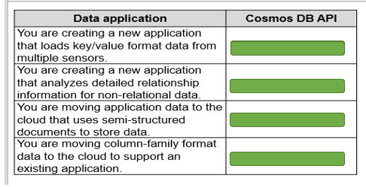

A)

1. Azure Table API
2. Cassandra API
3. Core (SQL) API
4. Gremlin API
5. MongoDB API

B)

1. Azure Table API
2. Cassandra API
3. Core (SQL) API
4. Gremlin API
5. MongoDB API

C)

1. Azure Table API
2. Cassandra API
3. Core (SQL) API
4. Gremlin API
5. MongoDB API

D)

1. Azure Table API
2. Cassandra API
3. Core (SQL) API
4. Gremlin API
5. MongoDB API

## Question 84: Azure Non-Relational Data Offering

Select the appropriate option from the drop-down list to complete the sentence.

Choose the correct options

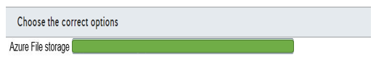

Allows you to select the underlying hardware and operating system

Is the recommended storage for key/value storage implementation

Supports direct mounting by windows, macOS, and Linux

Supports redundancy across multiple regions by default

## Question 85: Cosmos DB API

Which two statements identify features that are supported by Azure Cosmos DB Table API but not Azure Table storage? Each correct answer presents part of the solution.

Choose the correct answers

Data is organized and distributed by partition keys and row keys.

Manual and automatic failovers are supported.

Multi-master replication is supported across multiple regions.

Each row in a table can have a different number of columns.

## Question 86: Cosmos DB account **

Complete the Cosmos DB general resource hierarchy used by all APIs.  
  
To answer, select the correct resource from the drop-down menus.

Choose the correct options

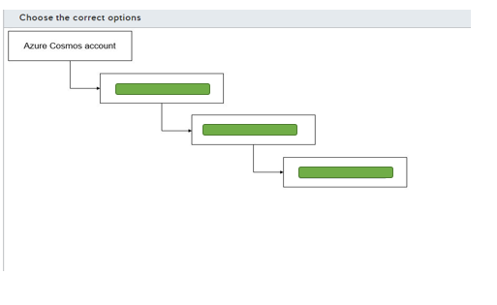

A)

1. Blob
2. Container
3. Database
4. Item

B)

1. Blob
2. Container
3. Database
4. Item

C)

1. Blob
2. Container
3. Database
4. Item

## Question 87: Azure Non-Relational Data Offering

You plan to reduce storage costs to store older, non-structured data in Azure Blob storage. The data needs to be accessible occasionally to generate reports that must be available as soon as possible.  
  
You need to choose the most appropriate data tier for this data.  
  
Which tier should you use?

Choose the correct answer

Cool

Archive

Hot

## Question 88: Azure Non-Relational Data Offering

You are migrating an application to Azure. This application uses a shared network folder as a data store.  
  
You need to move the shared network folder to Azure storage.  
  
Which type of Azure storage should you use?

Choose the correct answer

Azure File storage

Azure Table storage

Azure Blob storage

Azure Queue storage

## Question 89: Azure Non-Relational Data Offering

You are creating an Azure Blob storage to store files for an application.  
  
The files must be replicated to another Azure region in case of a region outage.  
  
Which two redundancy types should you use? Each correct answer presents a complete solution

Choose the correct answers

Read-access geo-redundant storage (RA-GRS)

Geo-redundant storage (GRS)

Zone-redundant storage (ZRS)

Locally redundant storage (LRS)

## Question 90: Cosmos DB API

Match a Cosmos DB API to a type of non-relational data.  
  
To answer, drag the appropriate API to each data type. Each API may be used once, more than once, or not at all.

Drag and drop the answers

drag item 1

drag item 2

drag item 3

drag item 1

drag item 2

drag item 3

drag item 4

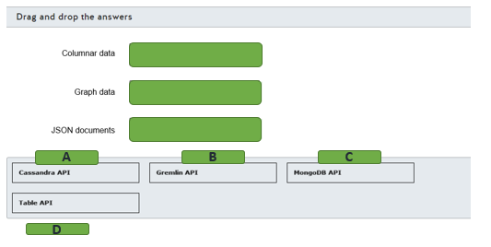

## Question 91: Azure Non-Relational Data Offering

You need to describe which elements compose a key in Azure Table storage.  
  
Which two elements compose a key? Each correct answer presents part of the solution.

Choose the correct answers

Value

Row key

Table name

Partition key

Timestamp

## Question 92: Azure Non-Relational Data Offering

To complete the following sentence, select the appropriate option from the drop-down menu.

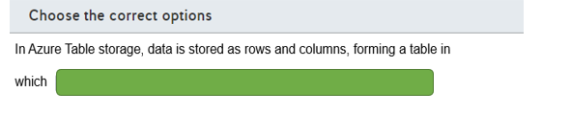

a group of columns is stored in different partitions

The number of columns is exactly the same in each row

The number of columns may vary according to each row

## Question 93: Azure Non-Relational Data Offering

You need to identify which non-relational data stores support multi-region writes and read replicas.  
  
To answer, select the appropriate options from the drop-down menus.

Choose the correct options

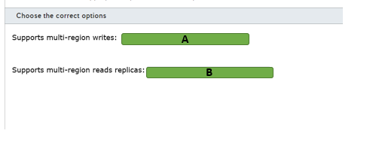

A)

1. Azure Table storage only
2. Cosmos DB Table API only
3. Cosmos DB Table API and Azure Table storage

B)

1. Azure Table storage only
2. Cosmos DB Table API only
3. Cosmos DB Table API and Azure Table storage

## Question 94: Cosmos DB API

You need to implement an Azure Cosmos DB data store.  
  
Which API should you use for each non-relational data store implementation? To answer, drag the appropriate API to the correct data store. Each API may be used once, more than once, or not at all.

Drag and drop the answers

drag item 1

drag item 2

drag item 3

drag item 1

drag item 2

drag item 3

drag item 4

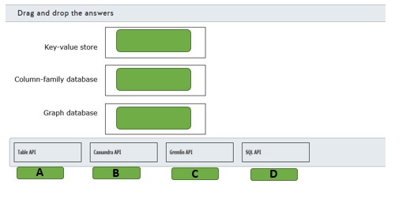

## Question 95: Azure Non-Relational Data Offering

You need to store training videos for company users.  
  
What Azure data service should you use?

Choose the correct answer

Azure SQL Database

Azure File storage

Azure Blob storage

Azure Table storage

# Identify basic management tasks for non-relational data

## Question 96: NoSQL Deployment options

You made configuration changes to a non-relational storage deployment. You want to copy these changes to other instances of the deployment that are already deployed in other tenants. You need to be able to preview the changes before they are applied.  
  
What should you use?

Choose the correct answer

Azure PowerShell

Azure Resource Manager (ARM) template

Azure portal

Azure CLI

## Question 97: Cosmos DB Account

You are deploying the following Azure data services:

* Two Cosmos DB Core (SQL) API databases
* One Cassandra API database
* One MongoDB API database
* One File storage instance
* Two PageBlobs

What is the minimum number of accounts that you need to create? To answer, select the correct number of accounts from the drop-down menus.

Choose the correct options

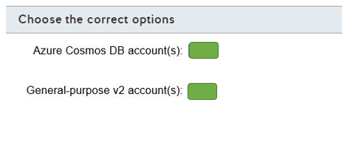

A)

1. 0
2. 1
3. 2
4. 3
5. 4

B)

1. 0
2. 1
3. 2
4. 3
5. 4

## Question 98: Cosmos DB account **

For each of the following statements, select Yes if the statement is true. Otherwise, select No.

|  |  |  |
| --- | --- | --- |
| **Statement** | **Yes** | **No** |
| The type of account to create is specified when you create an Azure Cosmos DB by selecting the API type. |  |  |
| Azure Cosmos DB account serverless mode is supported for all Cosmos DB APIs. |  |  |
| You can have up to one free tier Azure Cosmos DB account per Azure subscription. |  |  |

## Question 99: NoSQLTools

You need to provide temporary read-write access to your Azure Cosmos DB database to other users who do not have access to Azure portal or subscription.  
  
What should you use?

Choose the correct answer

Azure Data Factory connector

Azure Storage Explorer

Azure Data Studio

Azure Cosmos explorer

## Question 100: CosmosDB Security

For each of the following statements, select Yes if the statement is true. Otherwise, select No.

|  |  |  |
| --- | --- | --- |
| **Statement** | **Yes** | **No** |
| You can configure Cosmos DB IP firewall to override the requirement to present a valid authorization token to access data in your database. |  |  |
| You can configure Cosmos DB IP firewall to enable access for a specific IP address, an address range, or a combination of addresses and ranges. |  |  |
| You can configure Cosmos DB IP firewall to configure access from services that do not have a static IP address, such as Azure Functions. |  |  |

## Question 101: Cosmos DB Security

Your Azure subscription is configured with one virtual network (VNet) named Vnet1. You want to limit access to your Azure Cosmos DB account to select subnets in Vnet1.  
  
Which two actions should you perform? Each correct answer presents part of the solution.

Choose the correct answers

Add a rule in the Cosmos DB account to include the IP address 0.0.0.0.

Add a rule in the Cosmos DB account to enable access for the subnet.

Enable the Accept connections from within Azure datacenters option for your Azure Cosmos DB account.

Create a service endpoint in the subnet hosting the Cosmos DB account.

Create a service endpoint in each subnet for which you want to configure access.

## Question 102: NoSQL Tools

You create a command-line interface (CLI) script to copy files from an AWS S3 bucket to Azure Blob storage.  
  
You need to determine an appropriate CLI utility.  
  
Which CLI utility should you use?

Choose the correct answer

AzCopy

az storage blob

Azure Storage Explorer

Start-AzStorageBlobCopy

## Question 103: Cosmos DB account **

You manage an Azure Cosmos DB account.  
  
You need to determine which configurations can be defined at the account, database, or container levels.  
  
Which configurations are supported at each level? To answer, select the appropriate options from the drop-down menus.

Choose the correct options

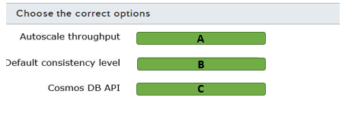

A)

1. Container level only
2. Database level only
3. Database and container levels

B)

1. Container level only
2. Database level only
3. Database and container levels

C)

1. Container level only
2. Database level only
3. Database and container levels

## Question 104: Cosmos DB Account

You have an Azure Cosmos DB account.  
  
You need to configure provisioned throughput for this account.  
  
At which two levels can you configure provisioned throughput? Each correct answer presents a complete solution.

Choose the correct answers

Container

Partition

Database

Item

## Question 105: NoSQL Tools

You are planning to migrate a MongoDB database to Azure Cosmos DB.  
  
What should you use to perform the migration?

Choose the correct answer

az cosmosdb

mongoexport

Cosmos DB Data Migration tool

Azure Storage Explorer

## Question 106: NoSQL Deployment options

To complete the sentence, select the appropriate tool from the drop-down menu.

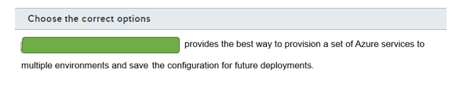

The Azure portal

Azure powerShell

An Azure Resources Manager template

## Question 107: Cosmos DB Security

To complete the sentence, select the appropriate role from the drop-down menu.

Choose the correct options

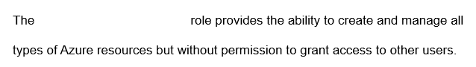

Contributor

Owner

User access administrator

## Question 108: NoSQL Tools

For each of the following statements, select Yes if the statement is true. Otherwise, select No.

|  |  |  |
| --- | --- | --- |
| **Statement** | **Yes** | **No** |
| You can use Azure Storage Explorer to manage Azure Blob Storage. |  |  |
| You can use Azure Storage Explorer to manage Azure Table Storage. |  |  |
| You can use Azure Storage Explorer to manage Azure Data Lake Storage. |  |  |

## Question 109: Azure Storage Security

You need to recommend an Azure store service that supports role-based access control (RBAC) at both file and directory levels.  
  
Which storage solution should you recommend?

Choose the correct answer

Azure Data Lake Storage

Azure Table Storage

Azure Blob Storage

Azure Databricks

## Question 110: Azure Storage Security

To complete the sentence, select the appropriate option from the drop-down menu.

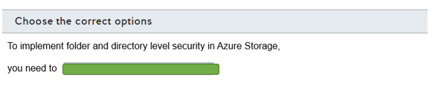

Enable hierarchical namespace

Use the cool access tier as default

Use premium performance

# ** Describe an analytics workload on Azure

# Describe analytics workloads

## Question 111: DW Basics

In which two situations should you use a data warehousing solution? Each correct answer presents a complete solution.

Choose the correct answers

You want to generate reports from historical data without impacting transactional processing.

You want to provide a platform for data mining.

You want to consolidate data from multiple sources into a non-relational store.

You want to optimize performance for a widely distributed transactional processing application.

## Question 112: OLTP vs OLAP

In reference to online transaction processing (OLTP), for each of the following statements, select Yes if the statement is true. Otherwise, select No.

|  |  |  |
| --- | --- | --- |
| **Statement** | **Yes** | **No** |
| Data is highly normalized with the schema strongly enforced on write. |  |  |
| Read and write workload requirements are balanced. |  |  |
| Changes made are rolled back automatically if a transaction is not completed. |  |  |

## Question 113: OLTP vs OLAP

For each application description, identify whether it describes an online transactional processing (OLTP) or online analytic processing (OLAP) workload.  
  
To answer, select OLTP or OLAP from the drop-down menus.

Choose the correct options

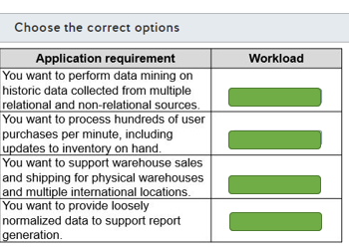

A)

1. OLAP
2. OLTP

B)

1. OLAP
2. OLTP

C)

1. OLAP
2. OLTP

D)

1. OLAP
2. OLTP

## Question 114: Fact/Dimention

You have a data model of a data warehouse solution as shown in the exhibit.

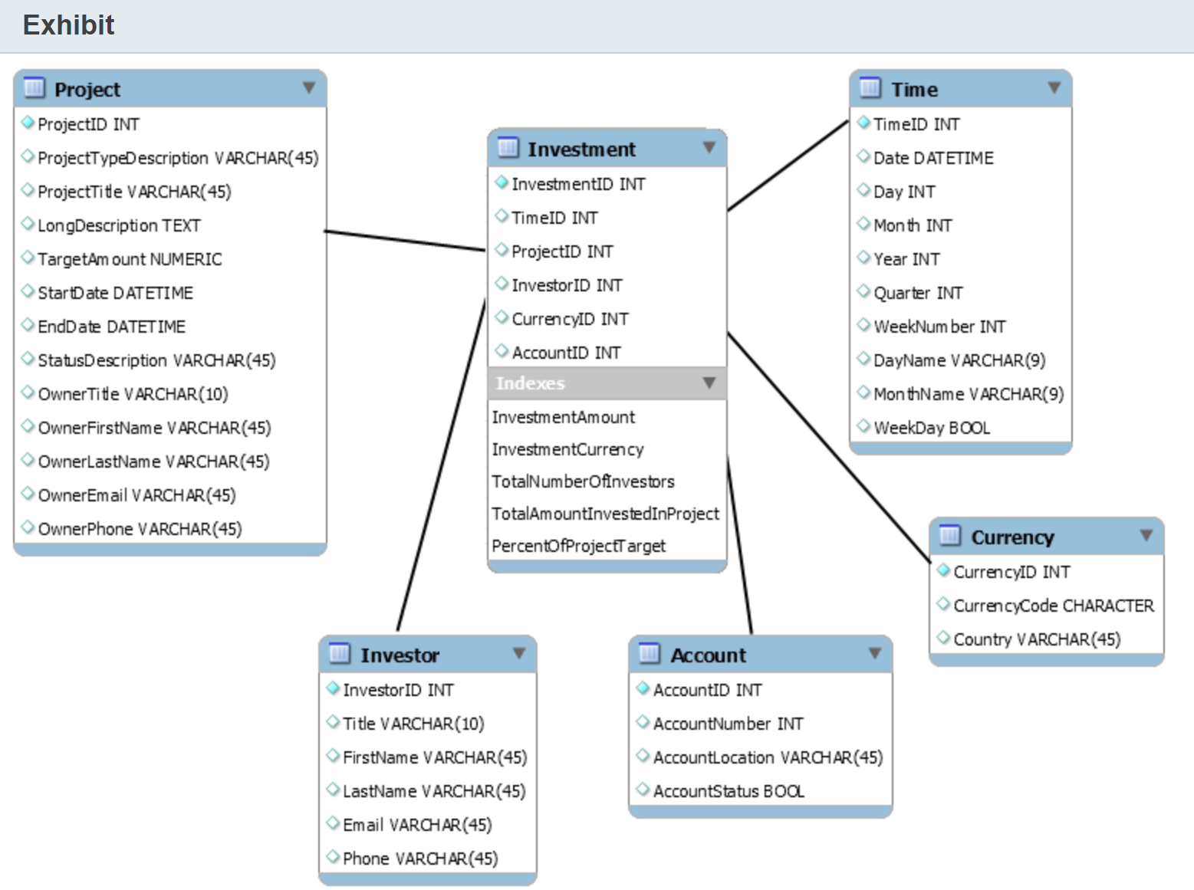  
  
You need to classify the data model.  
  
To answer, select the appropriate options from the drop-down menus.

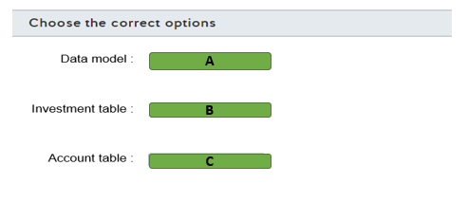

A)

1. Snow flake schema
2. Star schema

B)

1. Dimension table
2. Fact table

C)

1. Dimension table
2. Fact table

## Question 115: DW Basics

For each of the following tasks, select Yes if they are suitable for analytical workloads. Otherwise, select No.

|  |  |  |
| --- | --- | --- |
| **Task** | **Yes** | **No** |
| To generate complex ad-hoc reports using several aggregations |  |  |
| To perform e-commerce transactions |  |  |
| To perform big data analysis on a NoSQL database |  |  |

## Question 116: Fact/Dimension

You have a data model as shown in the exhibit.

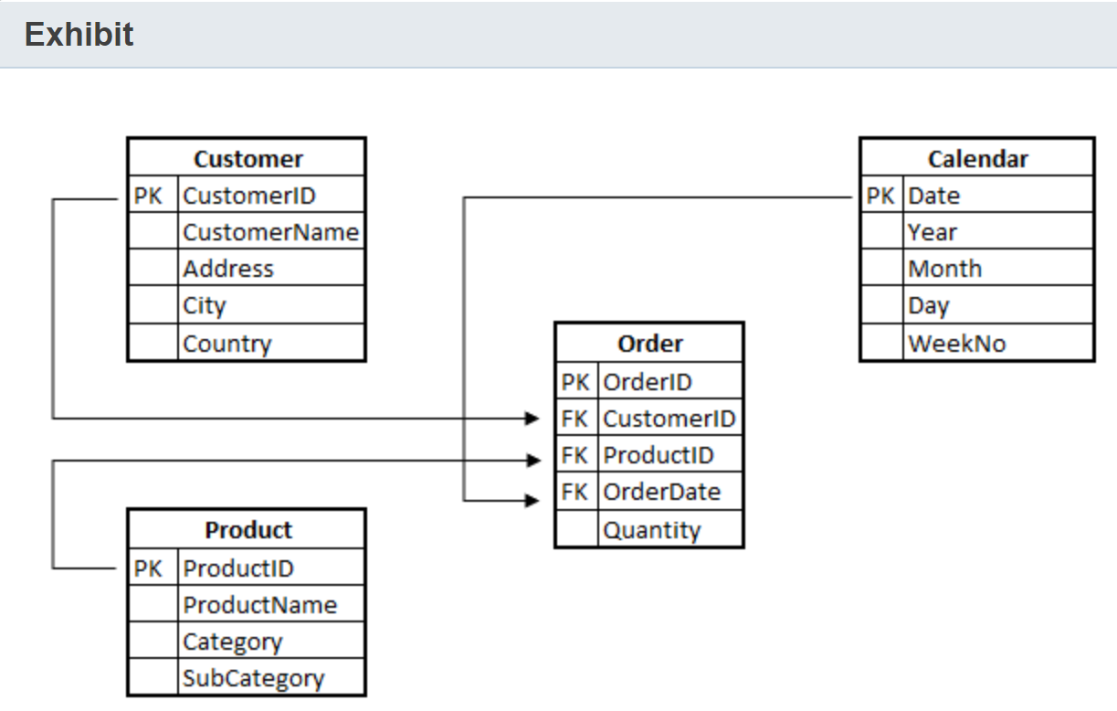  
  
To complete the following sentence, select the appropriate option from the drop-down menu.

Choose the correct options

Question includes an image that is part of the question and must be understood in order answer the question.

OLAP system

Star schema

Snow flake schema

## Question 117: Batch/Real

For each of the following statements, select Yes if the statement is true. Otherwise, select No.

|  |  |  |
| --- | --- | --- |
| **Statement** | **Yes** | **No** |
| You can use a batch workload to build a monthly payroll for your company. |  |  |
| You can use a streaming workload to monitor temperature sensors on a production line. |  |  |
| You can use a streaming workload to measure the weekly gas consumption in a neighborhood. |  |  |

## Question 118: Batch/Real

You need to collect real-time data generated by the anti-cheating platform of an online game.  
  
Which type of workload or processing workload should you use?

Choose the correct answer

Batch processing

Online analytical processing (OLAP)

Online transaction processing (OLTP)

Stream processing

## Question 119: OLTP/OLAP

You need to support a reporting system that performs data mining in a large amount of data.  
  
Which type of workload should you use?

Choose the correct answer

Online transaction processing (OLTP)

Batch processing

Online analytical processing (OLAP)

Stream processing

## Question 120: OLTP/OLAP

Your company uses an accounting system to keep track of all types of financial transactions.  
  
Which type of workloadis this an example of?

Choose the correct answer

Online transaction processing (OLTP)

Stream processing

Online analytical processing (OLAP)

Batch processing

# Describe the components of a modern data warehouse

## Question 121: Synapse/HDInsight - Common

You company plans to implement a data warehouse processing solution for a big data set in Azure. The solution must support massively parallel processing (MPP).  
  
Which two solutions should you use? Each correct answer presents a complete solution.

Choose the correct answers

Azure SQL Database

Azure Synapse Analytics

Apache Hive on HDInsight

SQL Server in a virtual machine (VM)

Azure Data Factory

## Question 122: Data Lake

What is the Azure Data Lake Storage Gen2 storage hierarchy?  
  
To answer, drag the hierarchy components to their appropriate places in the hierarchy.

Drag and drop the answers

drag item 1

drag item 2

drag item 3

drag item 1

drag item 2

drag item 3

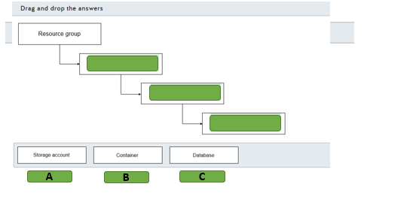

## Question 123: Synapse/HDInsight common

Which Azure service can you use to provision Azure Spark clusters?

Choose the correct answer

Azure HDInsight

Azure Synapse Analytics

Azure Data Factory

Azure Data Lake Storage Gen2

## Question 124: Synapse/HDInsight - Common

Your company has various data warehouse implementations.  
  
You need to assign each data service to the appropriate category.  
  
To answer, drag the appropriate category to the correct data service. Each category may be used once, more than once, or not at all.

Drag and drop the answers

drag item 1

drag item 1

drag item 2

drag item 1

drag item 2

drag item 3

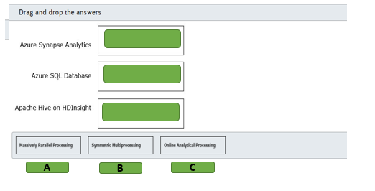

## Question 125: Data Lake

You work as a data engineer.  
  
You need to create an Azure Data Lake Storage Gen2 account for an analytical workload.  
  
What should you do to configure the storage account? To answer, select the appropriate options from the drop-down menus.

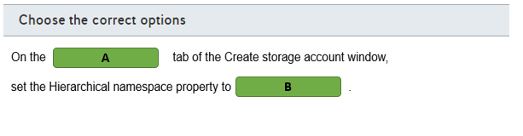

A)

1. Advanced
2. Basic

B)

1. Disabled
2. Enabled

## Question 126: Synapse

You are evaluating use cases for Azure Synapse Analytics.  
  
Which is the most appropriate use case for Azure Synapse Analytics?

Choose the correct answer

To store massive amounts of unstructured data in a hierarchical structure.

To serve as data storage for online transactional processing (OLTP) workloads.

To perform very complex queries and aggregations in a large amount of relational data.

To create dashboards and data visualizations from tabular data.

## Question 127: Synapse/HDInsight - Common

To complete the sentence, select the appropriate option from the drop-down menu.

Choose the correct options

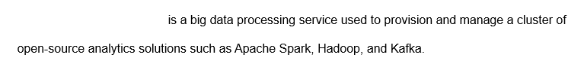

Azure Analysis Services

Azure Databricks

Azure HDinsight

## Question 128: Databricks

For each of the following statements, select Yes if the statement is true. Otherwise, select No.

|  |  |  |
| --- | --- | --- |
| **Statement** | **Yes** | **No** |
| Azure Databricks is an analytics platform based on Apache Spark. |  |  |
| Azure Databricks can process batch processing workloads only. |  |  |
| Azure Databricks provides an interactive workspace for exploration and data visualization. |  |  |

## Question 129: DataService Architecture

You need to evaluate which role each service performs in modern data warehousing.  
  
To answer, select the appropriate options from the drop-down menus.

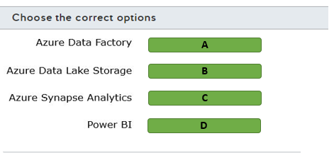

A)

1. Ingest data from source
2. Model and serve data
3. Store raw data
4. Visualize data

B)

1. Ingest data from source
2. Model and serve data
3. Store raw data
4. Visualize data

C)

1. Ingest data from source
2. Model and serve data
3. Store raw data
4. Visualize data

D)

1. Ingest data from source
2. Model and serve data
3. Store raw data
4. Visualize data

## Question 130: Data Lake

For each of the following statements, select Yes if the statement is true. Otherwise, select No.

|  |  |  |
| --- | --- | --- |
| **Statement** | **Yes** | **No** |
| Azure Data Lake Storage is built on top of Azure File storage. |  |  |
| Azure Data Lake Storage is capable of storing a large amount of data in a cost-effective way. |  |  |
| Azure Data Lake Storage enables hierarchical namespace compatible with Hadoop Distributed File System (HDFS). |  |  |

# Describe data ingestion and processing on Azure

## Question 131: DataFactory

Complete the diagram to identity the relationship between Azure Data Factory components and their use.  
  
To answer, select the correct components from the drop-down menus.

Choose the correct options

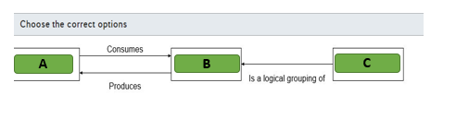

A)

1. Activity
2. Dataset
3. pipeline

B)

1. Activity
2. Dataset
3. pipeline

C)

1. Activity
2. Dataset
3. pipeline

## Question 132: Databricks

For each of the following statements, select Yes if the statement is true. Otherwise, select No.

|  |  |  |
| --- | --- | --- |
| **Statement** | **Yes** | **No** |
| Azure Databricks can read data from Azure Blob Storage, Azure Data Lake Storage, Azure Cosmos DB, and Azure SQL Data Warehouse. |  |  |
| Azure Databricks can directly process data streamed near real-time through Azure Data Factory using Kafka, Event Hub, or IoT Hub. |  |  |
| Users can terminate and restart interactive clusters and automated clusters. |  |  |

## Question 133: DataService Architecture

Match each Azure service with its role in a data warehouse architecture.  
  
To answer, drag the appropriate Azure service to its place in the data warehouse diagram. An Azure Service may be used once, more than once, or not at all.

Drag and drop the answers

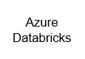

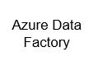

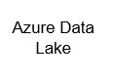

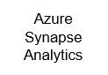









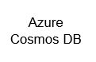

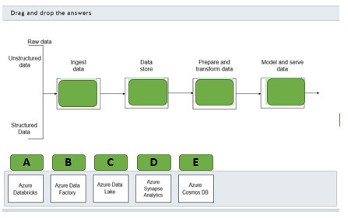

## Question 134: Data Factory

You need to evaluate Azure Data Factory.  
  
For each of the following statements, select Yes if the statement is true. Otherwise, select No.

|  |  |  |
| --- | --- | --- |
| **Statement** | **Yes** | **No** |
| Azure Data Factory can have multiple pipelines. |  |  |
| Pipeline can have multiple activities. |  |  |
| Activities in a pipeline can only run sequentially. |  |  |

## Question 135: DataService Architecture

Your company uses both relational and non-relational data.  
  
You need to recognize the tools that are suitable for each of the following tasks.  
  
What tools should you use? To answer, drag the appropriate option to the correct task. Each option may be used once, more than once, or not at all.

Drag and drop the answers

drag item 1

drag item 2

drag item 3

drag item 1

drag item 2

drag item 3

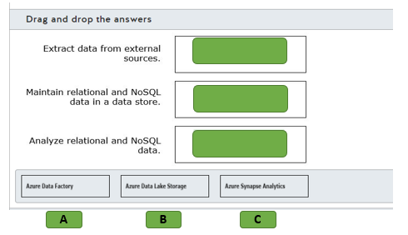

## Question 136: Data Factory

You have a data pipeline in Azure Data Factory.  
  
You need to initiate the pipeline execution.  
  
Which component initiates the pipeline execution?

Choose the correct answer

An activity

A trigger

A control flow

A dataset

## Question 137: Data Factory

To complete the sentence, select the appropriate option from the drop-down menu.

Choose the correct options

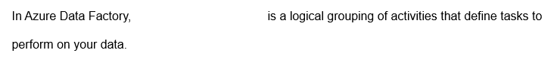

A dataset

A linked service

A pipeline

## Question 138: DataService Architecture

Your company uses Apache Spark for data processing tasks.  
  
You need to provision Azure services compatible with Apache Spark.  
  
Which two services should you use? Each correct answer presents part of the solution.

Choose the correct answers

Azure HDInsight

Azure Data Factory

Azure Data Lake Storage

Azure Databricks

## Question 139: Synapse

You have a large set of data stored in Azure Data Lake Storage in the parquet format.  
  
You need to query this data from an Azure Synapse Analytics using T-SQL.  
  
What should you use?

Choose the correct answer

Azure Databricks

PolyBase

Azure Data Factory

Azure HDInsight

## Question 140: Data Factory

For each of the following statements, select Yes if the statement is true. Otherwise, select No.

|  |  |  |
| --- | --- | --- |
| **Statement** | **Yes** | **No** |
| Azure Data Factory can load data from Azure Blob Storage, Azure Data Lake Storage, Azure Cosmos DB, and Azure Synapse Analytics. |  |  |
| Azure Data Factory can export data to Azure Data Lake Storage and Azure Synapse Analytics only. |  |  |
| Azure Data Factory can run SQL Server Integration Service (SSIS) packages using the Execute SSIS Package activity. |  |  |

# Describe data visualization in Microsoft Power BI

## Question 141: Power BI

What do you use to create Power BI paginated reports?

Choose the correct answer

Power BI service

Power BI Dashboard

Power BI Report Builder

Power BI Desktop

## Question 142: Dashboard

Which three tiles are standalone tiles that can be pinned to a Power BI Dashboard? Each correct answer presents part of the solution.

Choose the correct answers

Paginated report pages

Text boxes

Power BI apps

Streaming data

Web content

Interactive report pages

## Question 143: Dashboard

For each of the following statements, select Yes if the statement is true. Otherwise, select No.

|  |  |  |
| --- | --- | --- |
| **Statement** | **Yes** | **No** |
| Each report page displayed on a dashboard is based on a single dataset. |  |  |
| A dashboard can include pages pinned from multiple reports. |  |  |
| Dashboard content is limited to cloud data only. |  |  |
| One dashboard can be identified as your featured dashboard. |  |  |

## Question 144: Power BI

Match each description with the Power BI term that it describes.  
  
To answer, select the appropriate Power BI term from the drop-down menus.

Choose the correct options

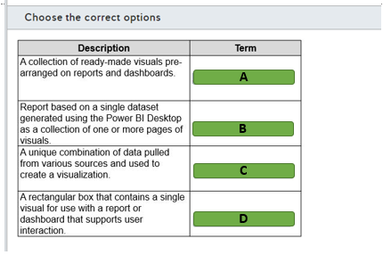

A)

1. App
2. Dashboard
3. Dataset
4. Interactive report
5. Paginated report
6. Tile

B)

1. App
2. Dashboard
3. Dataset
4. Interactive report
5. Paginated report
6. Tile

C)

1. App
2. Dashboard
3. Dataset
4. Interactive report
5. Paginated report
6. Tile

D)

1. App
2. Dashboard
3. Dataset
4. Interactive report
5. Paginated report
6. Tile

## Question 145: Power BI

You need to create an app workspace in Power BI and share its dashboard.  
  
Which option should you use?

Choose the correct answer

Power BI desktop

Power BI service and desktop

Power BI service

Power BI mobile app

## Question 146: Power BI

You need to determine which part of Power BI you should use in each activity of a common workflow.  
  
Which three activities and services should you use? Each correct answer presents part of the solution.

Choose the correct answers

Create a report on Power BI Desktop.

View and interact with reports on Power BI mobile.

Create a report on Power BI mobile.

Share a report on Power BI mobile.

Share a report on Power BI service.

## Question 147: Power BI

You need to determine which activities can be performed entirely in the Power BI service.  
  
For each of the following statements, select Yes if the statement is true. Otherwise, select No.

|  |  |  |
| --- | --- | --- |
| **Statement** | **Yes** | **No** |
| You can create reports and dashboards in the Power BI service. |  |  |
| You can share and distribute reports in the Power BI service. |  |  |
| You can design data modeling in the Power BI service. |  |  |

## Question 148: Power BI

To complete the sentence, select the appropriate option from the drop-down menu.

Choose the correct options

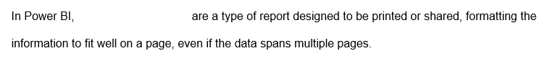

Dashboard

Paginated reports

reports

## Question 149: Power BI

You need to match the main Power BI components to each description.  
  
To answer, drag the appropriate component to each description. A component may be used once, more than once, or not at all.

Drag and drop the answers

drag item 1

drag item 2

drag item 3

drag item 4

drag item 1

drag item 2

drag item 3

drag item 4

drag item 5

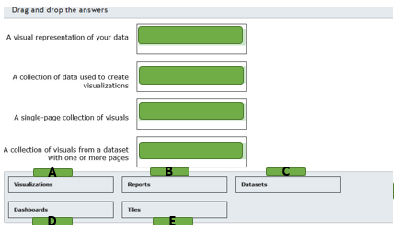

## Question 150: Power BI

For each of the following statements, select Yes if the statement is true. Otherwise, select No.

|  |  |  |
| --- | --- | --- |
| **Statement** | **Yes** | **No** |
| You can display visualizations only from a single dataset on a dashboard. |  |  |
| You can filter and slice the data shown on a dashboard. |  |  |
| You can export the underlying data used to build a tile to an Excel file. |  |  |