# 实验2 SQL数据定义和操作

学号：3200105788 姓名： 孙川

### 实验目的：

1. 掌握MySQL数据库的复杂SQL查询和DML语句的使用方法；
2. 掌握MySQL数据库的视图设计和使用方法。
3. 掌握MySQL数据库的索引设计和使用方法。

### 实验平台：

1. 数据库管理系统：MySQL

### 实验内容和要求：

1. 建立数据库school；
2. 数据的定义：

用create创建三张表，用alert增加主键和外键，

**S (SID,SNAME,AGE,SEX)**

**中文语义：学生（学号，姓名，年龄，性别）**

**SC (SID,CID,GRADE)**

**中文语义：学习（学号，课程号，成绩）**

**C (CID,CNAME,TEACHER)**

**中文语义：课程（课程号，课程名，任课教师）**

用insert添加如下数据；

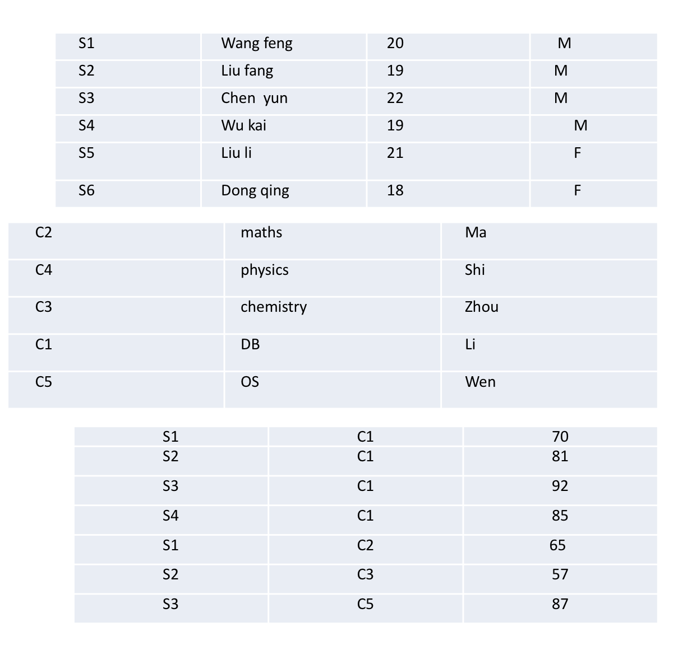­

1. 数据查询：

单表查询，

* 1. 查询全体学生的姓名、年龄；  
     select sname,age from s;
  2. 查询所有选修过课的学生的学号；  
     select distinct sname from sc,s where sc.sid=s.sid;
  3. 查询考试成绩低于60分的学生的学号；  
     select distinct sid from sc where grade<60;
  4. 查询年龄在20至23之间的学生姓名、性别和年龄；  
     select distinct sname,sex,age from s where (age<23)and(age>20);
  5. 查询所有姓liu的学生的学号、姓名和年龄；  
     select distinct sid,sname,age from s where sname like "%Liu%";
  6. 查询学习C1课程的学生最高分数；  
     select distinct max(grade) from sc;
  7. 查询各个课程号与相应的选课人数；  
     select cid,count(distinct sid) as times from sc group by cid;
  8. 查询选修C3课程的学生的姓名；  
     select distinct sname from sc,s where s.sid=sc.sid and cid="C3";
  9. 查询选修C1课程且成绩在90分以上的所有学生姓名。  
     select distinct sname from sc,s where s.sid=sc.sid and cid="C1" and grade>90;
  10. 查询每一门课程的平均成绩  
      select cid,avg(distinct grade) as avg_grade from sc group by cid;
  11. 查询授课教师名字中包括i的课程名  
      select cname from c where teacher like "%i%";
  12. 查询课程成绩在80～90的学生编号、课程编号  
      select sid,cid from sc where grade>80 and grade<90;

多表查询，

* 1. 查询最高成绩为80以上的课程名、最高成绩  
     select distinct cname,max(distinct grade) from c,sc where c.cid=sc.cid group by c.cid ;

嵌套查询；

1. 查询c1课程在平均分以上的学生信息  
   select @myvar:=avg(distinct grade) as avger from sc where cid="C1" group by cid;  
   select sname,s.sid,sex from s,sc where s.sid=sc.sid and sc.cid="C1" and sc.grade>@myvar;
2. 视图使用：根据表S,SC,C创建视图 S_C_SC,使其具有如下内容（学号，姓名，课程名，成绩），并使用视图查询姓Wu的各门课程成绩，修改视图中的数据观察视图和原关系表中的变化，删除视图；  
   **结果：  
   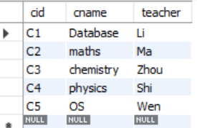对视图进行操作会相应更改表的键值（非安全模式下）**
3. 索引的使用：以课程编号为索引为C创建索引INDEX_CID使用查询语句，查看使用索引后数据的变化，删除索引。  
     
   
4. 数据更新：
   1. 用update命令修改c表中课程号为C3的课程的课程号修改为C6
   2. 用update命令修改sc表中课由“Li”任课的课程号为由“Wen”任课的课程号
   3. 用delete命令删除表sc中分数在60以下的记录
   4. 用delete命令删除表sc中课程名为“OS”的记录。
5. 删除三张关系表和数据库。

附上代码：

create database school;

use school;

create table s

(

    sid varchar(10),

    sname varchar(100) not null,

    age int not null,

    sex varchar(5) not null,

    primary key (sid)

)engine= InnoDB default charset=utf8mb3;

create table sc

(

    sid varchar(10),

    cid varchar(10),

    grade int not null

)engine=InnoDB default charset=utf8mb3;

create table c

(

    cid varchar(10),

    cname varchar(20),

    teacher varchar(20),

    primary key (cid)

)engine=InnoDB default charset=utf8mb3;

show tables;

insert into s

    (sid,sname,age,sex)

values("S1", "Wang feng", 20, "M");

insert into s

    (sid,sname,age,sex)

values("S2", "Liu fang", 19, "M");

insert into s

    (sid,sname,age,sex)

values("S3", "Chen yun", 22, "M");

insert into s

    (sid,sname,age,sex)

values("S4", "Wu kai", 19, "M");

insert into s

    (sid,sname,age,sex)

values("S5", "Liu li", 21, "F");

insert into s

    (sid,sname,age,sex)

values("S6", "Dong qing", 18, "F");

select *

from s;

insert into c

    (cid,cname,teacher)

values("C2", "maths", "Ma");

insert into c

    (cid,cname,teacher)

values("C4", "physics", "Shi");

insert into c

    (cid,cname,teacher)

values("C3", "chemistry", "Zhou");

insert into c

    (cid,cname,teacher)

values("C1", "DB", "Li");

insert into c

    (cid,cname,teacher)

values("C5", "OS", "Wen");

select *

from c;

insert into sc

    (sid,cid,grade)

values("S1", "C1", 70);

insert into sc

    (sid,cid,grade)

values("S2", "C1", 81);

insert into sc

    (sid,cid,grade)

values("S3", "C1", 92);

insert into sc

    (sid,cid,grade)

values("S4", "C1", 85);

insert into sc

    (sid,cid,grade)

values("S1", "C2", 65);

insert into sc

    (sid,cid,grade)

values("S2", "C3", 57);

insert into sc

    (sid,cid,grade)

values("S3", "C5", 87);

select * from sc;

#drop table sc;

select sname,age from s;

select distinct sname from sc,s where sc.sid=s.sid;

select distinct sname,sex,age from s where (age<23)and(age>20);

select distinct sid,sname,age from s where sname like "%Liu%";

select distinct max(grade) from sc;

select cid,count(distinct sid) as times from sc group by cid;

select distinct sname from sc,s where s.sid=sc.sid and cid="C3";

select distinct sname from sc,s where s.sid=sc.sid and cid="C1" and grade>90;

select cid,avg(distinct grade) as avg_grade from sc group by cid;

select cname from c where teacher like "%i%";

select sid,cid from sc where grade>80 and grade<90;

select distinct cname,max(distinct grade) from c,sc where c.cid=sc.cid group by c.cid ;

select @myvar:=avg(distinct grade) as avger from sc where cid="C1" group by cid;

select sname,s.sid,sex from s,sc where s.sid=sc.sid and sc.cid="C1" and sc.grade>@myvar;

create view my1 as select s.sid,sname,cname,grade from s,sc,c where s.sid=sc.sid and c.cid=sc.cid;

select * from my1;

select cname,grade from my1 where sname like "%Wu%";

SET SQL_SAFE_UPDATES=0;

update my1 set cname="Database" where cname="DB";

select * from c;

drop view my1;

create index index_cid on c(cid);

show index from c  ;

select * from c;

drop index index_cid on c;

update c set cid="C6" where cid="C3";

select @myvar:=  cid from c where teacher like "%Wen%";

update c,sc set sc.cid=@myvar where c.cid=sc.cid and c.cname="%Li%";

delete from sc where grade<60;

select @myvar:= cid from c where cname="OS";

delete from sc where cid=@myvar;

select * from sc;

drop table s;

drop table c;

drop table sc;

drop database school;