**Concepts Of Programming**

Assignment 1

**Q.1.** wap to demonstrate ternary operator .define a variable marks .ask its value from user and using ternary operator check if marks > 40 store "Pass" in result varible else store "Fail"

=>

**package** COP_Assignment1;

**import** java.util.Scanner;

**public** **class** PassOrFail {

**public** **static** **void** main(String[] args) {

System.***out***.println("Enter marks: ");

Scanner s = **new** Scanner(System.***in***);

**int** marks = s.nextInt();

String result = marks>40?"Pass":"Fail";

System.***out***.println(result);

}

}

**OUTPUT:**

**Case 1:**

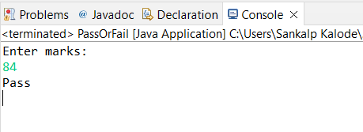

**Case 2:**

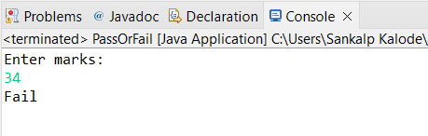

**Q.2.** using ternary check if number entered by user is positive or negative .

In case number is positive store "Positive number" else store negative number to Result variable

=>

**package** COP_Assignment1;

**import** java.util.Scanner;

**public** **class** PositiveNegative {

**public** **static** **void** main(String[] args) {

System.***out***.println("Enter a number: ");

Scanner s = **new** Scanner(System.***in***);

**int** num = s.nextInt();

String result = num > 0 ? "Positive" : "Negative";

System.***out***.println(result);

}

}

**OUTPUT:**

**Case 1:**

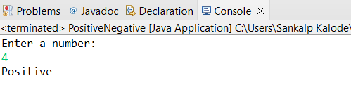

**Case 2:**

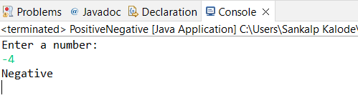

**Q.3.** WAP to ask name ,age and salary of an employee and print on console.

=>

**package** COP_Assignment1;

**import** java.util.Scanner;

**public** **class** employeeDetails {

**public** **static** **void** main(String[] args) {

Scanner s = **new** Scanner(System.***in***);

System.***out***.println("Enter employee name: ");

String name = s.next();

System.***out***.println("Enter employee age: ");

**int** age = s.nextInt();

System.***out***.println("Enter employee salary: ");

**float** salary = s.nextFloat();

System.***out***.println("Employee name is: " + name);

System.***out***.println("Employee age is: " + age);

System.***out***.println("Employee salary is: " + salary);

}

}

**OUTPUT:**

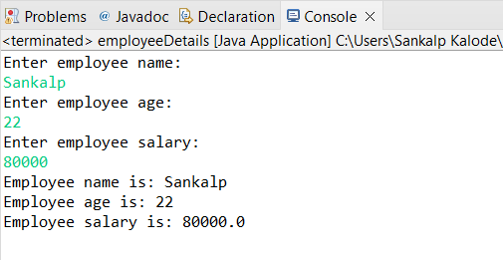

**Q.4.** wap that ask two numbers from user and print greater number among two

=>

**package** COP_Assignment1;

**import** java.util.Scanner;

**public** **class** greaterNumber {

**public** **static** **void** main(String[] args) {

System.***out***.println("Enter a number: ");

Scanner s = **new** Scanner(System.***in***);

**int** num1 = s.nextInt();

System.***out***.println("Enter another number: ");

**int** num2 = s.nextInt();

**if**(num1>num2)

{

System.***out***.println(num1 + " is greater than " + num2);

}

**else**

{

System.***out***.println(num2 + " is greater than " + num1);

}

}

}

**OUTPUT:**

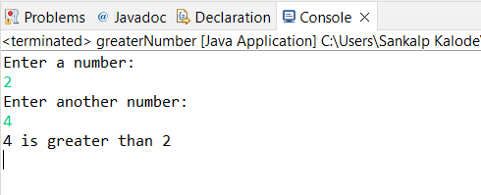

**Q.5.** wap to ask product name and price of product from user and calculate discount i.e

if price > 2000 then discount is 10 percent of price

else

discount is 7 % of price

=>

**package** COP_Assignment1;

**import** java.util.Scanner;

**public** **class** calculateDiscount {

**public** **static** **void** main(String[] args) {

Scanner s= **new** Scanner(System.***in***);

System.***out***.println("Enter product name: ");

String name = s.next();

System.***out***.println("Enter product price: ");

**float** price = s.nextFloat();

**float** new_price;

**float** discount;

**if**(price > 2000)

{

System.***out***.println("10% discount will be given");

discount = (price * 10)/100;

new_price = price - discount;

}

**else**

{

System.***out***.println("7% discount will be given");

discount = (price * 7)/100;

new_price = price - discount;

}

System.***out***.println("Discount: " + discount);

System.***out***.println("New discounted price : " + new_price);

}

}

**OUTPUT:**

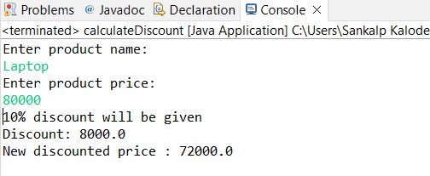

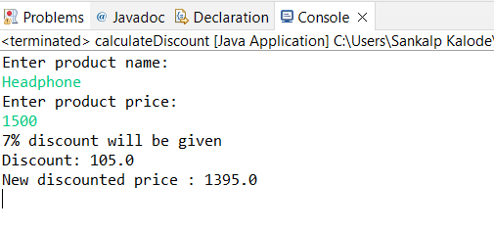

**Q.6.** Wap to swap two numbers

=>

**package** COP_Assignment1;

**import** java.util.Scanner;

**public** **class** swapNumbers {

**public** **static** **void** main(String[] args) {

Scanner s = **new** Scanner(System.***in***);

System.***out***.println("Enter a number: ");

**int** a = s.nextInt();

System.***out***.println("Enter another number: ");

**int** b = s.nextInt();

System.***out***.println("Before swaping");

System.***out***.println("a = " + a);

System.***out***.println("b = :" + b);

**int** temp;

temp = a;

a = b;

b = temp;

System.***out***.println("After swaping");

System.***out***.println("a = " + a);

System.***out***.println("b = " + b);

}

}

**OUTPUT:**

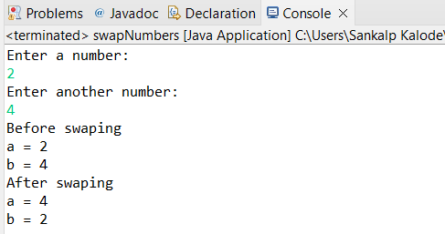

**Q.7.** How to swap two numbers without using a third variable?

=>

**package** COP_Assignment1;

**import** java.util.Scanner;

**public** **class** swapWithoutThirdVariable {

**public** **static** **void** main(String[] args) {

Scanner s= **new** Scanner(System.***in***);

System.***out***.println("Enter a number: ");

**int** a = s.nextInt();

System.***out***.println("Enter another number: ");

**int** b = s.nextInt();

System.***out***.println("Before swaping");

System.***out***.println("a = " + a);

System.***out***.println("b = " + b);

a = a+b;

b = a-b;

a = a-b;

System.***out***.println("After swaping");

System.***out***.println("a = " + a);

System.***out***.println("b = " + b);

}

}

**OUTPUT:**

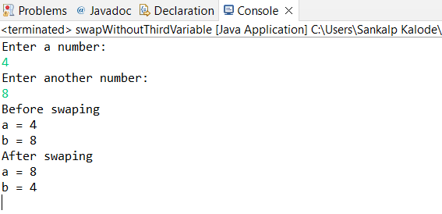

**Q.8.** wap to check is number is even or odd.

=>

**package** COP_Assignment1;

**import** java.util.Scanner;

**public** **class** checkEvenOdd {

**public** **static** **void** main(String[] args) {

Scanner s= **new** Scanner(System.***in***);

System.***out***.println("Enter a number: ");

**int** num = s.nextInt();

**if**(num==0 )

{

System.***out***.println(num + " is neither Even nor Odd.");

}

**else** **if**(num%2==0)

{

System.***out***.println("Even");

}

**else**

{

System.***out***.println("Odd");

}

}

}

**OUTPUT:**

**Case 1:**

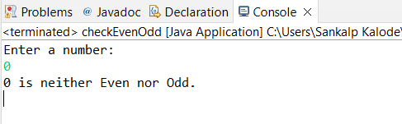

**Case 2:**

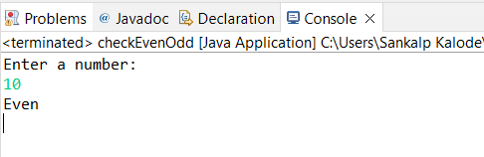

**Case 3:**

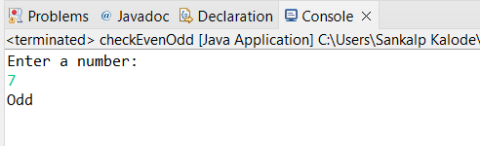

**Q.9.** A school has following rules for grading system:

a. Below 25 - F

b. 25 to 45 - E

c. 45 to 50 - D

d. 50 to 60 - C

e. 60 to 80 - B

f. Above 80 - A

Ask user to enter marks and print the corresponding grade

=>

**package** COP_Assignment1;

**import** java.util.Scanner;

**public** **class** gradingSystem {

**public** **static** **void** main(String[] args) {

Scanner s= **new** Scanner(System.***in***);

System.***out***.println("Enter marks: ");

**int** marks = s.nextInt();

**if**(marks<100 && marks>0)

{

**if**(marks < 25)

{

System.***out***.println("F");

}

**else** **if**(marks>=25 && marks<45)

{

System.***out***.println("E");

}

**else** **if**(marks>=45 && marks<50)

{

System.***out***.println("D");

}

**else** **if**(marks>=50 && marks<60)

{

System.***out***.println("C");

}

**else** **if**(marks>=60 && marks<80)

{

System.***out***.println("B");

}

**else**

{

System.***out***.println("A");

}

}

**else**

{

System.***out***.println("You have entered wrong marks");

}

}

}

**OUTPUT:**

**Case 1:**

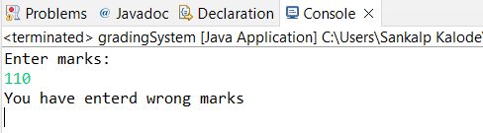

**Case 2:**

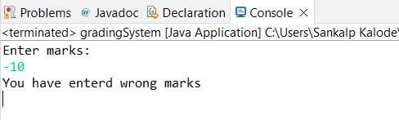

**Case 3:**

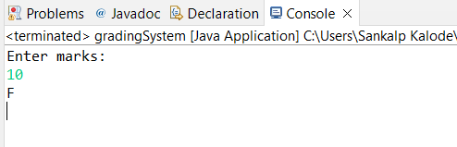

**Case 4:**

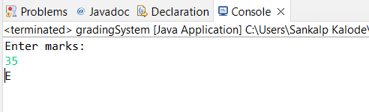

**Case 5:**

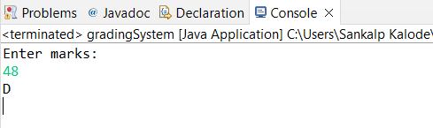

**Case 6:**

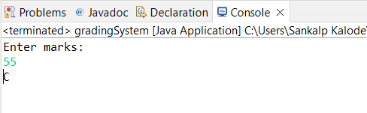

**Case 7:**

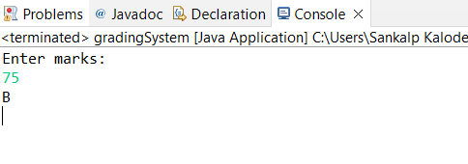

**Case 8:**

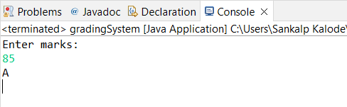

**Q.10.** wap to check greater number among three numbers

=>

**package** COP_Assignment1;

**import** java.util.Scanner;

**public** **class** greatestOfThree {

**public** **static** **void** main(String[] args) {

Scanner s= **new** Scanner(System.***in***);

System.***out***.println("Enter first number: ");

**int** a = s.nextInt();

System.***out***.println("Enter second number: ");

**int** b = s.nextInt();

System.***out***.println("Enter third number: ");

**int** c = s.nextInt();

**if**(a==b && b==c)

{

System.***out***.println("All numbers are same");

}

**else** **if**(a>b && a>c)

{

System.***out***.println(a + " is greater than " + b + " and " + c);

}

**else** **if**(b>a && b>c)

{

System.***out***.println(b + " is greater than " + a + " and " + c);

}

**else**

{

System.***out***.println(c + " is greater than " + a + " and " + b);

}

}

}

**OUTPUT:**

