Supplementary Material (Appendix)
Remote Sensing Image Change Caption Generation for Indian Sentinel-2 Imagery
Sankalp Chaturvedi (2025201083), KSPSVLN Siddardha Kumar Kavuri (2025201061), Rinkesh Verma (2025201070) · Mentor: Rama Chandra Prasad
Appendix tables and figures are cited in the main text as Appendix Table An and Appendix Figure An. Prediction sheets for all saved test samples are published at kaggle.com/datasets/kspsvlnsiddardha/rsicc-model-run-reports.

Appendix tables
Appendix Table A1. Full LEVIR-CC test metrics (n = 1,929).
Model | Loss | BLEU-1 | BLEU-2 | BLEU-3 | BLEU-4 | METEOR | ROUGE-L | Cosine
Phase 1 | 0.9690 | 0.4720 | 0.3855 | 0.3393 | 0.3027 | 0.5966 | 0.6214 | 0.6477
Phase 2 | 0.9345 | 0.5168 | 0.4237 | 0.3712 | 0.3284 | 0.6304 | 0.6545 | 0.7061
Final | 0.8982 | 0.5311 | 0.4355 | 0.3810 | 0.3365 | 0.6392 | 0.6604 | 0.7123
Phase 6 | 0.9225 | 0.5214 | 0.4297 | 0.3777 | 0.3358 | 0.6357 | 0.6624 | 0.7149
Phase 8, stage 1a (epoch 7) | — | 0.5092 | 0.4167 | 0.3658 | 0.3250 | 0.6155 | 0.6482 | 0.7007
Phase 8, stage 1b | — | 0 | 0 | 0 | 0 | 0 | 0 | 0.0104

Appendix Table A2. Training configuration.
Item | Phase 1 | Phase 2 | Final | Phase 6 | Phase 8 (1a) | Phase 8 (1b)
Input size (px) | 256 | 224 | 224 | 4 × 224 tiles | 224 | 224
Batch size | 16 | 16 | 16 | 16 | 8 | 8
Epochs | ≥ 10 | 10 | 15 | 15 | 15 | 10
Learning rate | 1×10⁻⁴ | 1×10⁻⁴ | 1×10⁻⁴ | 1×10⁻⁴ | 1×10⁻⁴ | 5×10⁻⁵
Weight decay | 1×10⁻⁵ | 1×10⁻⁵ | 1×10⁻⁵ | 1×10⁻⁵ | 1×10⁻⁵ | 1×10⁻⁵
Vocabulary | 733 | 733 | 1,300 | 1,300 | 733 | Qwen tokenizer

Appendix Table A3. Forgetting after SECOND-CC fine-tuning (LEVIR-CC test set).
Model | Loss | BLEU-4 | METEOR | ROUGE-L | Cosine
Final, before | 0.898 | 0.337 | 0.639 | 0.660 | 0.712
Final, after | 4.080 | 0.149 | 0.394 | 0.437 | 0.458
Phase 6, before | 0.923 | 0.336 | 0.636 | 0.662 | 0.715
Phase 6, after | 3.520 | 0.121 | 0.318 | 0.374 | 0.438

Appendix Table A4. Prediction behaviour on the saved prediction sheets (300 samples each).
Prediction sheet | Changed pairs called “no difference” | Unchanged pairs correct | Distinct captions
Phase 6, LEVIR-CC | 43 / 164 | 98 / 136 | 21
Phase 8, LEVIR-CC | 31 / 164 | 96 / 136 | 32
Final after fine-tuning, LEVIR-CC | 164 / 164 | 136 / 136 | 1
Phase 6, SECOND-CC | 16 / 255 | 33 / 45 | 97
Phase 8, SECOND-CC | 19 / 255 | 30 / 45 | 82

Appendix Table A5. Accepted and rejected patch pairs by region.
Region | Accepted | Rejected
Deccan | 3,902 | 2,738
Central-east | 3,179 | 2,485
North plains | 2,655 | 2,129
West desert | 2,095 | 2,033
North-east | 1,580 | 804
Himalaya | 1,529 | 1,095
South and islands | 670 | 994
Total | 15,610 | 12,278

Appendix Table A6. How often each model called a pair “change”, by human label (n = 495).
Human label | n | Qwen3-VL-32B | Qwen3-VL-235B
Seasonal | 214 | 200 (93%) | 67 (31%)
No change | 226 | 184 (81%) | 53 (23%)
Change | 55 | 49 (89%) | 25 (45%)

Appendix Table A7. Results on all labelled pairs (n = 962; human label where available, automatic label otherwise).
Rule | Recall | Precision | False-change rate
Qwen3-VL-32B | 96% | 26% | 47%
Qwen3-VL-235B | 79% | 48% | 15%
Both agree | 78% | 51% | 13%

Appendix figures
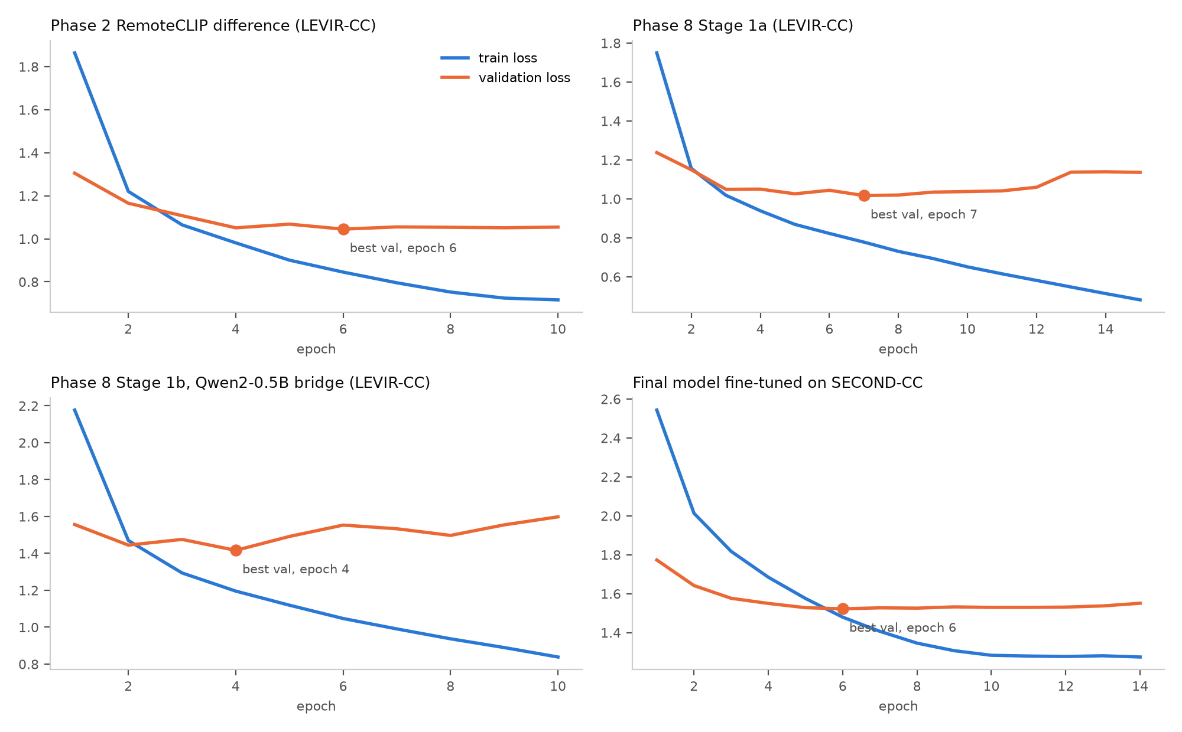
Appendix Figure A1. Training and validation loss for four runs: Phase 2, Phase 8 stage 1a, Phase 8 stage 1b and the Final model fine-tuned on SECOND-CC. Dots mark the best validation epoch.
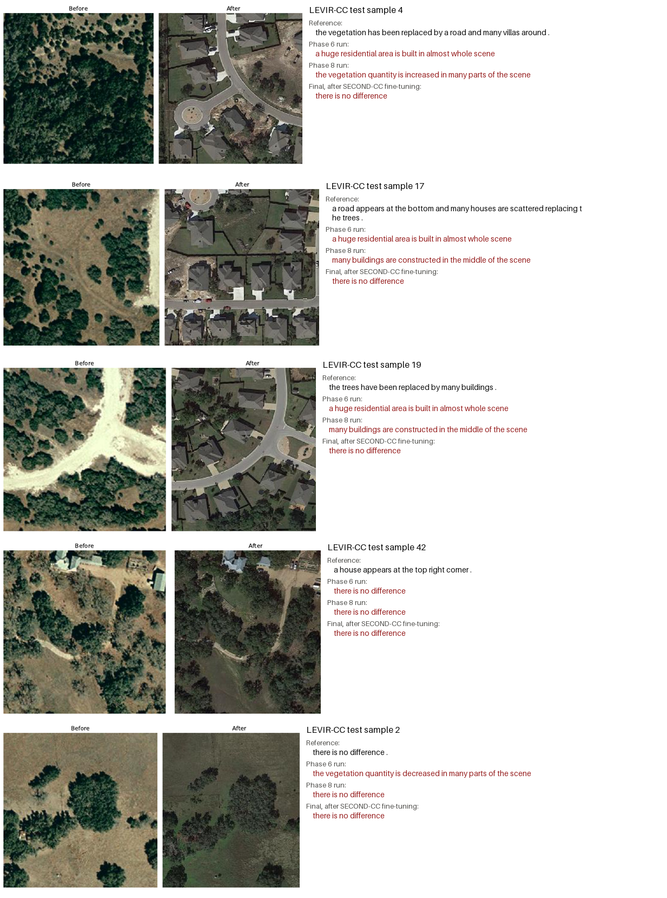
Appendix Figure A2. The same LEVIR-CC test pairs captioned by three runs, with the reference caption.
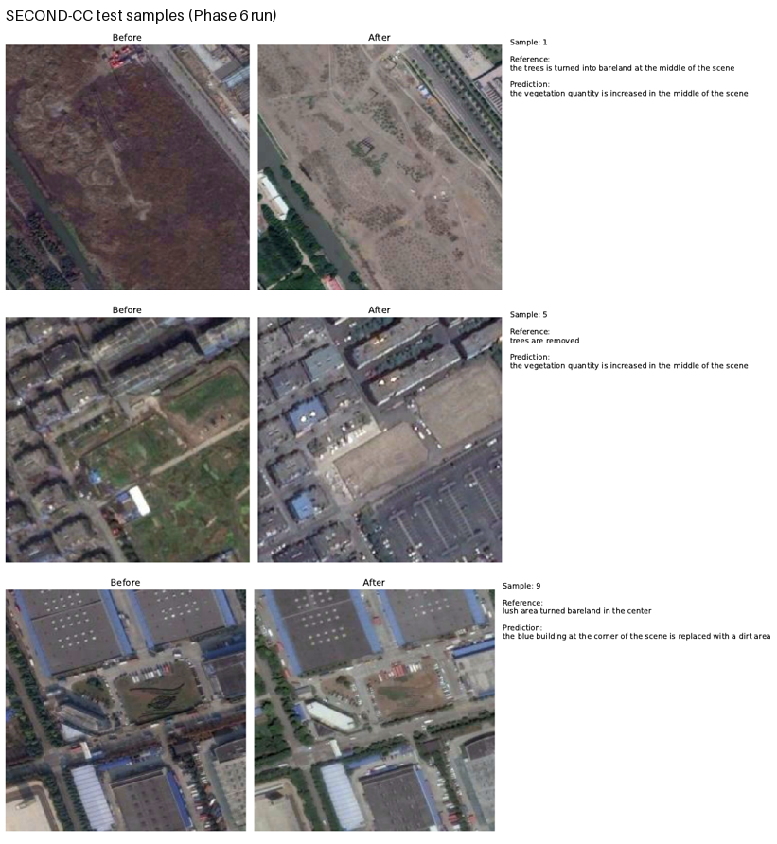
Appendix Figure A3. SECOND-CC test predictions (Phase 6 run).
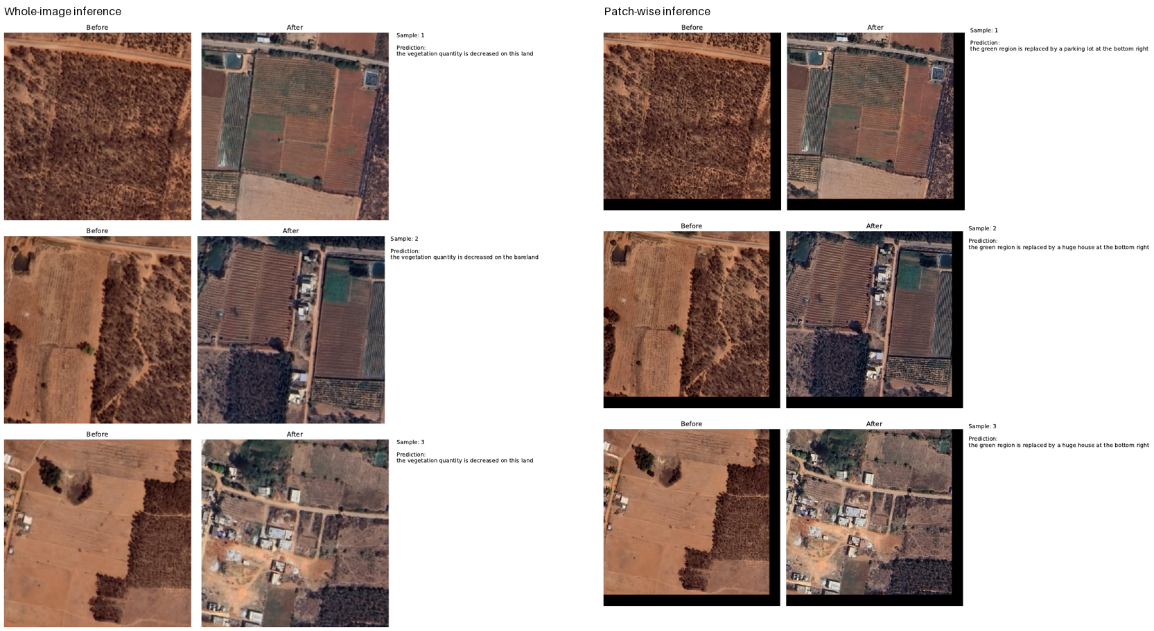
Appendix Figure A4. Whole-image (left) and patch-wise (right) inference on unlabelled high-resolution pairs.
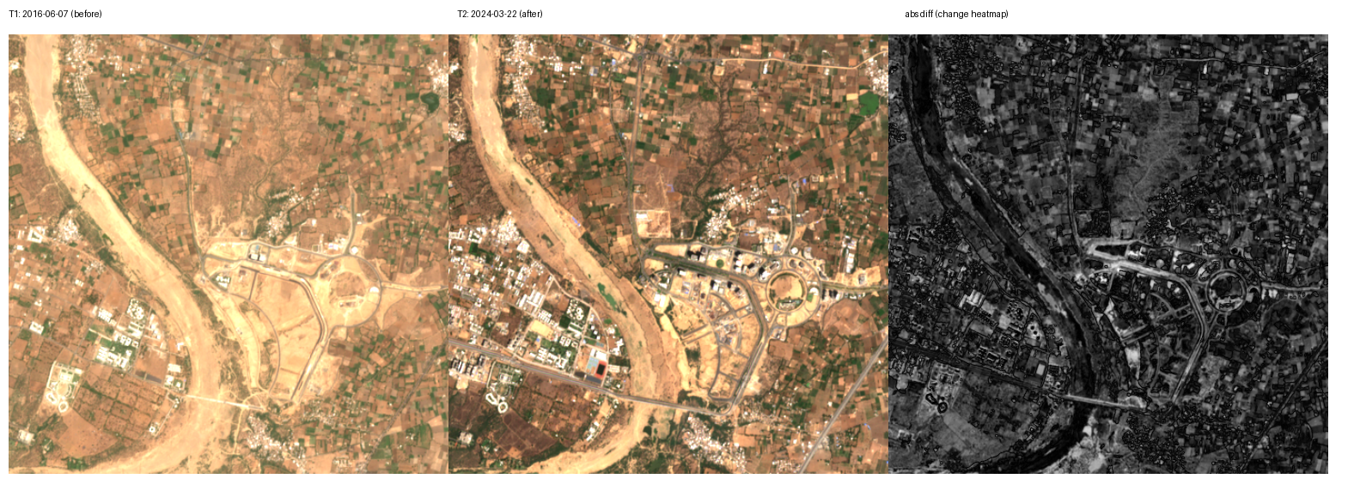
Appendix Figure A5. A pair from the pilot Indian Sentinel-2 collection with its absolute-difference map.
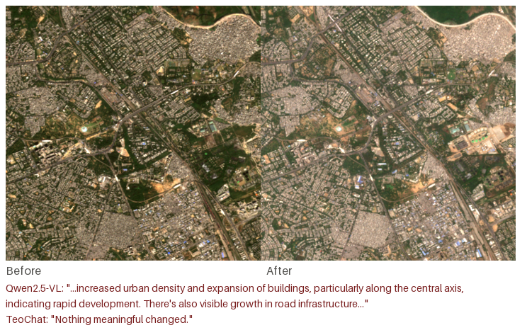
Appendix Figure A6. An Indian pilot pair with the answers of two off-the-shelf captioners.
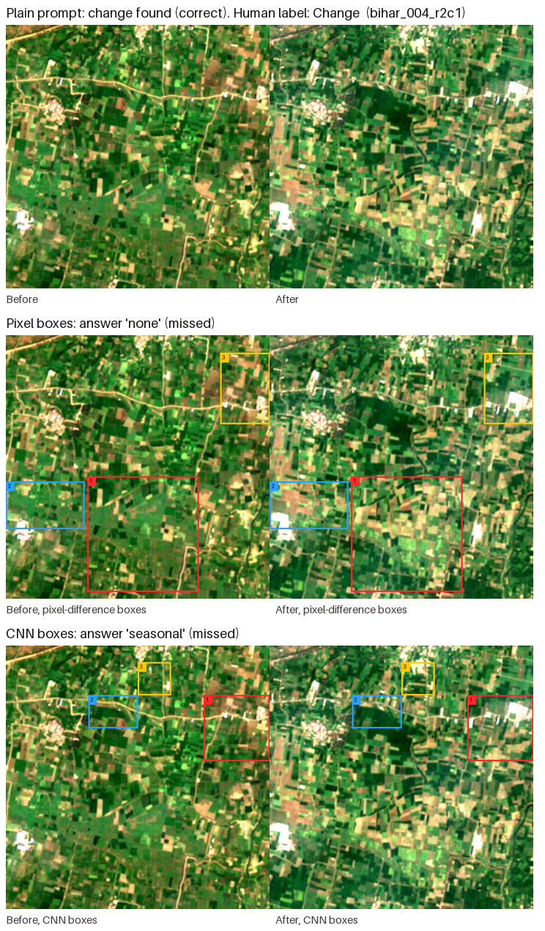
Appendix Figure A7. A human-confirmed change with pixel-difference and CNN region boxes; the plain question finds the change, the boxed prompts miss it.
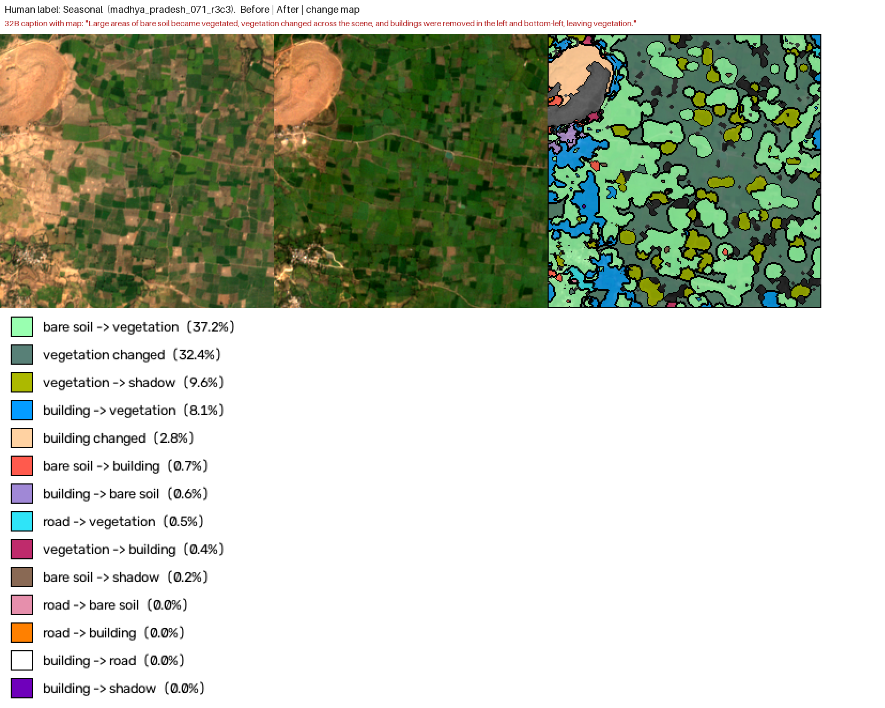
Appendix Figure A8. Rule-based change map on a pair labelled seasonal, with the caption written from it.
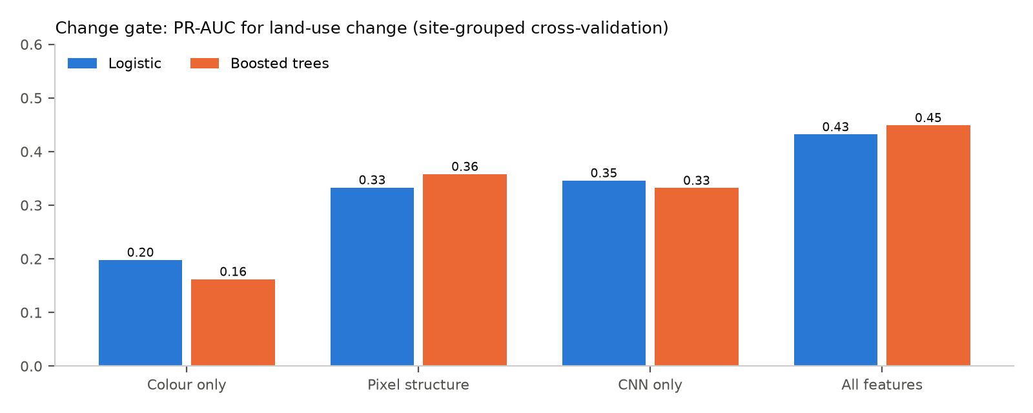
Appendix Figure A9. Change gate: precision–recall area under the curve (PR-AUC) per feature set, site-grouped cross-validation.
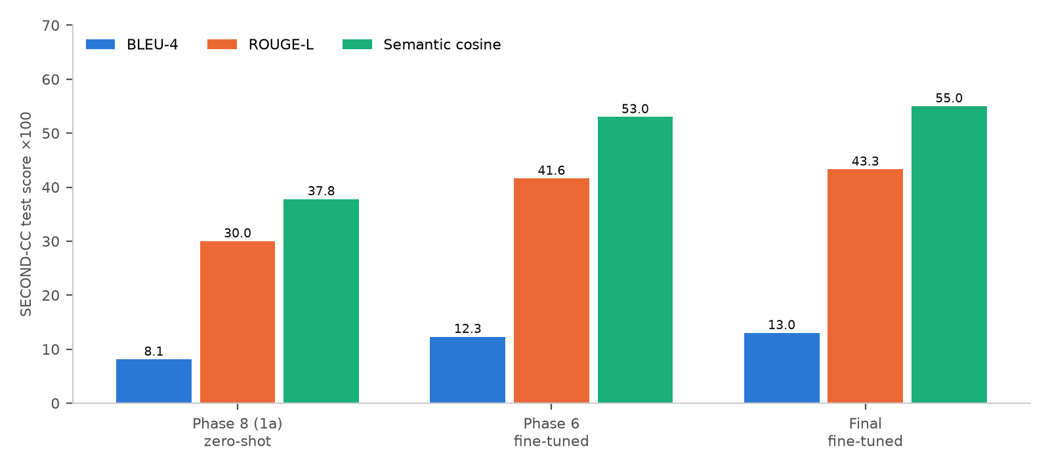
Appendix Figure A10. SECOND-CC test scores: zero-shot (Phase 8 stage 1a) and after fine-tuning (Phase 6, Final).

