1. Assign the value 7 to the variable guess_me. Then, write the conditional tests (if, else, and elif) to print the string 'too low' if guess_me is less than 7, 'too high' if greater than 7, and 'just right' if equal to 7.

🡪

guess_me = 7

if guess_me < 7:

print('too low')

elif guess_me > 7:

print('too high')

else:

print('just right')

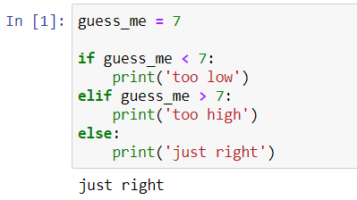

2. Assign the value 7 to the variable guess_me and the value 1 to the variable start. Write a while loop that compares start with guess_me. Print too low if start is less than guess me. If start equals guess_me, print 'found it!' and exit the loop. If start is greater than guess_me, print 'oops' and exit the loop. Increment start at the end of the loop.

🡪

guess_me = 7

start = 1

while True:

if start < guess_me:

print('too low')

elif start == guess_me:

print('found it!')

break

else:

print('oops')

break

start += 1

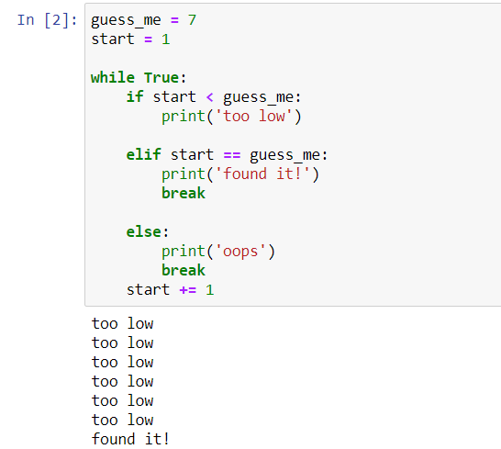

3. Print the following values of the list [3, 2, 1, 0] using a for loop.

🡪

numbers = [3,2,1,0]

for num in numbers:

print(num)

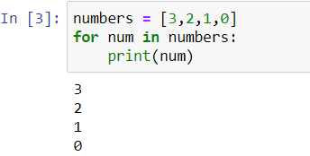

4. Use a list comprehension to make a list of the even numbers in range(10)

🡪 [i for i in range(10) if i%2==0]

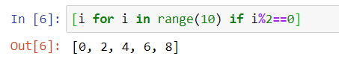

5. Use a dictionary comprehension to create the dictionary squares. Use range(10) to return the keys, and use the square of each key as its value.

🡪 squares = {key:key**2 for key in range(10)}

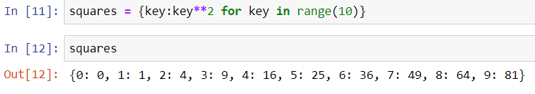

6. Construct the set odd from the odd numbers in the range using a set comprehension (10).

🡪 odd = set(num for num in range(10) if num%2 != 0)

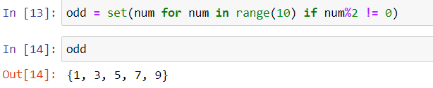

7. Use a generator comprehension to return the string 'Got ' and a number for the numbers in range(10). Iterate through this by using a for loop.

🡪

str_gen = ('Got ' + str(num) for num in range(10))

for i in str_gen:

print(i)

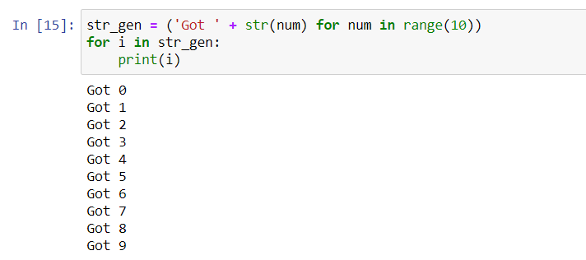

8. Define a function called good that returns the list ['Harry', 'Ron', 'Hermione'].

🡪

def good():

return ['Harry','Ron','Hermione']

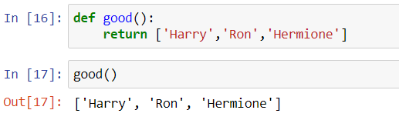

9. Define a generator function called get_odds that returns the odd numbers from range(10). Use a for loop to find and print the third value returned.

🡪

def get_odds():

for number in range(1, 10, 2):

yield number

count = 1

for number in get_odds():

if count == 3:

print("The third odd number is", number)

break

count += 1

Output is The third odd number is 5

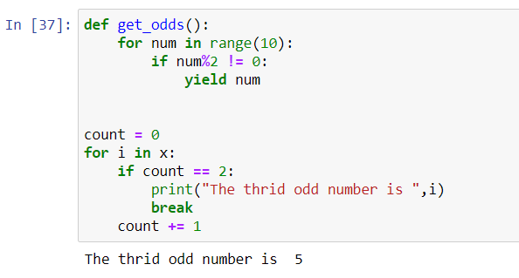

10. Define an exception called OopsException. Raise this exception to see what happens. Then write the code to catch this exception and print 'Caught an oops'.

🡪

class OopsException(Exception):

pass

def with_exception(a):

if a < 0:

raise OopsException(a)

try:

with_exception(-1)

except OopsException as err:

print('Caught an oops')

Ouput is Caught on oops

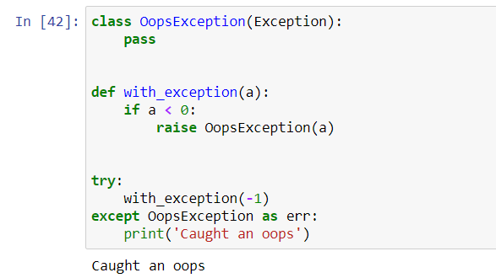

11. Use zip() to make a dictionary called movies that pairs these lists: titles = ['Creature of Habit', 'Crewel Fate'] and plots = ['A nun turns into a monster', 'A haunted yarn shop'].

🡪

titles =['Creature of Habit', 'Crewel Fate']

plots = ['A nun turns into a monster','A haunted yarn shop']

movies = {}

for title,plot in zip(titles,plots):

movies[title]= plot

print(movies)

Output is {'Creature of Habit': 'A nun turns into a monster', 'Crewel Fate': 'A haunted yarn shop'}

