1. Create a zoo.py file first. Define the hours() function, which prints the string 'Open 9-5 daily'. Then, use the interactive interpreter to import the zoo module and call its hours() function.

🡪import zoo

zoo.hours()

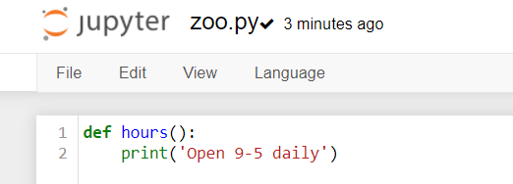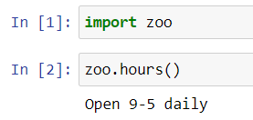

2. In the interactive interpreter, import the zoo module as menagerie and call its hours() function.

🡪import zoo as menagerie

menagerie.hours()

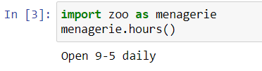

3. Using the interpreter, explicitly import and call the hours() function from zoo.

🡪

from zoo import hours

hours()

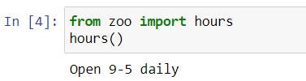

4. Import the hours() function as info and call it.

🡪

from zoo import hours as info

info()

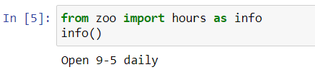

5. Create a plain dictionary with the key-value pairs 'a': 1, 'b': 2, and 'c': 3, and print it out.

🡪

plain = {'a':1, 'b':2, 'c':3}

print(plain)

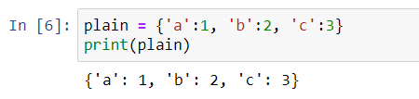

6.Make an OrderedDict called fancy from the same pairs listed in 5 and print it. Did it print in the same order as plain?

🡪

from collections import OrderedDict

pairs = (('a', 1), ('b', 2), ('c', 3),)

fancy = OrderedDict(pairs)

print('dict(pairs):', dict(pairs))

print('fancy=', fancy)

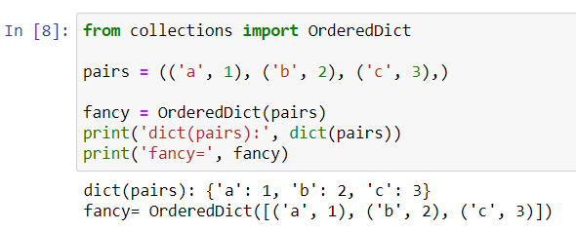

7. Make a default dictionary called dict_of_lists and pass it the argument list. Make the list dict_of_lists['a'] and append the value 'something for a' to it in one assignment. Print dict_of_lists['a'].

🡪from collections import defaultdict

dict_of_lists = defaultdict(list)

dict_of_lists['a'].append('something for a')

print(dict_of_lists['a'])

