**QUICK SORT**

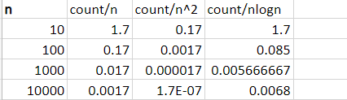

Therefore efficiency class is O(nlogn)

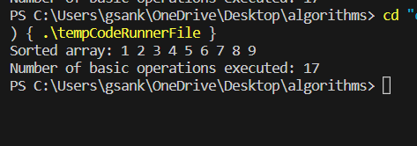

**Merge Sort**

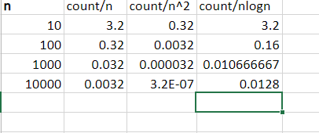

Therefore, efficiency class is O(nlogn).

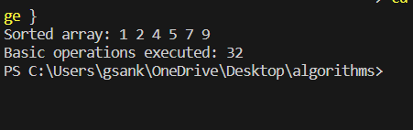

**Selection Sort**

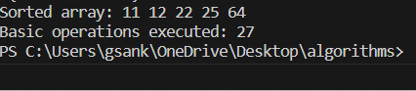

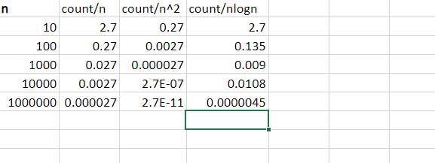

Therefore, Efficiency Class is O(n^2).

**Bubble Sort**

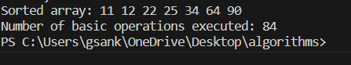

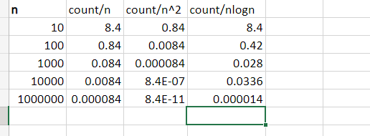

Therefore, efficiency class is O(n^2).

**Prims Algoritms**

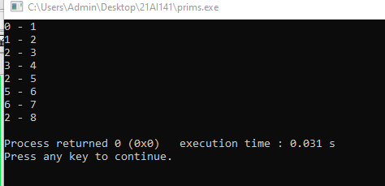

**Kruskal’s Algorithm**

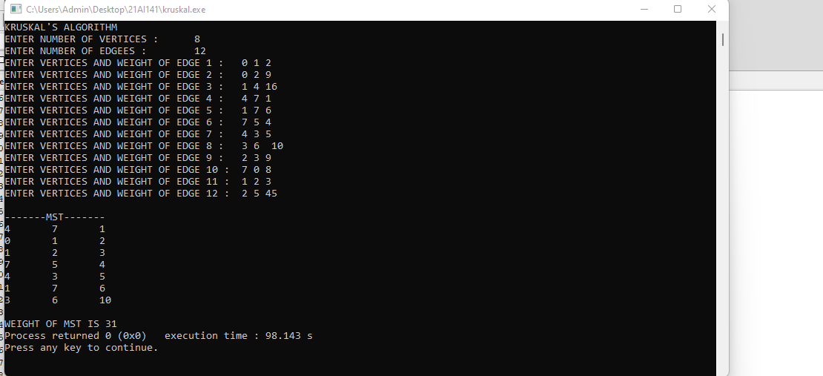

**Dijkatra’s Algorithm**

