

**Project 2**

**Benefit-Cost Analysis of Dam Construction Projects**

Sankalp Biswal

College of Professional Studies, Northeastern University Boston

ALY6050: Introduction to Enterprise Analytics

Professor Roy Wada

March 05, 2024

**INTRODUCTION**

In our analysis, we evaluated the financial viability of two dam construction projects by generating 10,000 random values to model the uncertainty in benefits and costs. The Benefit/Cost ratios (denoted as 𝛼₁ and 𝛼₂) were calculated and their frequency distributions analyzed. Our further investigations involved a goodness-of-fit test for a triangular distribution of the data and a detailed comparison of key metrics such as mean, variance, skewness, and the probability of one project outperforming the other.

**Part - 1 Analysis**

1. Generated 10,000 random values for benefits and costs of Dam 1 and Dam 2 respectively and then calculated Benefit/Cost ratio for both as 𝛼1and 𝛼2
   1. Random number was generated by using the formula below-



Fig. 1- Formula for number generation

* 1. Upon generating the random values, we then calculated the Benefit/Cost ratio for all the values.

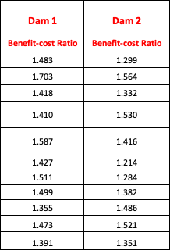

Fig. 2 – Values for 𝛼1and 𝛼2

1. Constructed tabular and graphical frequency distribution for 𝛼1and 𝛼2.

i) We have the graphical frequency distribution for Dam 1 and Dam 2 as shown below-

**Interpretation**

The shape of the distribution in the histogram is bell-shaped, which is characteristic of a normal distribution. This suggests that the data points tend to cluster around the mean of the data set, with the frequencies diminishing as the values move away from the mean towards the extremes on either end of the scale.

**Interpretation**

The distribution for "Observed frequency Dam 2" shown in the histogram also has a bell-shaped curve, indicating a normal distribution of observed values. The highest frequency is at the center of the distribution, with frequencies decreasing symmetrically as values move towards both the lower and higher ends of the range.

1. Calculated mean and standard deviation for total benefits, and total costs for Dam 1 and Dam 2.





**Interpretation**

From the above tables, we observe that observed mean and theoretical mean are identical for both Dam 1 and Dam 2, whereas the standard deviation has variation for both the Dams in terms of observed and theoretical values.

**Part -2 Analysis**

1. For this part we used **Triangular distribution** for determining the goodness of fit. The **triangular probability distribution** was chosen for its simplicity and its capacity to incorporate judgments about the minimum, and maximum values associated with the benefits and costs of the dam projects.
   1. We used the formula below for calculating theoretical probability

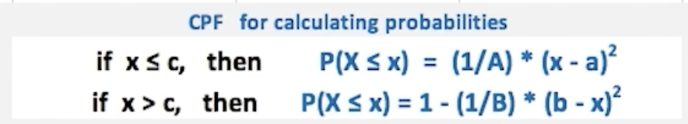

* 1. a, b, and c were calculated using *mean = a+b+c/3* . Now, by using Theoretical probability and the expected frequency, we will check for goodness of fit of triangular distribution. Let *alpha = 0.05, Degree of freedom = Number of bins – Number of parameter–1*; Since we have used a, b and c as our parameters, the number of parameters = 3. Therefore, *Df = 96.*

**Hypothesis –**

* Null Hypothesis (H0) : Triangular distribution is a good fit
* Alternate Hypothesis (H1) : Triangular distribution is not a good fit



**Interpretation**

We observe that **p-value = 0** i.e < **0.05** (Significance level). We **reject** the Null Hypothesis. Therefore, we have sufficient evidence to say that triangular distribution is not a good fit.

**Part 3 Analysis**

1. Completed table for Dam 1 and Dam 2 or 𝛼1and 𝛼2.



1. Interpretation for important metrics:

* **Mean**: Project 𝛼₁ has a higher average return than Project 𝛼₂.
* **Variance and Standard Deviation**: Both projects have similar levels of variability and risk.
* **Skewness**: Project 𝛼₁ is less skewed, suggesting a lower chance of extreme negative returns compared to 𝛼₂.
* **Probability Comparisons**: The probability of Project 𝛼₁ yielding a higher return than 𝛼₂ is 56.2%, indicating a slight advantage.

**Recommendation**

Based on the higher mean and lower skewness, along with a marginally higher probability of outperforming 𝛼₂, Project 𝛼₁ is the recommended option. With a value of 0.562, there is a 56.2% chance that project α1​ will yield a higher return than project α2​, based on the simulations or data analysis performed.

**Conclusion:**

The comparative analysis between Dam 1 and Dam 2 suggests that Dam 1, represented by 𝛼₁, holds a slight edge over Dam 2, with a 56.2% chance of providing a higher return based on the calculated Benefit/Cost ratios. Despite both projects showing similar levels of risk and variability, Dam 1's less skewed distribution and higher average returns point to a more favorable investment opportunity. However, the triangular distribution was not a good fit for the data, as indicated by the goodness-of-fit test. Therefore, Project Dam 1 is recommended for investment, while also acknowledging the close performance potential between the two projects and suggesting the decision should be bolstered by additional project-specific strategic considerations.

**References:**

1. Abud, T. P., Augusto, A. G., Fortes, M. Z., Maciel, R. S., & Borba, B. S. M. C. (2022, December 29). *State of the Art Monte Carlo Method Applied to Power System Analysis with Distributed Generation*. Energies. <https://doi.org/10.3390/en16010394>
2. Frasca. (n.d) Lab: Triangular Probability Distribution. [Video].Panopto. <https://northeastern.hosted.panopto.com/Panopto/Pages/Viewer.aspx?id=6f9e314d-3ab0-49bc-8f06-ac9300e649cf&start=2145.860645>