

**Project 5**

**Using Linear Programming Models to maximize profits**

Sankalp Biswal

College of Professional Studies, Northeastern University Boston

ALY6050: Introduction to Enterprise Analytics

Professor Roy Wada

March 26, 2024

**Introduction**

This report presents a linear programming approach to optimize the monthly net profit of a hardware company’s new distribution center. We focus on four main products, aligning inventory levels with financial and spatial constraints. The Excel Solver is utilized to maximize profits within these operational parameters.

**Analysis - Linear Programming Analysis for Hardware Distribution Company**

**1. Mathematical Formulation**

The goal is to maximize the company's monthly net profit by determining the optimal inventory levels for four products while adhering to budget and warehouse space constraints.

**Objective Function :** *Maximize Z* = 169.99*X*1 + 359.99*X*2 + 290.99*X*3 + 142.99*X*4

**Subject to:**

1. Budget Limit: 330*X*1 + 370*X*2 + 410*X*3 + 127 *X*4 ≤ 170,000
2. Warehouse Space Limit: 25*X*1+40*X*2+25*X*3+1.25*X*4 ≤ 12,300
3. Inventory Requirement for Pressure Washers and Go-Karts:

0.7*X*1 + 0.7*X*2 − 0.3*X*3 − 0.3*X*4 ≥ 0

1. Sales Requirement for Generators over Water Pumps: *X3* − 2*X*4 ≥ 0
2. Non-Negativity Constraints: *X*1,*X*2,*X*3,*X*4 ≥ 0

**2. Excel Model Formulation**

Each variable and constraint was modeled in Excel, with cell references corresponding to decision variables (X1 to X4). The Solver add-in was used to optimize the objective function under the given constraints.

**3. Solver Solution and Sensitivity Report**

Using the Solver add-in in Excel, we optimized the objective function. The sensitivity report report helps to understand how the solution might change with adjustments to the constraints and objective coefficients. Below are the table for optimal solution and sensitivity report.

*Table 1 – Optimal solution for the objective function*

|  |  |  |  |  |  |
| --- | --- | --- | --- | --- | --- |
|  | **Pressure Washers X1** | **Go-Karts X2** | **Generator X3** | **Water Pumps X4** | **Objective Z (Total Profit)** |
| **Optimal Solution** | 0.0 | 155.2 | 237.8 | 118.9 | 142050.7 |

*Table 2 – Sensitivity report*

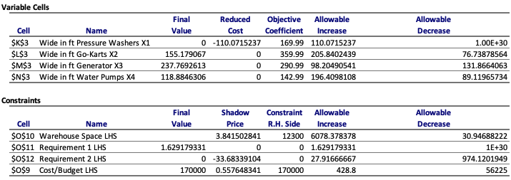

**4. Optimal Solutions Obtained**

The optimal solution derived from the Solver is as follows:

* Pressure Washers (*X*1​): 0 units
* Go-Karts (*X*2​): 155 units
* Generators (*X*3​): 237 units
* Water Pumps (*X*4​): 118 units

The optimal monthly profit based on this inventory mix is $142,050.70.

**5. Selling Price Adjustment for Zero Solution Value**

Pressure Washers (*X*1) have an optimal value of zero, indicating they are not part of the optimal product mix under current pricing. The smallest selling price for pressure washers so that this optimal value of zero changes is by increasing the amount by at least its reduced cost i.e $110.07 which results to $610.07.

**6. Additional Investment Recommendation**

The shadow price of $0.5576 for the budget constraint indicates that increasing the budget by one dollar would increase the profit by approximately $0.56. The slack is zero, indicating entire budget is already being utilized. Additional investment could lead to higher profits, up to an increase of $428.8 as shown by the allowable increase. This additional investment could lead to an increase in the net monthly profit by $240. This suggests the company could consider a budget increase if additional profitable investment opportunities are identified.

**7. Warehouse Size Recommendation**

The shadow price of 3.8415 for warehouse space suggests that for each additional square foot of space the profit would increase by $3.8. The optimal solution uses all available space (slack of zero), meaning no space is left unused. This increase is subject to the allowable increase, which is 6,078 square feet. The ideal size of the warehouse should be approximately 18,378 square feet and this increase in the size of the warehouse would contribute an additional $23,340 (Allowable Increase * Shadow Price) to the profits. Therefore, expanding the warehouse could therefore lead to increased profits, but the decision should also consider additional costs associated with larger space.

**Conclusion:**

Our linear programming model has delivered an optimal solution for inventory distribution that maximizes the monthly profit to $142,050.70. Despite pressure washers not contributing to this profit at current pricing, adjustments can be made for potential inclusion. The fully utilized budget suggests no immediate need for additional funds; however, warehouse expansion could increase profit by $23,340, indicating a possible strategic investment for growth.

**References:**

1. *Linear programming Solver Solution*. (n.d.). Retrieved from <https://northeastern.hosted.panopto.com/Panopto/Pages/Viewer.aspx?id=123d2f11-e475-4408-9670-ac920158132f&start=0>
2. *ChatGPT*. (n.d.). <https://chat.openai.com/>