Draft submission

ER provided: +1 mark  
Schema provided: +1 mark  
Database SQL provided: +1 mark  
Data Populated for 1 or 2 tables: +1 mark.

**ER Diagram:**

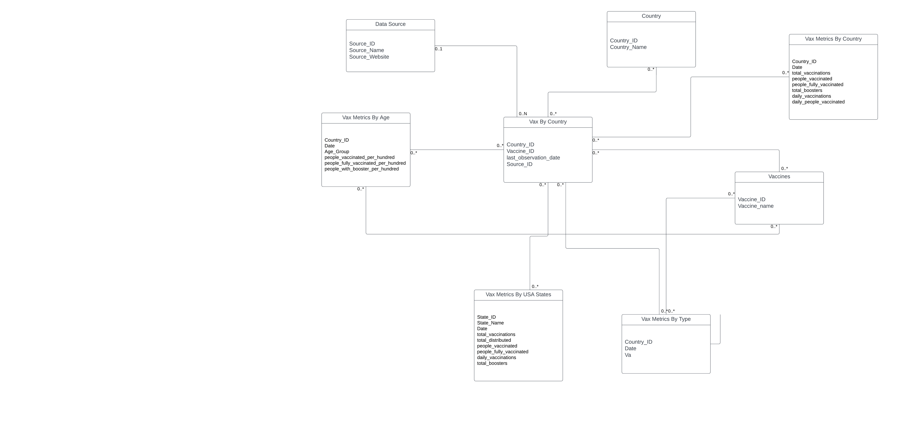

**Schema:**

* Country (Country_ID, Country_Name)
* Vaccines (Vaccine_ID, Vaccine_Name)
* Data_Source (Source_ID, Source_Name, Source_Website)
* Vax_By_Country (Country_ID, Vaccine_ID, Source_ID, last_observation_date, total_vaccinations, people_vaccinated, people_fully_vaccinated, daily_vaccinations, daily_people_vaccinated, total_boosters)
* Vax_Metrics_By_Country (Country_ID, Date, Vaccine_ID, people_vaccinated_per_hundred, people_fully_vaccinated_per_hundred, total_distributed, people_with_booster_per_hundred)
* Vax_Metrics_By_Type (Vaccine_ID, Age_Group, Total_Vaccinations, people_vaccinated, people_fully_vaccinated, total_boosters)
* Vax_Metrics_By_Age (Country_ID, Vaccine_ID, Age_Group, Date, people_vaccinated, people_fully_vaccinated, total_boosters)
* Vax_Metrics_By_USA_States (State_ID, State_Name, Date*, total_vaccinations, people_vaccinated, people_fully_vaccinated, people_with_booster_per_hundred, daily_vaccinations)

**Database SQL:**

1. **Create Country table**

**CREATE TABLE Country (**

**Country_ID INT PRIMARY KEY,**

**Country_Name VARCHAR(255)**

**);**

1. **Create Vaccines table**

**CREATE TABLE Vaccines (**

**Vaccine_ID INT PRIMARY KEY,**

**Vaccine_Name VARCHAR(255)**

**);**

**3) Create Data_Source table**

**CREATE TABLE Data_Source (**

**Source_ID INT PRIMARY KEY,**

**Source_Name VARCHAR(255),**

**Source_Website VARCHAR(255)**

**);**

**4) Create Vax_By_Country table**

**CREATE TABLE Vax_By_Country (**

**Country_ID INT,**

**Vaccine_ID INT,**

**Source_ID INT,**

**last_observation_date DATE,**

**total_vaccinations INT,**

**people_vaccinated INT,**

**people_fully_vaccinated INT,**

**daily_vaccinations INT,**

**daily_people_vaccinated INT,**

**total_boosters INT,**

**PRIMARY KEY (Country_ID, Vaccine_ID, Source_ID),**

**FOREIGN KEY (Country_ID) REFERENCES Country (Country_ID),**

**FOREIGN KEY (Vaccine_ID) REFERENCES Vaccines (Vaccine_ID),**

**FOREIGN KEY (Source_ID) REFERENCES Data_Source (Source_ID)**

**);**

**5) Create Vax_Metrics_By_Country table**

**CREATE TABLE Vax_Metrics_By_Country (**

**Country_ID INT,**

**Date DATE,**

**Vaccine_ID INT,**

**people_vaccinated_per_hundred DECIMAL(5, 2),**

**people_fully_vaccinated_per_hundred DECIMAL(5, 2),**

**total_distributed INT,**

**people_with_booster_per_hundred DECIMAL(5, 2),**

**PRIMARY KEY (Country_ID, Date, Vaccine_ID),**

**FOREIGN KEY (Country_ID) REFERENCES Country (Country_ID),**

**FOREIGN KEY (Vaccine_ID) REFERENCES Vaccines (Vaccine_ID)**

**);**

**6) Create Vax_Metrics_By_Type table**

**CREATE TABLE Vax_Metrics_By_Type (**

**Vaccine_ID INT,**

**Age_Group VARCHAR(255),**

**Total_Vaccinations INT,**

**people_vaccinated INT,**

**people_fully_vaccinated INT,**

**total_boosters INT,**

**PRIMARY KEY (Vaccine_ID, Age_Group),**

**FOREIGN KEY (Vaccine_ID) REFERENCES Vaccines (Vaccine_ID)**

**);**

**-7)Create Vax_Metrics_By_Age table**

**CREATE TABLE Vax_Metrics_By_Age (**

**Country_ID INT,**

**Vaccine_ID INT,**

**Age_Group VARCHAR(255),**

**Date DATE,**

**people_vaccinated INT,**

**people_fully_vaccinated INT,**

**total_boosters INT,**

**PRIMARY KEY (Country_ID, Vaccine_ID, Age_Group, Date),**

**FOREIGN KEY (Country_ID) REFERENCES Country (Country_ID),**

**FOREIGN KEY (Vaccine_ID) REFERENCES Vaccines (Vaccine_ID)**

**);**

**8) Create Vax_Metrics_By_USA_States table**

**CREATE TABLE Vax_Metrics_By_USA_States (**

**State_ID INT PRIMARY KEY,**

**State_Name VARCHAR(255),**

**Date DATE,**

**total_vaccinations INT,**

**people_vaccinated INT,**

**people_fully_vaccinated INT,**

**people_with_booster_per_hundred DECIMAL(5, 2),**

**daily_vaccinations INT**

**);**