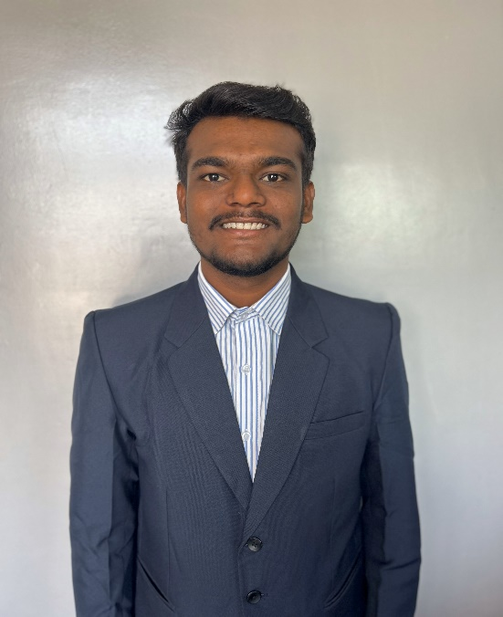

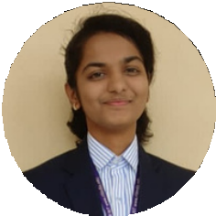

**Skills**

**Qualities**

Leadership Qualities Analytical Thinking Communication Problem-Solving

Time Management

**Language**

**English Marathi**

**Hindi**

Sankalp Kamble

Third Year (Computer Engineering) Undergraduate

Pursuing BTech degree from RIT, Islampur. I am passionate individual who isn't afraid to face any challenge. I'm passionate about my work and I know how to get the job done.

# EDUCATION

sankalpkamble354@gmail.com

## B-Tech (CGPA - 9.72)

**Rajarambapu Institute of Technology, Islampur. (2021-Present)**

+91 8530181021

https://www.linkedin.com/in/sankalp-kamble-164b60238/

## HSC (Percentage-95.67%)

**Smt. Kasturbai Walchand College , Sangli. (2019-2021)**

## SSC (Percentage-89.80%)

https://github.com/SankalpKamble

**Pradnya Prabodhini Prashala, Sangli. (2019)**

# PROJECTS

* C, C++
* Java + GUI
* HTML ,CSS, ReactJS
* MongoDB
* Git-Github
* SQL
* Figma



### Java Project - Student Management System. (12/2023 - Present)



Designed a project Student Management System using Java , GUI and MySQL database.



### Java Project - Quiz Application. (10/24 – 22/24)



Created Quiz application mini-project using Java GUI.



### Web-D Project- Movie Information Template. (10/2024 – 22/2024)



Crafted with HTML, CSS, and JavaScript, our Movie Information Template seamlessly integrates API methodology for a sleek and dynamic platform—bringing a professional touch to your cinematic data**.**



### 4.Java Project- Employee Management System. (07/2023 – 09/23)

Efficiently manage your workforce with our Employee Management System—a Java Swing-based solution offering streamlined administration and a user-friendly interface.



**ACHIEVEMENTS**

* **Oyster Kode Club | Outreach and Communication Head.**
* **Hacker-Rank 4 Star badge in Java.**
* **GeeksforGeeks 100+ DSA problems solving.**
* **Frontend Developer at Google Developers Student Club(GDSC) RIT.**

**Certifications**

* Java
* DBMS
* Frontend Development



# EXTRA CURRICULAR ACTIVITIES

* **Organized event WEB-WIZARD (Web-D Event) in TECHNOSPHERE.**
* **Member of Event Organizer Team of Non-technical event for TECHNOSPHERE.**
* **NSS (National Service Scheme) Volunteer for Blood Donation and Voter Id Campaign.**
* **Technical Team Member for Event Code-404 at Oyster Kode**