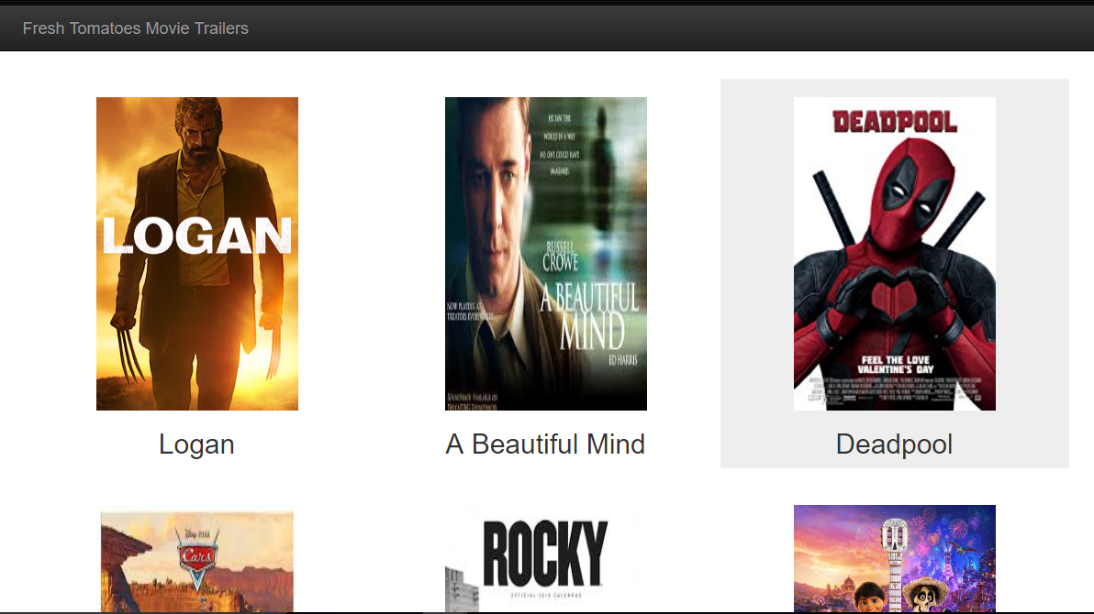

**About-**

The python script “center.py” on running in python3 application like spyder(anaconda) or python application would display a list of movies with their trailer on clicking them, the movies are displayed in box-art imagery.

**How to run-**

**Step:1** Clone this repository.

**Step:2** Navigate to the directory repository_name.

**Step:3** Run the python center.py

IDLE:

**Step:4** Open IDLE

**Step:5** In the menu bar click on Run -> Run Module or press F5 on your keyboard  
In case you need inspiration, you can find suggestions in the following posts:  
<http://stackoverflow.com/questions/2304863/how-to-write-a-good-readme> <https://robots.thoughtbot.com/how-to-write-a-great-readme> <http://www.wikihow.com/Write-a-Read-Me> <http://docs.writethedocs.org/writing/beginners-guide-to-docs/> <https://guides.github.com/features/mastering-markdown/>  
You can also have a look at our Writing a READMEs course.

**Step:5** Else, the project can be viewed by opening fresh_tomatoes.html file.