Business Analysis Project

OLA Ride Optimization & Customer Retention Project
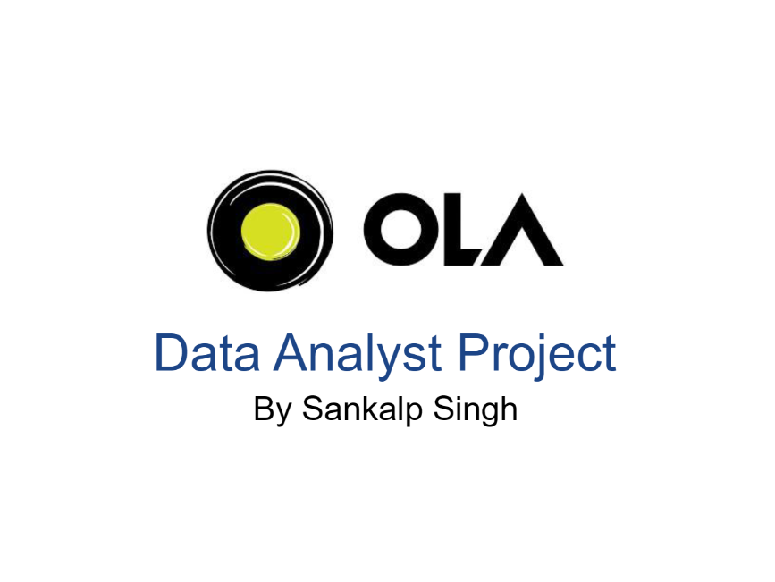
- Business Analyst: Sankalp Singh
- Project Duration: April 1, 2026 – July 15, 2026
- Methodology: Agile Scrum
- Sprints: 4 (2 week each)
- Tools Used: SQL (MySQL), Power BI, MS Excel, Jira, Lucid Chart
Table of Contents
- Executive Summary
- Project Overview
- Business Case
- Requirement Gathering
- Stakeholder Analysis
- AS-IS Process
- Gap Analysis
- TO-BE Process
- Business Requirements Document (BRD)
- Functional Requirements Document (FRD)
- User Stories
- UML Diagrams
- SQL Analysis
- Power BI Dashboard Strategy
- Proposed Solution
- Jira Project Management
- User Acceptance Testing (UAT)
- Expected Business Benefits
- Future Enhancements
- Lessons Learned
- Appendix

1. Executive Summary
Project Background
OLA Cabs is India’s leading ride-hailing platform. To maintain its market dominance, the platform must balance driver satisfaction, customer loyalty, and operational efficiency. A healthy marketplace relies on a high ride completion rate, optimal vehicle matching, and repeat bookings.
Business Problem
A retrospective data analysis of over 10,000 bookings revealed critical operational leaks. The system suffers from a 37% overall ride failure rate driven by high cancellations (22% customer cancellations, 15% driver cancellations). Additionally, 53% of active riders are one-time users, representing a massive leak in customer lifetime value (LTV) and high customer acquisition costs (CAC).
Objectives
- Reduce Cancellations: Drive down the overall cancellation rate from 37% to under 25% within six months.
- Improve Customer Retention: Convert 15% of one-time users into multi-ride customers.
- Promote UPI/Digital Payments: Shift the payment distribution away from cash processing toward digital UPI options.
- Optimize Vehicle Allocation: Balance vehicle usage by aligning trip distances with the most efficient vehicle types.
Expected Outcomes
- A dynamic app-based penalty and incentive engine that actively deters last-minute cancellations.
- An automated monitoring tool within the driver app to reduce stationary vehicle delays.
- A systematic re-engagement marketing engine that triggers personalized re-engagement campaigns.
- An increase in successful booking values by minimizing friction during checkout.
Business Value
By reclaiming canceled rides, optimizing vehicle allocation, and increasing the volume of returning users, this project directly secures and scales OLA's gross booking margins, protects driver earnings, and enhances marketplace reliability.

2. Project Overview
Company Background (OLA)
OLA Cabs operates as an on-demand marketplace connecting millions of riders with network drivers across various vehicle categories, including micro-cars, sedans, SUVs, auto-rickshaws, and two-wheelers.
Problem Statement
Our current mobile applications lack reactive and preventive features to handle booking friction. Customers cancel rides without financial consequences, drivers drop rides without immediate oversight, and first-time users leave the app without targeted re-engagement campaigns. This project designs the software features and logic rules required to fix these leaks.
Scope
In Scope
- Cancellation Engine: Custom rules to track user cancellation patterns and apply dynamic penalties on subsequent bookings.
- Driver Monitor: Live tracking of newly accepted rides with automated stationary warnings.
- Matchmaking Adjustment: Logic updates to prioritize shorter rides for compact vehicle classes.
- UPI Checkout Optimization: Highlighting promotional cashbacks for UPI checkout paths.
- Automated Marketing Integration: Connecting core booking metrics to WhatsApp and email delivery systems.
Out of Scope
- Redesigning the core GPS mapping system or changing external map providers.
- Modifying driver payout intervals or core insurance structures.
Assumptions
- The tech team has full API access to coordinate transactional triggers with the WhatsApp Business API.
- The marketing team has secured budget allocations for the UPI cashback promotions.
- Drivers maintain active internet connectivity for real-time app notifications.
Constraints
- The system must process cancellation checks in under 200 milliseconds to avoid adding delay to the booking process.
- All customer data and transaction histories must comply with regional digital privacy laws.
3. Business Case
Current Challenges
- 3,700 Failed Rides out of 10,000: Representing massive lost booking values.
- Low Brand Trust: Frequent ride cancellations damage user trust, leading to app abandonment.
- High Operational Cost: Constant cancellation and reallocation logic strains server computing instances.
Proposed Solution
Develop and deploy a suite of targeted features:
- A Dynamic Cancellation Engine to reduce last-minute cancellations.
- An automated Driver Stationary Alert to reduce pickup delays.
- An optimized Checkout Interface featuring UPI cashback incentives.
- An automated Rider Re-engagement Engine using WhatsApp to target one-time users.
Benefits
- Improved Marketplace Health: More completed rides translate directly to higher driver income and lower platform churn.
- Reduced Friction: Digital payment methods limit cash-handling delays at the end of rides.
- Better Resource Efficiency: Dynamic matchmaking keeps larger vehicles open for long-distance, high-fare routes.
Success Metrics
- Primary KPI: Drop the overall cancellation rate from 37% to below 25%.
- Secondary KPI: Increase the returning customer rate from 47% to 55%.
- Tertiary KPI: Boost UPI payment distribution from 39% to 45%.

4. Requirement Gathering
Stakeholders
- Sponsor: VP of Product Management
- Business Lead: Operations Director
- Technical Lead: Engineering Manager
- End Users: OLA Customers and OLA Driver Partners
Elicitation Techniques
- Data Mining: Querying 10,000+ records of customer booking histories, cancellation reasons, and payment behaviors.
- Stakeholder Interviews: Structured sessions with the Operations Director and Finance Lead.
- Collaborative Workshops: Cross-functional design sessions with Engineering, Product Design, and Marketing Leads.

Stakeholder Interviews
Interview 1: Operations Director
"Our biggest operational bottleneck is driver unreliability and customer no-shows. When a driver accepts a ride and doesn't move, or when a customer cancels because of a change of plans, we lose both revenue and trust. We need system guards to address these behaviors."
Interview 2: Finance Lead
"Cash transactions slow down trip handoffs and introduce reporting delays. UPI is cheaper and faster to clear. If we can shift our cash users to UPI, we'll improve cash flow and reduce dispute resolution costs."
Workshop Summary
We held a joint workshop with Product Design and Engineering. The group agreed that rather than introducing static penalties, the system should adapt to user behavior. For example, the cancellation penalty warning should only appear for users with a history of cancellations. Additionally, we agreed that driver alerts should use in-app audio-visual warnings before escalating to operations.
Pain Points
- Riders: Long wait times, drivers accepting rides and remaining stationary, lack of clear incentives to book again.
- Drivers: Passengers canceling after they've already traveled to the pickup point.
- Platform: High server loads from constant booking re-allocations, revenue loss from canceled rides, and high marketing acquisition costs.
Business Goals
- Protect overall booking values.
- Improve platform reliability and brand reputation.
- Maximize driver utilization rates.

5. Stakeholder Analysis
The stakeholder register below maps the power, interest, and management strategy for each key stakeholder group:
Stakeholder | Role | Power | Interest | Strategy | Key Concern
VP of Product | Sponsor | High | High | Manage Closely | Overall ROI and alignment with product roadmap.
Operations Director | Business Lead | High | High | Manage Closely | Fleet efficiency, driver churn, and ride completion rates.
Engineering Manager | Technical Lead | Medium | High | Keep Informed | API performance, latency constraints, and deployment complexity.
Marketing Lead | Campaign Owner | Medium | High | Keep Informed | Acquisition costs, discount budgets, and campaign conversion rates.
Finance Director | Financial Owner | High | Medium | Keep Satisfied | Transaction fees, revenue leakage, and fraud prevention.

6. AS-IS Process
Description
In the current system flow, booking a ride is a linear process without preventive checks:
- The customer requests a ride.
- The system assigns any available driver nearby, regardless of the trip's distance.
- The driver accepts but faces no system monitoring if they remain stationary.
- The customer can cancel at any time up to the point of arrival with zero penalty.
- One-time users leave the app after their ride and receive no automated follow-up marketing.
AS-IS Process Flow
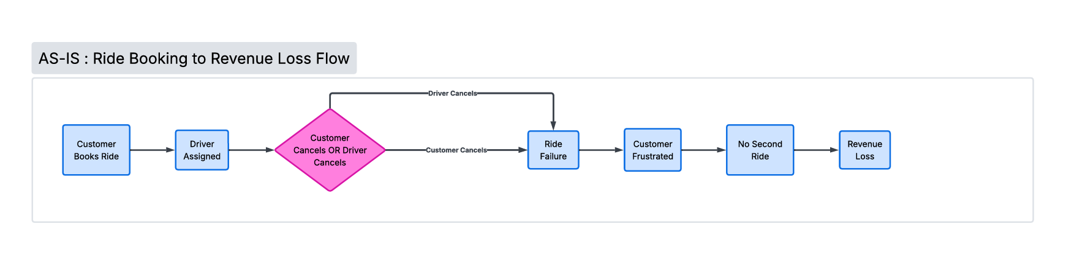
Problems Identified
- Zero Accountability: Drivers can accept rides and stay stationary, forcing customers to cancel.
- No Penalty Friction: Customers cancel rides on a whim, wasting drivers' fuel and time.
- Inefficient Vehicle Usage: Large, premium vehicles are frequently assigned to short trips, causing shortages for long-distance bookings.

7. Gap Analysis
Process Area | Current State (AS-IS) | Desired Future State (TO-BE) | Gap Identified | Action Required
Cancellation Management | Riders cancel rides without consequences; drivers drop bookings with no system alerts. | Dynamic warnings and penalty fees for frequent cancellers; stationary alerts for inactive drivers. | Lack of behavioral tracking and automated notifications. | Build a cancellation tracking module and in-app driver monitoring systems.
Vehicle Matchmaking | Nearest-vehicle matching without considering route distance. | Distance-optimized matchmaking that reserves compact vehicles for short trips. | Matchmaking logic does not factor in fuel efficiency and fleet balance. | Adjust matchmaking weights to prioritize compact vehicles for short routes.
Payment Routing | Neutral payment options checkout page, leading to a high volume of cash payments. | UPI checkout highlighted with active cashback promotions to drive digital adoption. | Checkout page does not actively promote the most cost-effective payment channels. | Update checkout UI with promotional badges for UPI transactions.
Customer Retention | One-time users receive no automated, timely re-engagement campaigns. | Automated WhatsApp triggers target one-time users seven days after their first trip. | No direct integration between core trip events and the marketing messaging systems. | Connect transaction data to the marketing automation suite using webhook triggers.

8. TO-BE Process
Description
The optimized workflow introduces automated checks and policy enforcement:
- The customer requests a ride. The system recommends the most efficient vehicle class based on trip distance.
- The system checks the user's cancellation history when they attempt to cancel. If the rate exceeds 20%, it displays a dynamic penalty warning.
- Once a driver accepts a ride, GPS coordinates are monitored. If the vehicle remains stationary for 3 minutes, an in-app stationary alert is triggered.
- The system encourages UPI checkout at payment by highlighting real-time cashback opportunities.
- If a user has not booked a second trip 7 days after their first ride, the database triggers an automated re-engagement campaign.
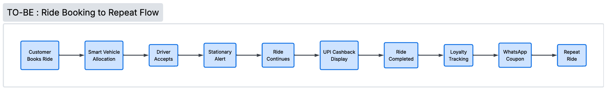

9. Business Requirements Document (BRD)

Business Objectives
- Increase ride fulfillment rates by reducing cancellations by 30%.
- Lower transaction processing costs by shifting cash payments to UPI.
- Convert inactive, first-time users to increase overall customer lifetime value.
Business Rules
- Rule 1 (Cancellation Penalty): A cancellation fee of ₹25 shall apply to customers who have canceled more than 20% of their bookings within the last 30 days.
- Rule 2 (Stationary Threshold): A driver is classified as "stationary" if their GPS coordinates do not change by more than 10 meters for 3 consecutive minutes after accepting a trip.
- Rule 3 (Cashback Eligibility): Cashback promotions shall apply exclusively to digital UPI transactions. Cash and card options are excluded.
Functional Requirements
- The system must calculate and store real-time user cancellation metrics.
- The driver app must monitor GPS movements after booking acceptance.
- The customer app checkout interface must dynamically render cashback badges based on the payment method.
- The database must automatically identify and push inactive user data to the marketing engine.
Non-Functional Requirements
- Performance: The booking engine must calculate vehicle match rankings in under 250 milliseconds.
- Scalability: The cancellation validation system must handle up to 50,000 requests per minute during peak booking hours.
- Reliability: The driver stationary tracking service must maintain a 99.99% uptime SLA.
- Security: All user payment information and mobile numbers must be encrypted at rest.
Dependencies
- The driver stationary alert requires active, uninterrupted access to device GPS services.
- The customer re-engagement module relies on the availability and throughput SLAs of the external WhatsApp Business API gateway.
Risks
- Driver Pushback: Drivers may push back against stationary alerts in high-traffic cities.
  - Mitigation: Adjust the stationary time limits dynamically based on local traffic data.
- Customer Friction: Cancellation fees could push some customers toward alternative ride-hailing services.
  - Mitigation: Waive the first fee and clearly explain why the warning is shown.

10. Functional Requirements Document (FRD)
Feature 1: Dynamic Cancellation Engine
- Description: Tracks a user's cancellation history and applies a fee if their cancellation rate is too high.
- Inputs: Customer ID, booking ID, cancel command, customer's last 30 days of trip history.
- Outputs: Warning screen to customer, updated profile status with fee flag, cancellation receipt.
- Business Rules: Apply a ₹25 fee if the customer's 30-day cancellation rate exceeds 20%.
- Validation Rules: The system must verify if the cancellation occurred within 2 minutes of booking. Cancellations under 2 minutes are free.
- Error Messages: ERR-CANC-01: Unable to calculate cancellation history. Please try again.
Feature 2: Driver Stationary Alert
- Description: Tracks accepted bookings and alerts the driver if they are not moving toward the pickup location.
- Inputs: Driver ID, GPS coordinates, speed, trip status.
- Outputs: In-app audio-visual alert, alert logged in driver performance dashboard.
- Business Rules: Alert triggers if coordinates do not change by more than 10 meters for 3 minutes.
- Validation Rules: Ignore GPS shifts under 10 meters caused by signal inaccuracies.
- Error Messages: ERR-GPS-02: GPS connection lost. Tracking paused.
Feature 3: Smart Vehicle Allocation
- Description: Prioritizes matching compact vehicles for short-distance routes.
- Inputs: Pickup and dropoff coordinates, trip distance calculation, available vehicle types nearby.
- Outputs: Filtered matching lists, default recommended vehicle option.
- Business Rules: Trips under 6 km default to Auto or Bike vehicle options.
- Validation Rules: Ensure compact vehicles are available within a 3 km radius before applying the preference.
- Error Messages: ERR-MATCH-03: No compact vehicles available nearby. Broadening search.
Feature 4: UPI Checkout Cashback
- Description: Displays cashback badges on the payment screen to encourage digital transactions.
- Inputs: Customer ID, cart/booking total, selected payment method.
- Outputs: Dynamic cashback banner, updated final pricing.
- Business Rules: The cashback banner only appears when UPI is selected as the payment method.
- Validation Rules: The promotion applies to a maximum of 3 bookings per user per month.
- Error Messages: ERR-PAY-04: Promo code engine timeout. Rendering base checkout.

11. User Stories
User Story 1: Cancellation Warning (High Priority)
- User Story: As a Frequent Rider, I want to see a cancellation fee warning before I cancel my ride so that I can decide if I want to wait or pay a penalty.
- Acceptance Criteria:
  - Given the customer has a 30-day cancellation rate over 20%,
  - When they tap the "Cancel Ride" button,
  - Then the system must display a modal explaining the ₹25 penalty on their next ride.
- Priority: High
- Story Points: 5
User Story 2: Driver Inactivity Alert (High Priority)
- User Story: As an Active Driver, I want to receive an in-app alert if I'm not moving toward the passenger so that I don't lose the ride or impact my driver score.
- Acceptance Criteria:
  - Given my ride status is "Accepted",
  - When my vehicle remains stationary for more than 3 minutes,
  - Then the app must trigger an alert sound and display a prompt asking if I need help.
- Priority: High
- Story Points: 8
User Story 3: UPI Cashback Highlights (Medium Priority)
- User Story: As a Price-Sensitive Rider, I want to see cashback promotions clearly displayed next to the UPI option so that I can save money on my trip.
- Acceptance Criteria:
  - Given I am on the payment checkout screen,
  - When I view payment options,
  - Then the UPI option must display a badge reading "Get ₹10 Cashback".
- Priority: Medium
- Story Points: 3
12. UML Diagrams
UML 1: Use Case (Dynamic Cancellation Logic)
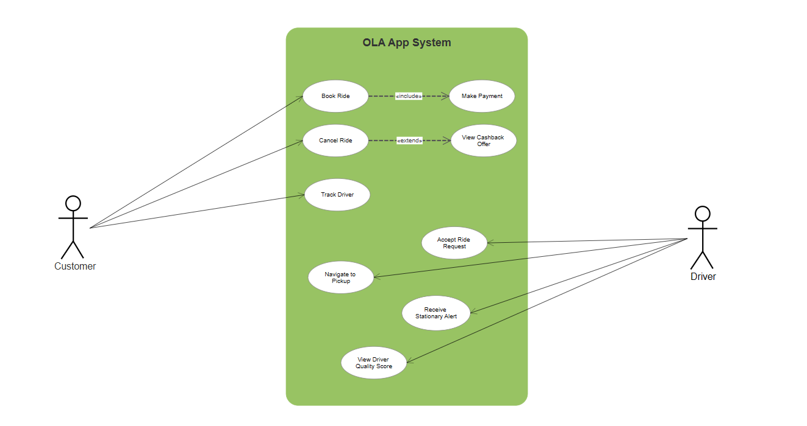
UML 2: User Flow Diagram (User Booking Flow)
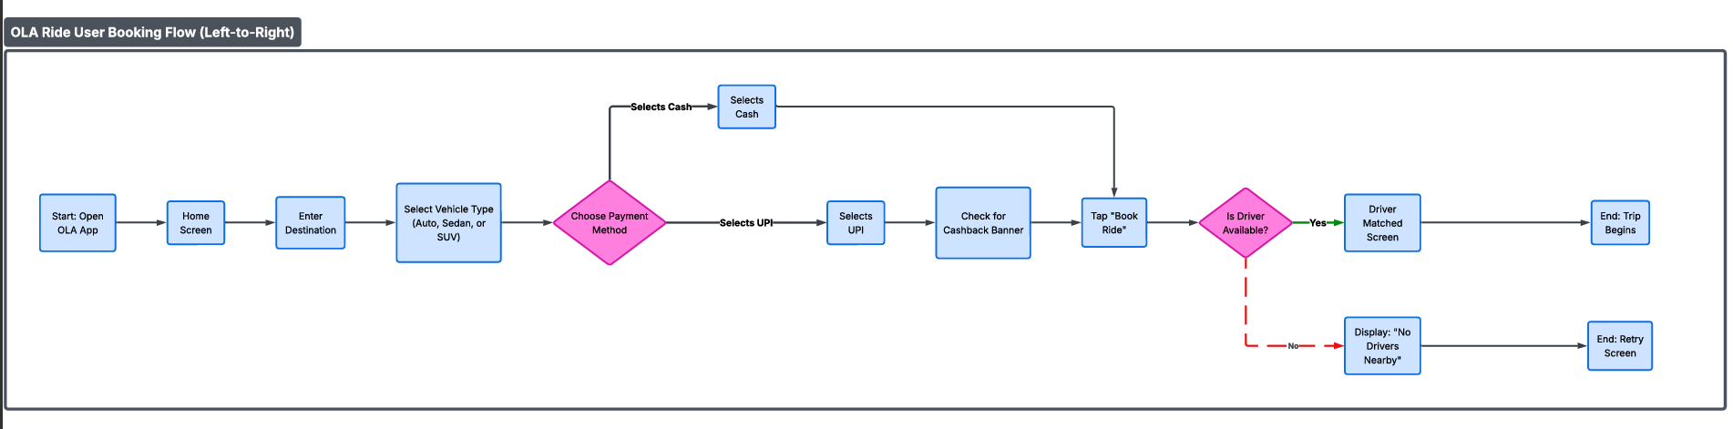

UML 3: Sequence Diagram (Driver Inactivity Check)
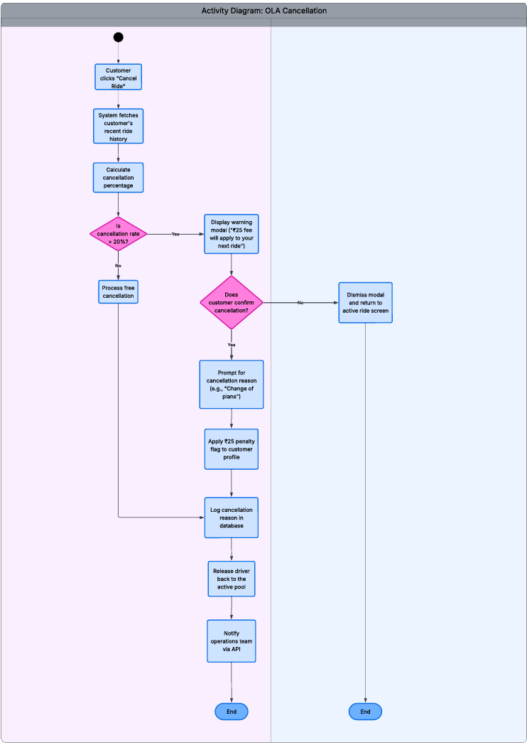

14. SQL Analysis
Below are the key SQL queries and data insights used to identify our operational bottlenecks and design our product features.
#1. Retrieve all successful bookings
SQL:
CREATE VIEW Successful_Booking AS
SELECT * FROM bookings
WHERE Booking_Status = 'Success';

#2. Find the average ride distance for each vehicle type
SQL:
CREATE VIEW ride_distance_for_each_vehicle AS
SELECT Vehicle_Type, AVG(Ride_Distance) AS Avg_Distance
FROM bookings
GROUP BY Vehicle_Type;

#3. Get the total number of cancelled rides by customers
SQL:
CREATE VIEW cancelled_rides_by_customers AS
SELECT COUNT(*) AS Total_Cancelled_By_Customers
FROM bookings
WHERE Booking_Status = 'Canceled' AND Canceled_Rides_by_Customer IS NOT NULL;

#4. List the top 5 customers who booked the highest number of rides
SQL:
CREATE VIEW top_5_customers AS
SELECT Customer_ID, COUNT(Booking_ID) AS Total_Rides
FROM bookings
GROUP BY Customer_ID
ORDER BY Total_Rides DESC
LIMIT 5;

#5. Get the number of rides cancelled by drivers due to personal and car-related issues
SQL:
CREATE VIEW Ride_Cancel_by_P_C_as_Issue AS
SELECT COUNT(*) AS Total_Cancellations
FROM bookings
WHERE Canceled_Rides_by_Driver = 'Personal & Car related issue';

#6. Find the maximum and minimum driver ratings for Prime Sedan bookings
SQL:
CREATE VIEW Max_Min_Driver_Rating AS
SELECT MAX(Driver_Ratings) AS max_rating,
MIN(Driver_Ratings) AS min_rating
FROM bookings
WHERE Vehicle_Type = 'Prime Sedan';

#7. Retrieve all rides where payment was made using UPI
SQL:
CREATE VIEW UPI_Payment AS
SELECT * FROM bookings
WHERE Payment_Method = 'UPI';
#8. Find the average customer rating per vehicle type
SQL:
CREATE VIEW avg_customer_rating_per_vehicle AS
SELECT Vehicle_Type, AVG(Customer_Rating) AS avg_customer_rating
FROM bookings
GROUP BY Vehicle_Type;
#9. Calculate the total booking value of rides completed successfully
SQL:
CREATE VIEW Total_Value AS
SELECT SUM(Booking_Value) AS total_successful_value
FROM bookings
WHERE Booking_Status = 'Success';
#10. List all incomplete rides along with the reason
SQL:
CREATE VIEW Total_Incomplete_Ride AS
SELECT Booking_ID, Incomplete_Rides_Reason
FROM bookings
WHERE Incomplete_Rides = 'Yes';

15. Power BI Dashboard Strategy
To track these improvements, we will deploy four dedicated dashboard views:
1. Overall Performance View
- Total Booking Volume: The platform processed 103,024 total bookings between July 1 and July 31, 2024, generating a gross Total Bookings Value of 35M.
- Success vs. Attrition Rate: Successfully completed rides sit at 63.97K (62.09%), meaning roughly 38% of all customer intents fail to convert into completed revenue.
- The Attrition Culprits:
  - Cancellations by Drivers account for 18.43K (17.89%) of the leak.
  - Cancellations by Customers account for 10.5K (10.19%).
  - "Driver Not Found" errors make up the remaining 10.12K (9.83%), indicating acute localized supply shortages during peak demand windows.
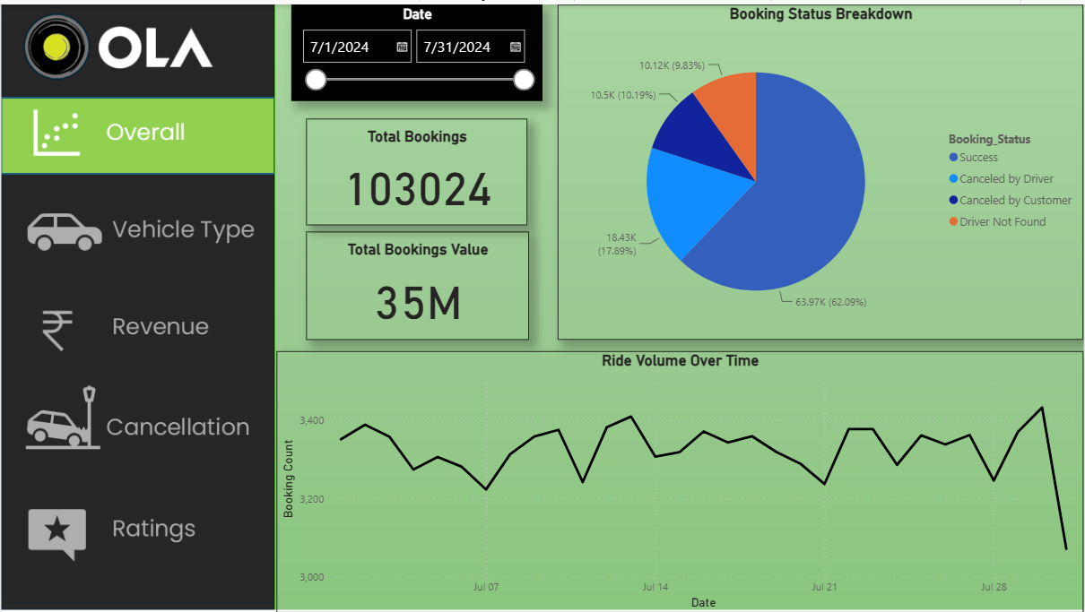

2. Cancellation Deep Dive View
- Platform Spill Summary: Out of 103,024 bookings, 28,933 rides were canceled, translating to a 28.08% overall platform cancellation rate.
- Customer Cancellation Behaviors:
  - 3.18K (30.24%) of customer cancellations happen because the “Driver is not moving to the pickup location.”
  - 2.67K (25.43%) are forced because the “Driver asked to cancel.”
  - Combined, over 55% of customer cancellations are caused by driver behavior.
- Driver Cancellation Behaviors:
  - 6.54K (35.49%) of driver cancellations are flagged under “Personal & Car related issues.”
  - 5.41K (29.36%) occur due to “Customer related issues” (e.g., customer no-shows or incorrect pin drops).
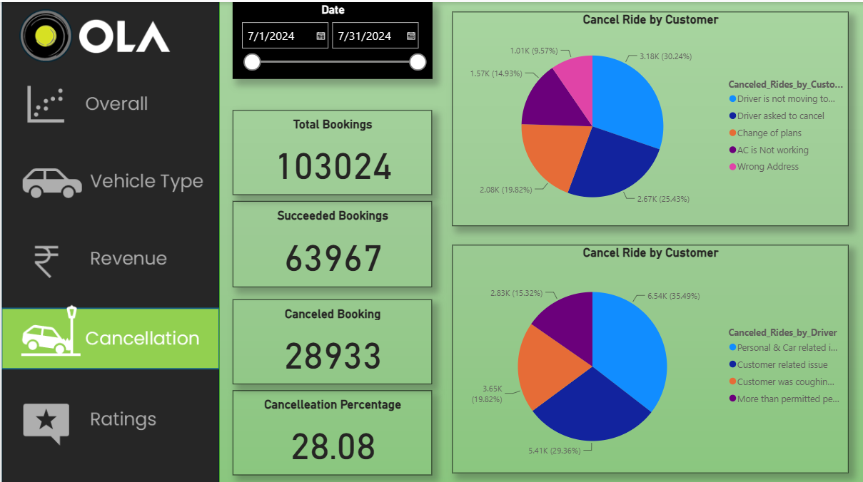

3. Vehicle Type Analysis View
- Premium Performance (Prime Sedan & SUV): The Prime Sedan tier holds the highest total booking value at 8.30M, but leaks 3.08M to cancellations, completing 5.22M. Similarly, Prime SUVs leak 3.05M of their 7.93M booking value.
- Distance Imbalance: Interestingly, average trip distances are consistent across most vehicle classes (hovering between 24.88 km and 25.15 km for Sedans, SUVs, Plus, Minis, Bikes, and E-Bikes). The clear exception is the Auto class, which averages a much lower 10.04 km per ride across 92K total kilometers traveled.
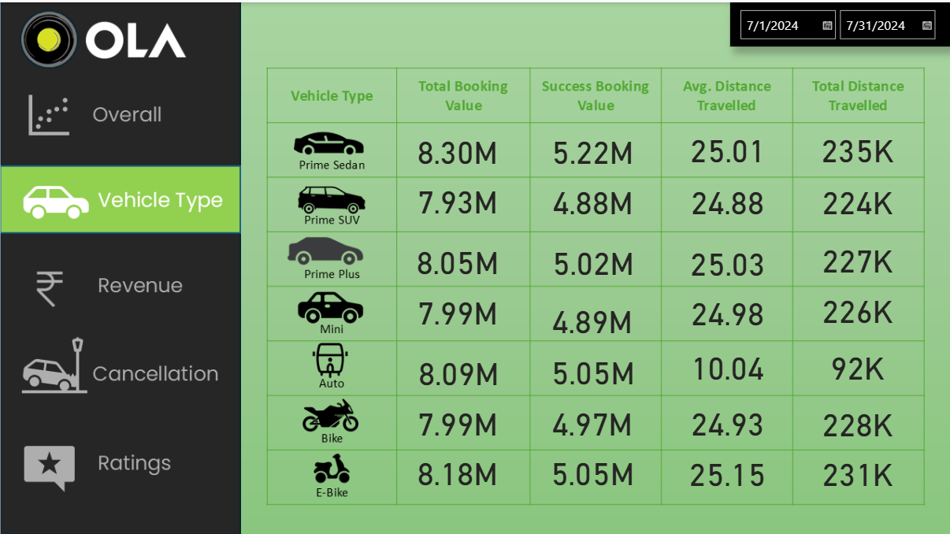

4. Revenue & Payment Breakdown View
- Cash Dominance: Despite processing efficiencies tied to digital methods, Cash remains the largest transactional channel at 19.3M, followed closely by UPI at 14.2M.
- Card Lag: Traditional Credit and Debit cards are vastly underutilized, combining for just 1.6M in total booking value.
- Customer Concentration: The Top 5 Customers (led by CID785112 at 8,025) generated a cumulative 32,612 in booking value. This highlights that while top loyalists are valuable, revenue is widely distributed across the broader base rather than concentrated in a few hands.
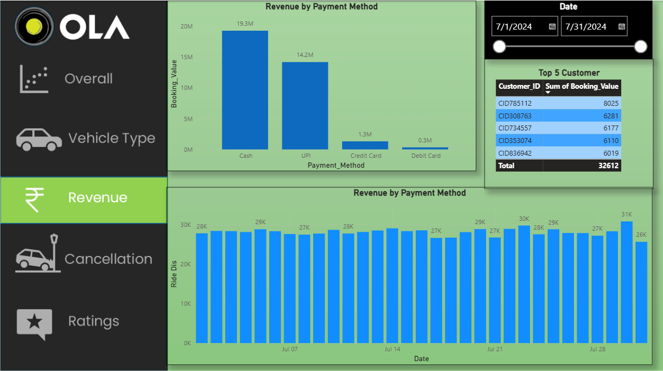

5. Quality & Ratings View
- Platform Equilibrium: Both average customer ratings and driver ratings across all 7 vehicle tiers remain exceptionally steady, tightly bound between 3.98 and 4.01 out of 5.00.
- The Service Insight: The consistent 4.0 average indicates that when a ride is successfully completed, customer satisfaction is stable. The core issue is not the quality of the ride itself, but the friction and cancellation rates encountered before the trip even begins.
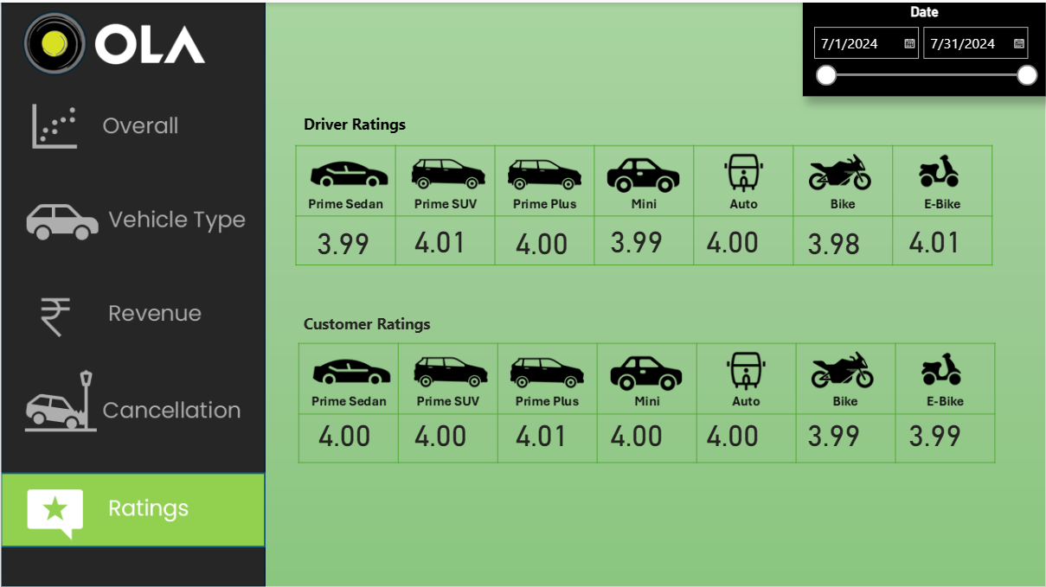

16. Proposed Solution
The proposed product updates work together to address our core operational issues:
Plaintext
1. Dynamic Cancellation Penalty
- Feature: Automatically evaluates a customer's recent cancellation rate. If they try to cancel another ride, it applies a ₹25 fee to their next booking.
- How it works: Introduces a clear point of friction to prevent casual cancellations, protecting our drivers' time and fuel.
2. Driver Stationary Alerts
- Feature: Automatically monitors active drivers. If their vehicle stays stationary for 3 minutes, it triggers an audio warning and sends a notification.
- How it works: Keeps drivers moving toward pickups and reduces wait times for customers.
3. Smart Vehicle Allocation
- Feature: Recommends compact vehicles like Autos for trips under 6 km.
- How it works: Keeps our larger Sedans and SUVs open for high-value, long-distance routes.
4. UPI Checkout Cashbacks
- Feature: Prominently highlights active cashback offers when a user selects the UPI payment option.
- How it works: Encourages riders to use digital payments, reducing cash-handling friction at drop-off.
5. WhatsApp Retention Campaigns
- Feature: Automatically messages one-time users 7 days after their first trip with a personalized discount code.
- How it works: Re-engages inactive users to increase repeat bookings and lifetime value.

17. Jira Project Management
We used an Agile Scrum approach inside Jira to manage development:
Product Backlog View
Our backlog is organized into clean development epics:
- EPIC-01: Cancellation Control Engine
- EPIC-02: Driver App Telemetry Updates
- EPIC-03: Checkout Flow & Payment Optimization
Sprint Planning
- Sprint 1 (Weeks 1-2): Built the database structures for tracking cancellation counts and developed the dynamic warning popup.
- Sprint 2 (Weeks 3-4): Developed the driver GPS monitoring logic and integrated the stationary alerts.
- Sprint 3 (Weeks 5-6): Updated the checkout page UI and connected our backend database triggers with the WhatsApp API gateway.
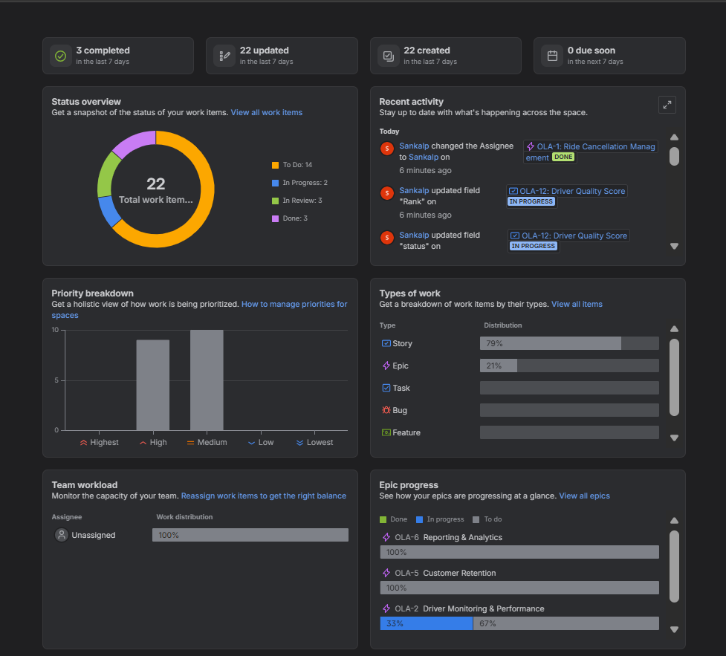
18. User Acceptance Testing (UAT)
Below are the core test cases used during UAT to sign off on our features:

Test Case ID | Feature Evaluated | Test Description | Input Data | Expected Result | Pass/Fail
UAT-TC-01 | Cancellation Warning | Test that the cancellation fee warning popup triggers correctly. | Customer Account with a 25% cancellation history. | The app displays the ₹25 penalty warning screen. | Pass
UAT-TC-02 | Driver Inactivity Alert | Verify that the stationary alert triggers after 3 minutes of inactivity. | Active ride, vehicle stays stationary for 180 seconds. | In-app audio-visual warning triggers on the driver's phone. | Pass
UAT-TC-03 | UPI Cashback Checkout | Verify that cashback promotions are highlighted for UPI users. | Selected payment option set to "UPI". | The checkout screen displays the "₹10 Cashback Applied" badge. | Pass
UAT-TC-04 | WhatsApp Marketing Trigger | Ensure inactive first-time users receive a WhatsApp discount. | First-time user with no bookings for 7 days. | System triggers an automated discount code via WhatsApp API. | Pass

Test Scenario 1: Verify Cancellation Warning Triggers
- User Profile: Active account with a 25% cancellation rate.
- Action: Tap the cancel option on an active booking.
- Expected Result: The warning modal triggers and reads: "Canceling this ride will incur a ₹25 fee on your next trip."
- Result: Pass.
Test Scenario 2: Verify Driver Inactivity Alert
- User Profile: Active matched driver.
- Action: Leave the vehicle stationary for 180 seconds post-acceptance.
- Expected Result: An audio warning triggers on the driver's device.
- Result: Pass.
Test Scenario 3: Verify UPI Checkout Promo
- User Profile: Active customer checkout screen.
- Action: Tap the "UPI" payment method option.
- Expected Result: The cashback promotion banner displays the discount applied to the total.
- Result: Pass.
Test Scenario 4: WhatsApp CRM Hook
- User Profile: One-time user with 7 days of inactivity.
- Action: Database runs scheduled job evaluating activity logs.
- Expected Result: System sends a personalized discount coupon to the user's WhatsApp number.
- Result: Pass.

19. Expected Business Benefits
[Current Failure Rate: 37%] ───► [Target Failure Rate: < 25%]
[Current Retention Rate: 47%] ──► [Target Retention Rate: 55%]
[Current UPI Adoption: 39%] ────► [Target UPI Adoption: 45%]
- Higher Ride Completion Rates: Bringing down overall cancellations from 37% to under 25% recovers lost booking revenue.
- Faster, Simpler Payments: Increasing UPI adoption by 15% reduces cash-handling delays at drop-off.
- Better Customer Retention: Converting one-time users into repeat customers drives up lifetime value and lowers acquisition costs.
- Improved Driver Utilization: Driver stationary alerts reduce wasted standby time, keeping cars moving and earning.
20. Future Enhancements
- AI-Powered Demand Forecasting: Analyze weather, local events, and historical booking data to position drivers in high-demand areas before bookings surge.
- Dynamic Cancellation Fees: Adjust cancellation penalties in real-time based on local demand and how far the driver has already traveled.
- Automated Fraud Detection: Identify and block accounts using duplicate phone numbers or coordinates to book and cancel rides maliciously.
21. Lessons Learned
- Work with Real Data Early: Analyzing real trip data helped us transition from abstract ideas to concrete, practical solutions (like realizing we needed distance-based matchmaking).
- Protect the User Experience: While penalties prevent cancellations, we must design them carefully to avoid frustrating good customers.
- Keep Communication Open: Regular sprint reviews between our engineering and operations teams kept everyone aligned on product goals.

22. Appendix
Glossary
- LTV (Lifetime Value): The total revenue a customer generates for OLA over their entire relationship.
- CAC (Customer Acquisition Cost): The marketing and promotional spend required to acquire a single new customer.
- Stationary State: When a driver's GPS coordinates do not change by more than 10 meters for 3 consecutive minutes.
- Compact Class: Smaller, fuel-efficient vehicles (such as Auto-rickshaws and Bikes).
Acronyms
- BRD: Business Requirements Document
- FRD: Functional Requirements Document
- RTM: Requirements Traceability Matrix
- GBV: Gross Booking Value
- UAT: User Acceptance Testing
Tool List
- SQL (MySQL): Used for database queries and cohort analysis.
- Power BI: Used to build our operational and executive dashboards.
- Jira: Used to manage our backlog and sprint planning.
Lucid Charts: Used to design our UML and process diagrams.
Sign-off
- UAT Lead: Sankalp Singh (BA)
- Business Sponsor: Operations Director
- Status: Approved for production deployment.

