Scenario 1: Delivery Time Analysis for an E-commerce Company
Ramishahope Artificial Intelligence Pvt Ltd
36, Old Anandas, SG Arcade, Marudhamalai Main Road, Vadavalli, Coimbatore -641041.
+91 6385383227 | www.hopelearning.net | mdaravind@hopelearning.net | 33AAMCR3722R1ZU

An e-commerce company tracks delivery times (in minutes) for 15 orders:
[25, 30, 35, 40, 45, 50, 55, 60, 65, 70, 75, 80, 85, 90, 95]
The company wants to analyze the delivery performance using percentiles and detect if there are any unusual delivery times.

✅ Question 1: Calculate Q1 and Q3
- Q1 (25th Percentile) → 25% of the data is below this value
- Q3 (75th Percentile) → 75% of the data is below this value
📌 Formula:
Q1=0.25×(n+1)Q1 = 0.25 \times (n + 1)Q1=0.25×(n+1) Q3=0.75×(n+1)Q3 = 0.75 \times (n + 1)Q3=0.75×(n+1)
- Q1 = 4th value → 40
- Q3 = 11th value → 75

✅ Question 2: Find the IQR
- Interquartile Range (IQR) measures the spread of the middle 50% of data.
📌 Formula:
IQR=Q3−Q1=75−40=35IQR = Q3 - Q1 = 75 - 40 = 35IQR=Q3−Q1=75−40=35

✅ Question 3: Detect Outliers
- Outliers are extreme values.
- Use these formulas to find boundaries:
📌 Formulas:
Lower Bound=Q1−1.5×IQR\text{Lower Bound} = Q1 - 1.5 \times IQRLower Bound=Q1−1.5×IQR Upper Bound=Q3+1.5×IQR\text{Upper Bound} = Q3 + 1.5 \times IQRUpper Bound=Q3+1.5×IQR
- Lower Bound = 40−1.5×35=−12.540 - 1.5 \times 35 = -12.540−1.5×35=−12.5 → No lower outliers
- Upper Bound = 75+1.5×35=127.575 + 1.5 \times 35 = 127.575+1.5×35=127.5 → No upper outliers .✅ Conclusion: No outliers in this dataset.

Scenario 2:
Ramishahope Artificial Intelligence Pvt Ltd
36, Old Anandas, SG Arcade, Marudhamalai Main Road, Vadavalli, Coimbatore -641041.
+91 6385383227 | www.hopelearning.net | mdaravind@hopelearning.net | 33AAMCR3722R1ZU
A teacher is analyzing the mathematics scores of students in her class. The scores are:
[45, 50, 55, 60, 60, 62, 63, 65, 90, 95]
Question:
- Calculate the mean, median, and mode of the scores.
- Explain why the median might be a better representation than the mean in this case.
Answer:
- Mean: 45+50+55+60+60+62+63+65+90+9510=65.5\frac{45 + 50 + 55 + 60 + 60 + 62 + 63 + 65 + 90 + 95}{10} = 65.51045+50+55+60+60+62+63+65+90+95​=65.5
- Median: Middle value = (60+62)/2=61(60 + 62) / 2 = 61(60+62)/2=61
- Mode: 60 (Occurs twice)
Explanation:
- The median is a better measure here because the high outliers (90 and 95) skew the mean. The median is not affected by extreme values, providing a better reflection of student performance.

Scenario 3:
Ramishahope Artificial Intelligence Pvt Ltd
36, Old Anandas, SG Arcade, Marudhamalai Main Road, Vadavalli, Coimbatore -641041.
+91 6385383227 | www.hopelearning.net | mdaravind@hopelearning.net | 33AAMCR3722R1ZU
A grocery store manager tracks how many customers visit the store daily for a month:
[5, 10, 8, 15, 20, 5, 12, 14, 10, 18]
Question 1:
- Create a frequency distribution table for this data.
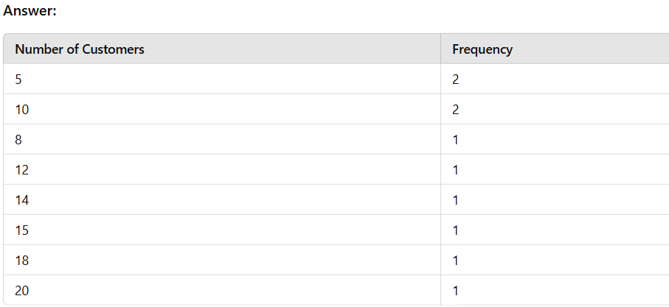

Scenario 4:
A real estate model has three variables:
- House Size
- Number of Rooms
Ramishahope Artificial Intelligence Pvt Ltd
36, Old Anandas, SG Arcade, Marudhamalai Main Road, Vadavalli, Coimbatore -641041.
+91 6385383227 | www.hopelearning.net | mdaravind@hopelearning.net | 33AAMCR3722R1ZU
- Number of Bathrooms
Question 1:
- How can you detect multicollinearity?
Answer:
- Logic:
  - Calculate the Variance Inflation Factor (VIF).
  - VIF > 10 indicates multicollinearity.
- Answer: High VIF means the variables are correlated, impacting model accuracy.
Scenario 5:
A company made a new medicine to lower blood pressure. They gave it to one group and gave a fake pill (placebo) to another group.

Question 1:
How can the company check if the new medicine works?

Solution:
- Make a guess (Hypothesis):
  - H0: The medicine doesn’t lower blood pressure.
  - H1: The medicine lowers blood pressure.
- Do a T-Test:
  - Find the p-value (a number that shows how likely the result happened by chance).
  - If p-value < 0.05, it means the medicine likely works.
- Final Answer:
  - If the p-value is small, the medicine is effective.

Scenario 6: Identifying Outliers in Sales Data
Ramishahope Artificial Intelligence Pvt Ltd
36, Old Anandas, SG Arcade, Marudhamalai Main Road, Vadavalli, Coimbatore -641041.
+91 6385383227 | www.hopelearning.net | mdaravind@hopelearning.net | 33AAMCR3722R1ZU
A company wants to find any unusual spikes in sales.
Question 1:
How can the company detect outliers in their sales data?
Logic:
- Step 1: Calculate the Interquartile Range (IQR).
- Step 2: Identify outliers using the formula:
Outliers=(Data<Q1−1.5×IQR) or (Data>Q3+1.5×IQR)Outliers = (Data < Q1 - 1.5 \times IQR) \text{ or } (Data > Q3 + 1.5 \times IQR)Outliers=(Data<Q1−1.5×IQR) or (Data>Q3+1.5×IQR)

Scenario 7: Understanding Customer Satisfaction
A restaurant conducted a survey to rate customer satisfaction on a scale of 1 to 5:
[5, 4, 4, 5, 3, 4, 5, 2, 4, 3]
✅ Question 1: How can the restaurant summarize the overall satisfaction?
Answer:
- Find the Mode to see the most common rating.
- Calculate the Mean and Median for further insights.
- If most ratings are 4 or 5, satisfaction is generally high.

