Ireland Housing Affordability Analysis
Using Python, Machine Learning and Power BI

By
Sankar Mannem
This report documents an end-to-end analytics project focused on measuring and explaining housing affordability patterns across Irish counties.

Table of Contents

- Executive Summary
- Chapter 1: Introduction
- Chapter 2: Project Aim and Objectives
- Chapter 3: Data Sources
- Chapter 4: Data Cleaning and Preparation
- Chapter 5: Feature Engineering
- Chapter 6: Exploratory Data Analysis
- Chapter 7: Affordability Analysis
- Chapter 8: Machine Learning Modelling
- Chapter 9: K-Means Clustering
- Chapter 10: Power BI Dashboard Development
- Chapter 11: Key Findings
- Chapter 12: Business Value of the Project
- Chapter 13: Limitations
- Chapter 14: Future Improvements
- Chapter 15: Conclusion

Executive Summary

Housing affordability is one of the most important challenges currently affecting Ireland. In many counties, property prices are high compared with income levels, making it difficult for individuals and families to purchase a home. This project analyses housing affordability across Irish counties by combining property price data, earnings data, and population data.
The main objective of this project was to understand how affordable housing is when average house prices are compared with annual income. To measure this, I created an affordability ratio for each county: Affordability Ratio = Average House Price / Annual Income. A higher affordability ratio indicates lower housing affordability.
The project followed a complete data analytics workflow. I cleaned and prepared the datasets using Python, performed exploratory data analysis, created new features, applied machine learning models, used K-Means clustering, and developed an interactive Power BI dashboard to present the results.
The findings show that Dublin and Wicklow have the highest housing affordability pressure. Dublin had an affordability ratio of approximately 14.33, while Wicklow had an affordability ratio of approximately 13.79. This means that the average house price in these counties is more than 13 times annual income.
Linear Regression performed well for predicting average county house prices, with an R² score of approximately 0.81. Random Forest performed weaker because the final merged dataset contained only 26 county-level observations. K-Means clustering grouped counties into three affordability tiers: High Affordability, Moderate Affordability, and Low Affordability. Dublin and Wicklow formed the Low Affordability group.
Overall, this project demonstrates an end-to-end data analytics process, including data cleaning, feature engineering, regression modelling, clustering, Power BI dashboard development, and business insight generation.

Project Snapshot

Area | Summary
Domain | Housing affordability and regional socio-economic analysis
Geography | 26 Irish counties
Main metric | Affordability ratio: Average House Price / Annual Income
Main finding | Dublin and Wicklow showed the strongest affordability pressure
Models used | Linear Regression, Random Forest, K-Means clustering
Dashboard tool | Power BI

Chapter 1: Introduction

Housing affordability is a major topic in Ireland because property prices have increased significantly in many regions. For many people, the issue is not only the price of a house, but whether income levels are high enough to support those prices.
In this project, I wanted to analyse housing affordability from a data-driven perspective. Instead of looking only at property prices, I compared average house prices with annual income. This gave a clearer picture of affordability across counties.
A county may have high house prices, but it may also have higher incomes. Similarly, a county may have lower house prices but still be difficult to afford if income levels are also low. For this reason, the project focuses on a price-to-income affordability ratio.
The project uses property price data, earnings data, and population data. Python was used for cleaning, analysis, feature engineering, modelling, and clustering. Power BI was used to create a dashboard that communicates the findings clearly.

Chapter 2: Project Aim and Objectives

2.1 Project Aim
The main aim of this project is to analyse housing affordability across Irish counties using property price data, earnings data, population data, machine learning, clustering, and Power BI dashboard visualisation.

2.2 Project Objectives
1. Clean and prepare property price, earnings, and population datasets.
2. Calculate recent average house prices by county.
3. Calculate annual income by county from weekly earnings data.
4. Create an affordability ratio for each county.
5. Identify the least affordable counties in Ireland.
6. Explore relationships between income, population, population growth, and house prices.
7. Apply regression models to predict average county house prices.
8. Compare Linear Regression and Random Forest model performance.
9. Use K-Means clustering to group counties into affordability tiers.
10. Design an interactive Power BI dashboard for presenting insights.
11. Document the project professionally for GitHub and portfolio use.

Chapter 3: Data Sources

This project used three main datasets. Each dataset contributed to a different part of the affordability analysis.

3.1 Property Price Data
The property price data was used to calculate average house prices by county. The dataset contained Irish property transaction records, including sale price, county, sale date, and other transaction-related details.
For the final affordability analysis, I used recent property transactions from 2022 to 2024. This made the analysis more relevant because the earnings data also covered recent years.
The full raw property transaction file was not uploaded to GitHub because it is a large transaction-level dataset. Instead, the final cleaned county-level dataset was uploaded.

3.2 Earnings Data
The earnings data contained county-level weekly earnings. I used the 2024 total weekly earnings value to estimate annual income. Annual income was calculated as Weekly Earnings × 52, which allowed income to be compared directly with average house prices.

3.3 Population Data
The population data contained county-level population figures for 2016 and 2022. It was used to understand population size and population growth across counties. Population growth was calculated as Population 2022 minus Population 2016.

Dataset | Purpose in project | Main fields used
Property price data | Calculate recent average house prices by county | County, price, sale date, year
Earnings data | Estimate annual income by county | County, total weekly earnings 2024
Population data | Add demographic context and population growth | County, population 2016, population 2022, change percentage

Chapter 4: Data Cleaning and Preparation

Data cleaning was an important stage of this project because the datasets came from different sources and had different formats.

4.1 Property Data Cleaning
The property price dataset required several cleaning steps. The price column contained formatting characters, so I cleaned it and converted it into numeric format. The sale date column was converted into a proper date format, and year and month columns were created from it.
Duplicate records were removed to avoid repeated transactions affecting the analysis. County names were cleaned and standardised so that the property data could be merged correctly with earnings and population data. After cleaning, I filtered the property data to include only transactions from 2022 to 2024 and calculated the average house price by county.

4.2 Earnings Data Cleaning
The earnings file required additional cleaning because the original Excel structure was not immediately ready for analysis. I selected the required rows and columns, renamed the columns clearly, and converted the earnings values into numeric format. The national total row was removed because it was not an individual county.

4.3 Population Data Cleaning
The population dataset was checked for missing values and duplicate records. A new population growth column was created using the 2016 and 2022 population values.

4.4 Final Merged Dataset
After cleaning all datasets, I merged them at county level. The final dataset contained 26 Irish counties and became the main dataset for modelling, clustering, and Power BI dashboard development.
- County
- Average house price
- Annual income
- Population 2022
- Population 2016
- Population growth
- Population percentage change
- Affordability ratio
- Cluster
- Affordability tier

Chapter 5: Feature Engineering

5.1 Annual Income
Annual income was calculated from weekly earnings using the formula Annual Income = Weekly Earnings × 52. This created a yearly income value for each county.

5.2 Average House Price
Average house price was calculated by grouping recent property transactions by county and taking the mean property price.

5.3 Population Growth
Population growth was calculated as Population 2022 minus Population 2016. This helped measure the increase in county population between 2016 and 2022.

5.4 Affordability Ratio
The affordability ratio was the main feature in this project. It was calculated as Average House Price divided by Annual Income. This ratio shows how many years of annual income would be required to buy an average house in a county. A higher ratio means lower affordability.

5.5 Affordability Tier
After applying K-Means clustering, counties were grouped into three affordability tiers: High Affordability, Moderate Affordability, and Low Affordability. These tiers made the results easier to interpret and present in Power BI.

Chapter 6: Exploratory Data Analysis

Exploratory data analysis was carried out to understand the main patterns in the dataset before applying machine learning.
The analysis showed that house prices vary strongly across counties. Dublin and Wicklow showed the highest affordability pressure, while counties such as Leitrim, Longford, and Roscommon were relatively more affordable.
One important observation was that income differences between counties were smaller than house price differences. This means that higher income does not always result in better affordability. In counties such as Dublin and Wicklow, house prices were much higher compared with income.
Population also provided useful context. More populated counties generally showed stronger house price pressure, especially Dublin and Cork.

Chapter 7: Affordability Analysis

The affordability ratio was used to rank counties by housing affordability. A higher affordability ratio means that the average house price is high compared with annual income. Therefore, counties with higher ratios are considered less affordable.

7.1 Least Affordable Counties

County | Average House Price | Annual Income | Affordability Ratio
Dublin | €612,168 | €42,714 | 14.33
Wicklow | €541,550 | €39,263 | 13.79
Kildare | €395,989 | €41,482 | 9.55
Meath | €361,427 | €39,812 | 9.08
Galway | €324,092 | €37,881 | 8.56
Cork | €339,725 | €39,813 | 8.53

Dublin had an affordability ratio of approximately 14.33, meaning the average house price was more than 14 times annual income. Wicklow had a ratio of approximately 13.79, which also indicates severe affordability pressure.
Other counties such as Kildare, Meath, Galway, Cork, Kilkenny, Wexford, Kerry, and Louth also showed strong affordability challenges.

7.2 Interpretation
This analysis showed that affordability pressure is not spread evenly across Ireland. Dublin and Wicklow are clear examples of counties where house prices are extremely high compared with annual income.

Chapter 8: Machine Learning Modelling

Machine learning was used to understand whether income and population-related features could help predict average house prices. The target variable was average house price. The input features included annual income, population 2022, and population percentage change.

8.1 Linear Regression
Linear Regression was used as the main predictive model. It performed well on the county-level dataset.
Metric | Result
R² Score | 0.81
Mean Absolute Error | €25,607
Root Mean Squared Error | €31,782

The R² score of approximately 0.81 means that the model explained around 81% of the variation in average house prices across counties. This suggests that annual income and population-related variables are useful for explaining house price differences between counties.

8.2 Random Forest
Random Forest was tested as a comparison model.
Metric | Result
R² Score | 0.14
Mean Absolute Error | €59,399
Root Mean Squared Error | €67,486

Random Forest performed weaker than Linear Regression. This was mainly because the final dataset contained only 26 county-level observations. Random Forest usually performs better with larger datasets because it needs more data to learn complex patterns.

8.3 Model Comparison
Linear Regression was selected as the better model for this project because it performed better and was easier to interpret. Random Forest was still useful as a comparison model because it showed that more complex models do not always perform better, especially when the dataset is small.

Chapter 9: K-Means Clustering

K-Means clustering was applied to group counties based on affordability patterns. The clustering used features such as average house price, annual income, and affordability ratio.
The counties were grouped into three tiers: High Affordability, Moderate Affordability, and Low Affordability.

9.1 Cluster Results

Affordability Tier | Number of Counties
High Affordability | 14
Moderate Affordability | 10
Low Affordability | 2

Dublin and Wicklow were grouped into the Low Affordability tier. This means they had the strongest housing affordability pressure compared with the other counties.

9.2 Cluster Summary

Affordability Tier | Average House Price | Average Annual Income | Average Affordability Ratio
High Affordability | €222,407 | €34,834 | 6.39
Moderate Affordability | €311,375 | €38,326 | 8.10
Low Affordability | €576,859 | €40,988 | 14.06

The cluster results show that income increased only slightly between the tiers, while average house price increased much more sharply in the Low Affordability group. This was one of the most important insights in the project because it shows that the affordability issue is mainly driven by the gap between house prices and income.

Chapter 10: Power BI Dashboard Development

Power BI was used to create an interactive dashboard for presenting the findings clearly. The dashboard contains three main pages: Executive Overview, Affordability Analysis, and Cluster Analysis.

10.1 Executive Overview Dashboard
The Executive Overview page gives a high-level summary of the housing affordability situation across Irish counties. It includes the number of counties analysed, total population, average house price, average affordability ratio, and affordability ratio ranking by county.

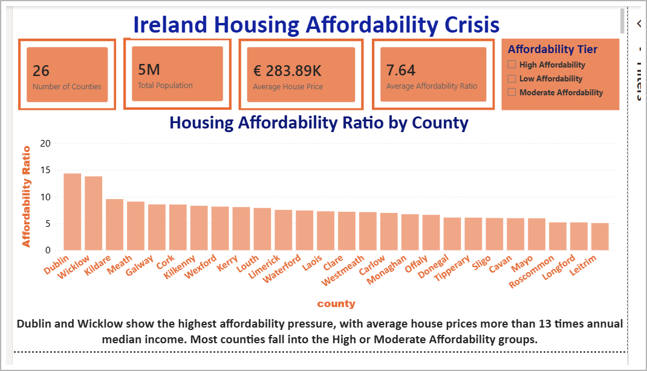
Figure 1: Executive Overview dashboard showing county-level housing affordability pressure.

10.2 Affordability Analysis Dashboard
The Affordability Analysis page focuses on county-level affordability patterns. It includes the top 10 least affordable counties, an income vs house price scatter plot, a county affordability table, and key insight text.
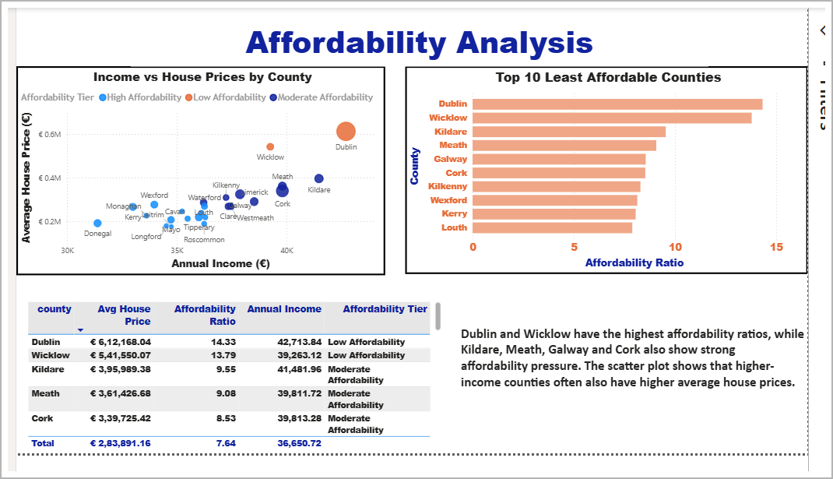
Figure 2: Affordability Analysis dashboard showing county rankings and the relationship between income and average house prices.

10.3 Cluster Analysis Dashboard
The Cluster Analysis page presents the K-Means clustering results. It compares average house price, annual income, affordability ratio, and the number of counties in each affordability tier.
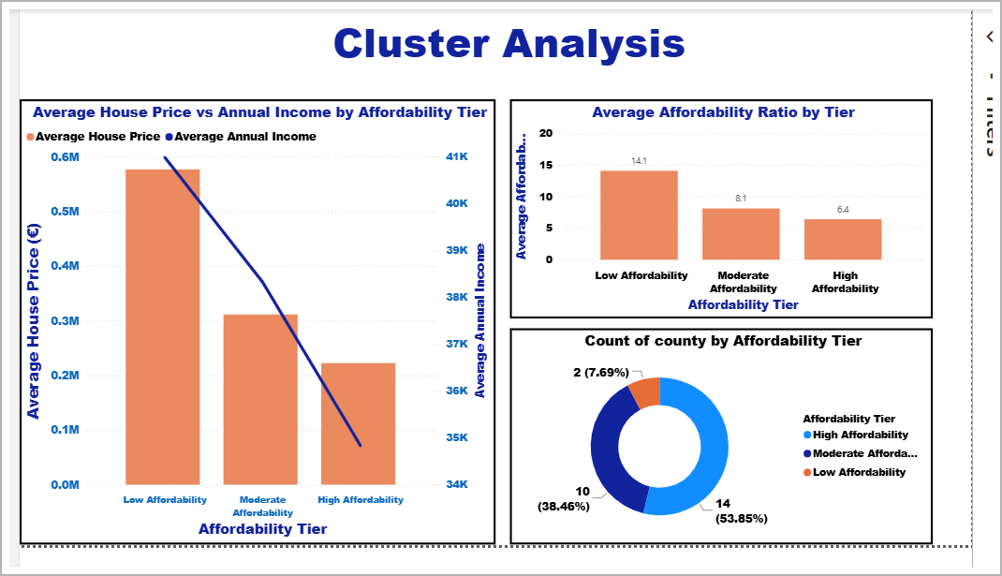
Figure 3: Cluster Analysis dashboard showing affordability tier comparison.

Chapter 11: Key Findings

1. Dublin and Wicklow are the least affordable counties in the analysis.
2. Dublin had an affordability ratio of approximately 14.33.
3. Wicklow had an affordability ratio of approximately 13.79.
4. Kildare, Meath, Galway, Cork, Kilkenny, Wexford, Kerry, and Louth also showed strong affordability pressure.
5. Higher income does not always mean better affordability because higher-income counties often also have higher house prices.
6. Population size is positively related to average house prices.
7. Linear Regression performed better than Random Forest on this small county-level dataset.
8. Random Forest underperformed because the dataset had only 26 county-level records.
9. K-Means clustering grouped counties into clear affordability tiers.
10. Dublin and Wicklow formed the Low Affordability group.
11. Power BI helped communicate the final results in a clear and interactive way.

Chapter 12: Business Value of the Project

This project provides value because it transforms raw housing, income, and population data into clear insights. The affordability ratio gives a simple way to compare counties and identify where housing pressure is strongest.
The machine learning section shows how county-level features can explain house price differences. The clustering section makes it easier to group counties into understandable affordability categories.
The Power BI dashboard adds further value by making the findings interactive and easy to communicate. This makes the project useful for portfolio presentation, recruiter review, and future analytical development.

Chapter 13: Limitations

- The final merged dataset contains only 26 county-level records, which limited the performance of complex machine learning models such as Random Forest.
- The affordability ratio only compares average house price with annual income. It does not include mortgage interest rates, deposits, rent, household expenses, tax, or family size.
- The analysis was completed at county level. A more detailed analysis at town, city, or local electoral area level could provide deeper insights because affordability can vary within the same county.
- Average house prices can be affected by very expensive properties. Future work could also use median house prices for comparison.

Chapter 14: Future Improvements

- Add rental price data.
- Include mortgage interest rates.
- Use median house prices as well as average prices.
- Analyse towns or local electoral areas instead of only counties.
- Add household income data if available.
- Create time-series forecasting for house prices.
- Build a live dashboard with regularly updated data.
- Compare affordability across different property types.

Chapter 15: Conclusion

This project analysed housing affordability across Irish counties using property price data, earnings data, and population data. The main focus was to compare average house prices with annual income and identify where housing is least affordable.
The results showed that Dublin and Wicklow had the highest affordability pressure. Dublin’s average house price was more than 14 times annual income, while Wicklow’s average house price was almost 14 times annual income.
Machine learning helped explain house price differences across counties. Linear Regression performed better than Random Forest because the dataset was small and the relationships were easier to interpret.
K-Means clustering grouped counties into High, Moderate, and Low Affordability tiers. Dublin and Wicklow formed the Low Affordability group, showing that the strongest housing pressure was concentrated in a small number of counties.
The Power BI dashboard helped present the findings in a clear and interactive way. Overall, this project demonstrates a complete data analytics workflow, including data cleaning, exploratory analysis, feature engineering, machine learning, clustering, dashboard development, and data storytelling.

