Streamlining IT Procurement:
Automating Standard Laptop Orders with Flow Designer
Problem Statement:
Today, standard laptop requests raised by employees are handled almost entirely by hand. Once a request is approved, someone still has to remember to notify the Hardware team, open a task, and hand over the correct details for configuration. Because this hand-off is manual, it is easy to miss or delay, which pushes out delivery timelines and leaves both the employee and the IT team without a clear, trackable record of where the request stands.
User Story:
As a member of the IT procurement team, I want the Standard Laptop request to automatically generate a configuration task for the Hardware team the moment it is approved, so that laptops are prepared without anyone having to chase the process manually, and employees receive their equipment faster.
Project Objective:
This project uses ServiceNow Flow Designer to automate the standard laptop procurement journey end to end. Specifically, it aims to:
- Automatically create a Catalog Task for the Hardware team as soon as a Standard Laptop request is approved.
- Remove manual hand-offs and reduce the chance of a request being missed or delayed.
- Give the requester and IT team clear, real-time visibility of task status.
- Improve overall turnaround time and productivity of the IT procurement process.

Task Initiation
Milestone 1 : Flow
Activity 1: Create a Flow to create a Catalog Task that updates the short description once the Service Request is approved, and assigns it to the Hardware group.
- Open ServiceNow.
- Click on All >> search for Flow Designer.
- Click on Flow Designer under Process Automation.
- Inside Flow Designer, click on New and select Flow.
- Under Flow properties, set Flow Name as “Standard Laptop Task”.
- Set Application as Global.
- Set Run As to “System User”.
- Click Submit.
[ 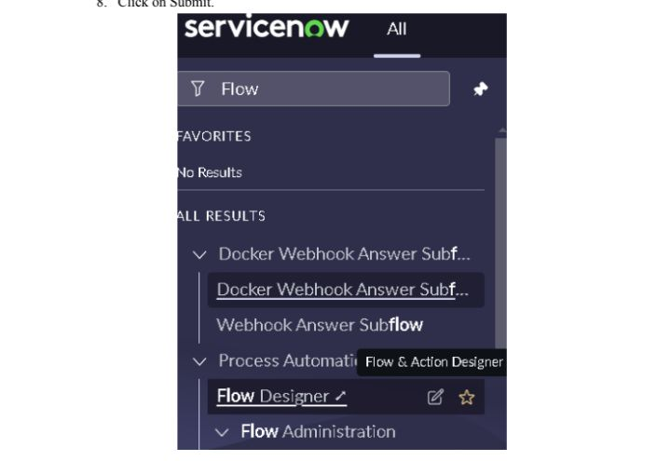Insert screenshot: Flow Designer > New Flow menu ]

- Click on Add a Trigger.
- Search for “Service Catalog” in the trigger list and select it.
- Click Done.
[ Insert screensho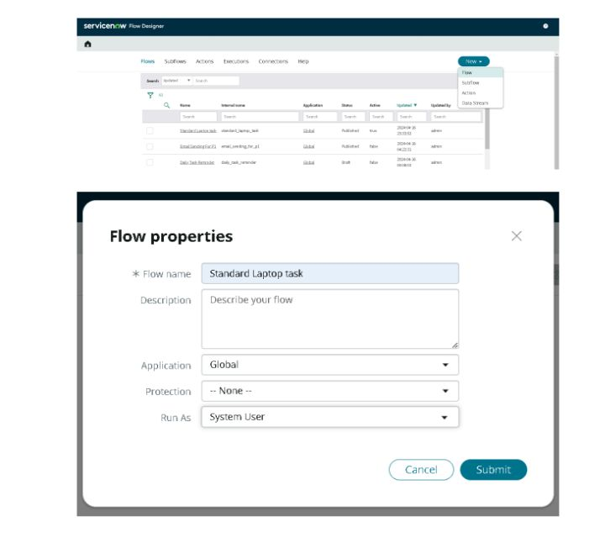t: Trigger selection — Service Catalog ]

- Under Actions, click Add an Action.
- Search for “Create Catalog Task” and select it.
- Set Action as Create Catalog Task.
- Drag and drop the Requested Item record into the Request Item field.
- The Table field auto-populates as Catalog Task [sc_task].
- Set Short Description to “Laptop needs to be configured”.
- Click Add Field Value.
- Set the Description field to “Laptop needs to be configured”.
- Set the Assignment Group field to “Hardware”.
- Set the Approval field to “Approved”.
- Leave the remaining fields at default and click Done.
- Save the Flow.
- Click Activate, then confirm by clicking Activate again.
[ Insert screen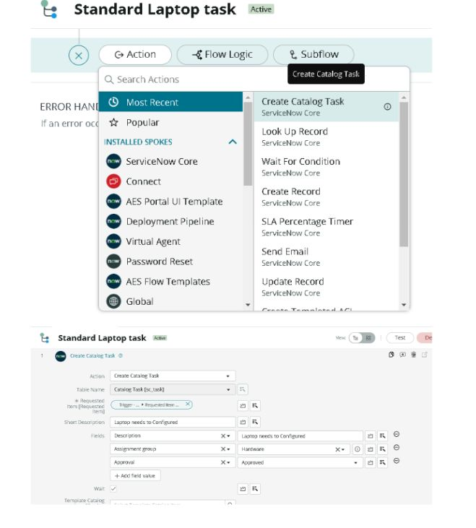s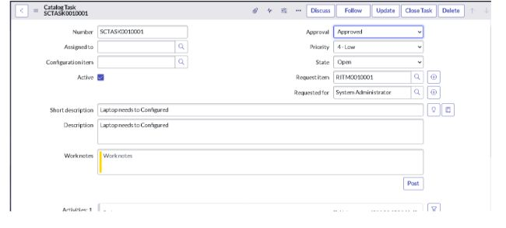hot: Create Catalog Task action — configured fields ]
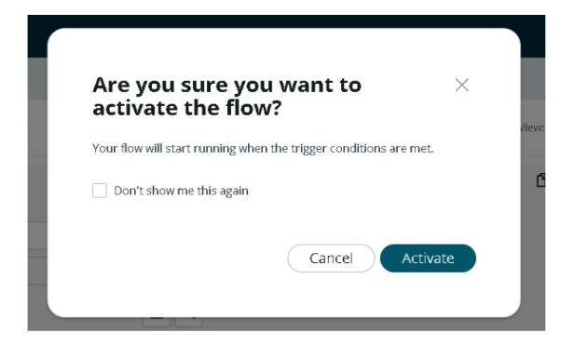[ Insert screenshot: Activate flow confirmation dialog ]
Milestone 2 : Flow Assignment
Activity 1: Assign the Flow to the Standard Laptop Service Catalog item.
- Open ServiceNow.
- Click on All and search for Maintain Items.
- Select Maintain Items.
- In the Name field, search for “Standard Laptop” and open that record.
- Open the Process Engine tab on the record.
- Remove any existing automation and select Flow instead.
- Set the Flow field to the flow created earlier, “Standard Laptop Task”.
- Save the record.
[ Insert screenshot: Standard Laptop catalog item — Process Engine tab ]
Milestone 3 : Service Catalog
Activity 1: Raise the request through the Service Catalog and take it through approval.
- Click on All >> search for Service Catalog.
- Open Service Catalog >> click on Hardware.
- Locate “Standard Laptop” and open it.
- Click Order Now to submit the request.
[ Insert screenshot: Standard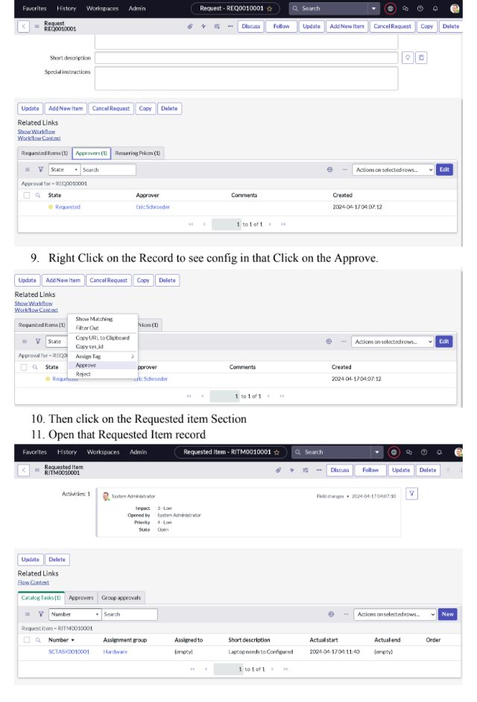 Laptop catalog item — Order Now ]

- On the Order Status screen, click the Request Number link.
- This opens the Request record — scroll to the Approvers section.
- Right-click the approval record and select Approve.
- Open the related Requested Item (RITM) record.
- Scroll to the Catalog Tasks section and open the generated task.
- Confirm the task shows the expected Short Description and Assignment Group (Hardware) — proof that the flow ran automatically on approval.
[ Insert screenshot: 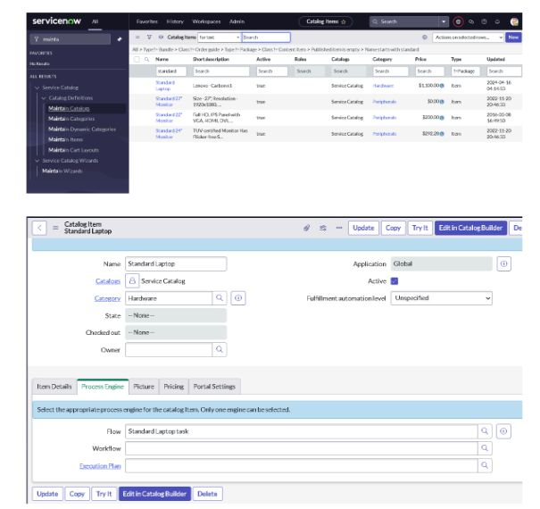Catalog Task record — auto-populated fields ]

Conclusion :
Automating the standard laptop procurement process with ServiceNow Flow Designer removes the manual hand-off between approval and configuration. The moment a request is approved, a Catalog Task is created automatically and routed straight to the Hardware team with the right details already filled in. This cuts down delays, keeps the process auditable, and gives both the requester and the IT team clear visibility into where each request stands — resulting in a faster, more reliable procurement experience.

