IS > Security>OAUTH  
  
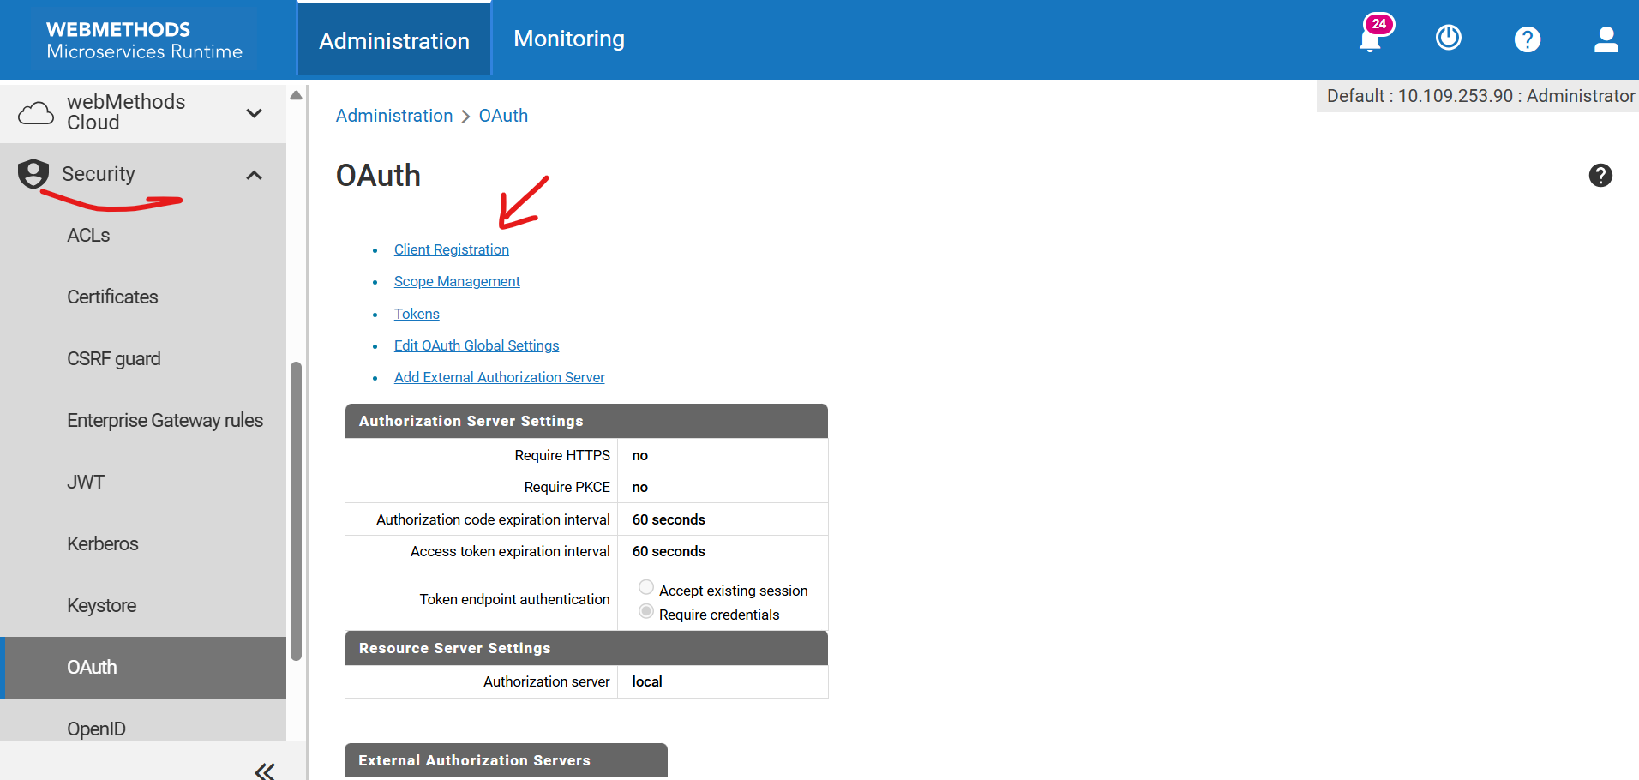

Client registration>register client  
fill details as below and save.

1. 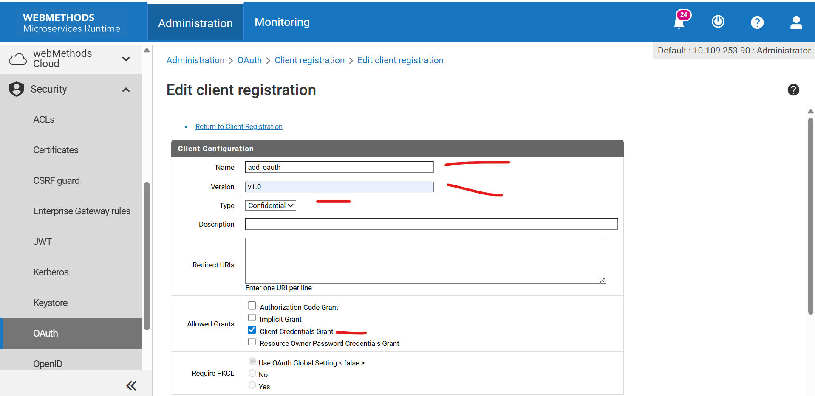  
     
     
   after saving it will generate some client secret copy that using snippet or any other way.  
     
   it look like this  
   A screenshot of a computer

   AI-generated content may be incorrect.  
     
     
   after client registration  
     
     
   A screenshot of a computer

   AI-generated content may be incorrect.  
     
   Scope management

click on [Associate Scopes to Clients](http://localhost:5555/WmRoot/security-oauth-scope-client-associations.dsp?webMethods-wM-AdminUI=true)  
select our client that we have already registered as below then save it.  
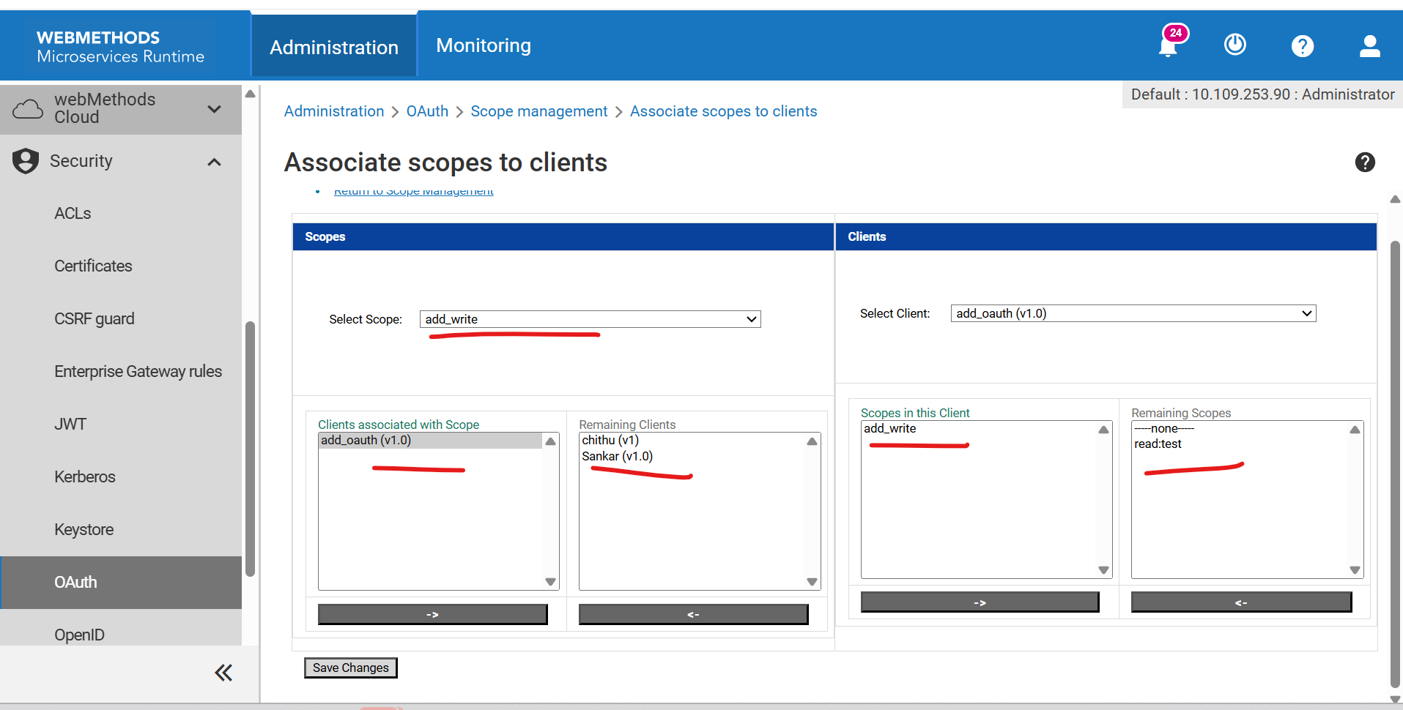

global settings related to oauth.

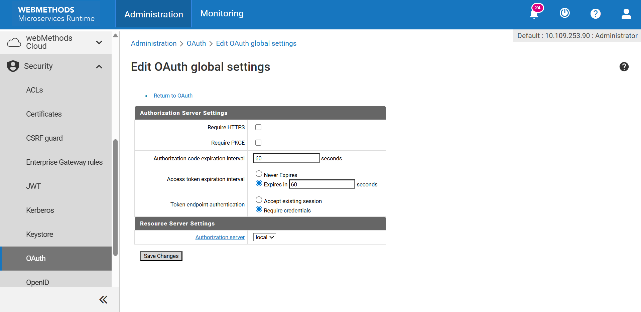  
  
  
go to user management >select our user(client id) and select group “OAuthClientGroup” this is inbuilt group used for oauth. Then save

Go to acls and create a acl as below and add our oauth client group. Then save  
  
  
set execute acls as below.  
  
