**🗂️ Adding a File Polling Port**

**Last Updated**: 2025-06-06

**📌 About This Task**

Use the following procedure to add a file polling port to Integration Server.

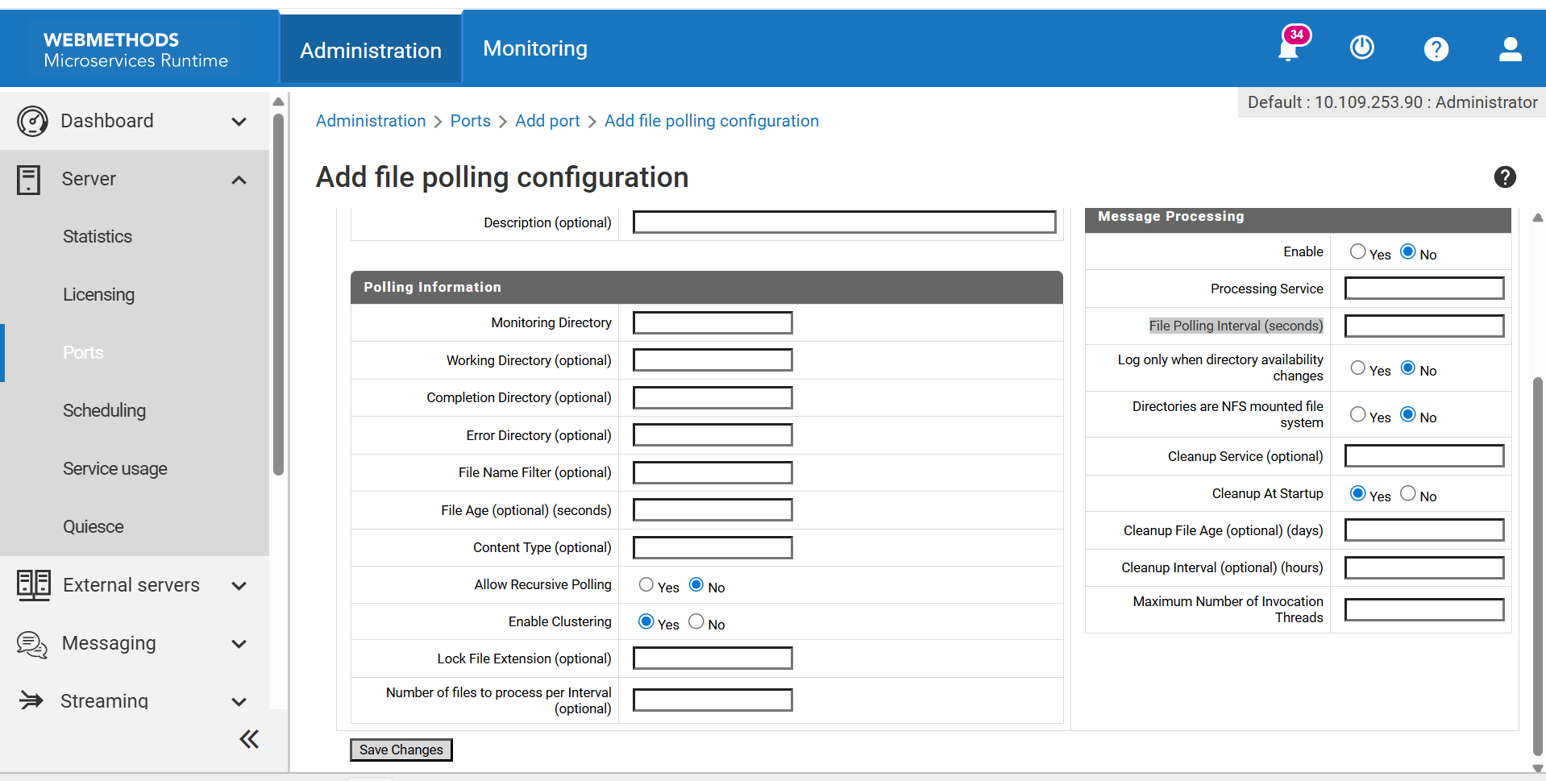

**🛠️ Procedure**

1. Open **Integration Server Administrator**.
2. Go to **Server > Ports**.
3. Click **Add Port**.
4. Select **IBM webMethods FilePolling**.
5. Click **Submit** — a configuration page will appear.

**📦 Package Information**

| **Parameter** | **Description** |
| --- | --- |
| **Package Name** | The package associated with this port. Enabling/disabling the package enables/disables the port. Use WmFlatFile for flat file processing. |
| **Alias** | Unique name for the port (1–255 characters). Can include letters, numbers, underscore _, period ., and hyphen -. |
| **Description** | Optional description of the port. |

**Note**: If you replicate this package to another server, a file polling port with the same settings is created.

* Same machine → shared monitoring directory
* Different machine → new monitoring directory created

**📁 Polling Information**

| **Parameter** | **Description** |
| --- | --- |
| **Monitoring Directory** | Directory to monitor for incoming files |
| **Working Directory** | Where files are moved for processing. Default: MonitoringDirectory\..\Work |
| **Completion Directory** | Where successfully processed files are moved. Default: MonitoringDirectory\..\Done |
| **Error Directory** | Where failed files are moved. Default: MonitoringDirectory\..\Error |
| **File Name Filter** | GLOB pattern to filter files (e.g., *.csv) |
| **File Age** | Minimum age (in seconds) before processing. Default: 0 |
| **Content Type** | Determines how file content is handled. See XML handling below. |
| **Allow Recursive Polling** | Yes/No — whether to poll subdirectories |
| **Enable Clustering** | Yes/No — whether to support clustering |
| **Lock File Extension** | Extension used to lock files during polling. Default: .lock |
| **Files Per Interval** | Max number of files to process per interval. Default: -1 (process all) |

**📄 XML Content Handling**

| **Content Type** | **Pipeline Variable** |
| --- | --- |
| text/xml or default | node (com.wm.lang.xml.Document) |
| application/xml | ffdata (java.io.BufferedInputStream) |

To override encoding, add filepollingport=encodingType to properties.cnf in:  
IntegrationServer_directory\instances\instanceName\packages\WmFlatFile\config

**🔐 Security**

* **Run services as user**: Specify the user to run the processing service. Can be internal or external.

**📬 Message Processing**

| **Parameter** | **Description** |
| --- | --- |
| **Enable** | Yes/No — whether to activate the port |
| **Processing Service** | Service to execute for each polled file. Must be the only service allowed from this port |
| **Polling Interval** | How often (in seconds) to poll the directory |
| **Log Only When Directory Availability Changes** | Yes/No — controls logging behavior for directory access |
| **NFS Mounted File System** | Yes/No — for UNIX systems with network-mounted directories |

**🧹 Cleanup Settings**

| **Parameter** | **Description** |
| --- | --- |
| **Cleanup Service** | Optional service to clean up directories |
| **Cleanup At Startup** | Whether to clean up Done/Error directories on startup |
| **Cleanup File Age** | Days before deleting processed files. Default: 7 |
| **Cleanup Interval** | How often (in hours) to check for cleanup. Default: 24 |
| **Max Invocation Threads** | Number of threads for the port (1–10) |

**🔒 Access Mode Configuration**

1. Go to the **Ports** page.
2. Click **Edit** in the **Access Mode** field.
3. Set Access Mode to **Deny by Default**.
4. Click **Add Folders and Services to Allow List**.
5. Enter the name of the **processing service**.
6. Remove any other services from the allow list.
7. Click **Save Additions**.

**Important**: If you change the processing service, update the allow list accordingly.