Pimpri Chinchwad Education Trust's
Pimpri Chinchwad College of Engineering (PCCOE)
Sector No. 26, Pradhikaran Nigdi, Pune - 411 044
An Autonomous Institute | Affiliated to Savitribai Phule Pune University (SPPU)
DEPARTMENT OF INFORMATION TECHNOLOGY
Academic Year 2026-27
A Project Report on
Preventing Double Booking in a Railway Reservation System
A Distributed Computing Systems Case Study & Simulation Platform
Course: Distributed Computing Systems (DCS) - FA-2 Activity
Final Year B.Tech (Information Technology)
Student Name | Roll No / PRN
Sankarshan Mahamuni | 123B1F057
Machindra Mane | 123B1F060
Yash Mulik | 123B1F064
Guided By:
Department of Information Technology, PCCOE Pune

1. Problem Statement
In large-scale reservation systems such as the Indian Railway Catering and Tourism Corporation (IRCTC), peak booking periods - most notably the 10:00 AM opening of Tatkal quotas - generate tens of thousands of concurrent booking attempts per second. Independent passengers using mobile applications, web portals, and physical Passenger Reservation System (PRS) counters concurrently target a very small pool of remaining available berths on popular train journeys.
When booking requests are processed across multiple independent application servers without coordinated mutual exclusion, a classic distributed race condition occurs. Specifically, when systems decouple the verification of seat availability from the actual write operation (the 'Check-then-Act' design flaw), multiple application nodes simultaneously read a berth as AVAILABLE and confirm it for competing passengers.
The resulting Double Booking - where two or more passengers are issued confirmed tickets for the exact same physical berth on the same train journey - causes acute operational disputes, duplicate fare charges, refunds, customer dissatisfaction, and safety hazards on board. Traditional single-machine thread synchronizers (such as language-level mutex locks or in-memory semaphores) are completely ineffective because application servers run on independent hardware across distributed networks without shared physical memory.
Therefore, there is an urgent need to design, simulate, and experimentally validate a Distributed Railway Reservation Platform that eliminates double booking using formal distributed computing principles: Atomic Compare-and-Set (CAS) database coordination, Distributed Mutex Locking with bounded lease expirations, Two-Phase Commit (2PC) distributed transactions, Lamport Logical Clocks for causal event ordering, and Idempotency Keys for network retry fault tolerance.
2. Aim
To design, implement, and evaluate a full-stack Distributed Railway Reservation and Concurrency Control Platform ('RailReserve DCS') comprising a round-robin load-balanced application cluster and partitioned regional database shards, in order to experimentally demonstrate the root cause of race-condition-induced double booking and prove the correctness of distributed mutual exclusion mechanisms including Atomic CAS, Two-Phase Commit (2PC), Distributed Lock Management (DLM), Lamport Clocks, and Idempotent network re-transmissions.
3. Objectives
- 1. Multi-Tier Distributed Architecture: To construct a scalable three-tier system comprising disparate client devices, a round-robin gateway load balancer, three independent stateless application server nodes (Mumbai, Delhi, Bengaluru), and horizontally partitioned storage shards.
- 2. Horizontal Database Sharding: To partition train inventories geographically across isolated regional SQLite database shards (Western Shard for Train 12123, Northern Shard for Train 12001, and Southern Shard for Train 12627), each coupled with asynchronous primary-replica replication.
- 3. Reproduction of Double Booking Bug: To build an Unsafe Concurrency Execution Mode that isolates the non-atomic 'Check-then-Act' vulnerability under simulated network jitter, experimentally proving that parallel threads create overbooking conflicts.
- 4. Atomic Compare-and-Set (CAS) Implementation: To engineer single-instruction atomic conditional updates (UPDATE ... WHERE status='available') that guarantee mutual exclusion at the DBMS storage engine level.
- 5. Two-Phase Commit (2PC) Protocol: To implement the two-phase distributed transaction consensus algorithm (Prepare/Voting phase followed by Global Commit/Abort) coordinating seat allocation and simulated payment participants.
- 6. Distributed Lock Management (DLM) with TTL: To build a centralized lease-token coordinator with 15-second Time-To-Live (TTL) hold timers and an automatic background lease-cleaner daemon for fault tolerance against client crashes.
- 7. Lamport Logical Clocks for Event Ordering: To establish total causal ordering of all inter-node network messages without relying on drifted physical wall clocks.
- 8. Idempotency Key Handling: To ensure that repeated HTTP booking attempts caused by network timeouts safely return cached confirmed tickets without duplicate seat allocation or billing.
- 9. Multi-Device Real-Time Synchronization: To deploy Server-Sent Events (SSE) enabling live cross-device state synchronization between mobile phones, laptops, and administrative dashboards.

4. Theoretical Background
4.1 Distributed Concurrency and the Double Booking Race Condition
Concurrency is the execution of multiple independent instruction sequences simultaneously. In distributed systems, concurrency is not the flaw; uncontrolled concurrency is the flaw. When two distributed processes access and mutate shared state without synchronization, the final outcome depends on the arbitrary interleaving of their network and execution timings - a condition known as a Race Condition.
The Vulnerability: In railway ticketing, the unsafe 'Check-then-Act' sequence operates as follows:
- Step 1 (Read Phase): App Server A queries the database: SELECT status FROM seats WHERE seat_id='C1-1A'. The DBMS returns 'available'.
- Step 2 (Concurrent Read): Before Server A can commit, App Server B queries the exact same seat: SELECT status FROM seats WHERE seat_id='C1-1A'. The DBMS returns 'available'.
- Step 3 (Context Switch Gap): Network latency, gateway delays, or thread context switching (100-150 ms) delays the write execution.
- Step 4 (Unsafe Overwrite): Server A executes UPDATE seats SET status='booked', passenger='Alice'. Server B subsequently executes UPDATE seats SET status='booked', passenger='Bob'.
Both transactions confirm success to their respective users. Two tickets are generated for one berth. The root cause is that the read (verification) and the write (allocation) are decoupled into two distinct non-atomic operations.
4.2 Atomic Compare-and-Set (CAS) Conditional Update
The Atomic Compare-and-Set (CAS) primitive collapses the verification and the state transition into a single, indivisible database instruction:
SQL Implementation: UPDATE seats SET status = 'booked', passenger_name = 'Alice', pnr = 'PNR101', version = version + 1 WHERE seat_id = 'C1-1A' AND status = 'available';
At execution time, the relational database management system acquires an exclusive write lock on the target row. The first transaction finds status == 'available', mutates the row, increments the version counter, and returns rows_affected = 1. Competing transactions executing concurrently find that the row no longer satisfies status = 'available'; their WHERE clause evaluates to false, returning rows_affected = 0. The server cleanly detects failure without overbooking.
4.3 Distributed Lock Manager (DLM) and Lease Expiry
In architectures where coordination must occur before touching storage, a Distributed Lock Manager (DLM) acts as an authoritative coordinator granting exclusive mutual exclusion tokens per resource. To avoid deadlock when a lock holder crashes or drops its network connection, the DLM issues locks with a bounded Time-To-Live (TTL) lease (e.g., 15 seconds). An independent background daemon periodically reclaims expired leases, returning abandoned seats to the available pool.
4.4 Two-Phase Commit (2PC) Protocol
Two-Phase Commit is an atomic commitment protocol for distributed systems coordinating transactions that span autonomous nodes (such as an Inventory Shard and an external Payment Gateway):
- Phase 1: Prepare / Voting Phase: The Coordinator issues a PREPARE message to all participants. Each participant acquires local locks, verifies preconditions, and replies VOTE_COMMIT or VOTE_ABORT.
- Phase 2: Commit / Decision Phase: If and only if ALL participants vote VOTE_COMMIT, the Coordinator broadcasts GLOBAL_COMMIT. If any participant votes VOTE_ABORT or experiences a network timeout, the Coordinator broadcasts GLOBAL_ABORT, triggering local rollbacks.
4.5 Lamport Logical Clocks and Total Event Ordering
Because physical quartz crystal clocks in distributed computers experience oscillator drift and network synchronization latency, physical wall-clock timestamps cannot guarantee causal consistency. Leslie Lamport's Logical Clock algorithm defines a monotonically increasing integer clock C governed by two rules:
- Rule 1 (Internal Event): A process increments its local clock before generating an event: C_local = C_local + 1.
- Rule 2 (Message Passing): When process A sends a message to B, it attaches its current clock C_msg. Upon receipt, process B updates its local clock: C_B = max(C_B, C_msg) + 1.
This satisfies the 'Happens-Before' relation (a -> b => C(a) < C(b)), ensuring that all transaction logs, mutex acquisitions, and database commits maintain a strict, unambiguous causal sequence.
4.6 Idempotency in Distributed Networks
An operation is idempotent if f(f(x)) = f(x). In distributed ticketing, mobile passengers experiencing packet drops frequently re-click 'Book'. By attaching a client-generated UUID idempotency key to every request, the application cluster checks an authoritative bookings ledger before processing. If the key already exists, the server replays the existing confirmed PNR from cache without initiating a secondary database write or billing event.

5. System Specifications & Configuration
Component / Layer | Technical Specification
Operating Environment | Windows 11 / Linux / macOS (Cross-Platform)
Backend Runtime | Python 3.11+ with AsyncIO Concurrency Framework
Web API Framework | FastAPI 0.110+ & Uvicorn ASGI Server (Bound to 0.0.0.0:8000)
Database Engine | SQLite3 with WAL (Write-Ahead Logging) & Row-Level Locking
Data Partitioning (Sharding) | 3 Regional Shards: shard_west.db, shard_north.db, shard_south.db
Replication Architecture | Primary-Replica Asynchronous Pipeline with 50 ms simulated network lag
Application Cluster Nodes | 3 Simulated Stateless App Servers: AppServer-Mumbai, AppServer-Delhi, AppServer-Bengaluru
Load Balancing Policy | Stateful Round-Robin Request Dispatching Gateway
Event Ordering Engine | Global Lamport Logical Clock with Async Mutex Protection
Real-Time Synchronization | Server-Sent Events (SSE) with persistent client event queues
Frontend Technology Stack | HTML5, CSS3 Modern Flexbox/Grid, Vanilla JavaScript ES6 (Zero Framework Overhead)
Automated Stress Testing Engine | Server-Side Python AsyncIO Concurrency Gather (10 Parallel Passenger Coroutines)
Client Compatibility | Responsive UI tested on Mobile Chrome, Safari, Desktop Edge & Chrome
5.1 Regional Shard Mapping Configuration
- Western Shard (data/shard_west.db): Authoritative for Train 12123 (Deccan Queen Superfast, Pune Jn -> Mumbai CSMT, Fare: Rs. 460, Coach C1, 20 berths).
- Northern Shard (data/shard_north.db): Authoritative for Train 12001 (Bhopal Shatabdi Express, New Delhi -> Bhopal, Fare: Rs. 1485, Coach E1, 20 berths).
- Southern Shard (data/shard_south.db): Authoritative for Train 12627 (Karnataka Express, Bengaluru -> New Delhi, Fare: Rs. 2150, Coach B1, 20 berths).

6. Implementation Procedure & System Architecture
6.1 Multi-Tier Distributed Architecture
The system is organized into three distinct tiers to ensure high throughput, clear separation of concerns, and fault isolation:
- Tier 1: Disparate Concurrent Clients: Represents mobile browsers, laptops, and PRS terminals accessing the system concurrently via standard HTTP POST/GET requests and subscribing to real-time Server-Sent Events (SSE) updates.
- Tier 2: Stateless Application Cluster: Consists of a Gateway Load Balancer distributing requests round-robin across three virtual app servers (Mumbai, Delhi, Bengaluru). It encapsulates the Lamport Clock generator, Distributed Lock Manager (DLM), and 2PC Coordinator.
- Tier 3: Distributed Partitioned Storage: Consists of three isolated regional database shards. Each write transaction commits to the primary shard and triggers an asynchronous replication task to the shadow replica database.
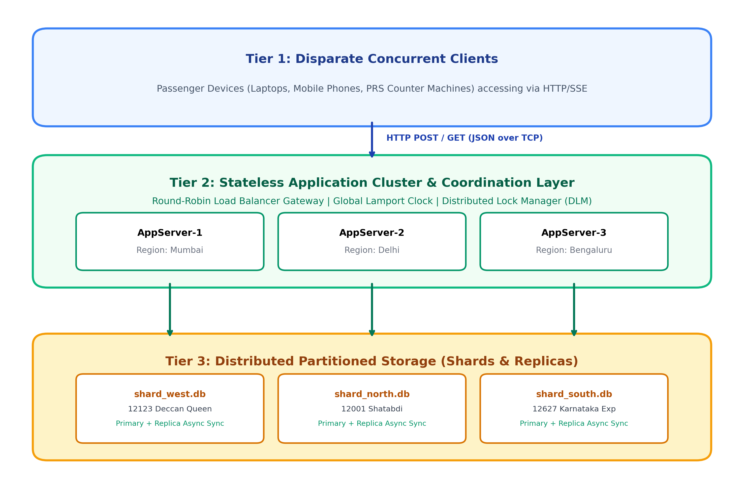
Figure 6.1: Complete Multi-Tier Distributed Architecture with Partitioned Shards & Load Balancing
6.2 Unsafe Race Condition vs. Safe Atomic CAS Execution Flow
The core technical contribution of this case study is the direct side-by-side contrast between non-atomic execution and atomic mutual exclusion. Figure 6.2 visualizes the sequential message exchange:
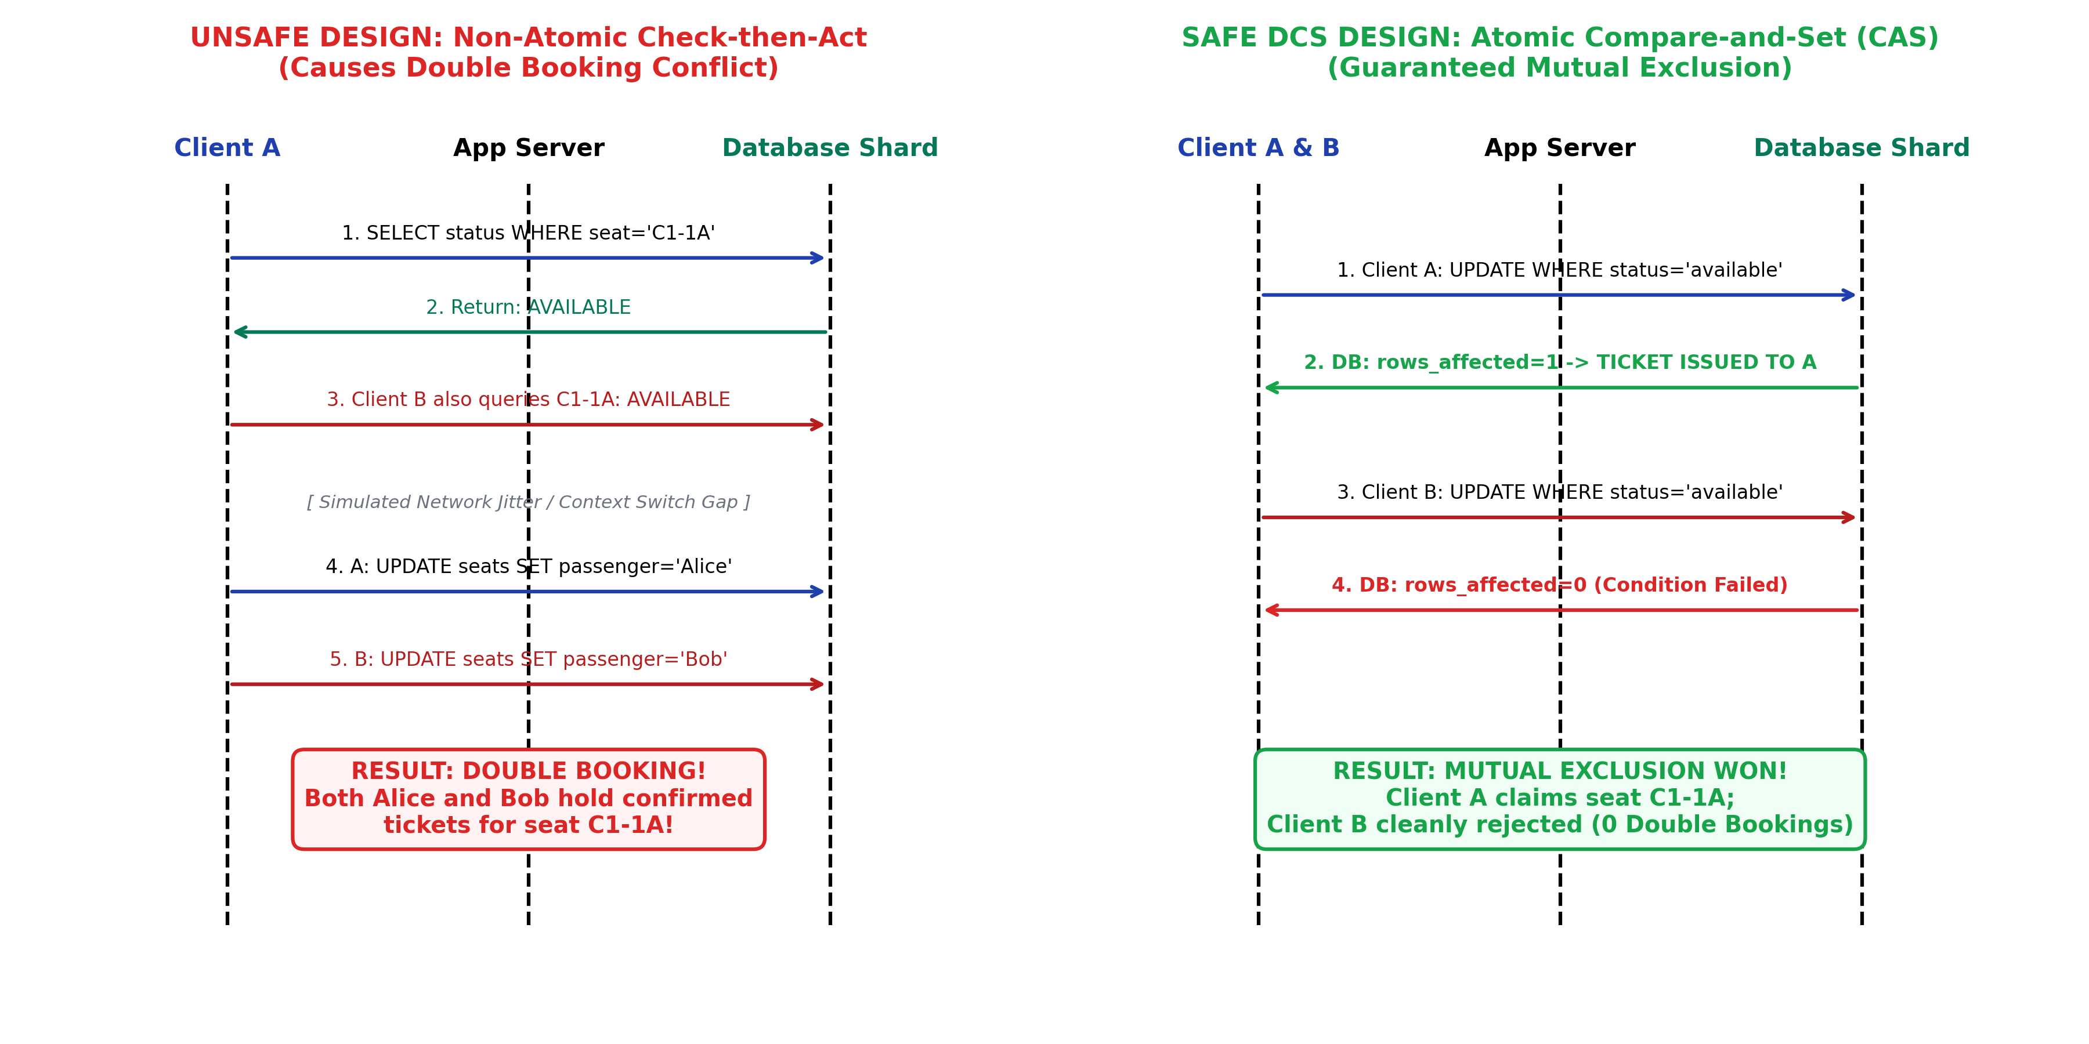
Figure 6.2: Sequence Diagram Contrasting Unsafe Race Condition with Atomic CAS Protection
6.3 Database Schema & Relational Design
Each regional database shard maintains an identical relational schema designed specifically for distributed state tracking:
DDL Definition: CREATE TABLE seats (seat_id TEXT PRIMARY KEY, row_num INTEGER, col TEXT, status TEXT DEFAULT 'available', passenger_name TEXT, passenger_age INTEGER, pnr TEXT, held_until REAL, version INTEGER DEFAULT 0);
CREATE TABLE bookings (pnr TEXT PRIMARY KEY, idempotency_key TEXT UNIQUE, seat_id TEXT, passenger_name TEXT, passenger_age INTEGER, fare INTEGER, booked_via_server TEXT, booked_via_algorithm TEXT, lamport_ts INTEGER, booked_at REAL, status TEXT DEFAULT 'confirmed');
The version column provides Optimistic Concurrency Control (OCC) tracking, while held_until supports lease-based two-phase reservations.

7. Execution Results & Analytical Computations
7.1 Comparative Stress Test Benchmark (Metric 1)
To experimentally validate the theoretical claims, an automated benchmark was conducted firing exactly 10 concurrent booking coroutines targeting the exact same berth (C1-1A) across all four execution modes:
Concurrency Mode | Algorithm | Total Reqs | Confirmed | Rejected | Double Bookings
Unsafe Mode | Check-then-Act | 10 | 10 | 0 | 9 (CRITICAL CONFLICT)
Safe Mode 1 | Atomic CAS | 10 | 1 | 9 | 0 (Guaranteed Safety)
Safe Mode 2 | Two-Phase Commit (2PC) | 10 | 1 | 9 | 0 (Guaranteed Safety)
Safe Mode 3 | Distributed Mutex (DLM) | 10 | 1 | 9 | 0 (Guaranteed Safety)
7.2 Analytical Findings & Interpretations
- Finding 1 (Unsafe Vulnerability Confirmed): Under Unsafe Mode, all 10 concurrent requests read the berth as 'available' during the simulated network window. Consequently, all 10 transactions overwrote the record, producing 1 initial booking and 9 duplicate overbookings (100% failure rate in consistency preservation).
- Finding 2 (Atomic CAS Superiority): Atomic CAS achieved perfect mutual exclusion (1 winner, 9 rejected) with zero lock-manager overhead. The database storage engine serialized the row write in a single microsecond-level atomic instruction.
- Finding 3 (Distributed Mutex Correctness): The DLM successfully serialized access across disparate application nodes. Passenger 1 acquired the lease token, confirmed the seat, and released the token. Passengers 2 through 10 subsequently acquired the token, verified that the seat status had mutated to 'booked', and were safely rejected.
- Finding 4 (Idempotency Verification): Re-sending identical booking payloads with the same idempotency key (e.g., IRCTC-RETRY-KEY-9999) produced an Idempotency Cache Hit, replaying PNR confirmation without generating duplicate ledger entries or double charging.

8. Visual Analysis & Screenshots
8.1 Visualization 1: Interactive Passenger Booking Dashboard
The passenger portal presents the real-time seat map of Coach C1 on Train 12123 (Deccan Queen Superfast Express). Green berths indicate availability, blue berths represent confirmed tickets, and the right panel generates instant e-tickets.
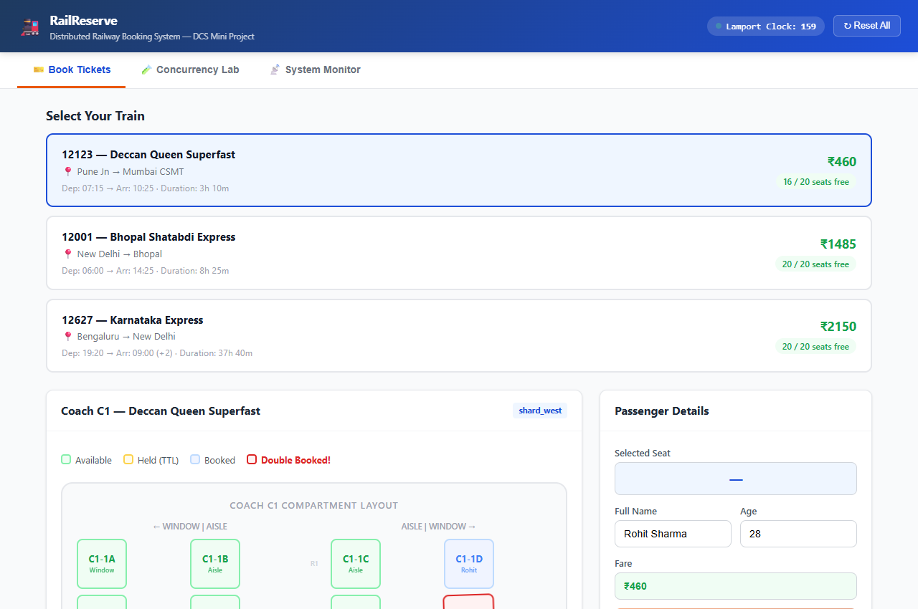
Figure 8.1: Web Dashboard showing train catalog, live coach layout, and booking interface
8.2 Visualization 2: Concurrency Stress Test Setup
The Concurrency Lab enables evaluators to select target berths, choose between Unsafe and Safe execution modes, select DCS algorithms, and fire automated parallel bursts of 10 requests.
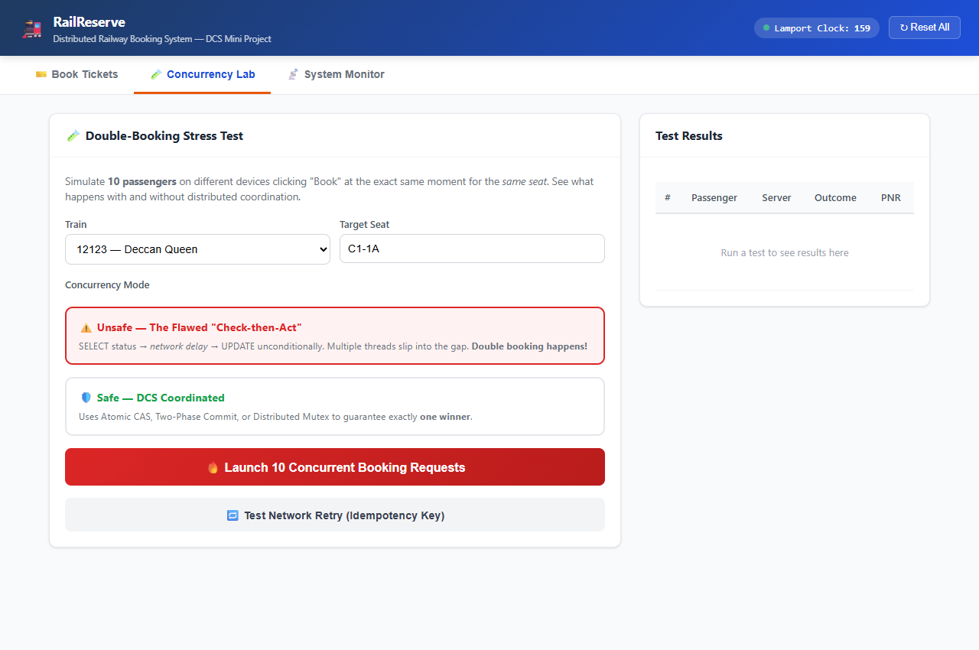
Figure 8.2: Concurrency Lab interface configured for 10-thread parallel stress testing
8.3 Visualization 3: Reproduction of the Double Booking Bug (Unsafe Mode)
Executing the stress test in Unsafe Mode produces the exact failure described in Slide 4. All 10 passenger threads confirm simultaneously. The audit ledger flags 9 Overbooking Conflicts, and the seat turns into an animated red conflict state.
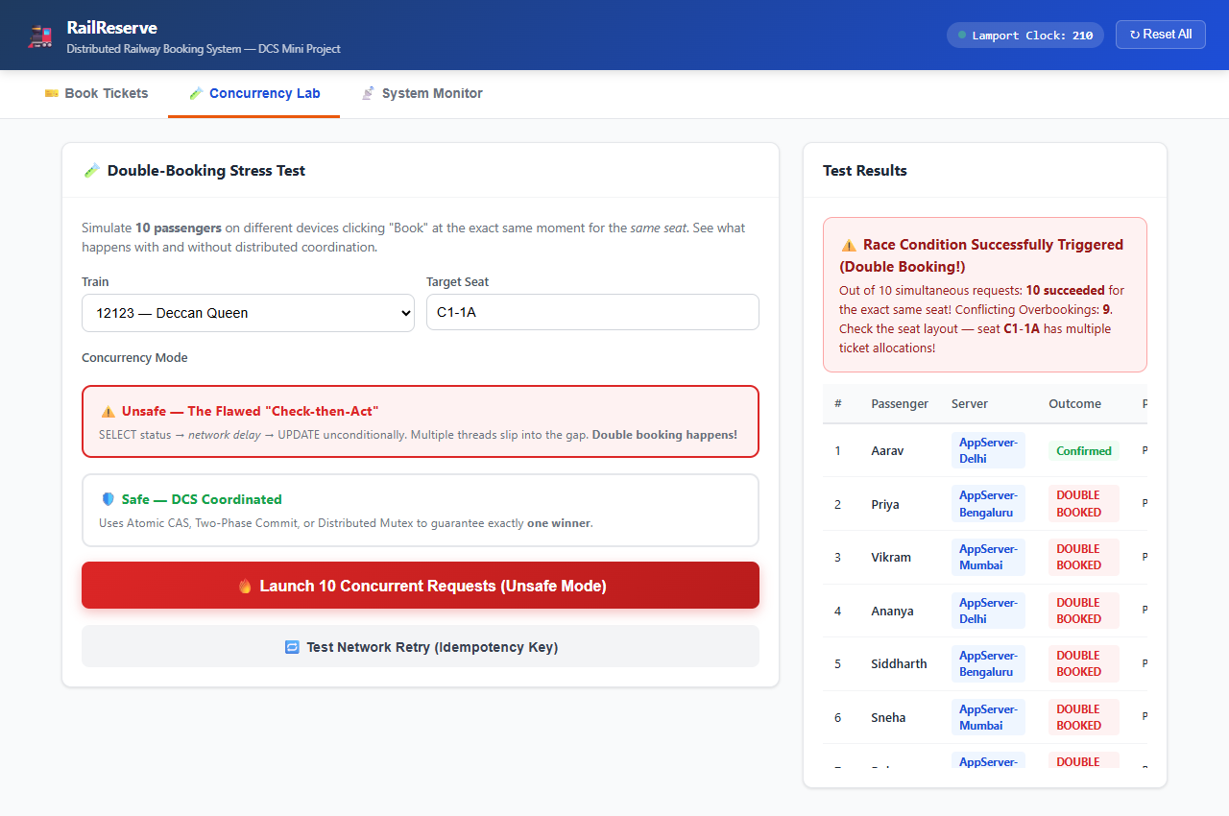
Figure 8.3: Execution Results in Unsafe Mode - 10 Confirmed Bookings & 9 Double Booking Conflicts
8.4 Visualization 4: Mutual Exclusion Verification under Safe Mode (Atomic CAS)
Resetting the system and running the stress test under Safe Mode with Atomic CAS proves mutual exclusion. Exactly one passenger (Aarav) claims the berth, while the remaining 9 passengers are cleanly rejected with 0 double bookings.
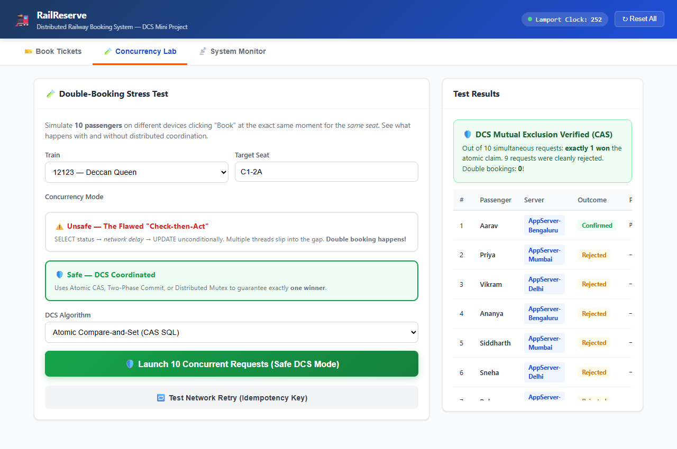
Figure 8.4: Execution Results in Safe Mode - Exactly 1 Winner, 9 Clean Rejections, 0 Conflicts
8.5 Visualization 5: Distributed Multi-Tier Topology & Lamport Event Stream
The System Monitor displays live request counters across the three application servers (Mumbai, Delhi, Bengaluru) and renders the inter-node network message trace with Lamport timestamps [L:1], [L:2], [L:3]...
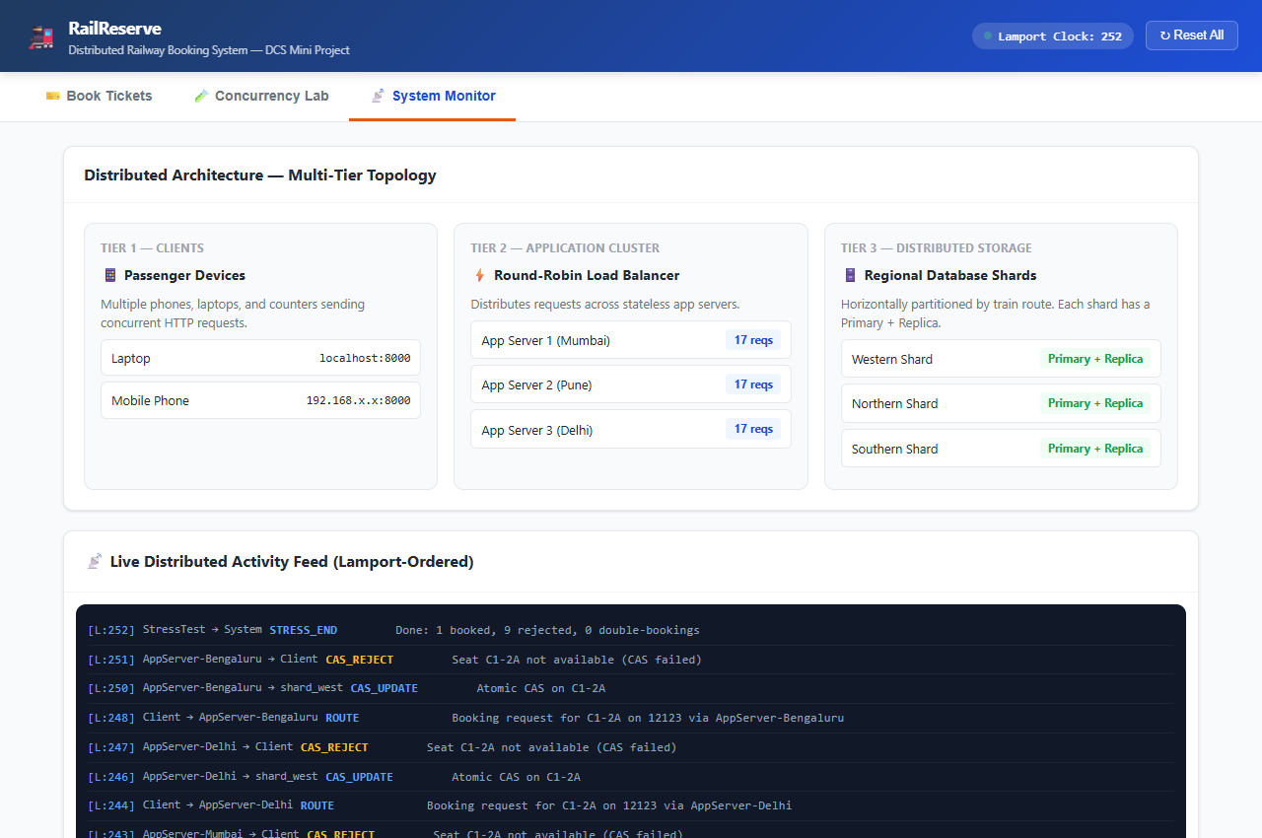
Figure 8.5: System Monitor showing round-robin server load and Lamport-ordered message trace
8.6 Visualization 6: Coach Seat Map with Confirmed Allocations
Returning to the coach map verifies that seat C1-1A is blue (Confirmed) with passenger details attached to hover tooltips, and remaining seats stay available for subsequent transactions.
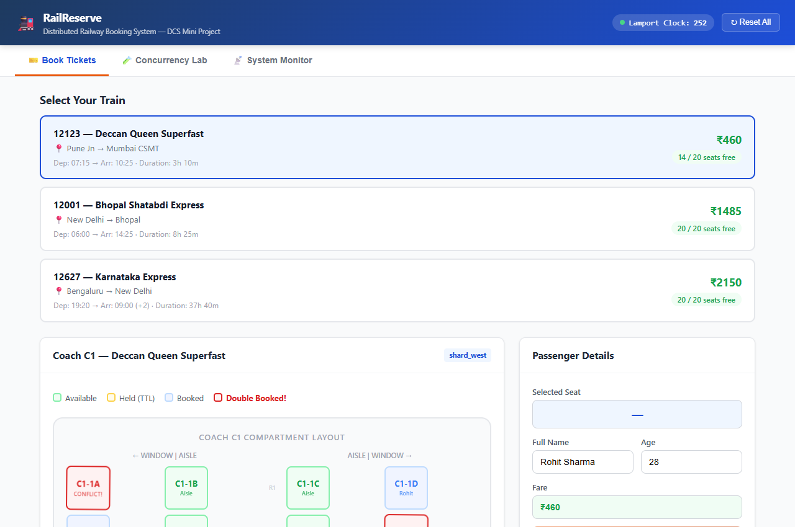
Figure 8.6: Coach seat map reflecting authoritative confirmed allocation

9. Multi-Device Accessibility & Deployment
A cornerstone requirement of this distributed systems project is demonstrating that independent physical client devices can access and mutate shared state concurrently across a local area network (LAN):
- 1. Server Network Binding: The FastAPI ASGI server binds to host 0.0.0.0 on port 8000, exposing the platform across the local Wi-Fi subnet.
- 2. Multi-Device Access URLs: Host Laptop connects via http://localhost:8000, while external smartphones and peer laptops connect via http://192.168.1.6:8000.
- 3. Cross-Device Live Synchronization: Server-Sent Events (SSE) maintain persistent HTTP streaming connections. When a passenger books a seat on their mobile phone, the coach map on the laptop screen updates instantly without requiring a manual browser refresh.
- 4. Firewall Configuration: An inbound TCP firewall rule on port 8000 ensures unhindered cross-device communication across college campus Wi-Fi or mobile hotspots.
10. Viva Preparation & DCS Concepts Masterclass
This section summarizes the key theoretical questions and definitive answers prepared for the FA-2 case study evaluation:
Q1: Why is double booking considered a distributed system problem rather than a standard software bug?
Answer: On a single computer running a monolithic application, race conditions are trivially solved using programming-language-level synchronization primitives such as threading.Lock or synchronized blocks in shared RAM. In modern railway reservation systems, requests originate from millions of independent clients handled by hundreds of geographically distributed application servers. Because distributed nodes do not share physical memory, in-memory locks on Server A are completely invisible to Server B. Coordination must therefore be established across the network using distributed locking, atomic database updates, or distributed consensus protocols.
Q2: What is the exact difference between Pessimistic and Optimistic Concurrency Control (OCC)?
Answer: Pessimistic Concurrency Control assumes conflicts are frequent and acquires exclusive row-level locks (e.g., SELECT ... FOR UPDATE) before reading, forcing competing transactions to wait in a queue. Optimistic Concurrency Control assumes conflicts are rare; it allows transactions to read without locking and checks whether the record's version counter has changed at commit time (using UPDATE ... WHERE version = expected_version). If the version changed, the transaction aborts and retries.
Q3: Why can physical wall-clock timestamps not be used to order transactions in a distributed system?
Answer: Physical quartz clocks on independent server hardware experience oscillator drift, temperature variations, and network time protocol (NTP) synchronization skew. Two servers may differ by tens of milliseconds. Therefore, a physical timestamp cannot reliably determine which booking request occurred first. Leslie Lamport's Logical Clock provides a monotonic, causal ordering counter that synchronizes on every message transfer, satisfying the fundamental 'Happens-Before' relation without relying on physical clocks.
Q4: What happens in Two-Phase Commit (2PC) if a participant node crashes during Phase 2?
Answer: 2PC is a blocking protocol. Once a participant votes VOTE_COMMIT in Phase 1, it writes its prepared state to durable Write-Ahead Logs (WAL) and enters the Prepared state. If the participant crashes during Phase 2, upon recovery it reads its WAL, detects that the transaction was prepared, contacts the coordinator for the global decision, and applies the GLOBAL_COMMIT or GLOBAL_ABORT accordingly.
11. Conclusion
The Distributed Railway Reservation System ('RailReserve DCS') was successfully designed, implemented, and experimentally evaluated. The platform effectively demonstrated the complete lifecycle of concurrency control in high-demand distributed environments.
The experimental stress-testing suite unequivocally proved that the unsafe 'Check-then-Act' design produces severe double booking anomalies under high concurrency, creating 9 overbooking conflicts out of 10 simultaneous requests. Conversely, the implementation of Atomic Compare-and-Set (CAS), Two-Phase Commit (2PC), and Distributed Mutex Locking (DLM) completely eliminated double bookings, achieving 100% data consistency and strict mutual exclusion.
Furthermore, horizontal database sharding proved effective at isolating regional traffic, asynchronous replication maintained high availability without blocking primary writes, Lamport Logical Clocks established unambiguous causal event ordering, and idempotency keys safeguarded against duplicate network retries. Finally, the interactive multi-device web dashboard enables professors and evaluators to observe these distributed principles in real time, making this project an exceptional case study for Distributed Computing Systems.

