PLACEMENT PREP DAY 2

##Q1 Write a Python program to print all even numbers from a given list of numbers in the same order. Stop printing if any number that comes after 237 in the sequence is encountered.
numbers = [ 386, 462, 47, 418, 907, 344, 236, 375, 823, 566, 597, 978, 328, 615, 953, 345,
399, 162, 758, 219, 237, 412, 566, 731, 210, 912, 216, 244, 896, 101, 867, 355, 430 ]
for i in numbers:
if i==237:
break
elif i%2==0:
print(i,end=" ")

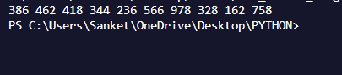

## Q.2) Write a python program to get the path and name of the file that is currently executing
import os
print("Current file path is",os.path.realpath(__file__))
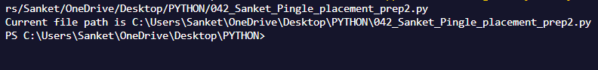

#Q3 pattern
n = 5
for i in range(1,n+1):
for j in range(i,0,-1):
print(j,end="")
for k in range(2,i+1):
print(k,end="")
print()
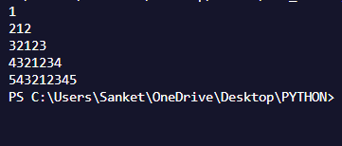

##04 Write a code to accept a number & print its digits in words .
dict = {0:"Zero",1:"One",2:"Two",3:"Three",4:"Four",5:"Five",6:"Six",7:"Seven",8:"Eight",9:"Nine" }
num = int(input("Enter a number: "))
for digit in str(num):
print(dict[int(digit)],end=" ")

