INTRODUCTION
Problem Statement:

TEAM ID | LTVIP2026TMIDS69886
PROJECT NAME | Automated car catalog system for enhanced showroom management

Car showrooms and dealerships often face challenges in managing and streamlining their catalog of cars, including various models and categories. The manual processes involved in handling customer requests, approvals, and task assignments can lead to inefficiencies, delays, and potential errors. This can negatively impact customer satisfaction and operational efficiency User story:
As a showroom manager I want to automata system to handle customer request for different car models in Mahindra catalogue so that can ensure timely approval efficient task assignment and better customer communication without manual intervention Project objective:
To develop a based automation system that streamline the request process for a car model in the Mahindra catalogue.. the system will automatically approval work flow task assignment and notification there by and enhancing operational efficiency.
Challenges:

This faced during the "Without ServiceNow" phase of implementing an Automated Car Catalog System for enhanced showroom management:

- Manual Data Entry and Errors o Without automation tools like ServiceNow, catalog data (vehicle details, specs, images) must be entered manually, increasing the risk of human errors and inconsistencies.
- Lack of Centralized Data Access o Showroom staff may struggle with scattered information across spreadsheets or isolated systems, making real-time access to up-to-date car inventory difficult.
- Poor Workflow and Communication o Without integrated workflow management, coordination between sales, inventory, and procurement teams can be inefficient, leading to delays and miscommunication.
- Limited Reporting and Analytics o Generating insights (like popular models, inventory turnover, or customer interest trends) becomes time-consuming and less reliable without automated dashboards.
- Inadequate Tracking and Updates o Vehicle availability, test drive scheduling, and delivery status updates are harder to track, affecting customer service quality and operational visibility.

Solution requirements

Functional requirements

Flowing are the functional requirements

Fr. No | Functional requirements | Sub-functional requirements
Fr-1 | Service catalog | Create catalog  Create categories
Fr-2 | User creation | Create a user
Fr-3 | Role creation | Create role
Fr-4 | Group creation | Create group
Fr-5 | Table creation | Creat a table
Fr-6 | Workflow | Workflow assignment to mahendra Service catalog
F-7 | Service portal | Searching created catalog are available in  Service portal
Fr-8 | Result | Chack result
Non-functional requirements

Following are the non-functional requirements

Fr. No | Non functional requirements | Description
Nfr-1 | Usability | As described previously) How easy and intuitive the platform is for users to interact with.
Nfr-2 | Security | Measures to protect data, prevent unauthorized access, and ensure compliance (e.g., encryption, access controls).
Nfr-3 | Reliability | How consistently the system performs as  expected, without failures or errors.
Nfr-4 | Performance | How fast the system responds (e.g., page load times, response time for queries).
Nfr-5 | Availability | The percentage of time the system is operational and accessible (e.g., uptime, disaster recovery).
Nfr-6 | Scalability | The ability of the system to handle increasing numbers of users, data, or transactions without degradation

Data flow diagram


Service

Catalog

Role

Creation

User

Creation

Group

Creation

Work

Flow

Service

Portal

Result

Technology stack

Architecture of service now

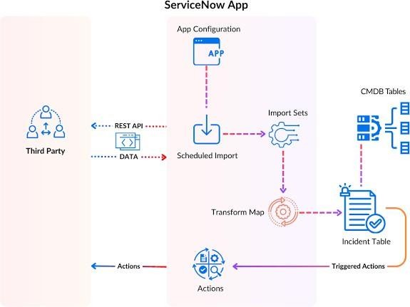

ServiceNow Architecture Overview

1. Third Party (Left side)

External systems or applications (e.g., monitoring tools, databases, CMDBs) are referred to as "Third Party".
These systems send data to ServiceNow through REST APIs.

2. REST API & DATA

The third-party system communicates with ServiceNow using REST APIs.

Data is pushed or pulled via APIs and is then passed to the next processing stage in ServiceNow.

3. Scheduled Import

The incoming data is managed using Scheduled Import jobs.

These jobs are configured in the ServiceNow App Configuration and determine when and how data should be imported.

4. Import Sets

Once data reaches ServiceNow, it goes into Import Sets, which act as staging tables to temporarily hold the data.

5. Transform Map

Transform Maps define how data in the Import Sets should be mapped to the target tables.

It transforms and processes raw input data to align with the structure of target tables (like Incident or CMDB tables).

6. Target Tables

These are the final destinations for processed data:

CMDB Tables (Configuration Management Database): Used for storing configuration items and their relationships.
Incident Table: For storing incident records.
Other relevant business-specific tables.

7. Triggered Actions

Once data reaches these tables, Triggered Actions can take place.

These actions might include workflows, notifications, or integrations with other ServiceNow modules.

Project design

Proposed solution templet

Project team shall fill the following in formation in the solution template

S. No | Parameter | Description
1 | Problem statement (problem to be solved) | An automated car catalog system in ServiceNow to streamline showroom management through real-time inventory updates and enhanced operational efficiency
2 | Idea/description | An automated car catalog system in ServiceNow to streamline showroom management through real-time inventory updates and efficient data handling.
3 | Novelty/uniqueness | A unique integration of automated car cataloging with ServiceNow to enable real-time, intelligent showroom management and seamless service operations.
4 | Social impact/customer satisfaction | Enhancing showroom management with an automated car catalog system in ServiceNow improves customer satisfaction through faster service and accurate information, while promoting sustainable, tech-driven operations
5 | Business model(revenue model) | A subscription-based SaaS model offering automated car catalog and inventory management through ServiceNow to optimize showroom operations and customer experience.
6 | Scalability of the solution | The solution is highly scalable, allowing seamless integration of multiple showrooms and car models across regions within the ServiceNow platform.
Automated car catalog system for enhanced showroom management

What is catalog system

A catalog system in ServiceNow is a feature that allows users to request IT or business services through a structured and user-friendly interface. It organizes services into categories, making it easy for users to find and request items like software access, hardware, or support. Each request triggers workflows for approval and fulfillment, streamlining service delivery.

Types:

- IT Service Catalog – Offers IT services like password reset, software install. o Business Service Catalog – Provides HR, finance, and other non-IT services. o Technical Service Catalog – Contains backend services used by IT staff. o Hardware Catalog – Lists physical assets like laptops, monitors, phones. o Software Catalog – Offers software products and licenses for request.
- Facility Catalog – Requests related to office space, maintenance, or equipment.

Milestone 1: Service catalog Purpose:
- Streamlines vehicle listing and updates in real-time. o Simplifies car request and reservation workflows. o Enables role-based access for showroom staff.
- Improves tracking of vehicle availability and status. o Automates approvals and inventory management.
Uses:

- Streamlined Car Inventory Requests – Allows staff to request vehicle listings or updates with predefined forms.
- Automated Vehicle Onboarding – Simplifies adding new car models to the digital catalog through workflow automation.
- Real-Time Status Updates – Enables tracking of vehicle availability, maintenance, and delivery schedules.
- Role-Based Access – Controls who can view or modify catalog details, ensuring data integrity.
- Service Request Analytics – Provides insights into car-related service trends and showroom demands.

Activity 1: Create catalog

- Open service now.

- Click on All >> search for Maintain Catalog.

- Click on Maintain Catalog under Catalog Definition.

- After opening Maintain Catalog Click on new.

- Give Catalog Name as “Mahendra ”.

- Application should be Global.

- Give description as it is a car showroom.

- Click on Submit.
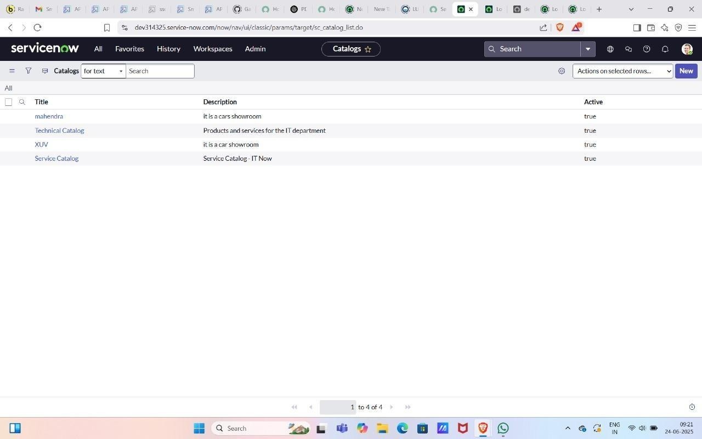

Activity 2: Create categories

  - After submitting you can see the catalog Mahindra in the list.
  - Open Mahendra Catalog Scroll down.
  - Click Categories And Click on New.
  - Give Title as Sudden.
  - Search and add catalog as Mahendra.
  - Click on submit.
  - Create two more categories as XUV and Sports.
  - Click on Catalog Items and Click on new.
  - . Give it a name as polo.
  - Select catalog as Mahendra.
  - Select category as Sudden.
  - short description as Volkswagen Polo - Compact Hatchback with Superior Comfort and Efficiency.
  - Give Description The Volkswagen Polo is a stylish and compact hatchback known for its agile performance, modern design, and premium features. Equipped with a 1.0-liter TSI engine, the Polo offers an impressive balance of power and fuel efficiency, making it an ideal choice for urban driving and longer journeys alike. This model includes advanced safety features, a touchscreen infotainment system, and spacious seating, ensuring comfort and convenience for all passengers. The Polo stands out with its sporty look, LED headlights, and alloy wheels, reflecting Volkswagen’s commitment to quality and design.
  - Click on Picture and add image.

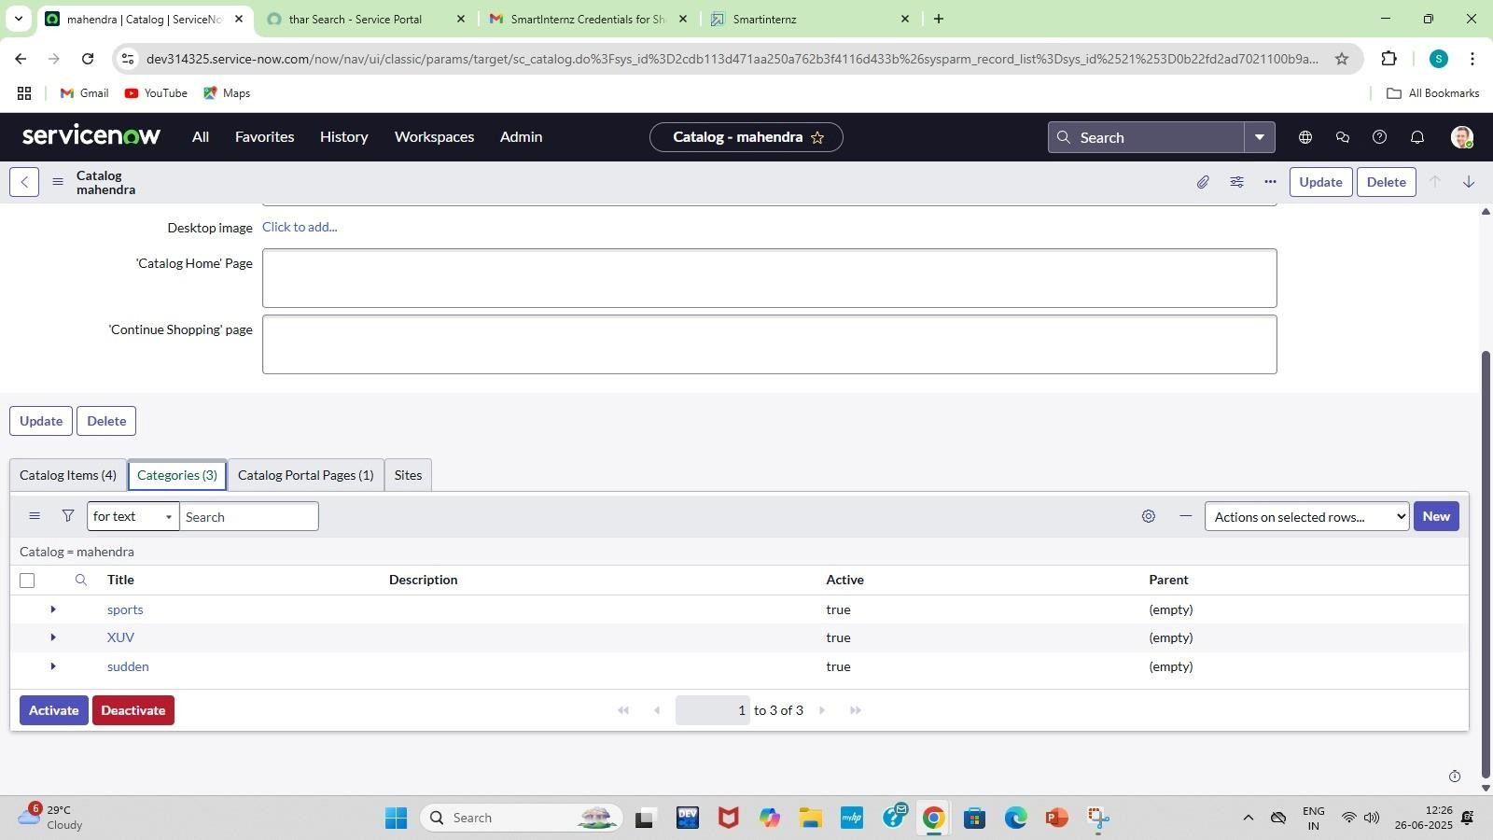

Milestone 2: User creation

Purpose:

- Enable seamless addition and management of car inventory in the showroom. o Provide personalized access to car catalog data for sales and service staff. o Streamline user roles and permissions for catalog interaction and updates. o Facilitate efficient customer service through quick user-driven lookups.
- Support real-time updates and access to car features, pricing, and availability

Uses:
o showroom-specific permissions for accessing car catalog data. o Auto-link user profiles with relevant sales performance dashboards. o Enable personalized notifications for catalog updates or car arrivals.
- Control user access to test drive scheduling and booking features

- Open service now.

- Click on All >> search for Users.

- Click on Users>> under System Security.

- Click on new, give user ID as 01 and name as sales person and add the role emp1.
- Save and Submit.

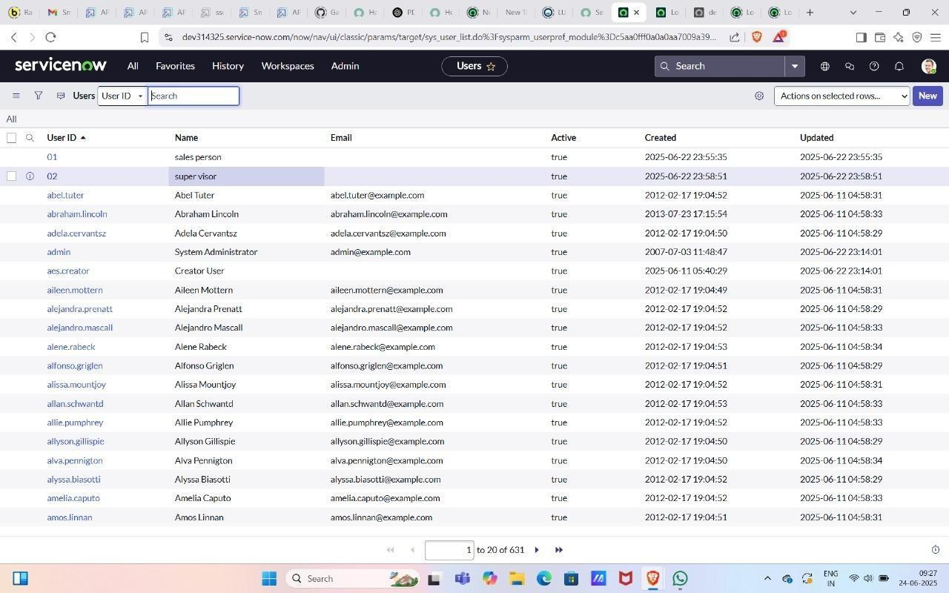

Milestone3: Role creation Purpose:
- Streamline inventory control by assigning catalog management roles. o Enhance customer service through dedicated sales and inquiry roles. o Ensure data accuracy with roles for catalog content validation. o Enable secure access via role-based permission settings.
- Facilitate workflow automation through role-specific task assignments.

Uses:

- Inventory Admin Role – Maintains car stock records and availability updates. o Service Technician Role – Logs maintenance schedules and service history. o Customer Service Role – Handles customer inquiries and booking processes. o System Admin Role – Configures catalog workflows and manages user permissions.

Steps

- Click on the Service now logo and click on all and search for roles.

- Click on Roles >>Under system security.

- Click on new and give the name as emp1.

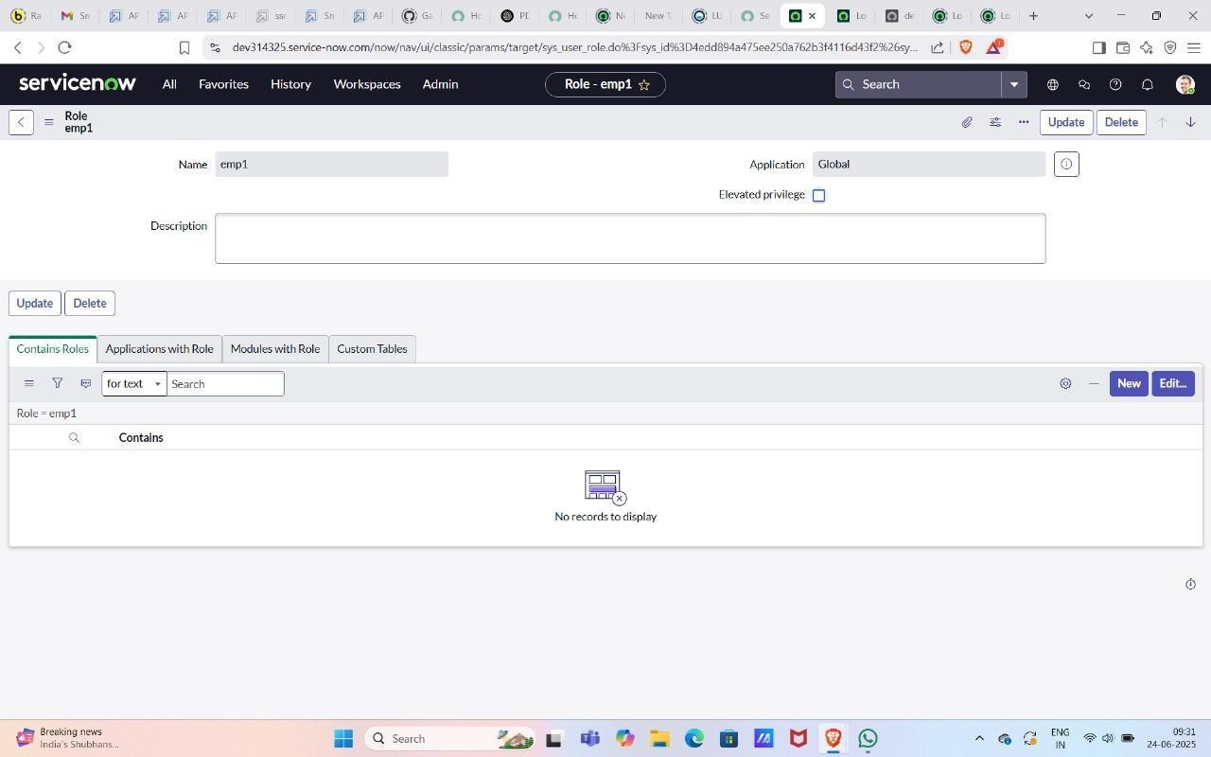

Milestone 4: Group creation Purpose:
- Centralize vehicle data for easy access and updates. o Streamline car inventory tracking and availability. o Improve coordination across sales and service teams. o Automate workflows for faster car assignment and display. o Enable real-time catalog updates and reporting in ServiceNow.

Uses:

- Streamlines vehicle inventory tracking with real-time updates. o Automates new car entries and categorization in the catalog.
- Enables quick search and filtering of cars by features or availability. o Simplifies task assignment for vehicle preparation and servicing.
- Provides dashboards for showroom managers to monitor car status.

Steps:

- Click on All>>Search for groups.

- Click on groups>>under Security System.

- Click on new and give the group's name as showroom.

- Give the group manager as Abraham Lincoln. And Submit.
- Add group members as Salesperson, Salesperson2 and 3.And update.



Milestone5: Table creation Purpose:
  - Centralize car inventory data for real-time access and updates. o Track vehicle specifications to assist in customer decision-making. o Manage showroom availability and vehicle status efficiently.
  - Enable automated workflows for test drives, bookings, and services o Generate analytics and reports for sales and performance monitoring.
Uses:

  - Organizes vehicle data into structured tables for easy access and tracking.
  - Enables dynamic filtering of cars by model, price, and features for quick customer queries.
  - Supports real-time inventory updates to reflect showroom stock accurately. o Facilitates seamless integration with service and sales workflows.
  - Improves reporting and analytics by storing historical sales and service records.

Activity1: Create a table
Steps
- click on All>>Search for Tables.

- Click on Tables>>under System definition.

- Click on the new give name as cars fulfilment.

- Give extended table as Task table.
- Save and submit.

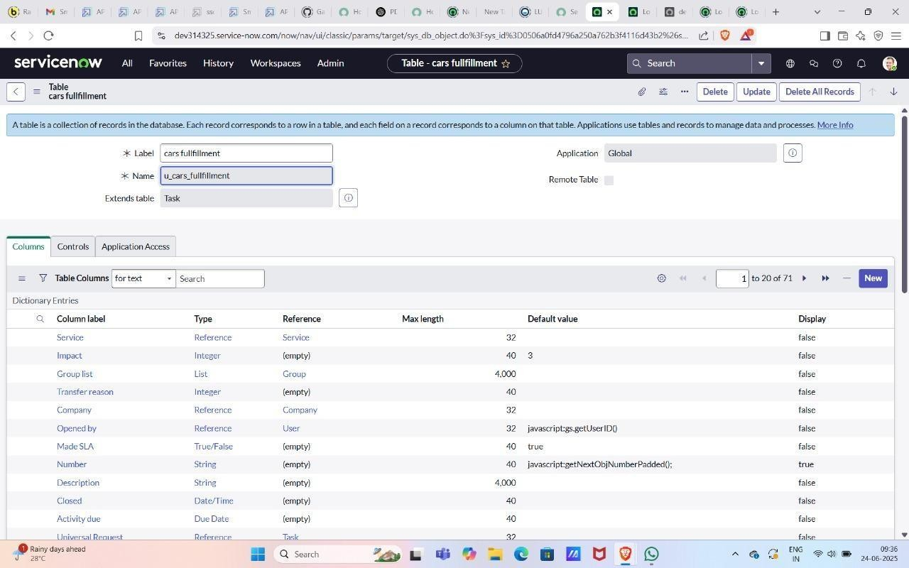

Milestone 6: Workflow

Purpose:

  - Centralizes car inventory data for real-time visibility. o Automates vehicle listing and update processes. o Improves customer inquiry handling with quick access to specs.
  - Integrates service scheduling and vehicle availability.
  - Generates reports for sales and stock performance insights.

Uses:

  - Auto-updates inventory – Syncs new car arrivals and availability in real-time. o Streamlines test drive scheduling – Automates customer booking and reminders. o Simplifies vehicle detail access – Centralizes specs, images, and pricing for sales teams. o Tracks customer interactions – Logs inquiries and preferences for follow-up.
  - Generates performance reports – Provides insights on popular models and sales trends.

Steps

  - Navigate to Homepage.
  - Click on all search Workflow Editor.
  - Click on New Workflow.
  - Under the name field search for Test Select that record.
  - After creating workflow you can see begin and end.
  - Drag the approval user from core and give name as sales.
  - Give the user as a sales person.
  - Drag the approval user from core and give name 2nd level.
  - Add a user as supervisor.
  - Drag create task from core and give name as car company
  - Give task type car fulfilment table and priority-1.
  - Give task values from values
  - Set values as car status Ready to Pickup.
  - tate Closed Complete and submit.
  - Drag the create task from core and give it name as car production.
  - Give task type car fulfilment table and priority-1.
  - Give task values from values
  - Set values as car status deployment failed.
  - State closed Incomplete.And Submit.
  - Drag Notification from core and give name as Booking Notification.
  - Add To user as Abraham Lincoln and group as Showroom.
  - Give the subject as car showroom and message
<html>
<body style="font-family: Arial, sans-serif;">
<!-- Background Logo Wrapper -->
<div style="background-image:
url('${C:\Users\saipr\OneDrive\Pictures\Screenshots\Screenshot 2024-10-28 125727.png}'); background-size: contain; background-repeat: no-repeat; background-position: center; padding:
20px; text-align: center;">
<!-- Background Logo Wrapper -->
<div style="background-image:
url('${C:\Users\saipr\OneDrive\Pictures\Screenshots\Screenshot 2024-10-28 125727.png}'); background-size: contain; background-repeat: no-repeat; background-position: center; padding: 20px; text-align: center;">

<!-- Overlay Content -->
<div style="background: rgba(255, 255, 255, 0.8); padding: 20px; border-radius: 8px;">
<h2 style="color: #333;">Car Request Notification</h2>
<p style="color: #555;">
Hello, your request for a car model has been submitted and approved.
</p>

-- Dynamic Fields -->
<p><strong>Requested Car:</strong> ${requested_for}</p>
<p><strong>Status:</strong> ${approval}</p>

<p style="color: #333;">Thank you for choosing Mahendra!</p>
</div>

</div>

</body>

</html>
- Submit.
- Drag the Notification and give the name as car reject.

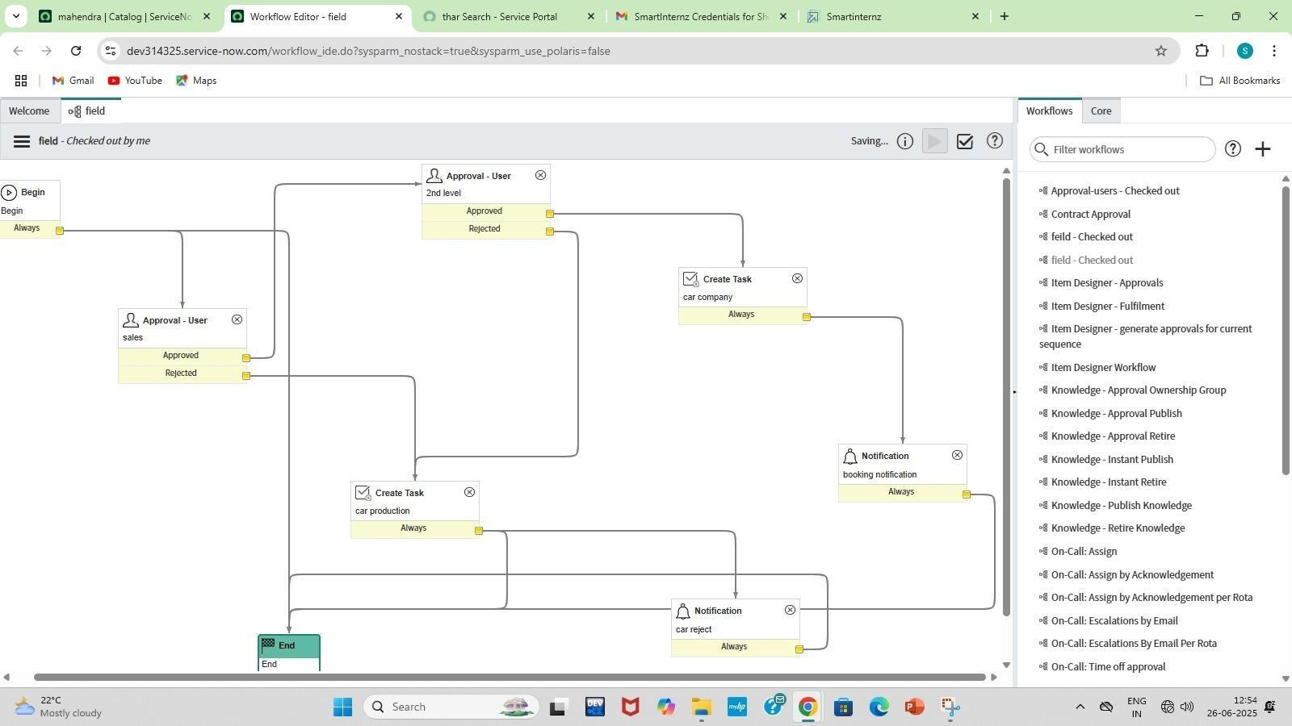
Milestone7: Service portal
Purpose:

  - Streamlines car inventory tracking and updates in real-time. o Enables quick access to detailed vehicle specifications for staff and customers. o Automates booking and test drive scheduling through the portal. o Improves customer experience with a self-service car catalog interface.
  - Reduces manual errors and enhances operational efficiency in showroom workflows.
Uses:

  - Real-time vehicle inventory updates for accurate showroom display. o Self-service car search and filter options for customers and staff.
  - Streamlined booking and test-drive scheduling directly via the portal. o Integrated maintenance history and service status for each vehicle.
  - Automated notifications and alerts for stock changes or promotions.

Steps

    - Check the cars are available in the service portal. And order it.

    - To open a service portal copy the url of your instance up to com/ and give sp press enter for example(https://dev266346.service-now.com/sp).
    - Search the catalog item which you are created.

    - Search for thar. And order it.

    - After ordering the car you get a request number and Delivery date.

    - Search for thar. And order it.

    - After ordering the car you get a request number and Delivery date.

Milestone8: Result Purpose:
  - Streamlines car inventory tracking and updates in real-time.
  - Enhances customer experience with quick vehicle information access.
  - Automates car model categorization and availability status.
  - Reduces manual data entry errors and improves efficiency.
  - Integrates service requests and vehicle management seamlessly.
Uses:

  - Faster vehicle lookup and inventory updates.
  - Streamlined sales and service workflows.
  - Improved customer experience through real-time data.
  - Reduced manual errors and data redundancy.
  - Enhanced reporting and decision-making capabilities.

After ordering the car request is approved you get a mail the order will be delivered. And Based on your order being approved or rejected you will receive a rejected mail.
Conclusion
The Car Catalog System project for a car showroom in ServiceNow successfully addresses the need for a streamlined, automated approach to managing car catalog items, customer requests, and approval workflows. By organizing car models into easily navigable categories and leveraging ServiceNow's powerful automation features, the system enhances operational efficiency, reduces manual intervention, and improves customer satisfaction.

FUNCTIONAL AND PERFORMANCE TESTING

Milestone: workflow

Purpose:
o Centralizes car inventory data for real-time visibility. o Automates vehicle listing and update processes. o Improves customer inquiry handling with quick access to specs. o Integrates service scheduling and vehicle availability.
- Generates reports for sales and stock performance insights.

Uses:
- Auto-updates inventory – Syncs new car arrivals and availability in real-time. o Streamlines test drive scheduling – Automates customer booking and reminders.
- Simplifies vehicle detail access – Centralizes specs, images, and pricing for sales teams.
- Tracks customer interactions – Logs inquiries and preferences for follow-up.
- Generates performance reports – Provides insights on popular models and sales trends.

Activity1: Workflow Assignment to Mahendra service Catalog.

- Navigate to Homepage.
- Click on all search Workflow Editor.
- Click on New Workflow.
- Under the name field search for Test Select that record.
- After creating workflow you can see begin and end.
- Drag the approval user from core and give name as sales.
- Give the user as a sales person.
- Drag the approval user from core and give name 2nd level.
- 9 .Add a user as supervisor.
- 10 Drag create task from core and give name as car company
- 11.Give task type car fulfilment table and priority-1.
- 12.Give task values from values
- 13.Set values as car status Ready to Pickup.
- 14.tate Closed Complete and submit.
- 15.Drag the create task from core and give it name as car production.
- 16Give task type car fulfilment table and priority-1.
- 18.Give task values from values
- Set values as car status deployment failed.
- State closed Incomplete.And Submit.
- 21.Drag Notification from core and give name as Booking Notification.
- Add To user as Abraham Lincoln and group as Showroom.
- Give the subject as car showroom and message
<html>
<body style="font-family: Arial, sans-serif;">
<!-- Background Logo Wrapper -->

<div style="background-image:
url('${C:\Users\saipr\OneDrive\Pictures\Screenshots\Screenshot 2024-10-28 125727.png}'); background-size: contain; background-repeat: no-repeat; background-position: center; padding:
20px; text-align: center;">
<!-- Background Logo Wrapper -->
<div style="background-image:
url('${C:\Users\saipr\OneDrive\Pictures\Screenshots\Screenshot 2024-10-28 125727.png}'); background-size: contain; background-repeat: no-repeat; background-position: center; padding: 20px; text-align: center;">

Output results


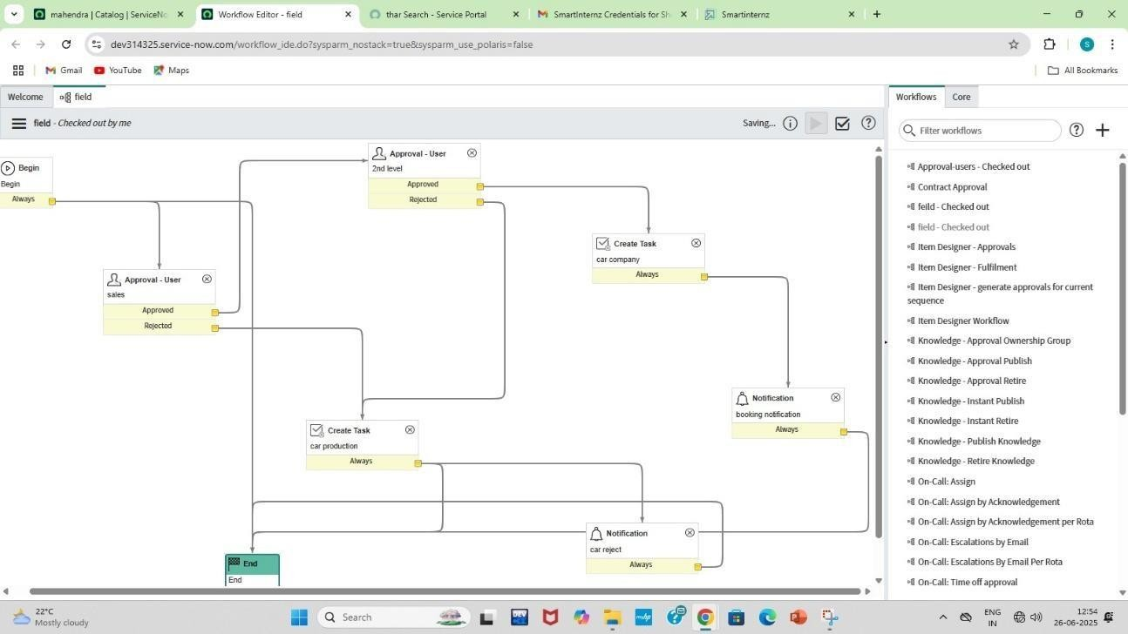



Advantages &Disadvantages

Advantages of Service now

- Workflow Automation: Service Now excels at automating a wide range of business processes across IT, HR, customer service, and more.
- Single System of Record: It provides a unified platform to manage various departmental operations, breaking down silos and offering a holistic view of workflows, data, and services.

- Scalability and Flexibility: Being a cloud-native platform, ServiceNow can easily scale to meet the needs of growing organizations, from small businesses to large enterprises
- Enhanced User Experience (Self-Service): ServiceNow offers intuitive self-service portals and mobile apps, empowering users to find answers, request services, and track progress independently.
- Data-Driven Insights and Reporting: With built-in analytics and reporting tools, Service Now provides valuable insights into operations, performance, and trends, enabling data- driven decision-making and continuous improvement.
- Integration Capabilities: The platform boasts robust integration capabilities (e.g., through Integration Hub) to connect with other existing systems and applications, creating a seamless flow of information across the enterprise.
- Improved Collaboration: By centralizing information and workflows, Service Now facilitates better communication and collaboration among different teams and departments.
- Security and Compliance: Service Now provides a secure cloud environment with features like role-based access control, multi-factor authentication, and real-time compliance tracking to protect sensitive data.

Disadvantages of ServiceNow:

- Cost: ServiceNow is a premium enterprise solution, and its licensing costs can be substantial, especially for smaller or mid-sized organizations. Implementation and ongoing maintenance also contribute to the overall expense.
- Complexity and Learning Curve: While powerful, ServiceNow can be complex to set up, configure, and manage. It requires specialized skills and dedicated administrators or partners to fully leverage its capabilities. The initial learning curve for new users can also be steep.
- Extensive Customization Challenges: While customization is a strength, over- customization or poorly planned customizations can lead to technical debt.
- Implementation Time and Effort: A successful ServiceNow implementation often requires significant time, planning, and resources, including organizational change management to ensure user adoption.

- Vendor Lock-in: Due to the deep integration and reliance on the ServiceNow ecosystem, organizations might experience a degree of vendor lock-in, making it difficult to switch to other platforms in the future.
- Performance Issues (if not optimized): If not properly configured or if there are excessive custom scripts, the platform can experience performance degradation, leading to slower response times.
- Limited NLU/AI Maturity (in some areas): While ServiceNow incorporates AI, particularly in Virtual Agent, some users find its Natural Language Understanding (NLU) capabilities can be limited for highly.
- Reporting and Analytics Depth: While it offers good reporting, some organizations with very complex analytical

conclusion

The core purpose of ServiceNow is to make work, work better for people and businesses. It achieves this by transforming manual, siloed processes into intelligent, connected digital workflows across the entire enterprise. Primarily, it aims to automate and optimize service delivery, whether in IT, HR, customer service, or other operational functions. By providing a unified cloud platform with a common data model, ServiceNow breaks down departmental barriers, enabling seamless information flow and collaboration. ServiceNow is a cloud-based platform designed to streamline and automate IT service management (ITSM) and enterprise workflows. Its purpose is to enhance efficiency, visibility, and user experience across departments like IT, HR, and Customer Service. Looking ahead, the future scope of Service now

