DEPLOYING MICROSERVICES USING DOCKER COMPOSE

Prepared in the partial fulfillment of the Summer Internship Program on AWS

AT


Under the guidance of

Mrs. Sumana Bethala, APSSDC Mr. Anil Kumar Varanasi, APSSDC Submitted by
SWATHI ROKKALA, 23221A05A2, BVC ENGINEERING COLLEGE, (Batch -1)

SHERU LALITHA SREE, 23221A05B1, BVC ENGINEERING COLLEGE, (Batch -1)

KUNCHANAPALLI JASHUVA, 23221A0493, BVC ENGINEERING COLLEGE, (Batch -1)

HIMA PRAVEENA PULLETIKURTHI, 23221A0594, BVC ENGINEERING COLLEGE, (Batch -1)

MAGAPU SANKEERTHANA, 23221A0572, BVC ENGINEERING COLLEGE, (Batch -1)

ACKNOWLEDGEMENT

I would like to express my heartfelt gratitude to all those who have contributed to the successful completion of my summer internship project at Andhra Pradesh Skill Development Corporation (APSSDC). This opportunity has been an enriching and transformative experience for me, and I am truly thankful for the support, guidance, and encouragement I have received along the way.
First and foremost, I extend my sincere regards to Mrs Sumana Bethala and Mr Anil Kumar Varanasi, my supervisors and mentors, for providing me with valuable insights, constant guidance, and unwavering support throughout the duration of the internship. Their expertise and encouragement have been instrumental in shaping the direction of this project.
I would like to thank the entire team at Andhra Pradesh Skill Development Corporation (APSSDC) for fostering a collaborative and innovative environment. The camaraderie, knowledge sharing, and feedback I received from my colleagues significantly contributed to the development and success of this project.
In conclusion, I am honoured to have been a part of this internship program, and I look forward to leveraging the skills and knowledge gained to contribute positively to future endeavours.
Thank you. Sincerely,
Swathi Rokkala, 23221A05A2, swathirokkala99@gmail.com
Sheru Lalitha Sree, 23221A05B1, lalithaseru@gmail.com
Kunchanapalli Jashuva, 23221A0493, jashuvakunchanapalli7@gmail.com
Hima Praveena Pulletikurthi, 23221A0594, himapraveenapulletikurthi@gmail.com
Magapu Sankeerthana, 23221A0572, keerthi3515@gmail.com

ABSTRACT

This presentation provides a practical demonstration of containerizing and orchestrating a Java Spring Boot microservices architecture using Docker and Docker Compose. Containerization ensures consistent deployments, strict dependency isolation, and independent scalability across varied environments. The tutorial centers on a financial application comprising two interdependent microservices built with Java 17 and Spring Boot 3: a Ledger Service for maintaining core account balances, and a Transfer Service for processing money transfers via synchronous communication with the ledger.

The technical implementation begins with crafting individual Docker files for each service. These configurations define the build process, package the source code, and expose necessary network ports. To enable inter-container communication, the tutorial replaces hardcoded localhost references with dynamic environment variables, leveraging Docker’s internal network resolution to connect the services.

The entire deployment lifecycle is seamlessly automated through a centralized Docker Compose file. This orchestrates the simultaneous building of both containers, maps internal ports to the host machine, and injects the required network routing parameters.

Following deployment, the integrated system is thoroughly validated using Postman and Swagger UI. End-to-end API testing confirms the successful creation of accounts and execution of batch transactions across the newly containerized network. Finally, a failure-mode scenario is simulated by intentionally stopping the Ledger Service container. Subsequent transfer requests fail predictably with a clear error message, illustrating the tight architectural dependencies and demonstrating how Docker handles real-time operational status. This guide offers a comprehensive, actionable blueprint for developers deploying container-driven microservices.

TABLE OF CONTENTS

S.No Content Pg.No
- Introduction and Solution Overview 5
- Benefits of Dockerizing Microservices 6
- Containerizing the Services 9
- Orchestrating with Docker Compose 11
- Deployment and Execution 23
- System Validation and API Testing 26
- Failure-Mode Testing 29
- Conclusion…………………………………………………………………………………..

INTRODUCTION

The foundation of any robust containerized deployment begins with a comprehensive understanding of the underlying application architecture. In this demonstration, the solution is designed around a simulated financial application engineered to process and manage banking transactions. To highlight the complexities and benefits of container orchestration, the architecture is deliberately divided into two distinct, yet highly interdependent microservices: the Ledger Service and the Transfer Service. Both of these components are developed using a modern technology stack—specifically leveraging Java 17 and the Spring Boot 3 framework—and they interact with one another exclusively through standard REST APIs.
Architecture of the Financial Application:
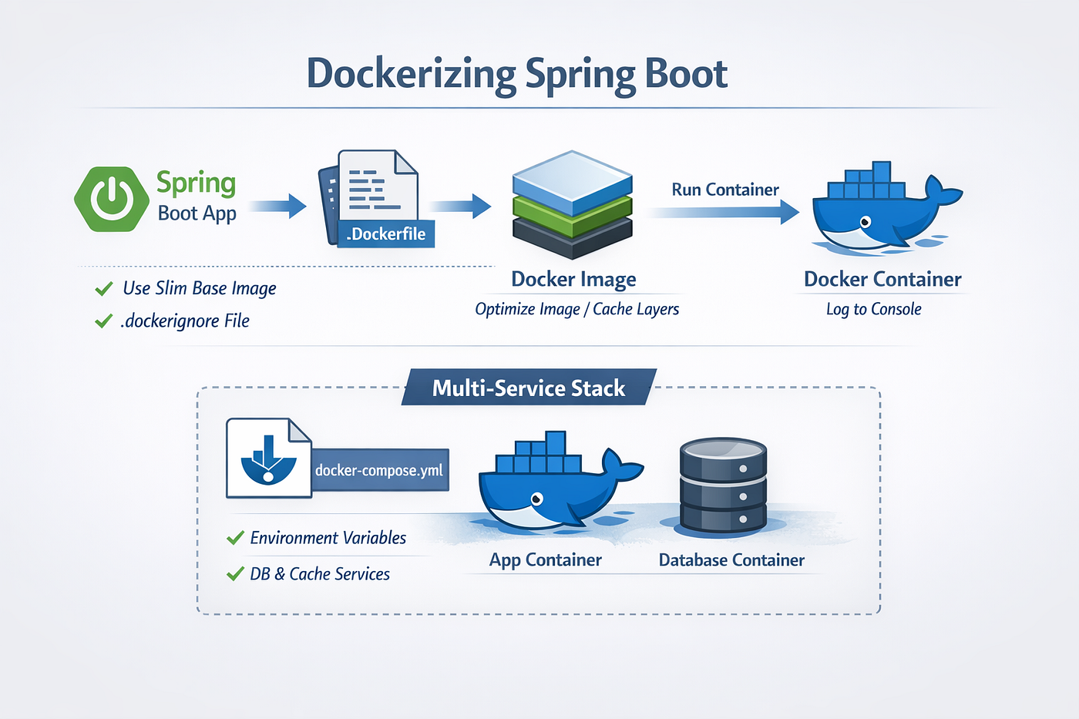

At the core of the application’s data management is the Ledger Service. This service acts as the central system of record for the financial ecosystem. Its primary responsibilities include maintaining accurate account balances, generating new accounts with initial funding, and persistently logging all transactional data. By isolating these critical data-keeping functions into a dedicated service, the architecture ensures that the state of user accounts remains secure and centralized. In a standard local development environment, the Ledger Service is configured to listen for internal network requests on port 8081.
Working in tandem with the ledger is the Transfer Service. This service serves as the operational engine for moving funds, specifically designed to handle the business logic required to execute batch money transfers between different users. It acts as the front-facing component of the application, exposed to the end-user on port 8080.
Crucially, the Transfer Service is completely dependent on the Ledger Service to finalize any operations. It cannot create accounts or natively verify balances on its own; instead, it must establish a synchronous connection to the Ledger Service to write the transfer records. If the Ledger Service is unavailable, the Transfer Service cannot fulfill its primary function. This strict separation of concerns highlights a fundamental principle of microservices: by decoupling transaction processing from data persistence, the system becomes highly modular. Because both services operate in a stateless manner regarding incoming requests, they can be scaled entirely independently based on real-time traffic demands.

2.Benefits of Dockerizing Microservices

Transitioning from a traditional monolithic application to a distributed microservices architecture introduces a host of operational complexities. When managing multiple interconnected services, coordinating their individual deployment environments, underlying dependencies, and scaling requirements can quickly become a logistical challenge. This is exactly where Docker steps in as a transformative tool. By wrapping each microservice in its own lightweight, portable container, Docker fundamentally solves these operational bottlenecks. In this section, we will explore the core advantages of adopting a containerized approach, focusing on how it streamlines development workflows, fortifies system resilience, and optimizes resource management.
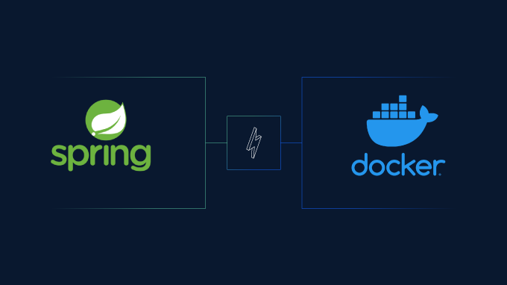

2.1 Consistency Across Environments
One of the most notoriously frustrating phrases in software development is, "It works on my machine." This friction occurs because a developer's local workstation often differs significantly from testing, staging, or production servers. Docker eliminates this discrepancy entirely through the principle of environmental consistency. When you dockerize a microservice, you are not just packaging the application’s source code; you are bundling the exact version of the operating system, the runtime environment (such as Java 17), the required libraries, and all system-level configurations into a single, immutable image. Consequently, whether the container is executed on a developer's local laptop, a centralized QA server, or a high-availability cloud cluster, the underlying environment remains mathematically identical. This guaranteed consistency drastically reduces deployment failures, accelerates the debugging process, and ensures that the software behaves predictably no matter where it is deployed.

2.2 Dependency Isolation
In a microservices ecosystem, it is common for different services to require different versions of the same underlying software. For instance, a legacy service might rely on Java 8, while a newly developed component, like our Transfer Service, requires Java 17. Running these directly on the same host machine would cause severe dependency conflicts. Docker solves this by providing strict structural isolation. Each container operates within its own enclosed file system and network space. The dependencies of the Ledger Service are completely walled off from the dependencies of the Transfer Service. This isolation ensures that upgrading or modifying the libraries of one microservice poses zero risk of breaking another. Furthermore, this encapsulation makes the system inherently more secure; if a single microservice is compromised, the isolation layer makes it exceedingly difficult for the vulnerability to spread to the host system or neighboring containers.

2.3 Independent Scalability
Traditional monolithic applications force you to scale the entire system as a single unit, even if only one specific function is experiencing high traffic. This results in a massive waste of computing resources. Dockerizing microservices introduces the ability to scale independently. Because both our Ledger and Transfer services are stateless—meaning they do not store user session data locally—they can be replicated instantly. If the Transfer Service experiences a sudden surge in transaction requests during a peak financial period, you can spin up multiple additional instances of just the Transfer container to handle the load, without needing to touch the Ledger Service. Once the peak period ends, these extra containers can be gracefully spun down. This granular control over resource allocation means you only use the exact compute power you need, maximizing both efficiency and cost-effectiveness.

2.4 Portability and Cloud Agnosticism
The final major advantage of this architecture is absolute portability. Because a Docker container encapsulates everything it needs to run, it is completely agnostic to the underlying infrastructure. A containerized microservice does not care if it is being hosted on an on-premises physical server, a virtual machine, or a managed cloud platform like AWS, Google Cloud, or Azure. This portability is crucial for modern deployment practices. It prevents vendor lock-in, allowing organizations to migrate their workloads seamlessly between different cloud providers to take advantage of better pricing or specific geographical availability. Furthermore, it enables incredibly flexible deployment strategies, allowing teams to seamlessly mirror complex production architectures right on their local machines.

3.Containerizing the Services (Dockerfile Configuration)

With the architectural benefits established, the next practical step in our deployment journey is containerizing each individual Spring Boot application. In Docker, this is achieved by creating a Dockerfile—a sequential script of instructions that acts as a blueprint. It tells the Docker engine exactly how to assemble a self-contained, runnable image of your application. Because our microservices are structurally isolated, each requires its own dedicated Dockerfile located within its respective project directory.

3.1 Creating the Ledger Service Dockerfile
The Ledger Service serves as our foundational data layer. Its Dockerfile is relatively straightforward, focusing purely on securely building and exposing the application to the network.
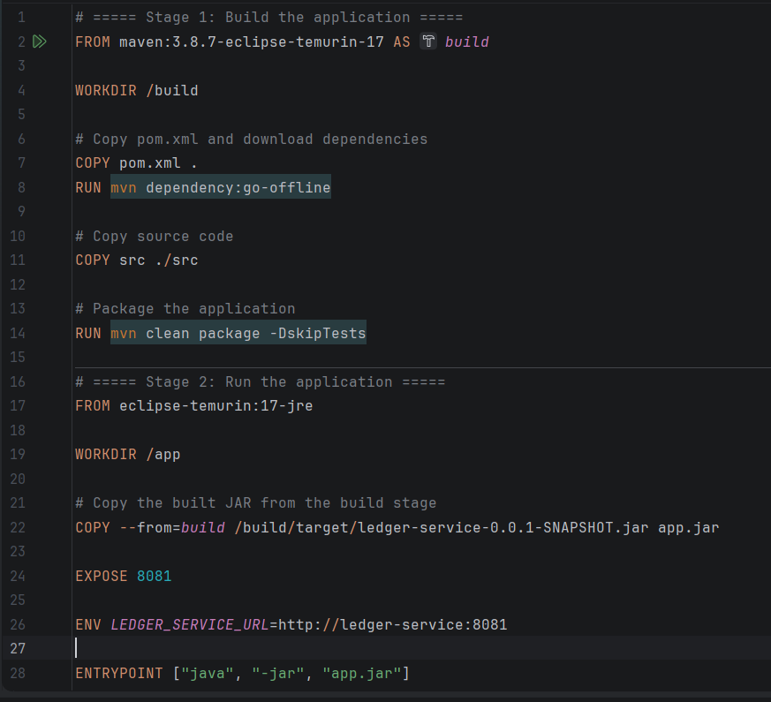
- Defining the Base Image: The configuration begins by pulling a compatible Java 17 base image, ensuring the container's runtime environment perfectly matches the Spring Boot 3 development environment.
- Copying Assets: Next, it instructs Docker to copy the project dependencies (like the pom.xml) and the application's source code from the host machine into the container's isolated file system.
- Building the Application: It triggers the build command to compile the code, run necessary checks, and package the Spring Boot application into a standalone, executable JAR file.

- Exposing Ports: Finally, it explicitly exposes port 8081 to allow incoming network traffic and defines the entry point command (e.g., java -jar) to start the application when the container boots.

3.2 Creating the Transfer Service Dockerfile
The Transfer Service requires a nearly identical build process, but it introduces a critical networking concept. Because it acts as the operational engine, it cannot function without sending data to the Ledger Service.
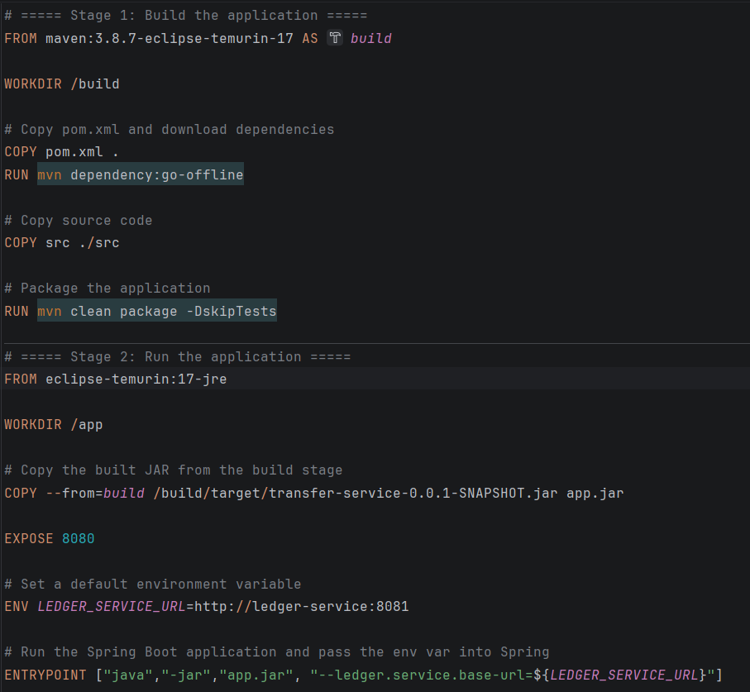
- Standard Build Steps: Just like the Ledger Service, this Dockerfile pulls the Java 17 environment, copies the necessary source files, packages the application, and sets the startup command. It then exposes port 8080, which acts as the front-facing API for our end-users.
- Environment Variable Integration: The crucial difference lies in how it handles inter-service connections. In a standard local setup, the Transfer Service might look for the Ledger Service at localhost:8081. However, inside a Docker ecosystem, localhost refers only to the inside of that specific container.
- Dynamic Service Resolution: To solve this, the application is configured to accept network parameters via environment variables. This setup ensures that when we orchestrate the containers later, we can dynamically inject the Ledger Service's internal network address (e.g., ledger-service:8081) straight into the Transfer Service, establishing a seamless connection without hardcoding static IP addresses.

4. Orchestrating with Docker Compose
While individual Dockerfiles successfully package each microservice, managing them separately requires executing multiple manual terminal commands and configuring complex network bridges by hand. To streamline this process, we utilize Docker Compose—an orchestration tool designed to define, run, and manage multi-container applications simultaneously from a single, centralized configuration file.

4.1 Configuring the docker-compose.yml File
At the root directory of the project, we introduce the docker-compose.yml file. This YAML file acts as the master blueprint for our entire architectural stack. Within it, we define our two core components under the services block: the ledger-service and the transfer-service. For each service, the configuration specifies the build context, pointing Docker exactly to the directory path where each respective Dockerfile resides. Furthermore, the Compose file dictates the port mapping, binding the internal container ports to our host machine. By mapping port 8081 for the ledger and 8080 for the transfer API, the microservices become readily accessible from our local browser or external testing tools.
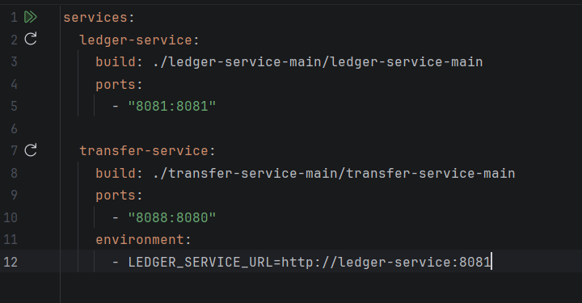

4.2 Handling Inter-Container Communication
By default, when applications are spun up using a Docker Compose file, they are automatically placed onto a shared internal bridge network. This built-in DNS resolution is a powerful feature because it allows containers to discover and communicate with one another using their defined service names rather than relying on brittle, static IP addresses. Inside this isolated network environment, the Ledger Service is immediately recognizable to neighboring containers simply as ledger-service.

4.3 Resolving Network Dependencies (Environment Variables)
This internal networking capability elegantly resolves the dependency challenge highlighted during the containerization phase. Because the Transfer Service cannot operate without the Ledger Service, it must be provided with the exact internal routing address. Within the docker-compose.yml file, under the transfer-service setup, we declare an environment block. Here, we inject the dynamic connection string directly into the container—passing the Ledger Service URL as http://ledger-service:8081. When Docker Compose boots the Transfer Service, it reads this injected environment variable, seamlessly overriding any local development defaults. This guarantees flawless, synchronous API communication between the two microservices the moment the environment goes live.

5. Deployment and Execution

With the individual Dockerfile instructions finalized and the centralized docker-compose.yml file configured to handle network routing, the architecture is completely prepared. The next phase transitions the application from static source code into an active, containerized runtime environment. This deployment process highlights the efficiency of Docker Compose, condensing what would traditionally be a complex sequence of build and launch commands into a single, automated workflow.

5.1 Building and Running Containers via IntelliJ/CLI
To initiate the deployment process, a developer must trigger the Compose file from the root directory of the project. If utilizing a traditional Command Line Interface (CLI), this is achieved by simply navigating to the correct folder and executing the docker-compose up command.
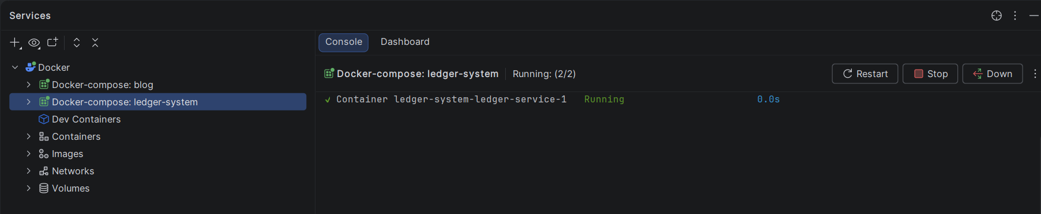
However, the tutorial highlights a more integrated approach. By leveraging a modern Integrated Development Environment (IDE) like IntelliJ IDEA, developers can utilize visual tools to execute the Docker Compose file directly from the editor interface. Clicking the execute button within the IDE seamlessly runs the underlying docker-compose up command. Once triggered, Docker reads the YAML configuration, pulls the necessary Java 17 base images, sequentially builds the individual Ledger and Transfer snapshots as defined in their Dockerfiles, establishes the internal bridge network, and boots the applications. While the initial build takes a few moments to download dependencies and compile the source code, subsequent launches are significantly faster due to Docker’s intelligent caching mechanisms.

5.2 Verifying Container Status in Docker Desktop
After the deployment script concludes, it is critical to verify the operational health of the newly spun-up environment. Rather than relying solely on terminal logs, the tutorial demonstrates this verification process using Docker Desktop's graphical user interface.
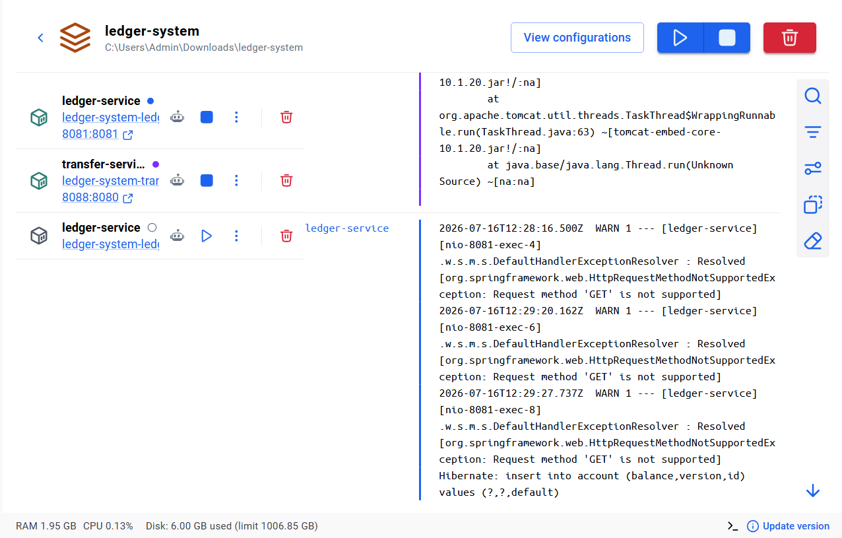
By opening Docker Desktop and navigating to the active containers dashboard, the developer is presented with a clear visual hierarchy of the running architecture. The microservices are grouped together under a single application stack. Expanding this group provides granular visibility into the environment: both the Ledger Service and the Transfer Service are visible, alongside critical metadata such as their uptime (e.g., "created 1 minute ago") and their exact mapped ports (8081 and 8080). Confirming that both containers display an active, running status visually validates that the automated deployment was successful, proving that the services are fully operational and ready to process incoming API requests.

6. System Validation and API Testing

Once the multi-container environment is live, the next phase is validating the integration to ensure the microservices communicate correctly. Because they expose standard REST endpoints, validation is performed externally using Postman and Swagger UI. This testing phase systematically verifies that network routing, data persistence, and service interdependencies function exactly as designed.
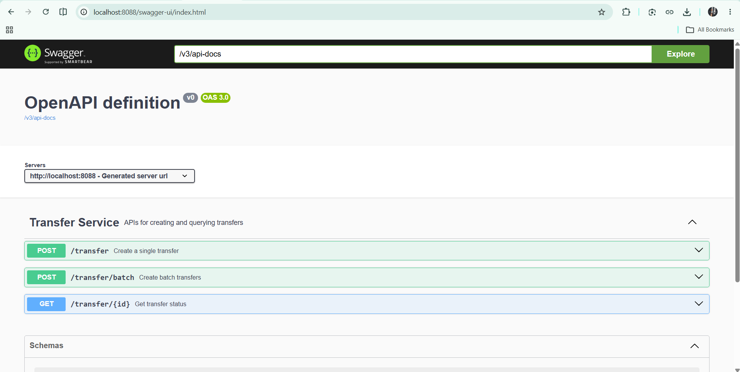

6.1 Service Health Checks using Postman
The validation process begins with a baseline health check to ensure the containers are fully initialized. Using Postman, a GET request is dispatched to the Ledger Service's dedicated health endpoint at http://localhost:8081/ledger/healthy. A successful initialization returns a standard HTTP 200 OK status code along with a response payload stating "up". This confirms that the Ledger container is stable and listening for traffic on its designated port.

6.2 Account Creation and Initial Balances
With the Ledger Service active, the instructor establishes the initial application state by seeding data. Because the Transfer Service operates statelessly and cannot create accounts natively, all data provisioning happens directly through the system of record. Using Postman, POST requests are sent to the Ledger Service's account endpoint (http://localhost:8081/account). Three distinct test accounts are successfully generated with initial balances of 3,000, 4,000, and 6,000 units respectively, with the service returning unique identifiers for each.
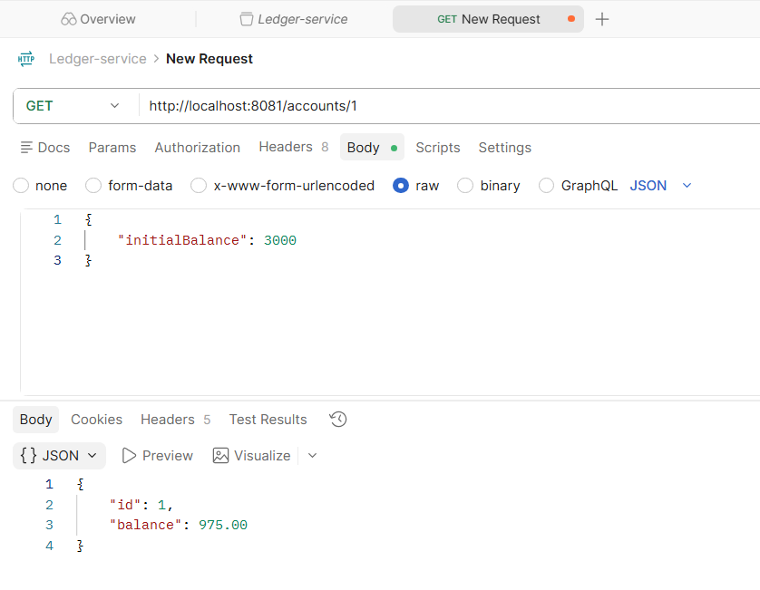

6.3 Executing Batch Transfers via Swagger UI
The final validation step tests the inter-container communication bridge. The instructor accesses the Transfer Service’s documentation via Swagger UI at http://localhost:8080 and structures a batch transaction payload to shift funds sequentially among the three accounts. Upon execution, the Transfer Service processes the request and leverages Docker’s internal DNS network to dynamically forward the records to http://ledger-service:8081.
The Swagger UI dashboard displays a status of "success" and a message of "transfer complete." To finalize the end-to-end validation, the instructor returns to Postman to query the account balances from the Ledger Service. The updated payloads reflect mathematically accurate, modified balances, proving that both microservices are seamlessly interacting across the shared Docker network.
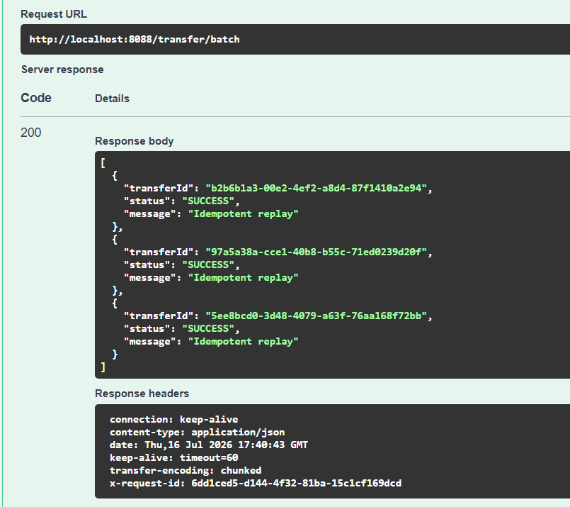

7. Failure-Mode Testing
The true test of a distributed microservices architecture is not merely how it performs under ideal conditions, but how gracefully it handles unexpected disruptions. In the final technical segment of the tutorial, the instructor demonstrates failure-mode testing by intentionally simulating a critical component outage. This exercise practically illustrates the cascading effects of dependency failures within a containerized ecosystem.
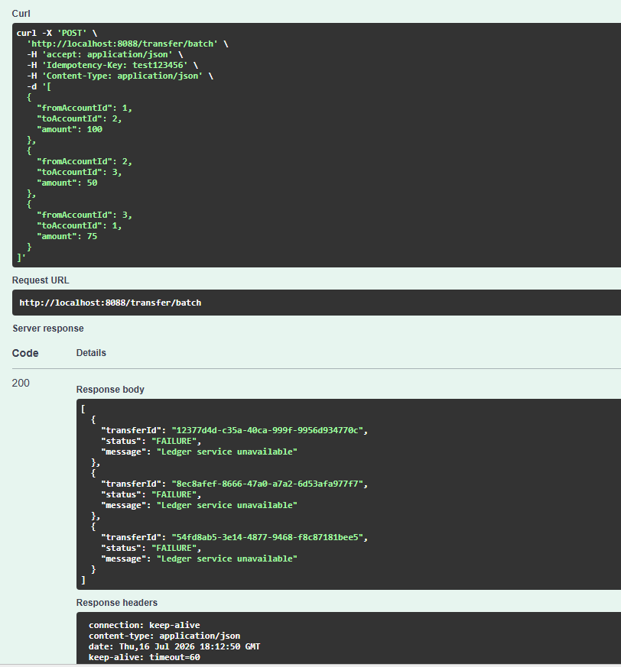

7.1 Simulating a Service Outage (Stopping the Ledger Service)
To replicate a real-world server crash, network partition, or maintenance downtime, the instructor forcefully stops the Ledger Service container. Because the Ledger Service acts as the foundational system of record, halting this container completely severs the data connection that the Transfer Service relies upon to finalize transactions. It is important to note that while the Ledger container is down, the Transfer Service container remains fully active, healthy, and listening for API requests on port 8080. However, its essential backend dependency is now entirely unreachable.

7.2 Observing Application Behavior and Error Handling
With the backend offline, the instructor initiates a new batch transfer request through the Swagger UI to observe the system's reaction. Instead of experiencing a hanging connection, a generic timeout, or a catastrophic system-wide crash, the architecture handles the localized failure predictably. The active Transfer Service processes the incoming request, attempts to route the payload to the downed Ledger container via the internal Docker network, and correctly identifies the dead end. It immediately returns a controlled, formatted error response to the user. The payload explicitly displays a "failure" status accompanied by the precise message: "ledger service unavailable." This proves that the system's failure domains are properly isolated; a crash in the data layer did not take down the front-facing operational layer.

8. Conclusion
The project concludes by summarizing the immense value of orchestration tools in modern software development. By utilizing Docker and Docker Compose, the instructor successfully transformed a complex, interdependent Java Spring Boot application into a highly portable, easily deployable stack. The step-by-step journey—from drafting isolated Dockerfiles to establishing automated bridge networks and validating robust error handling—provides developers with a comprehensive blueprint. Ultimately, this containerized approach guarantees that applications remain consistent, scalable, and resilient, regardless of whether they are running on a local development machine or a production cloud environment. 

