A Personalized Static Hand Gesture Recognition System for Real-Time Smart Device Control Using Lightweight Machine Learning

Group: CST 08

Research Methodology and Scientific Writing CST 395-2

Problem
Individuals with physical disabilities especially those who are paralyzed or unable to walk face significant challenges in controlling everyday home appliances such as lights, fans, or air conditioners. Simple tasks like turning devices ON or OFF often require physical movement or assistance, which can limit independence and comfort in their own homes.
Most gesture-based smart home systems:
  - Rely on a fixed gesture vocabulary
  - Limited gesture-to-device flexibility
  - Lack of personalization
  - Heavy computational requirements

Solution
To address the accessibility challenges faced by individuals with physical disabilities particularly those who are paralyzed or unable to walk this project proposes a Personalized Static Hand Gesture Recognition System for real-time smart device control. The system is designed to enable touchless interaction with home appliances (such as lights, fans, and air conditioners) using only a standard laptop webcam and a low-cost Arduino interface, with no need for special sensors or high-performance hardware.
The key features of the proposed solution include:
  - User-Defined Gesture Vocabulary - Choose any gesture from a pre- listed gesture pool
  - Flexible Gesture-to-Device Mapping
  - Lightweight Machine Learning Models
  - Real-Time Performance and Feedback

Background
Controlling smart home devices like lights, fans, and ACs usually requires switches, remotes, or voice commands. However, for people with disabilities especially those who cannot walk these methods can be difficult or impossible to use. Gesture control offers a hands-free and natural way to operate home appliances. But most existing systems use fixed gestures, cannot be customized, and often require powerful hardware like GPUs.
This project aims to build a system that lets users choose their own hand gestures and map them to any smart device, using only a laptop webcam and Arduino. It focuses on being personalized, lightweight, and real-time, making it accessible, practical, and user-friendly for everyone, especially those with mobility challenges.

Objectives
- Develop a Flexible Gesture Pool and Mapping Interface
Create a pool of up to 50 distinct static hand gestures using MediaPipe landmark data. Build a user-friendly interface that allows users to select up to 25 gestures from this pool and map each gesture to control a specific smart device (e.g., light, fan, AC) with ON/OFF actions.

- Design and Implement a Lightweight, Real-Time System
Ensure the entire system including gesture detection, classification, and device control is optimized to run efficiently on non-GPU hardware (standard laptops).

- Employ Lightweight Machine Learning for Gesture Recognition
Use classical ML models such as k-Nearest Neighbors (k- NN) and Support Vector Machine (SVM) to classify hand gestures based on 63-dimensional feature vectors extracted from webcam input. These models are chosen for their balance of speed, accuracy, and low computational cost, making them ideal for real-time performance without requiring large datasets or deep learning.

Research Gap that we found
  - Existing systems use predefined gestures with no support for user customization.
  - Users cannot freely map gestures to different devices or actions.
  - Most systems are designed for only one or two fixed devices (e.g., just a light or fan).

Novelty
This project introduces a personalized, real-time gesture recognition system that uniquely combines user customization, lightweight machine learning, and real-world smart device control features not jointly addressed in existing solutions. The key novelties include:
  - User-Defined Gesture Mapping
  - Predefined 50-gesture pool with flexibility
  - Flexible Device Control Interface
  - Lightweight, Real-Time ML Architecture
  - Hardware Integration for Practical Deployment

Methodology

- Gesture Pool Design:
  - Define and capture a set of 50 visually distinct one-hand gestures using a webcam.
  - MediaPipe will extract 21 landmark points per gesture.
  - Each gesture will be stored with a unique ID and label.

- User Mapping Interface:
  - Build a configuration UI where the user selects:
  - A device (from 5 available)
  - A gesture (from 50 available)
  - The action (ON or OFF) Mappings will be saved in a config file (JSON/CSV) and editable anytime.

- ML-Based Classification:
  - Use user-selected gestures to train a lightweight ML model (e.g., k- NN, SVM)
  - When gesture is shown, predict its ID based on live landmarks from webcam
  - Match it to mapped device + action and send the command

- Real-Time System Control: o Connect to Arduino
  - Send "device_id:action" command on gesture detection

Expected Outcomes
By the end of this project, you will deliver:
  - A complete, real-time gesture recognition and control system
  - A clean UI for custom gesture-device mapping
  - Measurable performance (≥90% accuracy for mapped gestures)
  - Hardware integration (Arduino-controlled ON/OFF devices)

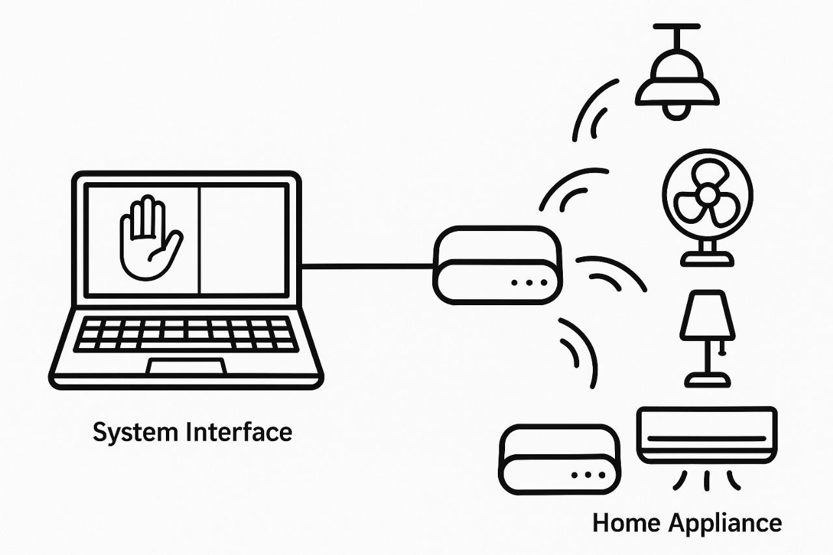
Figure 1: Expected Outcome

Work Flow

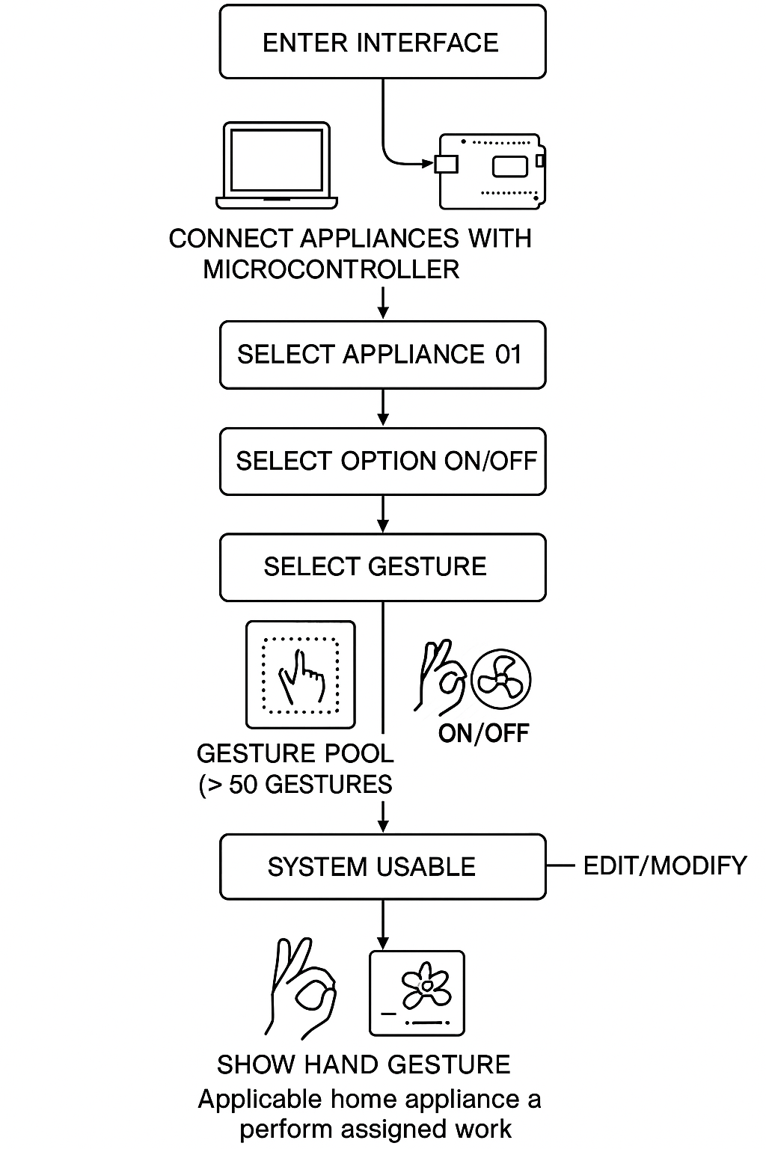
Figure 2: Work Flow Chart

